Question Bank in Corporate Tax and Financial Planning
Module-1

- Define the term “person” and “assessee” under the income tax act. What is regarded as income under the income tax act?
- How Residential Status of the following is Determined:
- Individual
- HUF
- Company
- Firm
- AOP and BOI
- Define the term “person” and “assessee” under the income tax act. What is regarded as income under the income tax act?
- Write short notes on: (a) Assessment year (b) Previous Year (c) Charge of income tax (d) Capital asset (e) Agricultural income (f) Person (g) Assessee (h) Revenue Vs Capital expenditure (i) Gross Total Income (j) Capital receipts (k) Revenue Receipts Vs Capital Receipts (l) Tax Return (m) Method of accounting

- State whether the following are capital or revenue receipts/expenses and give your reasons:
- AB & Co. received Rs.2,00,000 as compensation from CD & Co. for premature termination of contract ofagency.
- Sales-tax collected from the buyer of goods.
- PQ Company Ltd. instead of receiving royalty year by year, received it in advance in lump sum.
- An amount of Rs. 1,50,000 was spent by a company for sending its production manager abroad to studynew methods of production.
- Payment of Rs. 50,000 as compensation for cancellation of a contract for the purchase of machinery witha view to avoid an unnecessary expenditure.
- An employee director of a company was paid Rs. 1,75,000 as a lump sum consideration for not resigningfrom the directorship.
Hint File Name TAX LAWS AND PRACTICE AY 2014-15 (Illustration on Page No. 32)

- State, with reasons in brief, whether the following are capital or revenue receipts/expenditure :
- Rs. 20,000 spent in connection with obtaining a licence for running a cinema hall.
- Rs.3,00,000 received as compensation for termination of contract of agency.
- Lump sum received as advance rent.
- Overhaul expenses of second hand machinery.
- Payment to an employee to retain him in job.
Hint File Name TAX LAWS AND PRACTICE AY 2014-15 (Practical Question No. 1 on Page No. 40)

- ‘Every assessee is a person, but every person need not be an assessee’. Critically examine the statement with reference to the relevant definitions under the provisions of the Income Tax Act, 1951.
OR

“The incidence of tax depends upon the residential status of an assessee.” Discuss.

- “Income tax is a tax on income and not a tax on every item of money received.” Explain this statement with reference to capital and revenue receipts.
Hint File Name TAX LAWS AND PRACTICE AY 2014-15 Q. 3 & Q.4 (ELABORATIVE QUESTIONS 1 &2 on Page No. 40)

- Mr. P, an Indian Citizen, is living in Delhi since 1960, left for Japan on July 1, 2009. He comes back on August 7, 2013. Determine his residential status for the assessment year 2014-15.
Hint File Name TAX LAWS AND PRACTICE AY 2014-15 (Illustration 1 on Page No. 46)
- What are the basic principles for arriving at business income?

- Dr. Q, an Indian Citizen and a Professor in IIM, Lucknow, left India on September 15, 2013 for USA to take up Professor’s job in MIT, USA. Determine his residential status for the assessment year 2014-15.
Hint File Name TAX LAWS AND PRACTICE AY 2014-15 (Illustration 2 on Page No. 47)

- Mr. R is a foreign citizen. Determine his residential status for the assessment year 2014-15 on the assumptionthat during financial years 1999-00 to 2013-14, he was present in India as follows:
P.Y Days P.Y. Days
2013-2014 185 days 2005-2006 300 days
2012-2013 85 days 2004-2005 150 days
2011-2012 275 days 2003-2004 200 days
2010-2011 75 days 2002-2003 180 days
2009-2010 200 days 2001-2002 20 days
2008-2009 90 days 2000-2001 40 days
  - 150 days 1999-2000 300 days
2006-2007 30 days
Hint File Name TAX LAWS AND PRACTICE AY 2014-15 (Illustration 3 on Page No. 47)
- Mr. A is a foreign citizen. His father was born in Delhi in 1954 and mother was born in England in 1960. His grandfather was born in Delhi in 1932. Mr. A is coming to India to see TajMahal and visit other historical places in India. He comes to India on 1st November, 2013 for 200 days. He has never come to India before. Determine his residential status for AY 2014-15.
Hint File Name TAX LAWS AND PRACTICE AY 2014-15 (Illustration 4 on Page No. 47)

- ABC HUF’s whole affairs of business are completely controlled from India. Determine its Residential status for AY 2014-15 (a) if Karta is ROR in India for that year (b) If Karta is NR in India but he satisfies both the additional conditions (c) If Karta is RNOR in India.
Hint File Name TAX LAWS AND PRACTICE AY 2014-15 (Illustration 1on Page No. 50)

- XY & Co. is a partnership firm whose operations are carried out in India. However, all meetings of partners take place outside India as all the partners are settled abroad. Determine Residential status of firm for AY 2014-15.
Hint File Name TAX LAWS AND PRACTICE AY 2014-15 (Illustration 2on Page No. 50)

- Explain the cases, where the income of the previous year is assessable in the previous year itself instead of the assessment year.
Ans: The income of an assessee for a previous year is charged to income-tax in the assessment year, following the previous year. However, in certain cases, the income is taxed in the previous year in which it is earned. These exceptions have been made to protect the interests of revenue. The exceptions are as follows:
- Where a ship, belonging to or chartered by a non-resident, carries passengers, livestock, mail or goods shipped at a port in India, the ship is allowed to leave the port only when the tax has been paid or satisfactory arrangement has been made for payment thereof. 7.5% of the freight paid or payable to the owner or the charterer or to any person on his behalf, whether in India or outside India on account of such carriage is deemed to be his income which is charged to tax in the same year in which it is earned?
- Where it appears to the Assessing Officer that any individual may leave India during the current assessment year or shortly after its expiry and he has no present intention of returning to India, the total income of such individual for the period from the expiry of the respective previous year up to the probable date of departure from India is chargeable to tax in that assessment year,
- If an AOP/BOI etc. is formed or established for a particular event or purpose and the Assessing Officer apprehends that AOP/BOI is likely to be dissolved in the same year or, in the next year, he can make assessment of the income up to the date of dissolution as income of the relevant assessment year.
- During the current assessment year, if it appears to the Assessing Officer that a person is likely to charge, sell, transfer, dispose of or otherwise part with any of his assets to avoid payment of any liability under this Act, the total income of such person for the period from the expiry of the previous year to the date, when the Assessing Officer commences proceedings, is chargeable to tax in that Assessment Year.
- Where any business or profession is discontinued in any assessment year, the income of the period from the expiry of the previous year up to the date of such discontinuance may, at the discretion of the assessing Officer, be charged to tax in that assessment year.

- Mr. Y earns the following income during the previous year ended on 31st March, 2014. Determinethe income liable to tax for the assessment year 2014-15 if Mr. Y is (a) resident and ordinary resident (b) residentand not ordinary resident, and (c) non-resident in India during the previous year ended on 31st March, 2014.
(i) Honorarium received from Government of India (Travelling and other incidental expenses of Rs.7,000were incurred in this connection)- Rs.20,000
(ii) Profits earned from a business in Tamilnadu controlled from Pakistan –Rs.50,000
(iii) Profits earned from a business in U.K. controlled from Delhi- Rs.30,000
(iv) Profits earned from a business in U.S.A. controlled from Pakistan and amount deposited in a bankthere- Rs.40,000
(v) Income from a house property in France, received in India-Rs. 10,000
(vi) Past untaxed foreign income brought into India during the year- Rs. 25,000
(vii) Dividends from a German company credited to his account in Pakistan- Rs.35,000
(viii) Dividends declared but not received from an Indian company- Rs.20,000
(ix) Agricultural income from Burma not remitted to India- 40,000
(x) Pension for services rendered in India, but received in Pakistan- Rs. 30,000
Hint File Name TAX LAWS AND PRACTICE AY 2014-15 (Illustration on Page No. 65)

- X had the following income during the previous year ended 31st March, 2014:
  - Salary Received in India for three Months –Rs.9,000
  - Income from house property in India- Rs.13,470
  - Interest on Saving Bank Deposit in State Bank of India- Rs. 1,000
  - Amount brought into India out of the past untaxed profits earned in Germany- Rs.20,000
  - Income from agriculture in Indonesia being invested there-Rs.12,350
  - Income from business in Bangladesh, being controlled from India- Rs.10,150
  - Dividends received in Belgium from French companies,out of which Rs. 2,500 were remitted to India- Rs.23,000
You are required to compute his total income for the assessment year 2014-15 if he is: (1) a resident; (ii) a notordinarily resident, and (iii) a Non-resident.
Hint File Name TAX LAWS AND PRACTICE AY 2014-15 (Illustration on Page No. 64)

- Mr. A earns the following income during the previous year ended 31st March, 2014. Determine the income liable to tax for the assessment year 2014-15 if Mr. A is (a) resident and ordinarily resident in India, (b) resident and not ordinarily resident in India, and (c) non-resident in India during the previous year ended 31st March, 2014.
  - Profits on sale of a building in India but received in Holland- Rs. 20,000
  - Pension from former employer in India received in Holland- Rs. 14,000
  - Interest on U.K. Development Bonds (1/4 being received in India) –Rs. 20,000
  - Income from property in Australia and received in U.S.A. –Rs. 15,000
  - Income earned from a business in Abyssinia which is controlled from Jullundur (Rs. 30,000 received in India) –Rs. 70,000
  - Dividend on shares of an Indian company but received in Holland [not qualifying for exemption under Section 10(34)] –Rs. 10,000
  - Profits not taxed previously brought into India- Rs. 40,000
  - Profits from a business in Nagpur which is controlled from Holland- Rs. 27,000
Hint File Name TAX LAWS AND PRACTICE AY 2014-15 (Illustration on Page No. 63)

- What are the different categories into which the assessees are divided regarding residence and how is the residence of assessees determined for income-tax purposes? Explain.
- Explain the followings:
- Block of assets
- Agriculture Income
- Assessee and representative assessee

- What tests would you apply to determine the residence of :
- a Hindu Undivided family,
- a firm,
- a limited company,
- an individual.
Hint File Name TAX LAWS AND PRACTICE AY 2014-15 Q. 14 & Q.15 (ELABORATIVE QUESTIONS 1 & 2 on Page No. 68)
- Write short notes on the followings:
- Taxability of income by virtue of business connection
- Income deemed to be received in India
- Income deemed to accrue or arise in India
- Assessee
- Hindu Undivided Family
- Previous Year
- Assessment Year
- Persons
- Income
- Distinguish between the followings:
- Resident and Not Ordinary Resident
- Domestic Company and Foreign Company
- Resident and Non-Resident
- Capital Receipt and Revenue Receipt
- Total Income and Gross Total Income
- Slab Rate and Fixed rate
Hint File Name TAX LAWS AND PRACTICE AY 2014-15 Page No. 40
- Mr. B is employed in a non-seasonal factory at a salary of Rs. 2,400 P.M. Besides, he also gets dearness allowance @ Rs.600 P.M. and bonus @ Rs. 200 P.M. He retires on December 31, 2013 and gets Rs. 75,000 asgratuity under the Payment of Gratuity Act after serving 31 years and 4 months in that factory. Compute theamount of gratuity which is exempt under the Income-tax Act, 1961.
Hint File Name TAX LAWS AND PRACTICE AY 2014-15 Illustration Page No. 84
- Discuss the meaning of income which is deemed to accrue or arise in India.

- Mr. P, an employee of a company, receives Rs.7,75,000 as leave salary at the time of his retirement onDecember 31, 2013. Determine the amount of taxable leave salary for the assessment year 2014-15 fromthe following information:
Salary at the time of retirement Rs. 25,000
Average salary received during last 10 months:
– From March 1, 2013 to September 30, 2013 Rs. 24,000
– From October 1, 2013 to December 31, 2013 Rs. 25,000
Duration of Service 26 years
Leave entitlement for each year of service 1½ months
Leave availed while in service 8 months
Leave at the credit of employee at the time of retirement
(26 X5/3 – 8) 31 months
Leave salary paid at the time of retirement
(i.e. Rs. 25,000 x 31) Rs.7,75,000
Hint File Name TAX LAWS AND PRACTICE AY 2014-15 Illustration Page No. 87-88

- Mr. G who lives in Lucknow, gets the following emoluments during the previous year ended on March 31, 2014. Emoluments of 10 months from X Ltd.: Basic Salary Rs. 5,000 P.M. dearness pay forming part of the basic pay Rs. 500 P.M. and house rent allowance Rs.1,000 P.M. Emoluments of 2 months from Y Ltd.: Basic salary Rs. 6,000 P.M.; house rent allowance Rs. 2,500 P.M. and Rs.20,000 being Commission @ 2% of sales achieved by Mr. G (Sales target achieved by him was Rs.10,00,000 during this period). One month salary due from Y Ltd. during 2012-13 is received by him in April 2013. He pays Rs. 3,000 per month as house rent throughout the previous year. Determine the amount of house rent allowance chargeable to tax for the assessment year 2014-15.

Hint File Name TAX LAWS AND PRACTICE AY 2014-15 Illustration Page No. 92

- Valuation of rent free unfurnished accommodation :
Mr. Shyam, employed at Mumbai, receives the following from his employer during the previous year:
Rs.
Basic Salary 60,000
Bonus 1,800
Entertainment allowance (taxable) 6,000
Electricity expenses 2,000
Professional tax paid by the employer 2,000
Rent free house (owned by Employer) :
Fair rent 48,000
Salary of gardener 2,400
Garden Maintenance 1,200
Salary of watchman 1,800
Determine the value of taxable perquisites in respect of rent free house assuming
(a) Mr. Shyam is a Government Officer and the fair rent as arrived at by the Government is Rs. 6,000 p.a
(b) Mr. Shyam is a semi-Government employee, and
(c) Mr. Shyam is employed by a private company.
Hint File Name TAX LAWS AND PRACTICE AY 2014-15 Illustration Page No. 159

- Mr. Ramamurthy, an employee of M/s. Gopalkrishnan& Co. of Chennai receives during the previous yearended March 31, 2014 the following payments :
Rs.
Basic Salary 40,000
Dearness allowance 3,000
Leave Salary 5,400
Professional tax paid by employer 1,000
Fair rent of the flat provided by employer 6,000
Rent paid for furniture 1,000
Rent recovered by employer 3,000
Contribution to Statutory Provident Fund 4,000
Employer’s contribution to Statutory Provident Fund 4,000
Compute his taxable income for the Assessment Year 2014-15.
Hint File Name TAX LAWS AND PRACTICE AY 2014-15 Illustration Page No. 159-160

- Mr. Sunil is the General Manager of a Transport Company drawing a salary of Rs. 15,000 per month. The company has provided him with accommodation in Rajkot for which 10% of his basic salary is deducted. Actual rent paid by the company for the accommodation is Rs.1,20,000 per annum. He also received entertainment allowance of Rs. 500 per month. He is provided by the company with a car having engine cubic capacity of 1.8 Ltrs. For his personal and official use but running and maintenance expenses for the same are borne by the assessee himself. He is in receipt of bonus equivalent to 2 month’s salary. Compute his taxable income under the head “salary” for the assessment year 2014-15. Assume the population of Rajkot is 20 lakhs. Hint: Page no:107 Illustration 4.57 GirishAhuja

- Mr. Alex Joseph, an American, came to India for the first time 10-01-2010 and left for Britain on 15-09-2010. He again came to India on 01-05-2013 and left for Korea on 15-06-2013. Determine his residential status.
Solution:
During the previous year 2013-14, Mr. Alex Joseph was in India only for 46 days only. So he is a non-resident for the assessment year 2014-15.

- Mr. Ahammed Khan, a citizen of India went to Tokyo to join a course in Business Administration on 01-03-2013 and came back to India on 5th September,2013. Determine his residential status for the A.Y 2014-15.
Solution:
During the P.Y. 2013-14, Ahammed Khan was in India for a period of 208 days
(26+31+30+31+31+28+31), and therefore he satisfies the basic conditions. As he satisfies boththe additional conditions, he is ordinarily resident for the A.Y. 2014-15.

- Mr. Ashish retired in September, 2013 after having put in 42 years of service in a company. His average salary for 10 months preceding Sept. 2013 was Rs:2500 p.m. He received a gratuity of Rs;60,000. Compute his taxable gratuity.
Solution:
Mr.Ashish is not covered by the Payment of Gratuity Act,1972. He has put in 42 years of completed service. Here, least of the following is exempted:
½ month’s salary for every completed years of service (250x ½ x 42) = 52,500
Actual amount of gratuity received = Rs: 60,000
Statutory limit = Rs: 10,00,000
Computation of taxable Amount of Gratuity
Particulars Rs:
Amount of gratuity received 60,000
Less: amount exempted 52,500
Taxable Gratuity 7500

- Mr. Atul, covered under the Payment of Gratuity Act, 1972, retires on 10th January, 2014 after
serving the company for 16 years. At the time of retirement his basic salary was Rs:4,400 p.m. and DA Rs:80 p.m. On retirement he receives Rs:1,0,00 as gratuity. Compute the amount of gratuity exempt U/s 10(10).
Solution :
As Mr. Atul is covered by the Payment of Gratuity Act, 1972, out of the gratuity received by him, the least of the following is exempted u/s 10(10):

15 days salary for every completed years of service:
(4400+800) x 15/26 x 16 years = 48,000
Actual amount of gratuity received = Rs: 1,00,000
Statutory limit = Rs:10,00,000
Therefore exempted amount = 48,000.

- Mr.Afsal was employed in a company. He took voluntary retirement on 1st December, 2013 afterCompleting 25 years of service. On 1st January, 2014 his salary was Rs: 4,000 p.m. after adding the annual increment. The total leave availed during service is 10 months and actual amount received is Rs: 1,60,000 on encashment. Compute the amount exempt regarding encashment of earned leave.
Solution:
The exempted amount of leave encashment is least of the following:
Cash equivalent of earned leave (15 months leave x Rs:4,000) = Rs: 60,000
Ten months average salary (10 months x Rs; 4,000) = Rs: 40,000
Actual amount of leave salary received = Rs: 1,60,000
Statutory Limit = Rs: 3,00,000
Therefore, the exempted amount of leave salary is Rs: 40,000.

- Mr. Abhijth retired on 31st October, 2013 after serving 20 years. He received Rs: 96,000 as leaveEncashment for 12 months. His average salary at the time of retirement amounted to Rs: 7,400. He had 2 months leave at his credit. Find the taxable amount of leave encashment.
Solution:
Exempted amount of leave encashment is least of the following:
Cash equivalent of earned leave (2 months leave x Rs:7,400) = Rs: 14,800
Ten months average salary (10 months x Rs; 7,400) = Rs: 74,000
Actual amount of leave salary received = Rs: 96,000
Statutory Limit = Rs: 3,00,000
Therefore, the taxable amount of leave salary = 96,000 – 14,800 = Rs: 81,200

- Mr. K. Asif is Asstt. Manager of a Textile company of Jaipur, since 1988. He has submitted the following particulars of the financial year 2013-14:
- Basic salary Rs. 2,40,000.
- Dearness Allowance Rs. 5,000 per month (Rs. 200 p.m. enters into retirement benefits).
- Education Allowance for two children at Rs.150 p.m. per child.
- Commission on sales 1% of turnover of Rs. 10,00,000.
- Entertainment Allowance Rs. 700 p.m.
- Traveling Allowance for his official tours Rs. 30,000. The entire amount is spent on the official tour.
- He was given cloth worth Rs. 1,000 by his employer free of cost.
- He resides in the flat of the company. Its market rent is Rs. 12,000 p.m. A watchman and a cook have been provided by the company at the bungalow who are paid Rs.400 per month each.
- He has been provided with a motor car of 1.8 ltr. Engine capacity for his official as well as personal use. The running and maintenance costs are borne by the company.
- Employer’s contribution to R.P.F is Rs.40,000 and the interest credited to this fund at 13% rate amounted to Rs. 16,250.
- Contribution by K. Asif to recognized provident fund Rs. 40,000.
- Rent of house recovered from K. Asif Rs. 1,500 p.m.
- Tax deducted at source from the above payments Rs. 6,000.
Compute income from salaries for the assessment year 2014-15. Assume the population of Jaipur is 26 lakhs as per 2001 census.
Page no:108 Illustration 4.60 GirishAhuja

- Sri Bharat is a purchase officer in a company in jaipur. He furnished the following particulars regarding his income for previous year 2013-14:
- Basic salary Rs. 17,000 p.m.
- Bonus Rs. 5,000.
- Dearness allowance Rs. 3000 p.m.
- Travelling allowance Rs. 45,000. He spends Rs. 30,000 or official purposes.
- Reimbursement of medical bills Rs. 25,000 (treatment was done in a Government hospital in India)
- He lived in a bungalow belonging in the company. Its fair rent is Rs. 15,000 per month. The company has provided on this bungalow the facility of a watchman and a cook each of whom is being paid a salary of Rs. 250 per month. The company paid in respect of this bungalow Rs. 5,000 for electric bills and Rs. 3,000 for water bills.
- He has been provided with 1.5ltr.engine capacity car for official and personal use. The maintenance and running expenses of the car (including driver) are borne by the company.
- The following amounts were deposited in his provident account;
  - Own contribution Rs. 24,000,
  - Company’s contribution Rs. 30,000 and
  - Interest @ 12% p.a.Rs.12,600.
- Rent of house recovered from Bharat Rs. 21,600.
Compute his taxable income from salary for the assessment year 2014-15. Assume the population of Jaipur is 26 lakhs as per 2001 census.
Hint: Page no:109 Illustration 4.61 GirishAhuja
- Mr. Joginder Pal is employed with a transport firm. He is member of an unrecognized provident fund. He has been drawing salary 8,000 p.m. since 1.1.2013. Dearness allowance, forming part of pay for superannuation benefits, is paid 10% of his salary. He gets house rent allowance 1200 per month. He pays rent of 2,000 p.m. He contributes 10% of his salary to the fund and the employer contributes 20%. The employer also reimburses his personal club bills amounting to 19,000. Besides, he is paid 400 p.m. as transport allowance.
He retires on 1.1.2014 after 28 year and 9 months of service. He gets 81,000 as accumulated balance from the provident fund. It consists of 15,000 as his contribution and 12,000 interest thereon. The employer’s contribution is 30,000 and interest thereon is 24,000. He also gets gratuity of 1, 60,000.
After retirement, he gets pension 3,000 p.m. On 1.3.2014 he surrenders one half pension for a consolidated amount of 1, 20,000.
He has made the following payments/ investments during the previous year 2013-2014
- Life insurance premium amounting 2,000 on the policy taken on the life of his married son.
- Public provident fund deposit 5,000.
- Refund of 10,000 to the life insurance corporation of India on account of loan taken for the purchases of a flat, allotted in March, 2,000.
- Purchase of National Savings Certificates, VIII issue, amounting to 3,000
- Contribution of 5,000 under the jeevan Dhara Scheme of life Insurance Corporation of India.
From above information you are required to compute his total income for the assessment year 2014-2015 and his tax liability.
Hint: Page no: 111Illustration 4.64 GirishAhuja
- X has been in service of Y & Co (P) Ltd., since 1st February 1985, in Delhi. During the financial year ending 31.3.2014 X received from the company salary 90,000 p.m. dearness allowance 15,000 p.m. city compensatory allowance 2,000 p.m. entertainment allowances 5,000 per month and house rent allowance 25,000 p.m. X resides in the house property owned by his HUF for which he pays a rent of 30,000 p.m. X has been in receipt of entertainment allowance from company since February, 1985.
X contributes 10,000 p.m. to the recognized provident fund. The company is also contributing an equal amount. X retires from the service of the company on 31.12.2013 when he was allowed a gratuity of 9, 00,000 and pension of 40,000 p.m. On 1.2.2014 he got one half of the pension commuted and received 15, 00,000 as commuted pension. He also received 20, 00,000 as the accumulated balance of the recognized provident fund. Compute his income under the head salary for the assessment year 2014-15.
Hint Page No. 114 Illustration: - 4.68 GirishAhuja

- X, a Director of ABC Pvt. Ltd. Pune is Offered an employment with the following two alternative packages: I II
Rs. Rs.

Basic Pay per annum 1, 38,000 1, 38,000
Conveyance allowance for private use 9,000 Nil
Motor car facility for private use of X and his
familymembers (valued) Nil 9,000
Entertainment Allowance 18,000 Nil
Club facility (Valued) Nil 18,000
Children Education Allowance (for 2 children) 9,700 Nil
Free Education Facility in an institution run by the Nil 9,700
Employer for children (Valued)
Rent Free unfurnished house with fair rental value 30,000 30,000
Which of the two packages should X opt for on the assumption that both employer and employee will contribute 20% of the basic pay towards an unrecognized provident fund. Assume the population of pune is more than 25 lakhs as per 2001 census.

Hint: Page no:112 Illustration:- 4.65 GirishAhuja
- Ms. Rakhi is an employee in a private company. She receives the following medical benefits from the company during the previous year 2013-14 :
Rs.
(1) Reimbursement of following Medical Expenses incurred by Ms. Rahi -
- On treatment of her self employed daughter in a private clinic 4,000
- On treatment of herself by Family doctor 8,000
- On treatment of her Mother-in-law dependent on her, in a Nursing Home 5,000
(2) Payment of premium on Mediclaim Policy taken on her health. 7,500
(3) Medical Allowance. 2,000 p.m.
(4) Medical Expenses Reimbursed on her Son's treatment in a Government Hospital. 5,000
(5) Expenses incurred by company on the treatment of her minor son abroad. 1,05,000
(6) Expenses in relation to Foreign Travel and stay of Rahi and her son abroad for Medical
Treatment. (Limit prescribed by RBI for this is Rs. 2,00,000) 1,20,000
Discuss about the taxability of above benefits and allowances in the hands of Rahi
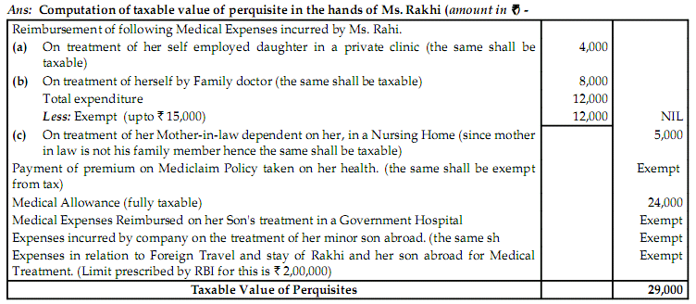

Module-II

- M/s ABC Ltd. filed a return of income for assessment year 2014-15 declaring an annual income of Rs.3,25,000. The return is accompanied by Profit and Loss account as under:

Profit and Loss A/c for the year ending 31.03.2014
 | Rs. |  | Rs.
To salaries, bonus and office expenses | 1,00,000 | By Gross Profit | 5,70,000
To interest on loan | 40,000 | By interest on bank deposits | 12,000
To interest for delayed payment of VAT | 20,000 | By dividend from UTI | 18,000
To interest on delayed payment of Income Tax | 5,000 | By dividend from foreign companies | 9,000
To income tax paid | 45,000 | By Income tax refund | 15000
To interest on loan for purchase of shares of Indian companies | 5,000 | By custom draw back | 1,50,000
To interest on loan for payment of income tax | 5,000 | By VAT refund (earlier not allowed as deduction) | 5,000
To Road construction expenses | 50,000 | By interest from income tax department | 5,000
To entertainment expenses | 12,000
To income tax proceeding expenses | 12,000
To penalty levied by customs | 5,000
To provision for income tax | 50,000
To contribution to recognized provident fund | 40,000
To reserve for bad debts | 44,000
To depreciation | 36,000
To Net Profit | 3,25,000
Total | 7,84,000 | Total | 7,84,000

The profit and loss account has following notes:
- Rs.7,500 on account of bonus remained unpaid at the end of the year.
- Last installment of contribution to provident fund of Rs.2,000 has been paid before the date of filing return of income but after the date as per provident fund act,
- Depreciation allowable as per the income tax rules is Rs.33,000.
There is no other information available with the return of income. Compute business income of the company for AY 2014-15.

Hint: Page 233 Unsolved Question 9 girishAhuja

- From the following profit and loss account of R for the year ending 31.3.2014, compute his gross total income for the AY 2014-15:
Profit and Loss A/c for the year ending 31.03.2014
 | Rs. |  | Rs.
Opening Stock | 15,00,000 | Sales | 1,07,00,000
Purchases | 75,20,000 | Closing Stock | 20,00,000
Wages | 20,00,000 | Gift from father | 1,00,000
Rent | 60,000 | Sale of Car | 1,70,000
Repairs of car | 30,000 | Income Tax refund | 30,000
Wealth tax paid | 20,000
Medical expenses | 30,000
General expenses | 1,10,000
Depreciation of Car | 30,000
Advance income Tax paid | 1,00,000
Profit for the Year | 16,00,000
 | 1,30,00,000 |  | 1,30,00,000
Information:
- R carries on his business from rented premises half of which is used as his residence.
- R bought a car during the year for Rs.2,00,000. He charged 15% depreciation on the value of car. The car was sold during the year for Rs.1,70,000. The use of the car was 3/4th for the business and 1/4th for personal purposes.
- Medical expenses were incurred during sickness of R for his treatment.
- Wages include Rs.60,000 on account of R’s driver.
Hint: Unsolved Ques. 2 Page No. 230 GirishAhuja

- X furnishes the following particulars for the previous year relevant to the assessment
year 2014-15.
Profit and Loss A/c for the year ending 31.03.2014
 | Rs. |  | Rs.
To Salary to staff | 22,000 | By Gross Profit | 2,50,000
To Entertainment expenses | 13,000
To General expenses | 11,000
To Bad Debts | 4,500
To Reserve for bad debts | 10,000
To Advertisement expenses | 7,000
To Interest on X’s capital A/c | 3,000
To expenditure on acquisitions of Patent rights | 28,000
To Telephone expenses | 12,000
To Depreciation | 10,000
To Provision for income tax | 4,000
To net profit | 1,25,500
 | 2,50,000 |  | 2,50,000
Other information:
- Salary to staff includes salary paid to a relative which unreasonable to the extent of Rs.3,100.
- Provision for income tax is excessive to the extent of Rs.3,000.
- Depreciation on tangible assets according to the income tax provision comes Rs.9,500.
- During the previous year 2013-14 the following payments were made and the same have not been debited to Profit and loss account of 2013-14.
- Rs.3,000 paid on 10.9.2013 on account of outstanding custom duty of the previous year 2012-13.
- Rs.5,000 paid on 15.12.2013 on account of outstanding sales tax of the previous year 2012-13.
- Patents were acquired on 4.11.2013
Hint: Page No. 225 Solved Illustration 6.41 Girish Ahuja

- X age 66 years, a resident individual, furnishes the following particulars for the relevant AY 2014-15:
Profit and Loss Account
For the year ending March 31, 2014
 | Rs. |  | Rs.
Salary to staff | 34,000 | Gross Profit | 6,86,000
General Expenses | 48,000 | Commission and discount | 2,17,200
Bad Debts written off | 15,000 | Sundry receipts | 43,000
Reserve for losses | 2,000 | Short term profit on sale of  Investment | 31,000
Fire Insurance premium  (office premises) | 4,200
Advertisement Rs.2,400  Add: Outstanding 1,600 | 4,000
Interest on X’s Capital | 3,500
Interest on Bank Loan | 14,500
Expenditure on acquisition of a  Patent right acquired and put  To use on June 30,2013 | 17,000
Lump Sum consideration for acquiring Know-how on March 3,2009 | 60,000
Depreciation on Plant and Machinery | 28,000
Provision for outstanding  Sales Tax and excise duty | 13,000
Net Profit | 7,34,000
Total | 9,77,200 | Total | 9,77,200

Other Information:
- Advertisement expenditure includes Rs.3,400, being cost of 2 diaries ( cost of each being Rs.1,700) presented to customers.
- Depreciation on plant and machinery according to income tax provision comes to Rs.29,700.
- Salary to staff includes payment of Rs.8,000 to a relative which is unreasonable to the extent of Rs.3,000.
- General expenses include (a) expenditure of Rs.4,800, incurred by X on training of his employees, (b) commission of Rs.10,000 for securing a business order, and (c) compensation of Rs.6,000 paid to an employee while terminating his service in the business interest.
- Out of outstanding sales tax and excise duty, Rs.3,000 is paid on July 10 ,2009 and Rs.8,000 is paid on October 3 , 2009. The balance is not paid as yet. Due date of filing return of income is July 31, 2013.
- Income of X from company deposit is Rs.12,000, which is not shown in the Profit and Loss Account.

Determine the taxable income and tax liability of X for the AY 2014-15, assuming that insurance premium paid by X on the life of Mrs. X is Rs.3, 200.
Find out the taxable income of X for the assessment year 2013-14. Due date of filing return of income of assessment years 2012-13 and 2013-14 is 30th September of the relevant previous year.

- Vasudev, an Indianresident (aged 45 years), owned a residential house in Bangalore. It was acquired by Vasudev, on 15.10.1986 for Rs.8,40,000. It was sold for Rs. 70,00,000 on 09.11.2013. The State Stamp Valuation Authority fixed the value of property to be at Rs.75,00,000. The assessee paid 2% of the sale consideration as brokerage for the sale of the said property. Vasudev acquired a residential house in Chennai on 15.12.2013 for Rs.7,00,000 and deposited Rs.4,00,000 on 10.04.2014 in the capital gain bond of Rural Electrification Corporation Ltd. (RECL). He deposited Rs.5,55,000 on 10.07.2014 in the Capital Gain deposit Scheme in a nationalized bank for construction of additional floor on the residential house property acquired in Chennai. Compute the capital gain chargeable to tax in the hands of Mr. Vasudev for the assessment year 2014-15. Cost inflation Index: Financial year 1986-87= 140, Financial Year 2013-14= 939

Hint: Revisionary Test Paper Page 15 Que. 6(a)

- Mr. Janardan furnishes the following data for the previous year ending 31.03.2014:
1. 10,000 unlisted Equity shares of CD Ltd., were sold on 31.05.2013 at Rs.500 per share.
2. The above shares were acquired by Mr. in the following manner:
  - 5000 shares were gifted to him on 01.06.1980. The Fair Market Value as on 01.04.1981, per share was Rs. 50.
  - 2,000 bonus shares were issued by CD Ltd. on 21.07.1985.
  - 3,000 shares were acquired at Rs.125 per share on 01.02.1994.
3. A residential house was purchased on 01.05.2014, for Rs.25 Lakhs, out of the sale proceeds of the shares. Mr. Janardanwas already owning a residential house, before the purchase of this house. Compute the capital gain chargeable to tax in the hands of Mr. Janardan for the assessment year 2014-15. Cost inflation Index: Financial year 1993-94= 244, Financial Year 2013-14= 939

Hint: Revisionary Test Paper Page 16 Que. 6(b)

- Write short notes on the followings:
- Normal depreciation and additional depreciation
- Block of assets

- Advise an assessee about the admissibility or otherwise of the claims, with regard to the following items, giving reasons:
- Compensation paid to an employee for premature termination of his services.
- Amount spent i n a successful suit filed against another for infringing the assessee’s trade mark.
- Penalty paid to customs authorities for importing prohibited goods which yielded a large margin ofprofits.
- Travelling expenses of a director who went to Europe f or negotiating the purchase of a new heavymachinery which was eventually installed next year.
- Cost of erecting a medical annex e to the factory for the emergency treatment of the employees.
- Lump-sum consideration paid f or acquiring know-how Rs.6,00,000.
- Loss of Rs.1,000 which were snatched away from the khazanchee’s possession while going to bank to deposit the amount.
- Loss due to embezzlement by an employee.
- Brokerage paid f or raising loan f or the business.
- Rs. 1,000 spent in connection with installation of a new telephone connection.
- Fees paid t o lawyer for drafting t he Deed of Agreement with an outsider relating to the setting-up the business.
- Pension paid to the window and children of a deceased engineer of t he factory voluntarily.
- Interest paid f or funds borrowed specifically for the acquisition of a capital asset.
Hint Page 270 Illustration file name TAX LAWS AND PRACTICE AY 2014-15
- On 15th November, 2013 Mohan sold 1 kg. of gold, the sale consideration of which was Rs.4,50,000. He acquiredthe gold on August 18, 1978 for Rs.64,000. Fair market value of 1 kg. of gold on April 1, 1981 was Rs. 62,000.Find out the amount of capital gain chargeable to tax for the assessment year 201415. Cost inflation index for 1981-82 and 2013-14 are 100 and 939 respectively.
Hint Page 300-301 Illustration file name TAX LAWS AND PRACTICE AY 2014-15
- A has the following incomes for the previous year 2013-14:
Rs.
Business income (–) 30,000 (viz. business loss of 30,000)
Short term capital gains 6,000
Longtermcapital gains 1,90,000
A deposits Rs.9,000 in public provident fund account. You are required to find out his tax liability for the assessmentyear 201415.
Hint Page 316 Illustration file name TAX LAWS AND PRACTICE AY 2014-15
- Distinguish between
  - ‘Exemption to capital gains under section 54G’ and ‘exemption to capital gains under section 54GA’.
  - ‘Long-term capital gain’ and ‘short-term capital gain’.
Hint Page 321 file name TAX LAWS AND PRACTICE AY 2014-15

- What are ‘capital assets’? What items are not included in capital assets?
Hint Page 321 file name TAX LAWS AND PRACTICE AY 2014-15

- X ltd is engaged in the business of manufacture of computer hardware since 1995. During the PY 2013-14, the following assets are acquired and put to use-
(Rs. in thousand)
Block-1 Block-2 Block-3
Rate of Depreciation 15% 30% 60%
No. of assets in the block 11 12 17
Depreciated value of the block on
April 1,2013 18,00 25,00 5,00
Additions of plants(new) during the
PY 13-14
Plant A 57,00
Plant B 4,00
Plant C 17,00
Sale of old plants( one in each block) 8 28,70 42,00

- Plants A,B and C are acquired during May 2008 and put to use during September 2008. However, Plant B is put to use in the last week of March 2009. Find out the amount of depreciation, additional depreciation and capital gain.

Module-III
- Mr. Garg, a resident individual, furnishes the following particulars of his income and other details for the previous year 2013-14.
Rs.
- Income from Salary 15,000
- Income from Business (before providing depreciation) 66,000
- Long term capital gain on sale of Land 10,800
- Loss on maintenance of Race Horses 15,000
- Loss from Gambling 9,100
The other details of unabsorbed depreciation and brought forward losses pertaining to Assessment Year 2013-14 are as follows:
Rs.
- Unabsorbed depreciation 11,000
- Loss from Speculative business 22,000
- Short term capital loss 9,800
Compute the Gross Total Income of Mr. Garg for the Assessment Year 2014-15 and the amount of loss, if any, that can be carried forward, or not.

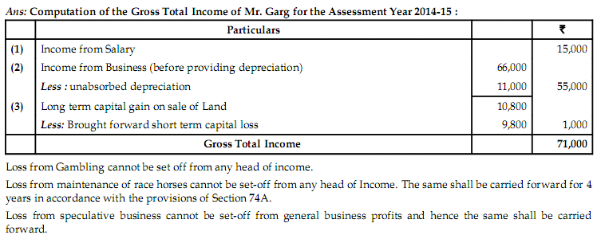
- State in brief the applicability of tax deduction at source provisions, the rate and amount of tax deduction in the following cases for the previous year 2013-14:
  - Winning by way of jackpot in a horse race Rs.1,00,000.
  - Payment made by a firm to sub-contractor Rs.3,00,000 with outstanding balance of Rs.1,20,000 shown in the books as on 31.03.2014.
  - Rent paid for plant and machinery Rs.1,50,000 by partnership firm having sales turnover of Rs.2,00,000 and net loss of Rs.15,000.
  - Payment made to Chris Gayle, a cricketer, by a newspaper for contribution of articles Rs.25,000.
Hint: Revisionary Test Paper Page 28 Que. 10(b)
- Explain how contributions to political parties are deductible in the hands of corporate and non- corporate assessees under the income-tax law.
Ans: Section 80GGB provides for deduction of any sum contributed in the previous year by an Indian company to a political party. Section 80GGC provides for deduction of any sum contributed by any other person to a political party. However, this deduction will not be available in respect of sum contributed by a local authority and every artificial juridical person, wholly or partly funded by the Government.
It may be noted that cash donations to political parties would not qualify for deduction under Section 80GGB and Section 80GGC.
Deduction under Sections 80GGB and 80GGC would be available in respect of contributions made to a political party registered under Section 29A of the Representation of the People Act, 1951.
Note: For the purpose of Section 80GGB, the word "contribute" shall have the same meaning assigned to it under Section 293A of the Companies Act, 1956, which provides that –
(a) a donation or subscription or payment given by a company to a person for carrying on any activity which is likely to effect public support for a political party shall also be deemed to be contribution for a political purpose;
(b) the expenditure incurred, directly or indirectly, by a company on advertisement in any publication (being a publication in the nature of a souvenir, brochure, tract, pamphlet or the like) by or on behalf of a political party or for its advantage shall also be deemed to be a contribution to such political party or a contribution for a political purpose to the person publishing it.
However, it may be noted that as per Section 37(2B), no allowance shall be allowed in respect of expenses incurred by him on advertisement in any souvenir, brochure, tract or the like published by any political party. It is only after computation of gross total income, contribution to a registered political party is allowed as deduction under Section 80GGB to a company.

- Discuss in brief the deductions given by Section 80C, 80D & 80G.
Answer:SECTION 80C - [DEDUCTION FOR SAVINGS]
Deduction is allowed in respect of amount paid during the previous year as life insurance premium, or contribution to Public Provident Fund or Tuition fee for children etc. The maximum deduction allowed is Rs 1,00,000.
SECTION 80D- [DEDUCTION FOR MEDICLAIM POLICY]
Deduction is allowed in respect of amount paid during the previous year as medical insurance premium the maximum deduction allowed is Rs 15,000
SECTION 80G – [DEDUCTION FOR DONATIONS]
Deduction is allowed in respect of amount paid during the previous year AS DONATION to
- National Defence fund set up by the Central Govt. @ 100%
- Prime Minister’s National Relief Fund @ 100%
- Rajiv Gandhi Foundation @ 50% Etc.

- Green holds 25% shares in Blue Ltd. along with his relatives. Blue Ltd. has employed Mrs. Green at a salary of Rs. 50,000 per month. She does not hold any technical or professional qualification.
Other incomes of Green are as follows :
– Business :Rs. 4,50,000
– Dividend from Blue Ltd. :Rs. 1,80,000
Other income of Mrs. Green is income from house property (net of deduction under section 24) of Rs. 1,20,000.Compute taxable income and tax liability of Green and Mrs. Green for Assessment Year 2014-15.
Hint Page 351 illustration file name TAX LAWS AND PRACTICE AY 2014-15
Ans: 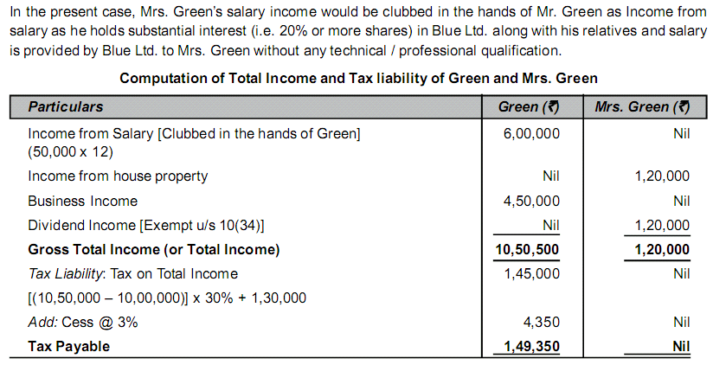
- Red holds 40% of shares in a Company. Mrs. Red (a CS) i s employed i n the company as a Company Secretary and i s getting salaryof Rs. 15,000 per month. Compute total income and tax payable by Red and Mrs. Red for the Assessment Year 2014-15 assuming other income of Red i s Rs. 2,00,000 from a business and dividend income from company i s Rs. 3,00,000.
Hint Page 351 illustration file name TAX LAWS AND PRACTICE AY 2014-15
Ans: 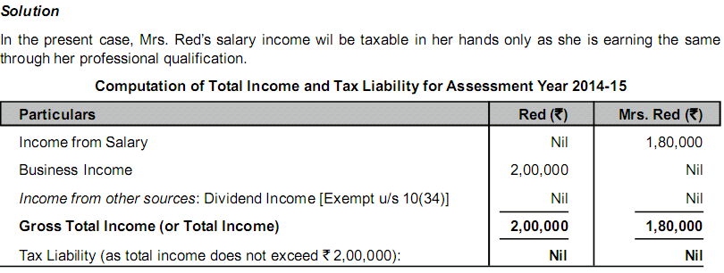

- What do you mean by “Set-off and carry forward of losses”? Which losses can be carried forward?
- Discuss the provisions of the Income-tax Act relating to the set-off of losses.
- “Loss can be carried forward only by the person, who has incurred the loss.” Discuss.

- Mr. Ram who is a person with disability submits the following information. Compute (a) the Taxable Income (b) theTax Payable f or the assessment year 2014-2015.
Rs.
(i ) Salary (per annum ) 3,00,000
(i i) Rent received 48,000
(iii) Dividend from Co-operative Society 1,000
(iv ) Interest on Savings Bank Deposits 18,000
(v ) Interest on Government securities 1,000
(v i) Winning from Lotteries (gross) 5,000
(v ii) NSC (VIII Issue) purchased during the year 10,000
(v iii) Deposit under PPF Scheme 30,000
He earned a long-term capital gain of Rs. 15,000 on sale of gold during the year.
Hint: Page 400 Illustration file name TAX LAWS AND PRACTICE AY 2014-15
- Rahul who is a resident i n India, is a person with disability. He provides the following particulars of his income f or the year ended 31.3.2014.
Rs.
(a) Salary for working as a cable operator (per month) 18,000
(b) Interest on government securities (gross) 45,000
(c) Dividend from Indian Company 5,000
(d) Honorarium from schoolof orphanage for giving his service 49, 000
He has donated Rs. 20,000 to the school for orphanage which i s approved as a charitable institution and contributed Rs.2,000 to Prime Minister National Relief Fund. He has also paid Rs. 3,000 by credit card as premium of Medi claim policy. His father is also a person with disability and is dependent on him formedical treatment and rehabilitation. Rahul spends Rs.8,000 during the year on him.
Compute the Total Income for the Assessment Year 2014-15, assuming he has deposited Rs. 20,000 in Public Provident Fund Account.
Hint: Page 401 Illustration file name TAX LAWS AND PRACTICE AY 2014-15
- Explain in brief the deduction for the medical insurance premium paid by the assessee.
- Enumerate the various rebates and reliefs available to individuals under the Income-tax Act, 1961.
- Explain the concept of MAT and its rationale.
Hint: Page 455 Elaborative question-6 file name TAX LAWS AND PRACTICE AY 2014-15

- Write short notes on the following:
- Carry forward of business loss
- Carry forward of capital loss
- Set off of gambling losses

- Rahul who is a resident in India, is a person with disability. He provides the following particulars of his income for the year ended 31.3.2014.
Rs.
(a) Salary for working as a cable operator (per month) 18,000
(b) Interest on government securites (gross) 45,000
(c) Dividend from Indian Company 5,000
(d) Honorarium from school of orphanage for giving his service 49,000
He has donated Rs.20,000 to the school for orphanage which is approved as a charitable institution and contributed Rs.2,000 to Prime Minister National Relief Fund. He has also paid ` 3,000 by credit card as premium of mediclaimpolicy. His father is also a person with disability and is dependent on him for medical treatment and rehabilitation.Rahul spends Rs.8,000 during the year on him.
Compute the Total Income for the Assessment Year 2014-15, assuming he has deposited Rs.20,000 in PublicProvident Fund Account.
Hint: Page No. 401 Chapter-6 Solved IllustrationTAX LAWS AND PRACTICE AY 2014-15

- Discuss the conditions to be satisfied in respect of contributions qualifying for deduction u/s 80C and when and how tax is to be deducted at source from salary u/s 192, explain.
- Explain any four of the followings:
- Adventure in the Nature of Trade
- Speculative Transactions
- Capital receipts and revenue receipts

Module-IV

- What are the objectives of tax planning? Enumerate the requisites f or its success.
Hint: Page No. 585 Que. No.4 TAX LAWS AND PRACTICE AY 2014-15
- Distinguish between tax evasion and tax avoidance?
Hint: Page No. 585 Que. No.2TAX LAWS AND PRACTICE AY 2014-15

- Distinguish Tax Evasion, Tax Avoidance, Tax Mitigation and tax planning.
Ans: Tax Evasions, Tax Avoidance, Tax mitigation and Tax Planning
The methods adopted to reduce the tax liability can be broadly put into four categories: "Tax Evasion";”Tax Avoidance”, "Tax Mitigation", "Tax Planning". The difference between these four methods sometimes become blurred owing to the perception of the tax authorities and / or tax payer.
Tax Evasion : Tax Evasion term is usually used to mean 'illegal arrangements where liability to tax is hidden or ignored i.e. the tax payer pays less than he is legally obligated to pay or by hiding income or information from tax authority. Thus, here the tax liability is reduced by "illegal and fraudulent" means. For example: understatement of income.
Tax Avoidance : Tax Avoidance refers to the legal means so as to avoid or reduce tax liability, which would be otherwise incurred, by taking advantage of some provision or lack of provision in the law. Thus, in this case tax payer tries to reduce his tax liability but here the arrangement will be legal, but may not be as per intent of the law. Thus, in this case, tax payer does not hide the key facts but is still able to avoid or reduce tax liability on account of some loopholes or otherwise. For example: misinterpreting the provisions of the IT Act.
Tax Mitigation : "Tax Mitigation" is a situation where the taxpayer takes advantage of a fiscal incentive afforded to him by the tax legislation by actually submitting to the conditions and economic consequences that the particular tax legislation entails. A good example of tax mitigation is the setting up of a business undertaking by a tax payer in a specified area such as Special Economic Zone (SEZ).
Tax Planning : Tax Planning is defined as "arrangement of a person's business and / or private affairs in order to minimize tax liability". For example: availing deduction.
- Mr.Anurag is entitled to a salary of Rs.18, 000 per month. He is given an option by his employer either to take house rent allowance or a rent free accommodation which is owned by the company. The HRA amount payable was Rs.4, 500 per, month. The rent for the hired accommodation was Rs.5, 250 per month at New Delhi. Advice Mr.Anurag whether it would be beneficial for him to avail HRA or RFA.

- R who is neither a director nor has substantial interest in any company, is offered on 1.4.2013 an employment by G Ltd., New Delhi with the following two alternatives:
 | Alternative I | Alternative II
 | Rs. | Rs.
Basic Pay | 40,000 | 40,000
Bonus | 2,000 | 2,000
Education allowance for the children | 4,400 | Nil
Education facility | Nil | 4,400
Servant allowance | 3,000 | Nil
Free domestic servant | Nil | 3,000
Entertainment allowance | 6,000 | 6,000
Club Facility | Nil | 6,000
Conveyance allowance for private purposes | 3,000 | Nil
Free car facility for private purposes | Nil | 3,000
Allowance for gas, electricity and water supply | 1,000 | Nil
Free gas, electricity and water supply | Nil | 1,000
A rent free unfurnished house: Fair Rent | 6,000 | 6,000
Which of the two alternative R should opt for?
Hint: Page No. 123 unsolved Question 22 from Girish Ahuja

- A company wants to raise capital of Rs. 20,00,000 for a project where earning before tax shall be 30% of the capital employed. The company can raise debt fund @ 12% p.a. Suggest which of the 3 alternatives should it opt for:
- Rs.20,00,000 to be raised by equity capital
- Rs.16,00,000 by equity and Rs.4,00,000 by loans
- Rs.4,00,000 by equity capital and Rs.16,00,000 by loans.
Assume the company shall distribute the entire amount of profits as dividend and tax rate is 30%.
Ans: 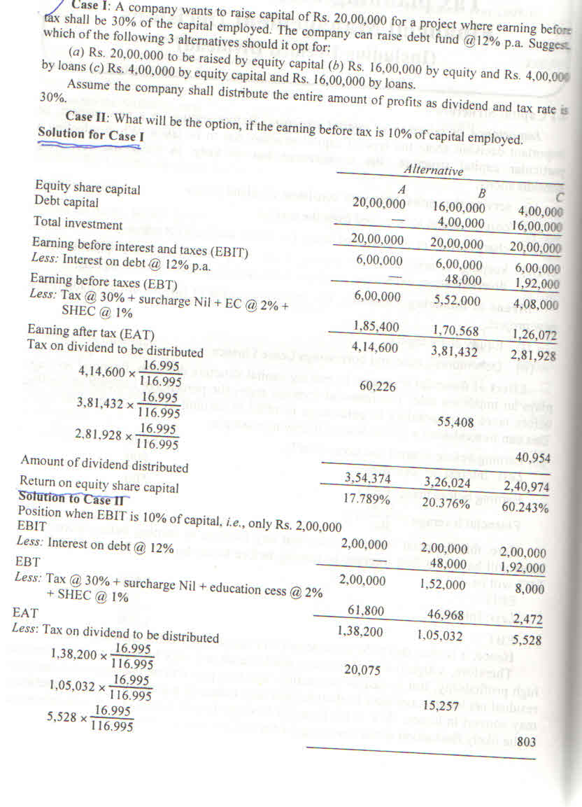
- X, a Director of ABC Pvt. Ltd. Pune is Offered an employment with the following two alternative packages:
Particulars | Package I  Rs. | Package II  Rs.
Basic Pay per annum | 1, 38,000 | 1, 38,000
Conveyance allowance for private use | 9,000 | Nil
Motor car facility for private use of X and his  family members (valued) | Nil | 9,000
Entertainment Allowance | 18,000 | Nil
Club facility (Valued) | Nil | 18,000
Children Education Allowance (for 2 children | 9,700 | Nil
Free Education Facility in an institution run by the  Employer for children (Valued) | Nil | 9,700
Rent Free unfurnished house with fair rental value | 30,000 | 30,000

Which of the two packages should X opt for on the assumption that both employer and employee will contribute 20% of the basic pay towards an unrecognized provident fund. Assume the population of pune is more than 25 lakhs as per 2001 census.
Hint: Page No.112 Solved Illustration No. 4.65 from Girish Ahuja

- Briefly describe the tax provision with reference to Location and Nature of New Business.
Answer: TAX MANAGEMENT IN LOCATION OF THE NEW BUSINESS
1. Sec. [ 10A] : Tax Holiday for newly established undertaking in Free Trade Zone:
First 5 Years – 100 % of profits and gains is allowed as deduction
Next 2 Years : 50% of such Profit and Gains is deductible for further 2 assessment years.
Next 3 Years : for the next three consecutive assessment years, so much of the amount not exceeding 50% ofthe profit as is debited to the profit and loss account year in respect of which the deduction is to be allowed and credited to a reserve account (to be called the ''Special Economic Zone Re-investment Allowance Reserve Account'') to be created and utilised for the purposes of the business of the assessee
2. Sec. [ 80IA] : an [undertaking] which,—
(a) is set up in any part of India for the generation or generation and distribution of power if it begins to generate power at any time during the period beginning on the 1st day of April, 1993 and ending on the 31st day of March, 2010;
(b) starts transmission or distribution by laying a network of new transmission or distribution lines at any time during the period beginning on the 1st day of April, 1999 and ending on the 31st day of March, 2010.
(c) undertakes substantial renovation and modernisation of the existing network of transmission or distribution lines at any time during the period beginning on the 1st day of April, 2004 and ending on the 31st day of March, 2010.
Deductions allowed is 100% or 30% of profits from such eligible business
3. Sec. [80IB] : Deduction in respect of Profits of Industrial Undertaking located in backward State or District. Deduction allowed is either 100% and /or 30% for 10 years depending upon case to case.
4. Sec. [80IB(11B)] : The amount of deduction in the case of an undertaking deriving profits from the business of operating and maintaining a hospital in a rural area shall be 100% of the profits and gains of such business for a period of five (5) consecutive assessment years, beginning with the initial assessment year.
5. Sec. [ 80IC] : Profits from Industrial Undertaking located in the specified States,. States are State of Jammu & Kashmir, Himachala Pradesh, Uuttaranchal and North Eastern States. Deduction allowed is 100% of such profit.
6. Sec.[ 80 LA] : Where the gross total income of an assessee,— (i) being a scheduled bank, or, any bank incorporated by or under the laws of a country outside India; and having an Offshore Banking Unit in a Special Economic Zone; or (ii) being a Unit of an International Financial Services Centre , there shall be allowed a deduction from such income, of an amount equal to— 100% of such income for five consecutive assessment years beginning with the assessmentyear.
- Specify with proper explanation whether the following acts can be considered as an
act of (A) Tax management; or (B) Tax planning; or (C) Tax evasion
(i) R deposits Rs.45,000 in P.P.F account so as to reduce total income from 2,45,000 to 2,00,000.
(ii) R industries ltd. installed an air conditioner costing Rs.60,000 at the residence of a director as per terms of his appointment; but treats it as fitted in quality control section in the factory. This is with the objective to treat it as plant for the purpose of computing depreciation.
(iii) R Ltd. maintains register of tax deduction effected by it to enable timely compliance.
(iv) R Ltd. issues a credit note for Rs.36,000 for brokerage payable to Suresh, Who is son of R, managing director of the company. The purpose is to increase his income from Rs.18,000 to Rs.54,000 and reduce its income correspondingly.

Module-5

- Describe briefly the procedures regarding collection and recovery of Tax by the authorities.
Hint: Page 501Elaborative question-1 file name TAX LAWS AND PRACTICE AY 2014-15
- What is Tax deducted at Source?
Hint: Page 501Elaborative question-2 file name TAX LAWS AND PRACTICE AY 2014-15
- What is self-assessment? What are the consequences of non-payment of tax on “Self-assessment”? Hint: Page No. 433 Pont 15.14GirishAhuja
- Write short notes on the followings:
- Advance payment of tax
- Tax deducted at source
- Is it compulsory to file a return of income? What is the time limit for submission of the return of income?
Hint: Page No. 435 Theoretical question Q.1 GirishAhuja
- What is submission of return of income? What are the important provisions given in Income Tax Act, 1961?
- Discuss the conditions to be satisfied in respect of contributions qualifying for deduction u/s 80C and when and how tax is to be deducted at source from salary u/s 192, explain.

- What do you understand by Permanent Account Number? Mention the transactions where quoting of PAN is compulsory.
Hint: Page No. 435 Theoretical question Q.5 GirishAhuja
- What is self-assessment? What are the consequences of non-payment of tax on “Self-assessment”?
- Answer any two of the following three sub divisions. What are the provisions relating to tax deduction at source in respect of :
(A) ABC and Co. Ltd. Paid Rs.19,000 to one of its Directors as sitting fees on 01-01-2014.
(B) Mr. X sold his House to Mr. Y on 01-02-2014 for Rs. 60 lacs ?

Ans:(A) As per section 194-J, a company shall be liable to deduct tax at source @ 10% on any remuneration or fees or commission paid to a director, on which the tax is not deductible under section 192. The limit of Rs. 30,000 under section 194-J is not applicable on any remuneration or fees or commission payable to director of a company.Tax deductible under section 194-J = Rs. 19,000 x 10% = Rs.1,900.

(B)Since the sale consideration of house property exceeds Rs. 50 lacs, Mr. Y is required to deduct tax at source under section 194-IA at the time of credit of such sum to the account of Mr. X or at the time of payment, whichever is earlier. Tax @ 1% of the sale consideration is required to be deducted by Mr. Y under section 194-IA. Tax deductible under section 194-IA = Rs. 60 lacs × 1% = Rs. 60,000.

- Explain with brief reasons whether the return of income can be revised under Section 139(5) of the Income-tax Act, 1961 in the following cases:
  - Belated return filed under Section 139(4),
  - Return already revised once under Section 139(5).
  - Return of loss filed under Section 139(3).
Answer:Any person who has furnished a return under Section 139(1) or in pursuance of a notice issued under Section 142(1) can file a revised return if he discovers any omission or any wrong statement in the return filed earlier. Accordingly,
  - A belated return filed under Section 139(4) cannot be revised. Only a return furnished under Section 139(1) or in pursuance of a notice issued under Section 142(1) can be revised.
  - A return revised earlier can be revised again as the first revised return replaces the original return. Therefore, if the assessee discovers any omission or wrong statement in such a revised return, he can furnish a second revised return within the prescribed time i.e. within one year from the end of the relevant assessment year or before the completion of assessment, whichever is earlier.
  - A return of loss filed under Section 139(3) is deemed to be return filed under Section 139(1), and therefore, can be revised under Section 139(5).

- Enumerate the circumstances in which an individual assessee is empowered to sign and verify his return of income under Section 139 by himself or otherwise by an authorized signatory.
Ans:
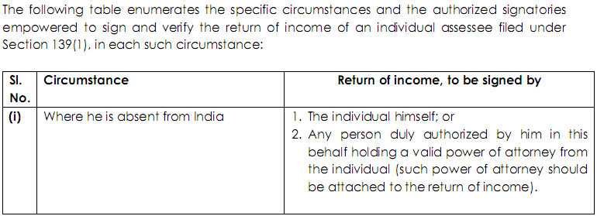

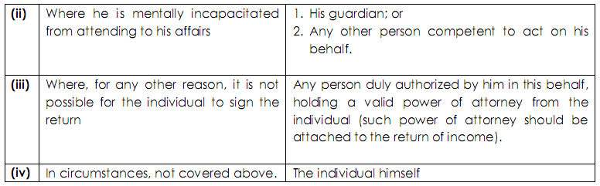

- Describe briefly the procedures regarding collection and recovery of Tax by the authorities.
Hint Page No. 501 Elaborative Question 1 in chapter 10 in file Name TAX LAWS AND PRACTICE AY 2014-15

- State the income-tax authorities who are empowered to administer the Income-tax Act and explain their powers, functions and jurisdiction in relation to assessment of income.
Hint Page No. 528 Elaborative Question 1 in chapter 11 in file Name TAX LAWS AND PRACTICE AY 2014-15

- Explain the following :
(a) Return of loss; (b) Belated return; (c) Revised return; and (d) Voluntary return.
Hint Page No. 528 Elaborative Question 3 in chapter 11 in file Name TAX LAWS AND PRACTICE AY 2014-15
- What is self-assessment? What are the consequences of non-payment of tax on “Self-assessment”?
Hint Page No. 528 Elaborative Question 4 in chapter 11 in file Name TAX LAWS AND PRACTICE AY 2014-15

