Course File

Faculty Name: Dr Rajeshkumar Kiri |  | Class: MBA Sem III
Subject Code: MB0322 |  | Subject Name: Financial Investment Analysis and Portfolio Management
Course Completion Date: |  | Total Classes Taken:
S.No | File Item Checklist | Status of submission (Please mark ✓ )
1 | Syllabus | ✓
2 | Vision, Mission, PEOs, POs(Program Outcomes) | ✓
3 | Course Plan | ✓
4 | Class Attendance record Month wise | ✓
5 | Assignments (Unit I &II, III &IV) | ✓
6 | Assignment (Unit I &II, III &IV) (Best,good,satisfactory)one copy | ✓
7 | Class Test Ques. Paper | ✓
8 | Class Test Result | ✓
9 | Presentation Topics | ✓
10 | Case Study/ Caselates | ✓
10 | Efforts taken for Weak Students | ✓
11 | Result Analysis (Attainment Level) | ✓

Pre-requisites:
Credit points: 3
Credits Offered Semester: III
Department with siting location: Management Telephone: 9426753085
Email: rajeshkumarkiri.mba@indusuni.ac.in

Vision

- To emerge as a prominent management institute in the country, attracting high-profile talent- students, researchers and faculty- and creating an eco-system conducive for intellectual excellence

- Nurturing the talent into socially relevant and dedicated managers, entrepreneurs, business leaders and thought leaders

- Contributing positively to the society in terms of innovative business models, practices and a body of knowledge in sync with Indian values and ethos.

Mission
- Be a magnet and attract high-profile talent from all over the country and abroad.

- Foster and sustain an intellectual ambience that would facilitate pursuit of excellence.

- Be a hub of intellectual excellence, a hub of solution providers for the industry and society.

- Forge meaningful partnerships with academia, industry, government and the social sector to promote sustainability, inclusiveness and ethical participation with global perspective.

- Be a hub to facilitate fusion of research and knowledge with industrial practices to nurture industry-ready talent.

Programme Educational Objectives (PEOs)

PEO1: To nurture high profile leadership and/or entrepreneurial capabilities combined with professional and lifelong learning skills.
PEO2: To nurture multi-disciplinary skills to have a gestalt perspective of the business situations, and be able to address them with innovative, creative and sustainable solutions.
PEO3: To nurture the skills and capabilities to unlearn and re-learn continuously with the changing environment.
PEO4: Become socially responsible and value driven citizens committed to sustainable development.

MBA POs
PO1: Develop Business Acumen and domain knowledge (With knowledge of
management theories &amp; practices)
PO2: Develop Leadership and Team building
PO3: Enhance Critical Thinking, Analysis &amp; Problem Solving
PO4: Build Awareness of Global Business Environment
PO5: Comprehend Legal, Ethical and Social Responsibility
PO6: Develop Communication Skills, Interpersonal and Soft Skills

Course Objectives
To acquaint students with notions of investments and Securities market structure as well as to lead them into discussion of modern investments and portfolio theories. Also to equip them with ability to carry out security valuations and creation & monitoring of investment portfolios.

Course Outcomes (CO)

CO1: Students will understand the characteristics of different financial assets such as money market instruments, bonds, and stocks, and how to buy and sell these assets in financial markets.
CO2: Students will have the knowledge and skills to select and employ base level tools for financial analysis using time value of money, cost of capital and interest rates.
CO3: Students will have the knowledge and skills to analyze companies for investment purposes.
CO4: Students will know how to apply different valuation models to evaluate fixed income securities, stocks, and how to use different derivative securities to manage their investment risks.
CO5: Students will understand the benefit of diversification of holding a portfolio of assets, and the importance played by the market portfolio.
CO6: Students will know the overall concept of stock trading, selection of stocks both on fundamental and technical analysis, different types of market condition and managing portfolio diversification.

Course Content:

UNIT-I Overview: Investment concepts & Features, Investment Avenues, Stock Market Indices, Depository System and Listing of Securities
UNIT-II Introduction to Futures and Options, Risk and Return Market Regulators Multifactor Risk and Return Models.
UNIT-III Efficient Market Hypothesis, Introduction to Technical Analysis & Fundamental Analysis UNIT-IV Markowitz Model Sharpe Portfolio Optimization Model. Portfolio Construction
UNIT-V Portfolio Construction, Portfolio Evaluation, Portfolio Revision and Management

Text books
- . K Sasidharan, Alex K Mathews, Security Analysis and Portfolio Management, Tata McGraw hill, Latest Edition
- 2. M. Ranganathan& R. Madhumat, Investment Analysis & Portfolio Management, Pearson Education, Latest Edition
Additional Materials
- PunithavathyPandian, Security analysis and Portfolio mgt, Vikas, Latest Edition 2. Prasanna Chandra, Investment Analysis & Portfolio Management, Tata McGraw hill, Latest Edition 3. V. K. Bhalla, Sultan Chand, Latest Edition

Method of delivery
(Face to face lectures, self study material, Active Learning Techniques)

Study time
( Three Hours Per Week )

Blooms Taxonomy and Knowledge retention (For reference)
(Blooms taxonomy has been given for reference)

CO-PO Mapping (PO: Program Outcomes)

 | PO1 | PO2 | PO3 | PO4 | PO5 | PO6
CO 1 | 3 | 2 | 3 | 3 | 2 | 3
CO 2 | 2 | 3 | 2 | 2 | 2 | 2
CO 3 | 2 | 2 | 2 | 2 | 3 | 3
CO 4 | 2 | 3 | 2 | 2 | 3 | 2
CO 5 | 3 | 3 | 3 | 2 | 2 | 2
CO6 | 2 | 2 | 2 | 3 | 2 | 1

Blooms Taxonomy and Knowledge retention(For reference)

(Blooms taxonomy has been given for reference)

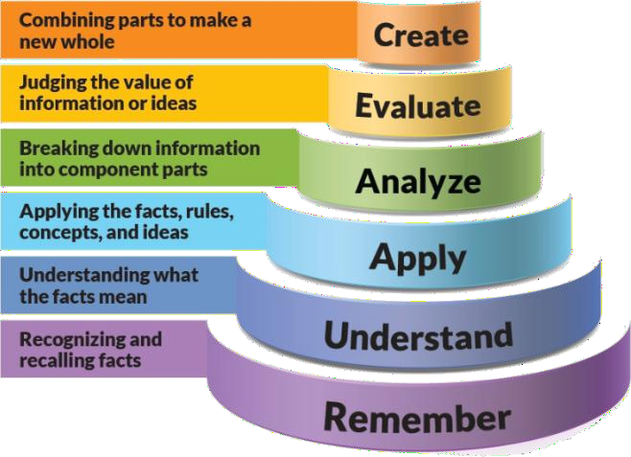

Figure 1: Blooms Taxonomy

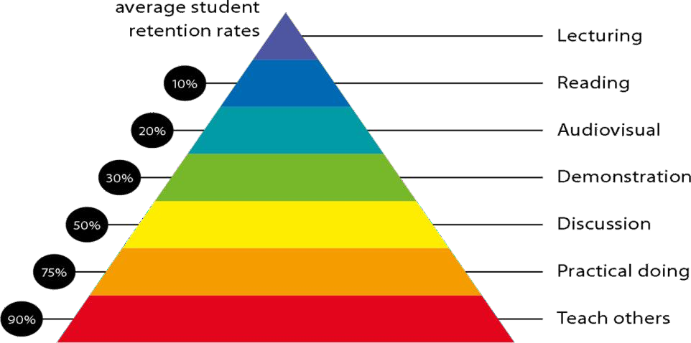

Figure 2: Knowledge retention

Practical work:
- ASSIGNMENT -1 Theory questions from unit 1&2
- ASSIGNMENT -2 To make portfolio of different sector shares and evaluate, Risk and return , Beta, Sharpe ratio

Lecture / tutorial times (As per time table)

Attendance Requirements

The University norms states that it is the responsibility of students to attend all lectures, tutorials, seminars and practical work as stipulated in the Course outline. Minimum attendance requirement as per university norms is compulsory for being eligible for mid and end semester examinations.

ASSESSMENT GUIDELINES

Your final course mark will be calculated from the following:

Assignment & Attendance 20 Marks

Mid semester 40 Marks

Final exam (closed book) 40 Marks

SUPPLEMENTARY ASSESSMENT

Students who receive an overall mark less than 40% in mid semester or end semester will be considered for supplementary assessment in the respective components (i.e mid semester or end semester) of semester concerned. Students must make themselves available during the supplementary examination period to take up the respective components (mid semester or end semester) and need to obtain the required minimum 40% marks to clear the concerned components.

Late Work

Late assignments will not be accepted without supporting documentation. Late submission of the reports will result in a deduction of the maximum mark per calendar day

Format

All assignments must be presented in a neat, legible format with all information sources correctly referenced. Assignment material handed in throughout the session that is not neat and legible will not be marked and will be returned to the student.

Retention of Written Work

Written assessment work will be retained by the Course coordinator/lecturer for two weeks after marking to be collected by the students.

University and Faculty Policies

Students should make themselves aware of the University and/or Faculty Policies regarding plagiarism, special consideration, supplementary examinations and other educational issues and student matters.

Course schedule (subject to change)
(Mention quiz, assignment submission, breaks etc as well in the table under the Teaching Learning Activity Column)

 | Week # | Topic & contents |  |  | CO Addressed |  | Teaching Learning Activity (TLA)
 | Weeks 1 | Overview: Investment concepts & Features, Investment Avenues, Stock Market Indices, Depository System and Listing of Securities |  |  | CO1 |  | Face to face lecture delivery
 | Weeks 2 | Stock Market Indices, Depository System and Listing of Securities |  |  | CO1 |  | Presentation and face to face lecture delivery
 | Week 3 | Introduction to Futures and Options, Risk and Return |  |  | CO2 |  | Presentation and face to face lecture delivery
 | Week 4 | Market Regulators Multifactor Risk and Return Models. |  |  | CO2 |  | Face to face lecture delivery
 | Week 5 | Efficient Market Hypothesis, |  |  | CO3 |  | Face to face lecture delivery
 | Week 6 | Introduction to Technical Analysis & Fundamental Analysis |  | CO2 |  | Face to face lecture delivery
 | Week 7 | Introduction to Technical Analysis & Fundamental Analysis |  | CO2 |  | Lecture delivery
 | Week 8 | Markowitz Model Sharpe Portfolio Optimization Model. |  | CO3 |  | Lecture delivery
 | Week 9 | Markowitz Model Sharpe Portfolio Optimization Model. |  | C04 |  | Face to face lecture delivery
 | Week 10 | Portfolio Construction |  | C05 |  | Presentation and lecture
 | Week 11 | Portfolio Construction, Portfolio Evaluation, Portfolio Revision and Management |  | C06 |  | Presentation and lecture
 | Week 12 | Portfolio Construction, Portfolio Evaluation, Portfolio Revision and Management |  | C06 |  | Presentation and lecture
 | Week 13 | Portfolio Construction, Portfolio Evaluation, Portfolio Revision and Management |  | C06 |  | Presentation and lecture
 | Week 14 | Portfolio Construction, Portfolio Evaluation, Portfolio Revision and Management |  | C06 |  | Presentation and lecture
 | Week 15 | Revision

Assessment Process:

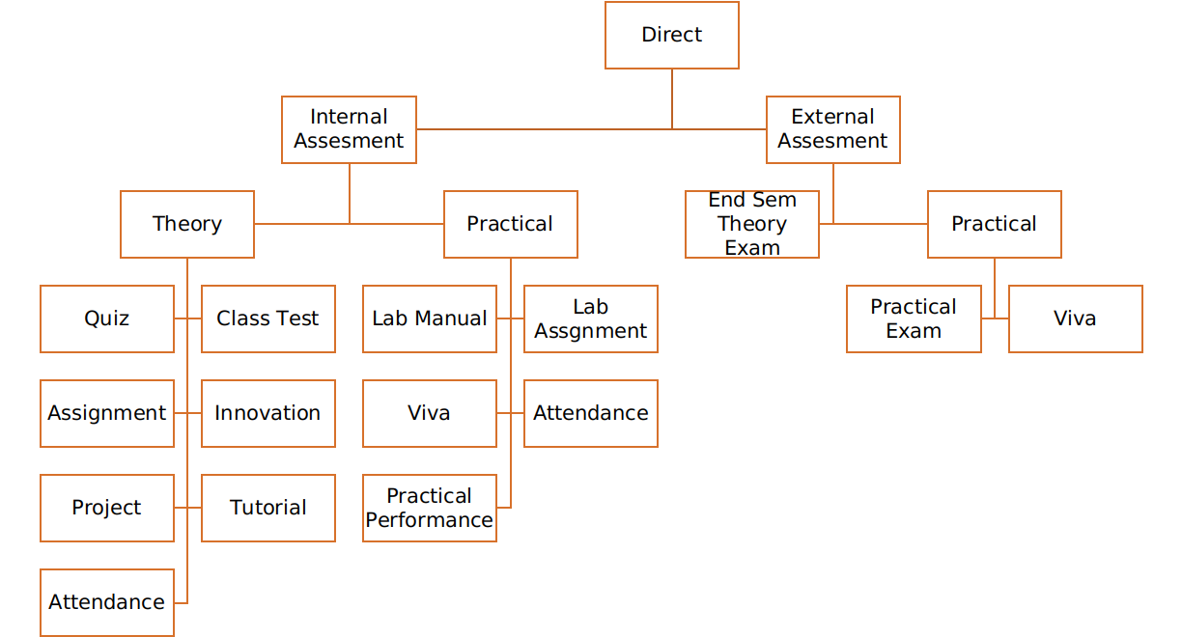
Direct Assessment method – The knowledge and skills learnt by the students are assessed directly from their performance through internal assessment and external assessment processes.
External assessment- Performance of student is recorded in university theory exams, laboratory exams and project evaluation.
Internal assessment- Performance of student is recorded through class assignments and tutorials, internal assessment tests, laboratory assignments, seminars and project progress review and evaluation.
T
Attainment of Course Outcomes (CO’s)Test

For End Semester Theory and Practical Exams
- Attainment Level 1: If < 45% students scoring ≥60% marks
- Attainment Level 2: If >45-75% students scoring ≥60% marks
- Attainment Level 3: If >75-100% students scoring ≥60% marks
For Internal Theory and Practical Exams
- Attainment Level 1: If <45% students scoring ≥75% marks
- Attainment Level 2: If >45-75% students scoring ≥75% marks
- Attainment Level 3: If >75-100% students scoring ≥75% marks

Internal Component with COs mapping
 | Name of the Component | Total marks | CO mapped
Component-1 | Mid Sem | 40 | CO-1, CO-2,CO-3
Component-2 | Assignment 1&2 | 20 | CO--3, CO-4

Faculty Signature HOD’s Signature

