Indus Institute of Management Studies

Course File
IMBA 5y

Course Name: Introduction to Management Thoughts

Course Code: BB0104

Facilitator: Dr Akanxa M Galande

Academic Year: 2022-23

Sr. No. | Title | Page No
1. | Departmental Vision and Mission
2. | Program Specific Outcome
3. | Course Objectives
4. | Course Outcomes with BT
5. | Method of Delivery
6. | Study Time
7. | CO-PO Mapping
8. | Syllabus
9. | Assessment Guidelines
10. | Course Schedule
11. | CO - PSO Matrix
12. | Assessment Methods
13. | Internal Component with CO mapping
14. | Course Attainment
15. | Observation and Plan of Action
16. | Assignments
17. | Question Bank
18. | Question Papers
19. | Multiple Choice Question
20. | Material (PPT Sample)
21. | CIE Bifurcation and Student List
23. | Viva Voce Questions
24. | Slow v/s Advanced Learners List - Proof of Revision Classes
25. | Result Analysis

Vision
- To emerge as a prominent management institute in the country, attracting high-profile talent- students, researchers and faculty- and creating an eco-system conducive for intellectual excellence
- Nurturing the talent into socially relevant and dedicated managers, entrepreneurs, business leaders and thought leaders
- Contributing positively to the society in terms of innovative business models, practices and a body of knowledge in sync with Indian values and ethos.

Mission
- Be a magnet and attract high-profile talent from all over the country and abroad.
- Foster and sustain an intellectual ambience that would facilitate pursuit of excellence.
- Be a hub of intellectual excellence, a hub of solution providers for the industry and society.
- Forge meaningful partnerships with academia, industry, government and the social sector to promote sustainability, inclusiveness and ethical participation with global perspective.
- Be a hub to facilitate fusion of research and knowledge with industrial practices to nurture industry-ready talent.

Programme Educational Objectives (PEOs)

PEO1: To develop overall understanding of business management and to sensitize towards leadership skills.
PEO2: To sensitize the students to the emerging global, competitive environment.
PEO3: To prepare the students to be responsible citizens with social and ethical commitment.

Name of Institute: Institute of Management Studies (IIMS) Name of Faculty: Dr Akanxa Galande
Course code:BB0104
Course name: Introduction to Management Thoughts
Prerequisites: HSC
Credit points: 3 Credits
Offered Semester: BBA sem 1

Course Lecturer (weeks 01 – 15)
Full name: Dr. Akanxa Galande
Department with siting location: Management
Telephone: 9979542755
Email: akanxagalande.mba@indusuni.ac.in
Consultation times: 2:00 PM to 4:00 PM
Students will be contacted throughout the Session via Mail with important information relating to this Course.

Program Outcomes
PO1: Enhance Conceptual clarity & domain knowledge
PO2: Develop Awareness of Business Environment
PO3: Build Effective oral & written communication skills
PO4: Prepare Original thinkers and creative problem solvers
PO5: Comprehend Ethical and Social Responsibility
PO6: Develop Ability for team building & effective human development

Course Objectives
This course provides a detailed explanation of the basic principles of Management used to manage an enterprise.
It aims at explain the concept, nature, significance of management, along with the various levels of Management and the skills required at each level.

Course Outcomes (CO)
Course Outcome:
CO1: Managerial functions like planning, and have the same basic knowledge on the international aspect of management.
CO2: To understand the planning process in the organization.
CO3: To understand the concept of organization.
CO4: Demonstrate the ability to directing, leadership and communicate effectively.
CO5: To analysis isolate issues and formulate best control methods.
CO6: Understand the complexities associated with management of human resources in the organizations and integrate the learning in handling these complexities.

Blooms Taxonomy and Knowledge retention (For reference)
(Blooms taxonomy has been given for reference)

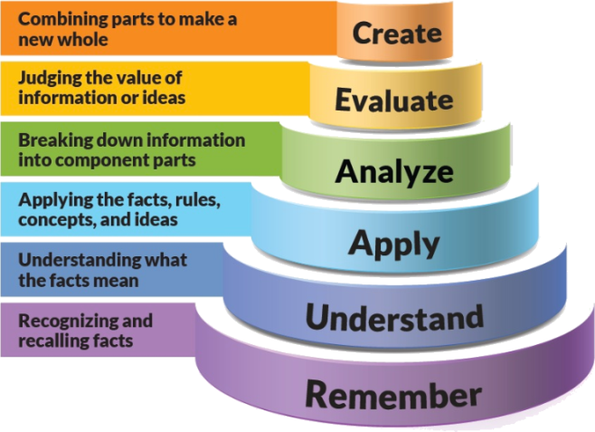
Figure 1: Blooms Taxonomy
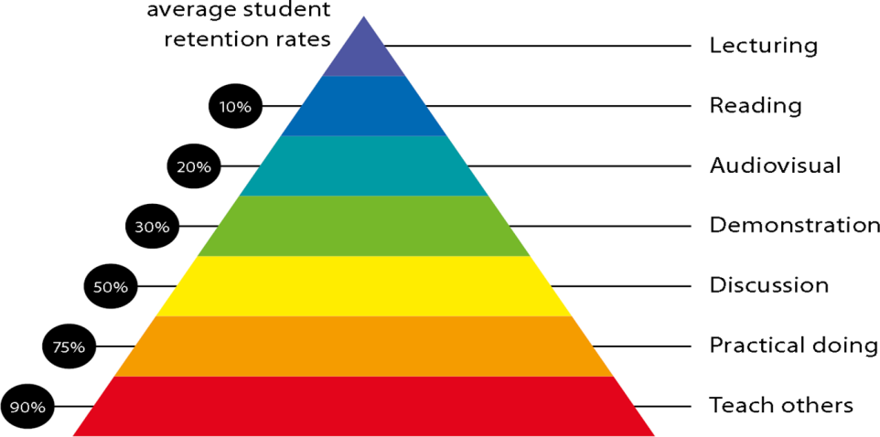
Figure 2: Knowledge retention

Method of delivery
Face to face lectures, Self Study Material, Active Learning Techniques, Case Studies, Audio-Visuals.

Study time
4 hours per week

CO-PO Mapping (PO: Program Outcomes)
 | PO1 | PO2 | PO3 | PO4 | PO5 | PO6
CO1 | 2 | 2 | 3 | 2 | 2 | -
CO2 | 3 | 1 | 2 | 2 | 1 | 3
CO3 | 2 | 3 | 2 | 3 | 2 | 3
CO4 | 2 | 1 | - | 3 | 3 | 2
CO5 | 2 | 3 | 2 | 2 | 2 | 1
CO6 | 2 | 3 | 3 | 2 | - | 2

Course Outline
(Key in topics to be dealt)

Unit-I
Introduction to Management:
Definition, Nature, Types of Managers, Managerial skills and Levels, Basic Functions of Management
Evolution of Management Theory: Scientific Management—F.W. Taylor, Henry L Gantt, Frank and Lillian Gilbreth, Theory of Henry Fayol, Fayol’s vs. Taylor’s comparison. Behavioral Model of Management (Hawthorne studies), Modern Theories of Management (Systems Management School, Situational Approach School)

Unit-II
Planning: Definition, Nature, Importance, Types of Planning, Steps in Planning
Organizing: Concept, Definition, Formal and Informal Organization, Organizational Structure, Span of Management, Delegation of authority, Departmentation

Unit-III
Staffing: Definition, Factors affecting Staffing—The External and Internal Environment, Identification of Job Requirements, Job Evaluation, Recruitment, Selection, Placement, Training and development
Leadership: Definition, Leadership Characteristics, Leadership Theories

Unit-IV
Directing and Controlling:
Meaning of Motivation, Motives, and Motivation theories
Meaning of directing & control, Need of Control, Control Process

Details of referencing system to be used in written work

Text books

L.M.Prasad – Principles and Practice of Management (2001) Sultan Chand and Sons - Edition- 5
Robbins, DeCenzo and Bhattacharyya Essential of Management Pearson Publication
Koontz, H. and Weihrich, H (1998) & (2001) Essentials Of Management (Tata McGraw Hill: New Delhi) Edition- 5th and 10th

- Harold Koontz and Heinz Weihrich, Essentials of Management: An International and Leadership Perspective, McGraw Hill Education.

2. Stephen P Robbins and Madhushree Nanda Agrawal, Fundamentals of Management: Essential Concepts and Applications, Pearson Education.

Additional Material
Stoner, Freeman & Daniel R Gilbert, Management; Pearson Education
Robbins & Coulter, Management; Prentice Hall (India) Pvt. Ltd
Robbins , Decenzo & Coulter, Fundamentals of Management; Pearson Education
Tripathy & Reddy , Principles of Management; Tata McGraw Hill
James H. Donnelly, Fundamentals of Management, Pearson Education.
B.P. Singh and A.K.Singh, Essentials of Management, Excel Books
Names of newspapers, magazines to be referred for better understanding of the course:
Harvard Business Review/ Business India / Business Today / Business World
“Vikalpa” –Journal of Indian Institute of Management, Ahmedabad,
SANKALPA: Journal of Management & Research, Effective Executive, etc.

Practical work:
Live project/ Assignments

Lecture/tutorial times:
Lecture
Lecture
Lecture

Attendance Requirements

The University norms states that it is the responsibility of students to attend all lectures, tutorials, seminars and practical work as stipulated in the Course outline. Minimum attendance requirement as per university norms is compulsory for being eligible for mid and end semester examinations.

ASSESSMENT GUIDELINES
Your final course mark will be calculated from the following:
Assignment 1 | 5%
Assignment 2 | 5%
Presentation | 5%
Attendance | 5%
Mid semester | 40%
Final exam (closed book) | 100%

SUPPLEMENTARY ASSESSMENT

Students who receive an overall mark less than 40% in mid semester or end semester will be considered for supplementary assessment in the respective components (i.e mid semester or end semester) of semester concerned. Students must make themselves available during the supplementary examination period to take up the respective components (mid semester or end semester) and need to obtain the required minimum 40% marks to clear the concerned components.

Practical Work Report/Laboratory Report:
NA

Late Work
Late assignments will not be accepted without supporting documentation. Late submission of the reports will result in a deduction of -% of the maximum mark per calendar day

Format
All assignments must be presented in a neat, legible format with all information sources correctly referenced. Assignment material handed in throughout the session that is not neat and legible will not be marked and will be returned to the student.

Retention of Written Work
Written assessment work will be retained by the Course coordinator/lecturer for two weeks after marking to be collected by the students.

University and Faculty Policies
Students should make themselves aware of the University and/or Faculty Policies regarding plagiarism, special consideration, supplementary examinations and other educational issues and student matters.

Plagiarism - Plagiarism is not acceptable and may result in the imposition of severe penalties. Plagiarism is the use of another person’s work, or idea, as if it is his or her own - if you have any doubts at all on what constitutes plagiarism, please consult your Course coordinator or lecturer. Plagiarism will be penalized severely.

Do not copy the work of other students.
Do not share your work with other students (except where required for a group activity or assessment
Course schedule (subject to change)
(Mention quiz, assignment submission, breaks etc as well in the table under the Teaching Learning Activity Column)

 | Week # | Topic & contents |  |  | CO Addressed |  | Teaching Learning Activity (TLA)
 | Weeks 1 | Introduction to Management:  Definition, Nature, Types of Managers |  |  | CO1 |  | Lecture
 | Weeks 2 | Managerial skills and Levels, Basic Functions of Management |  |  | CO1 |  | Audio-Visual
 | Week 3 | Evolution of Management Theory: Scientific Management—F.W. Taylor, Henry L Gantt, Frank and Lillian Gilbreth, Theory of Henry Fayol |  |  | CO1 & CO2 |  | Audio-Visual
 | Week 4 | Fayol’s vs. Taylor’s comparison. Behavioral Model of Management (Hawthorne studies) |  |  | CO3 |  | Lecture
 | Week 5 | Modern Theories of Management (Systems Management School, Situational Approach School) |  |  | CO3 |  | Lecture
 | Week 6 | Planning: Definition, Nature, Importance, Types of Planning, Steps in Planning |  | CO3 |  | Case Study
 | Week 7 | Organizing: Concept, Definition, Formal and Informal Organization, Organizational Structure |  | CO4 |  | Case Study
 | Week 8 | Span of Management, Delegation of authority, Departmentation |  | CO5 |  | Audio-Visual
 | Week 9 | Staffing: Definition, Factors affecting Staffing—The External and Internal Environment |  | CO3 & CO4 |  | Audio-Visual
 | Week 10 | Identification of Job Requirements, Job Evaluation |  | CO5 |  | Lecture
 | Week 11 | Recruitment, Selection, Placement, Training and development |  | CO5 |  | Lecture
 | Week 12 | Leadership: Definition, Leadership Characteristics, Leadership Theories |  | CO5 |  | Case Study
 | Week 13 | Directing and Controlling:  Meaning of Motivation, Motives, and Motivation theories |  | CO6 |  | lecture
 | Week 14 | Meaning of directing & control, Need of Control, Control Process |  | CO6 |  | lecture
 | Week 15 | Revision |  | CO6 |  | lecture

Faculty Signature HOD’s Signature

