**Name of Institute: Institute of Management Studies (IMS)**

**Name of Faculty: Dr. Daisy Kurien**

**Course code: BB0521**

**Course name:** Event Management

Pre-requisites: Understanding of Business and marketing concepts

Credit points: 3 Credits

Offered Semester: V

**Course Lecturer (Weeks 01 – 15)**

Full Name: Dr. Daisy Kurien

Department with siting location: Management

Telephone: 9428412928

Email: daisykurien.mba@indusuni.ac.in

Consultation times:2:00 pm to 4:00 pm

Students will be contacted throughout the Session via Mail with important information relating to this Course.

**Vision**

* To emerge as a prominent management institute in the country, attracting high-profile talent- students, researchers and faculty- and creating an eco-system conducive for intellectual excellence
* Nurturing the talent into socially relevant and dedicated managers, entrepreneurs, business leaders and thought leaders
* Contributing positively to the society in terms of innovative business models, practices and a body of knowledge in sync with Indian values and ethos.

**Mission**

* Be a magnet and attract high-profile talent from all over the country and abroad.
* Foster and sustain an intellectual ambience that would facilitate pursuit of excellence.
* Be a hub of intellectual excellence, a hub of solution providers for the industry and society.
* Forge meaningful partnerships with academia, industry, government and the social sector to promote sustainability, inclusiveness and ethical participation with global perspective.
* Be a hub to facilitate fusion of research and knowledge with industrial practices to nurture industry-ready talent.

# Programme Educational Objectives (PEOs)

PEO1: To nurture high profile leadership and/or entrepreneurial capabilities combined with professional and lifelong learning skills.

PEO2: To nurture multi-disciplinary skills to have a gestalt perspective of the business situations, and be able to address them with innovative, creative and sustainable solutions.

PEO3: To nurture the skills and capabilities to unlearn and re-learn continuously with the changing environment.

PEO4: Become socially responsible and value driven citizens committed to sustainable development.

# POs

PO1: Enhance Conceptual clarity & domain knowledge

PO2: Develop Awareness of Business Environment

PO3: Build Effective oral & written communication skills

PO4: Prepare Original thinkers and creative problem solvers

PO5: Comprehend Ethical and Social Responsibility

PO6: Develop Ability for team building & effective human development

# Course Objectives

To acquaint the students with concepts, issues and various aspects of event management.

# Course Outcomes (CO)

At the completion of the course, the student will be able to:

CO1: To familiarize students with the basic concepts of Event management

CO2: Obtain a sense of responsibility for the multidisciplinary nature of event management

CO3: Gain confidence and enjoyment from involvement in the dynamic industry of event management

CO4: Identify best practice in the development and delivery of successful conferences and corporate gatherings

CO5: Identify the key elements of a conference and the processes involved in venue selection, registration, catering, accommodation, transport, theming, security and entertainment

CO6: Identify management concepts which facilitate management of various categories of events.

# Course Outline

Unit 1

Introduction to Event and Event Management

• Need and importance of events

• Event Designing, 5 C’s of Events.

• 5 W’s of Event.

• Types of Events.

• Categories of Event and its characteristics.

• Objectives of Event Management.

Unit - 2

Facets of Event Management

• Event Infrastructure: Core Concept, Core People, Core Talent, Core Structure.

• Clients: Set Objectives for the Event, Negotiating Contracts with Event Organizers, Locating Interaction Points, Banners , Displays etc., at the Event, Preparing the Company’s Staff for the Event, Post-event Follow-up.

• Event Organizers: Role of Event Organizer, Qualities of an Event Organizer, Steps in Organizing an event.

• Venue: In-house Venue, External Venue.

Unit – 3

Execution of Event:

• Networking Components: Print Media, Radio Television, The Internet, Cable Network, Outdoor Media, Direct Media.

• Types of promotion methods used in events:Sales Promotions, Audience Interaction, Public Relations, Merchandising, In-venue Publicity, Direct Marketing, Advertising, Public relations.

• Activities in Event Management: Pre-event Activities, During event Activities, Post-event Activities.

• Functions of Event Management: Planning, Organizing, Staffing, Leading and Coordination, Controlling.

• Coordination among committees

• Event Management Information System.

• Technology in Event Management.- Role and Importance.

Unit - 4

Marketing of Event

• Event management Strategies

• Role of creativity

• Concept of Market in Events -Revenue Generating Customers and Nonrevenue Generating Customers.

• Segmentation for Events, Niche marketing in events.

• Targeting and Positioning of Events.

• Branding in Events.

• Reach Interaction Matrix.

• Concept of Pricing in Events.

• Implementation of Marketing Plan.

• Relationship Building.

# Method of delivery

Lectures, Role plays, Case studies, Video Cases

# Study time

Three hours per week

# Blooms Taxonomyand Knowledge retention(For reference)

(Blooms taxonomy has been given for reference)

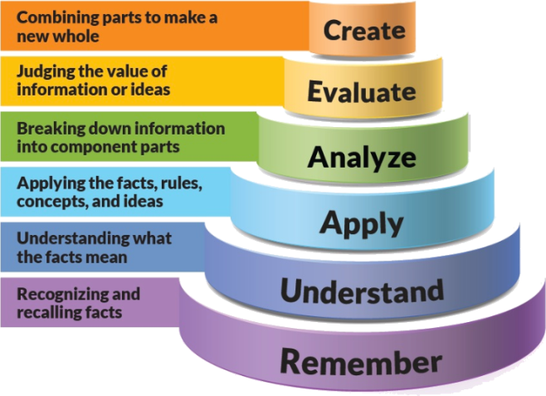

Figure 1: Blooms Taxonomy

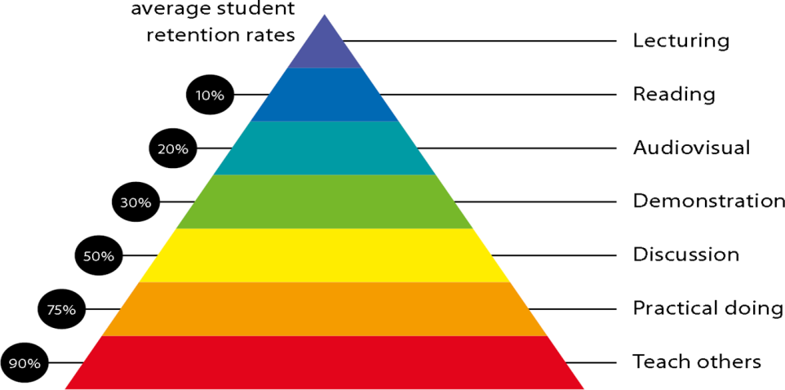

Figure 2: Knowledge retention

# Graduate Qualities and Capabilities covered

(Qualities graduates harness crediting this Course)

|  |  |
| --- | --- |
| **General Graduate Qualities** | **Specific Department of ManagementGraduate Capabilities** |
| **Informed**  Gain an understanding of marketing issues dominating the market in present time which may pose as a threat in marketing but is handled well may lead to better marketer- customer relation. | **1 Market knowledge, & awareness** |
| **Independent learners**  Locate, evaluate and synthesize complex situations and offer perspectives. Opportunities to acquire these abilities are developed through lectures, and case discussion. | **2 Information literacy, gathering & processing** |
| **Problem solvers**  Developing critical thinking skills that are pertinent for problem solving and innovation in today’s competitive market. Critically analyze the situation and offer solutions to situations. | **4 Problem solving skills** |
| **Effective communicators**  Develop the ability to reflect on issues on hand. Through active participation enhance the skills to communicate verbally and in writing and develop practices expected of today’s professionals. | **5 Written communication** |
| **6 Oral communication** |
| **7 Teamwork** |
| **Responsible**  Gain a better understanding of sustainable market. Being responsible in dealing and delivering value to all stakeholders | **10 Sustainability, societal & environmental impact** |

# Practical work:

Live project/ Assignments

# Lecture/tutorial times:

**As per Time Table**

# Attendance Requirements

The University norms states that it is the responsibility of students to attend all lectures, tutorials, seminars and practical work as stipulated in the Course outline. Minimum attendance requirement as per university norms is compulsory for being eligible for mid and end semester examinations.

# Details of referencing system to be used in written work

# Text books

* Event Management: Wagen, lynn Van Der, Pearson Education,
* Event Marketing and Management: Gaur, Sanjaya Singh, Vikas Publishing House Pvt Ltd.

# Reference Books

* Business Management : G. M. Dumbre, Success Publications, Pune.
* Event Planning And Management: Sharma, Diwakar, Deep & Deep Publication Pvt Ltd.
* Events Management: Raj, Razaq, SAGE Publication India Pvt. Ltd.

# Additional Materials

|  |
| --- |
| * Newspaper articles |
| * Video cases on current business issues |
|  |

# ASSESSMENT GUIDELINES

Your final course mark will be calculated from the following:

**Assignment**  10%

**Presentation 5%**

**Attendance 5 %**

**Mid semester** 40%

**Final exam** (*closed book*) 100 marks(40% )

# SUPPLEMENTARY ASSESSMENT

Students who receive an overall mark less than 40% in mid semester or end semester will be considered for supplementary assessment in the respective components (i.e mid semester or end semester) of semester concerned. Students must make themselves available during the supplementary examination period to take up the respective components (mid semester or end semester) and need to obtain the required minimum 60% marks to clear the concerned components.

# Late Work

Late assignments will not be accepted without supporting documentation. Late submission of the reports will result in a deduction of 5% of the maximum mark per calendar day

# Format

All assignments must be presented in a neat, legible format with all information sources correctly referenced. Assignment material handed in throughout the session that is not neat and legible will not be marked and will be returned to the student.

# Retention of Written Work

Written assessment work will be retained by the Course coordinator/lecturer for two weeks after marking to be collected by the students.

# University and Faculty Policies

Students should make themselves aware of the University and/or Faculty Policies regarding plagiarism, special consideration, supplementary examinations and other educational issues and student matters.

**Plagi**a**rism** - Plagiarism is not acceptable and may result in the imposition of severe penalties. Plagiarism is the use of another person’s work, or idea, as if it is his or her own - if you have any doubts at all on what constitutes plagiarism, please consult your Course coordinator or lecturer. Plagiarism will be penalized severely.

***Do not copy the work of other students.***

***Do not share your work with other students (except where required for a group activity or assessment).***

# Course schedule(subject to change)

|  |  |  |  |  |
| --- | --- | --- | --- | --- |
|  | Week # | Topic & contents | CO Addressed | Teaching Learning Activity (TLA) |
|  | Weeks 1 | Introduction to Event and Event Management | CO1, CO2 | Lecture, PPT Video, |
| Weeks 2 | Need and importance of events, Event Designing, 5 C’s of Events, 5 W’s of Event., Types of events | CO1 , CO2 | Lecture, Video |
| Week 3 | Categories of Event and its characteristics, Objectives of Event Management. | CO1, CO2 | Lecture |
| Week 4 | Facets of Event Management -Event Infrastructure: Core Concept, Core People, Core Talent, Core Structure | CO1, CO2 , CO3 | Lecture, Case Discussion |
| Week 5 | Clients: Set Objectives for the Event, Negotiating Contracts with Event Organizers | CO1, CO2, CO3 | Lecture |
|  | Week 6 | Locating Interaction Points, Banners, Displays etc., at the Event, Preparing the Company’s Staff for the Event, Post-event Follow-up. | CO1, CO2 | Lecture, Video |
| Week 7 | Event Organizers: Role of Event Organizer, Qualities of an Event Organizer, Steps in Organizing an event. Venue – In-house, External venue | CO4, CO5 | Lecture |
| Week 8 | Execution of Event: Networking Components: Print Media, Radio Television, The Internet, Cable Network, Outdoor Media, Direct Media. | CO3, CO5 | Lecture & video Case Discussion |
| Week 9 | Types of promotion methods used in events:Sales Promotions, Audience Interaction, Public Relations, Merchandising, In-venue Publicity, Direct Marketing, Advertising, Public relations. | CO5 | Lecture |
|  | Week 10 | Activities in Event Management: Pre-event Activities, During event Activities, Post-event Activities, Functions of Event Management: Planning, Organizing, Staffing, Leading and Coordination, Controlling, Coordination among committees | CO5, CO6 | Lecture |
| Week 11 | Mid Sem Exam | NA | NA |
|  | Week 12 | Event Management Information System, Technology in Event Management.- Role and Importance. | CO4, CO6 | Lecture , Video Case Discussion |
|  | Week 13 | Marketing of Event - Event management Strategies , Role of creativity, Concept of Market in Events -Revenue Generating Customers and Nonrevenue Generating Customers. | CO4, CO6 | Lecture |
|  | Week 14 | Segmentation for Events, Niche marketing in events, Targeting and Positioning of Events, Branding in Events | CO4, CO6 | Lecture and case Discussion |
|  | Week 15 | Reach Interaction Matrix, Concept of Pricing in Events, Implementation of Marketing Plan.  Relationship Building | CO4, CO6 | Lecture |

# Assessment process

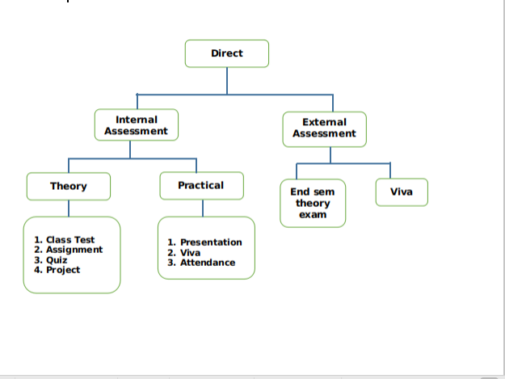

Direct Assessment method – The knowledge and skills learnt by the students are assessed directly from their performance through internal assessment and external assessment processes.

External assessment- Performance of student is recorded in university theory exams and project evaluation.

Internal assessment- Performance of student is recorded through class assignments and tutorials, internal assessment tests and project progress review and evaluation.

# Attainment of Course Outcomes (CO’s)

|  |
| --- |
| For End Semester Theory exam   1. Attainment Level 1: If < 45% students scoring ≥60% marks 2. Attainment Level 2: If >45-75% students scoring ≥60% marks 3. Attainment Level 3: If >75-100% students scoring ≥60% marks |
| For Internal Theory exam   1. Attainment Level 1: If <45% students scoring ≥75% marks 2. Attainment Level 2: If >45-75% students scoring ≥75% marks 3. Attainment Level 3: If >75-100% students scoring ≥75% marks |

Weights of Attainments are assigned as per University Evaluation criteria as below for A.Y. 2019-20 as follows:

University End Semester Examinations (ESE): Weightage: 40%

Institute Internal Assessment (CIE): Weightage: 60%

# Internal Component with COs mapping

|  |  |  |  |
| --- | --- | --- | --- |
|  | **Name of the Component** | **Total marks** | **CO mapped** |
| Component-1 | Mid semester exam | 40 | CO-1, CO-2,CO-3 |
| Component-2 | Presentation | 05 | CO-5, CO-6 |
| Component-3 | Assignment | 10 | CO-1, CO-2, CO-3, CO-4 |
| Component-4 | Attendance | 05 | CO1, CO2, CO3, CO4, CO5, CO6 |

# Course Attainment

|  |  |  |  |  |  |
| --- | --- | --- | --- | --- | --- |
| **CO Attainment** | **1** | **2** | **3** | **4** | **Internal assessment component total (1 to 4)** |
|  |
| **Internal component** |
| CO 1 | 2 | 3 |  | 1 | **2.0** |
| CO 2 | 2 | 3 |  | 1 | **2.0** |
| CO 3 | 3 |  | 2 | 1 | **2.0** |
| CO 4 | 3 | 3 |  | 1 | **2.3** |
| CO 5 |  | 3 |  | 1 | **2.0** |
| CO 6 |  |  | 2 | 1 | **1.5** |

**Indirect Attainment**

|  |  |  |  |  |
| --- | --- | --- | --- | --- |
| **S.N.** | **Course Outcome** | **L** | **M** | **H** |
| 1 | Are you able to familiarize with basic concepts of Event management? | 0 | 5 | 25 |
| 2 | Do you feel a sense of responsibility for the multidisciplinary nature of event management? | 4 | 8 | 22 |
| 3 | Have you gained confidence and enjoyment from involvement in the dynamic industry of event management? | 0 | 6 | 24 |
| 4 | Are you able to identify best practice in the development and delivery of successful conferences and corporate gatherings? | 6 | 10 | 20 |
| 5 | Are you able to identify the key elements of a conference and the processes involved? | 0 | 6 | 24 |
| 6 | Are you able to identify management concepts which facilitate management of various categories of events? | 4 | 8 | 22 |

**1-Low(L), 2-Medium(M), 3- High(H)**

# Overall Attainment

|  |  |  |  |  |  |  |  |
| --- | --- | --- | --- | --- | --- | --- | --- |
| **CO #** | **Internal Exam** | **Internal Exam*0.6** | **ESE** | **ESE*0.4** | **Direct Attainment (DA)** | **Indirect Attainment(IA)** | **Overall=0.8*DA+0.2*IA** |
|
|
| CO 1 | 2 | 1.2 | 2 | 0.8 | 2 | 2.7 | 2.14 |
| CO 2 | 2 | 1.2 | 2 | 0.8 | 2 | 2.666 | 2.1332 |
| CO 3 | 2 | 1.2 | 2 | 0.8 | 2 | 2.6333 | 2.12666 |
| CO 4 | 2.3 | 1.38 | 2 | 0.8 | 2.18 | 2.5 | 2.244 |
| CO 5 | 2 | 1.2 | 2 | 0.8 | 2 | 2.4 | 2.08 |
| CO 6 | 1.5 | 0.9 | 2 | 0.8 | 1.7 | 2.566 | 1.8732 |
| **Overall Course Attainment** | | | | | |  | 2.09951 |
| **Set Target for the course** | | | | | |  | 2.0 |
| **Course Attainment Status(Yes/No)** | | | | | |  | Yes |
|  | | | | | |  |  |

|  |  |
| --- | --- |
| Best Performing CO: | CO4 |
| Least Performing CO | CO6 |

# Observations

|  |  |
| --- | --- |
| 1 | CO attainment has been achieved |
| 2 | However, overall attainment level of CO6 is less |

# Plan of Action

|  |  |
| --- | --- |
| 1 | Management concepts for different categories of events may be more focused upon. |
| 2 | Guest sessions may be added to more value. |

**Faculty Signature HoDs Signature**