### Name of Institute: Institute of Management Studies (IMS)

### Name of Faculty: Dr. Daisy Kurien

**Course code: MBO312**

**Course name: Consumer Behavior**

Pre-requisites: Marketing Specialisation

Credit points: 3 Credits

Offered Semester: III

**Course Lecturer (Weeks 01 – 15)**

Full Name: Dr. Daisy Kurien

Department with siting location: Management

Telephone: 9428412928

Email: daisykurien.mba@indusuni.ac.in

Consultation times:2:00 pm to 4:00 pm

Students will be contacted throughout the Session via Mail with important information relating to this Course.

**Vision**

* To emerge as a prominent management institute in the country, attracting high-profile talent- students, researchers and faculty- and creating an eco-system conducive for intellectual excellence
* Nurturing the talent into socially relevant and dedicated managers, entrepreneurs, business leaders and thought leaders
* Contributing positively to the society in terms of innovative business models, practices and a body of knowledge in sync with Indian values and ethos.

**Mission**

* Be a magnet and attract high-profile talent from all over the country and abroad.
* Foster and sustain an intellectual ambience that would facilitate pursuit of excellence.
* Be a hub of intellectual excellence, a hub of solution providers for the industry and society.
* Forge meaningful partnerships with academia, industry, government and the social sector to promote sustainability, inclusiveness and ethical participation with global perspective.
* Be a hub to facilitate fusion of research and knowledge with industrial practices to nurture industry-ready talent.

**Programme Educational Objectives (PEOs)**

PEO1: To nurture high profile leadership and/or entrepreneurial capabilities combined with professional and lifelong learning skills.

PEO2: To nurture multi-disciplinary skills to have a gestalt perspective of the business situations, and be able to address them with innovative, creative and sustainable solutions.

PEO3: To nurture the skills and capabilities to unlearn and re-learn continuously with the changing environment.

PEO4: Become socially responsible and value driven citizens committed to sustainable development.

# Program Outcome(PO)

PO1: Develop Business Acumen & domain knowledge (With knowledge of management theories & practices)

PO2: Develop Leadership and Team building

PO3: Enhance Critical Thinking, Analysis & Problem Solving

PO4: Build Awareness of Global Business Environment

PO5: Comprehend Legal, Ethical and Social Responsibility

PO6: Develop Communication Skills, Interpersonal and Soft Skills

# Course Objectives

By participating in and understanding all facets of this Course a student will:

* Familiarize the students with the behavioural aspects of consumers.
* To understand the internal forces, external influences and processes that goes on to affect consumer behaviour, the challenges generated for the marketers and the strategies which could be implemented

# Course Outcomes (CO)

At the completion of the course, the student will be able to:

CO1. Examine the nature of Consumer behaviour and know how knowledge of consumer behaviour can be applied to marketing.

CO2. Comprehend the major concepts of Consumer Behavior and list their applications in marketing of products and services.

CO3: Identify build an understanding of the wide range of social, cultural and economic factors which influence consumer behaviour.

CO4: Analyze the decision making process of the consumers

CO5: Make a sense of select models used for understanding Consumer Behavior

CO6: Integrate dynamics of personality, perception, learning motivation and attitude to the choices consumers make.

# Course Outline

Unit 1 – **Consumers, Marketers and Technology:** Technology driven Consumer Behavior, Customer Value, Satisfaction, and Retention, Market Segmentation, Targeting and Positioning

Unit 2 – **The Consumer as an Individual:** Consumer Motivation, Personality and Consumer Behavior, Consumer Perception

Unit 3 - **The Consumer as an Individual:** Consumer Learning, Consumer Attitude Formation and Change, Communication and Consumer Behavior

Unit 4 – **Consumers in their Social and Cultural Settings :**The Family and Social Class, Influence of Culture on Consumer Behavior, Cross-Cultural Consumer Behavior: An International Perspective

Unit 5 – **The Consumer’s Decision-Making Process and Ethical Dimensions:** Consumers and the Diffusion of Innovations, Marketing Ethics and Social Responsibility , Consumer Research

# Method of delivery

Lectures, Case studies, Video Cases

# Study time

Three hours per week

# Blooms Taxonomyand Knowledge retention(For reference)

(Blooms taxonomy has been given for reference)

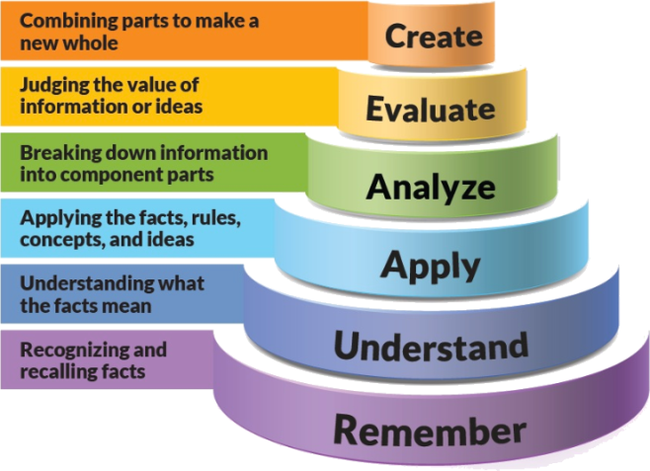

Figure 1: Blooms Taxonomy

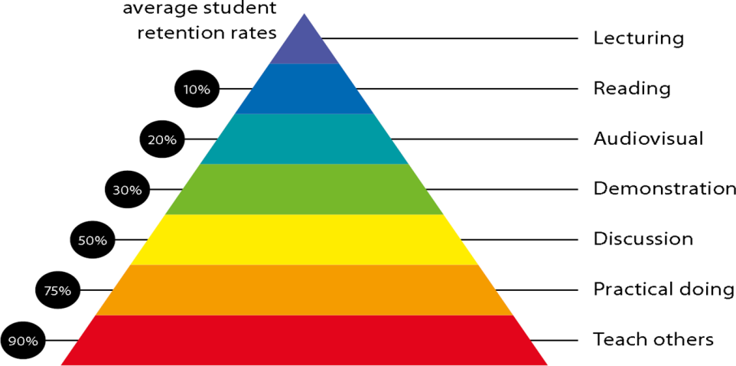

Figure 2: Knowledge retention

# Graduate Qualities and Capabilities covered

(Qualities graduates harness crediting this Course)

|  |  |
| --- | --- |
| **General Graduate Qualities** | **Specific Department of ManagementGraduate Capabilities** |
| **Informed**  Gain an understanding of marketing issues dominating the market in present time which may pose as a threat in marketing but is handled well may lead to better marketer- customer relation. | **1 Market knowledge, & awareness** |
| **Independent learners**  Locate, evaluate and synthesize complex situations and offer perspectives. Opportunities to acquire these abilities are developed through lectures, and case discussion. | **2 Information literacy, gathering & processing** |
| **Problem solvers**  Developing critical thinking skills that are pertinent for problem solving and innovation in today’s competitive market. Critically analyze the situation and offer solutions to situations. | **4 Problem solving skills** |
| **Effective communicators**  Develop the ability to reflect on issues on hand. Through active participation enhance the skills to communicate verbally and in writing and develop practices expected of today’s professionals. | **5 Written communication** |
| **6 Oral communication** |
| **7 Teamwork** |
| **Responsible**  Gain a better understanding of sustainable market. Being responsible in dealing and delivering value to all stakeholders | **10 Sustainability, societal & environmental impact** |

# Practical work:

Live project/ Assignments

# Lecture/tutorial times:

**As per Time Table**

# Attendance Requirements

The University norms states that it is the responsibility of students to attend all lectures, tutorials, seminars and practical work as stipulated in the Course outline. Minimum attendance requirement as per university norms is compulsory for being eligible for mid and end semester examinations.

# Details of referencing system to be used in written work

# Text books

1. Leslie Lazar Kanuk,S. Ramesh Kumar,Leon G. Schiffman, *Consumer Behaviour*, Pearson

**Reference Books:**

1. Blackwell and Engel,*Consumer Behaviour*, Cenage.
2. MajumudarRamanuj,*Consumer Behaviour* , Insights from Indian Market, PHI
3. Hoyer, Maclnnis andDasguptaBiztantra, *Consumer Behaviour*
4. Evans, *Consumer Behaviour,*Wiley
5. Lingquist Jay D, *Consumer Behaviour*, Cengage
6. [David Loudon](http://www.tatamcgrawhill.com/cgi-bin/same_author.pl?author=David+Loudon), [Albert Della Bitta](http://www.tatamcgrawhill.com/cgi-bin/same_author.pl?author=Albert+Della+Bitta), *Consumer Bahavior.*Tata McGraw Hill.

# Additional Materials

|  |
| --- |
| * Newspaper articles |
| * Video cases on current business issues |
|  |

# ASSESSMENT GUIDELINES

Your final course mark will be calculated from the following:

**Assignment 2 10%**

**Presentation 5%**

**Attendance 5 %**

**Mid semester 40%**

**Final exam (closed book) 100 marks (40%)**

# SUPPLEMENTARY ASSESSMENT

Students who receive an overall mark less than 40% in mid semester or end semester will be considered for supplementary assessment in the respective components (i.e mid semester or end semester) of semester concerned. Students must make themselves available during the supplementary examination period to take up the respective components (mid semester or end semester) and need to obtain the required minimum 60% marks to clear the concerned components.

# Late Work

Late assignments will not be accepted without supporting documentation. Late submission of the reports will result in a deduction of 5% of the maximum mark per calendar day

# Format

All assignments must be presented in a neat, legible format with all information sources correctly referenced. **Assignment material handed in throughout the session that is not neat and legible will not be marked and will be returned to the student.**

# Retention of Written Work

Written assessment work will be retained by the Course coordinator/lecturer for two weeks after marking to be collected by the students.

# University and Faculty Policies

Students should make themselves aware of the University and/or Faculty Policies regarding plagiarism, special consideration, supplementary examinations and other educational issues and student matters.

**Plagi**a**rism** - Plagiarism is not acceptable and may result in the imposition of severe penalties. Plagiarism is the use of another person’s work, or idea, as if it is his or her own - if you have any doubts at all on what constitutes plagiarism, please consult your Course coordinator or lecturer. Plagiarism will be penalized severely.

***Do not copy the work of other students.***

***Do not share your work with other students (except where required for a group activity or assessment).***

# Course Schedule(subject to change)

|  |  |  |  |  |
| --- | --- | --- | --- | --- |
|  | **Week #** | **Topic & contents** | **CO Addressed** | **Teaching Learning Activity (TLA)** |
|  | Weeks 1 | Consumers, Marketers and Technology: Technology driven Consumer Behavior | CO1 &CO2 | Lecture |
| Weeks 2 | Customer Value, Satisfaction, and Retention | CO1 & CO2 | Lecture, Video |
| Week 3 | Market Segmentation ,Targeting and Positioning | CO1, CO2 & CO3 | Lecture & Case Discussion |
| Week 4 | The Consumer as an Individual: Consumer Motivation | CO1, CO2 & CO6 | Lecture |
| Week 5 | Personality and Consumer Behavior | CO6 | Lecture & Case Discussion |
|  | Week 6 | Consumer Perception | CO6 | Lecture & Video |
| Week 7 | The Consumer as an Individual: Consumer Learning | CO6 | Lecture |
| Week 8 | Consumer Attitude Formation and Change | CO6 | Lecture & Video |
| Week 9 | Communication and Consumer Behavior | CO6 | Lecture & Case Discussion |
|  | Week 10 | Consumers in their Social and Cultural Settings :The Family and Social Class | CO3 | Lecture |
| Week 11 | Mid Semester examination | CO1, CO2, CO3, CO6 |  |
|  | Week 12 | Influence of Culture on Consumer behavior, Cross-Cultural Consumer Behavior: An International Perspective | CO3 | Lecture |
|  | Week 13 | The Consumer’s Decision-Making Process and Ethical Dimensions: | CO4, CO5 | Lecture |
|  | Week 14 | Consumer Decision Making and the Diffusion of Innovations | CO4, CO5 | Lecture |
|  | Week 15 | Marketing Ethics and Social Responsibility, Consumer Research | CO4 | Lecture & Case Discussion |

# Assessment process

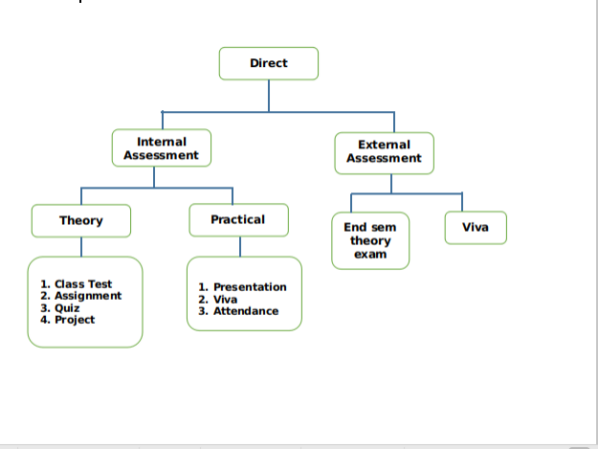

Direct Assessment method – The knowledge and skills learnt by the students are assessed directly from their performance through internal assessment and external assessment processes.

External assessment- Performance of student is recorded in university theory exams and project evaluation.

Internal assessment- Performance of student is recorded through class assignments and tutorials, internal assessment tests and project progress review and evaluation.

Weights of Attainments are assigned as per University Evaluation criteria as below for A.Y. 2019-20 as follows:

University End Semester Examinations (ESE): Weightage: 40%

Institute Internal Assessment (CIE): Weightage: 60%