Unit – III: Participation in Management-Concept & Pre-requisites, Forms & Levels of Participation, Benefit of worker participation in management, Role of workers participation in Labour welfare & Industrial hygiene

####Workers’ Participation in Management
The concept of workers’ participation in management is a broad and complex one. Depending on the socio-political environment and cultural conditions, the scope and content of participation may change. Various terms have come to be used to denote different forms and degree of participation. For example, joint consultation, labour-management cooperation, co-determination, joint decision making, workers’ participation in industry and workers’ participation in management. These terms or their variants have been interpreted and explained differently. In any case, a common thread running through all interpretations is the idea of associating employees in managerial decision- making. The International Institute for Labour Studies defined WPM as “the participation resulting from practices which increase the scope for employee’s share of influence in decision making at different tiers of organizational hierarchy with concomitant assumption of responsibility”.

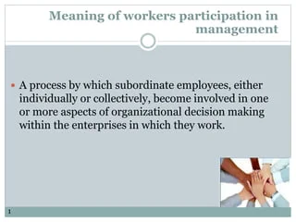

Workers’ Participation, may broadly, be taken to cover terms of association of workers and their representatives with decision-making process, ranging from exchange of information, consultation, decisions and negotiations to more institutionalized forms such as the presence of workers’ member on management or supervisory boards or even management by workers themselves.

####Pr-requisites of participation in management
- Participative management first of all requires a willingness from the managers to give up some charge to the workers and they must in turn be in a position such that the successful participation of all is ensured. It cannot be successful in any organization unless is carefully planned, timed and well thought upon.
- Since participative management is a style of decision making, therefore its implementation essentially requires a change in the employee’s idea of the latter. This change also means that there is a cultural change required in the organization vis-a-vis a change from a certain other style of decision making to participative style. It also brings with it a certain amount of resistance from the employees specially so from the older or the long term employees.
- The resistance is a reflection of the disbelief of the employees that their participation will not be respected and implemented. The onus here lies on the managers in putting in sincere efforts to convince them of the usefulness of their role in the decision making. The employees need proof that their ideas will be considered, discussed seriously and implemented finally if found beneficial to the organization. This is precisely why participative management needs to be implemented in phases; this way the employees are able to see proof that their ideas and suggestions hold weight. It also encourages them to come forth in future and also keeps them continuously engaged in thinking about the welfare of their organization.
- One more prerequisite for successful participative management is attitude of the top and middle management or those who seek employee interventions in decision making. They must approach employee involvement with a receptive and open mindset. This encourages participation. They must be open to new ideas and innovations. This may sound problematic in large organizations but how the suggestion is being received decides to a large extent whether or not the style of decision making can be successful.
- Since decision making is based on inputs of one and all, therefore its success also depends on the degree of participation of employees. In certain organizations despite obvious proofs, the employees decide not to participate or make contribution. In yet another organizations the employees are not skilled enough to make meaningful contributions to the final decision making process. This can be overcome by imparting the right kind of training and by the manager himself by ascertaining the individual strengths of his team members and asking for relevant contributions based upon the same.
- In large organizations in order to ascertain the relevance of suggestions, managers also need to set certain benchmarks for making inputs to various groups so that discussions are held at levels that are consequential and the solutions are feasible economically.
- Proof of implementations serves as the biggest marketing vehicle that encourages the employees to become more forthcoming. This also communicates to them that they are important and also motivates them more. Ideas that cannot be implemented need to be explained to the employees. This is important in order to avoid mistrust and promote participation.

####Different forms of participation are discussed below:

- Collective Bargaining:
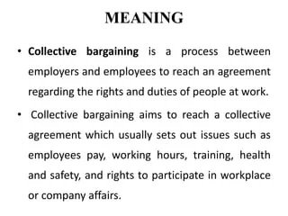
Collective bargaining is a matter of joint consultation, for which members must be prepared to act collectively and recognize their common interests. The most important learning is that it is a give and take process based on the strength and coordination amongst the members of groups.
It is said that, “Any business arrangement that is not profitable to the other person will in the end prove unprofitable for you. The bargain that yields mutual satisfaction is the only one that is apt to be repeated.”
The term collective bargaining was coined by Sydney and Beatrice Webb of Great Britain, which is said to be the “home of collective bargaining”. The idea of collective bargaining emerged from the industrial conflict and the growth of the trade union movement.
Collective bargaining is the process whereby workers organize together to meet, converse, and compromise upon the work environment with their employers. In various national labor and employment law contexts, collective bargaining takes on a more specific legal meaning.
In a broad sense, however, it is the coming together of workers to negotiate their employment. A collective agreement is a labor contract between an employer and one or more unions.
Collective bargaining consists of the process of negotiation between representatives of a union and employers (represented by management, in some countries by employers’ organization) in respect of the terms and conditions of employment of employees, such as wages, hours of work, working conditions and grievance- procedures, and about the rights and responsibilities of trade unions.
The parties often refer to the result of the negotiation as a Collective Bargaining Agreement (CBA) or as a Collective Employment Agreement (CEA).
According to International Labor Organization, collective bargaining is defined as “Negotiation about working conditions and terms of employment between an employer, a group of employers or one or more employer’s organization, on the one hand, and one or more representative workers organization on the other hand, with a view to reach an agreement.”
- Joint Management Councils:
Joint Management Councils (JMCs): JMCs were introduced first in 1958. These councils are formed at plant level with equal number of representatives from employers and employees. These are mainly consultative and advisory ones. Hence, neither the workers nor the employers take them seriously.
The responsibility of the JMCs is relating to matters such as working conditions, indiscipline, absenteeism, training, safety, accident prevention, preparation of holiday schemes, etc. However, it was alleged that JMCs and work committees appeared similar in their scopes and functions. Further, multiplicity of bipartite consultative bodies did not serve any purpose.
Under this system, joint consultative committees are set up comprising the representatives of the workers and employers to discuss various matters concerning the working conditions of workers in industry.The matters which are to be settled through collective bargaining such as wages, bonus etc. are excluded-from the scope of the committees. The matters which are generally taken up by these committees are prevention of accidents, management of canteens, water, meals, safety etc., issue and revision of work rules, avoidance of waste of time and materials absenteeism, indiscipline, training etc., Such committees may be formed on plant or shop level.
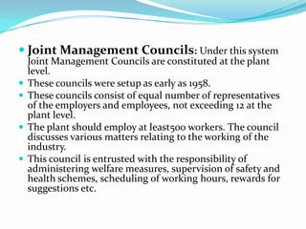

3.Works Committees:
Establishment of works committees in establishment employing 100 or more workers were made compulsory by the Industrial Disputes Act 1947 to introduce the system of labour-management participation through legislation. Such committees consist of equal number of representatives of workers and employer.
State Governments may, by general or special order, require the employer having 100 or more workers to constitute such works committees. The main purpose of such committees is to provide measures for securing and preserving amity and good relations between the employer and employees.
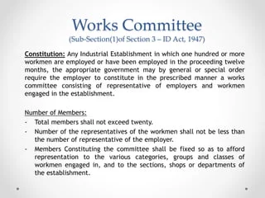
4.Appointments of Labour Directors:
Under this form of workers’ participation in management, one or two representatives of workers are nominated or elected as directors. These directors enjoy the same status rights and power as other directors of the company. Such directors may be elected by workers’ or may be nominated either by trade unions or by the management.
This system has been successfully implemented in many countries of the world. In India also, this scheme is applied in nationalised banks. In these banks two representatives of employees are elected on the board of directors. One such director is from clerical staff and another from supervisory staff.
The role of a worker representative in the board of directors is essentially one of negotiating the worker’s interest with the other members of the board. At times, this may result in tension and friction inside the board room. The effectiveness of workers’ representative at the board depend upon his ability to participate in decision-making, his knowledge of the company affairs, his educational background, his level of understanding and also on the number of worker representatives in the Board.

The basic idea behind incorporating workers’ representation on the Board of Directors is to safeguard the workers’ interest, usher industrial harmony and good relations between the workers and management. This is the highest form of workers’ participation in management.
The Government itself, as an employer, introduced this scheme in several public sector enterprises such as Hindustan Antibiotics Ltd., Hindustan Organic Chemicals Ltd., National Coal Mines Development Corporation, Bharat Heavy Engineering Ltd., National Textile Mills, etc. This scheme required the verification of trade union membership, identification of the representative union and selection of a worker director who is selected out of a penal of three persons furnished to the government by the representative union within a prescribed period. Subsequent to the nationalization of banks in 1970, the Government, under the Nationalized Banks (Management and Miscelleneous Provisions) Scheme 1970, introduced the nomination of workers’ representatives as directors to the Boards — one representing employees and the other representing officers for a tenure of 3 years. According to a study of the scheme introduced in the nationalized banks conducted by the National Labour Institute, the scheme has failed in its objectives because of the contentions raised about the scheme by both employees (trade unions) and employers.

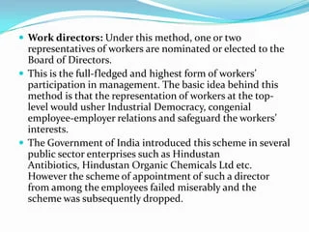

5.Co-Partnership/ Participation through Ownership:
Under this scheme of workers’ participation in management, the workers purchase same shares of the company in which they are working. Thus, they became shareholders of their company. Being shareholders, they take parts in the process of decision making and policy framing of their company by taking part in the meetings of the company at various levels.
They may send their representatives to the board of directors and thus, they may participate in the internal matters of the company. In addition to this, they get a share in the profits of camp any as dividend.
Under this scheme, workers are induced to buy equity shares of the company. Workers may be allowed to make payments in instalments, advanced loans or even give financial assistance to enable workers to buy equity shares.
Workers hold sixty-one per cent of the shares of Otto India, Calcutta and forty-one per cent of the shares of Sehgal Sanitary Fittings, Jalandhar, for example. As shareholders, workers take part in the management by way of electing their representatives to the Board of Directors. However, the workers’ participation under this method is limited.
- An employee stock ownership plan (ESOP) is an employee benefit plan that gives workers ownership interest in the company in the form of shares of stock.
- ESOPs encourage employees to give their all as the company’s success translates into financial rewards.

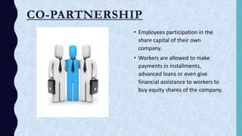
- Suggestion Scheme:
A very important form of workers’ participation in management is the suggestions scheme. Under this scheme, suggestions are invited from workers a various problems of the company. This scheme is mare commonly adapted and the problems related with workers. It provides new and valuable suggestions to the management and increases the feeling of integration among workers with their enterprise.
Under this scheme, a suggestion committee is constituted consisting of equal number of members from management and workers. A suggestion box is installed at an appropriate place in the organisation. Workers are invited and encouraged to put their suggestions for improving working of the organisation into the suggestion box. The suggestion committee periodically scrutinizes the suggestions given by the workers. Good suggestions are accepted and implemented and also rewarded. This encourages workers to make more and better suggestions.

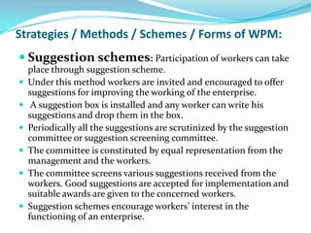

7.Quality Circles:
The concept of quality circles first originated in the United States of America and was later used by Japanese industries. The start of Quality Circles in Japan is credited to Dr. Kaoru Ishikawa of Tokyo University. It is an important group technique applied to ensure involvement of workers in decision making process.
They are small group of members involved in similar type of work, who voluntarily meet regularly once a week, fortnight or month, depending on the nature, intensity and frequency of the problem. A group of 8-12 members are formed to discuss problems related to quality and productivity. Consequently, recommendations are made and corrections are undertaken.
Quality Circles consist of 6-10 or 8-12 members and the membership is purely voluntary in nature. Every member is a leader and is elected by the members themselves. The nomination and selection of the leader is done by the group and after the completion of the project, another leader may be appointed.
Facilitator is selected by the management and his responsibilities include organizing and coordinating activities, along with his co-coordinator (semi-facilitator). Steering committee comprises of various departmental and divisional heads. They have the responsibility to review the operations of Quality Circles and provide any form of necessary support required by the Quality Circles group.
An Executive Committee (top management committee) consisting of the Chairman and the Managing Director, Directors, Chief Executives, General Manager and other top executives is formed. This is primarily an advisory committee to guide the Steering Committee and the facilitator.
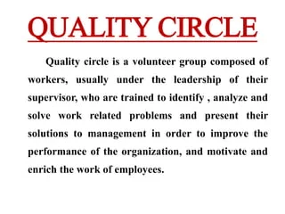
- Open Door Policy: It is a general invitation to all the employees to walk inside manager’s room any time and discuss their grievances and problem. It is an informal practice of giving the employees the freedom to discuss routine grievances and work related issues. Inspite of providing democratic benefits and freedom of expression, the system of Open Door Policy has proved ineffective, especially in large organizations.
- Workers’ Complete Ownership: Under this scheme, workers acquire complete control of management of their enterprise through an elected board or/and Workers’ Council. This system of participation is also called "self management." This prevails in Yugoslavia. In this system, two different sets of persons perform two distinct types of functions, namely, managerial and operative. This system of participation is characterized by virtues like workers’ identification with their organization, loyalty and responsibility to organization, etc. This ushers in industrial harmony and peace for the organization. Expectedly, trade unions favour this form of workers’ participation in management.
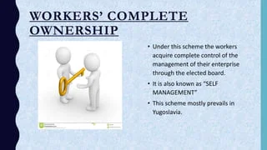

#####Levels of Workers Participation In Management
Having known the objectives of WPM, the question then is to what extent workers can participate in decision-making process. In other words, it is important to know the extents/levels of co-determination in an organisation.
Viewed from this angle, Mehtras has suggested five levels of workers’ participation ranging from the minimum to the maximum. Since these levels of workers’ influence the process and quality of decision making in an organisation. We are therefore highlighting here these levels briefly ranking them from the minimum to the maximum level of participation.
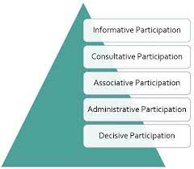

Informative Participation:
This refers to management’s information sharing with workers on such items those are concerned with workers. Balance Sheet, production, economic conditions of the plant etc., are the examples of such items. It is important to note that here workers have no right of close scrutiny of the information provided and management has its prerogative to make decisions on issues concerned with workers.

Consultative Participation:
In this type of participation, workers are consulted in those matters which relate to them. Here, the role of workers is restricted to give their views only. However the acceptance and non-acceptance of these views depends on management. Nonetheless, it provides an opportunity to the workers to express their views on matters involving their interest.
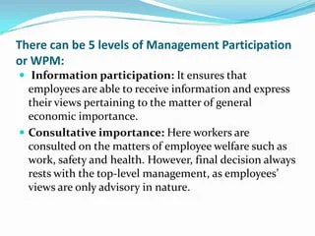

Associative Participation:
Here, the role of the workers’ council is not just advisory unlike consultative participation. In a way, this is an advanced and improved form of consultative participation. Now, the management is under a moral obligation to acknowledge, accept and implement the unanimous decision of the council.

Administrative Participation:
In the administrative participation, decisions already taken are implemented by the workers. Compared to the former three levels of participation, the degree of sharing authority and responsibility by the workers is definitely more in this participation.

Decisive Participation:
Here, the decisions are taken jointly by the management and the workers of an organisation. In fact, this is the ultimate level of workers’ participation in management.
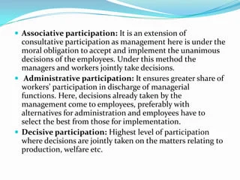

####Merits/benefits of Worker’s Participation:
Workers’ participation in management is a tool which promotes better industrial relations and establishes industrial peace. It is important concept for both management and workers. The need is to implement it honestly to reap its merits in the form of mutual understanding, increased efficiency of workers, increased production etc. Workers’ participation in management has several advantages.
1. Mutual Understanding:
In capitalistic economy, workers and capitalists are two groups having different interests. Both doubt integrity of each other because both are ignorant of each other’s problems and never try to know them. The worker participation extends the mutual understanding.
The workers and employees come nearer to each other and understand each other’s difficulties and problems. It gives employees a better understanding of their role in the working of industry and of the processes of production. Participation brings the two parties closer and makes them aware of each other’s problems. As a result, better understanding and mutual trust can be created between employer and workers.
2. Higher Productivity:
Co-operation of workers result in increased production and productivity. Better understanding and good relations are the pre-requisites of higher and better production. Production and productivity cannot be increased without effective cooperation of workers and management. Through participation worker learn the problems of industry and better understanding of their role.
Participation improves employee motivation and job satisfaction which in turn help to increase their efficiency. Higher productivity leads to lower cost per unit and greater profits which are beneficial to all.
3. Industrial Harmony:
As the worker become the partners of industry and take part in decision making, they extend full cooperation to the management in carrying out the decision. They have a sense of loyalty and better understanding. Thus the possible of dispute based an irrational grounds is reduced to the minimum. Continuous dialogue between management and worker improves peace in industry. As a result, industrial relation will certainly improve with worker participation in decision making process.
4. Less Resistance to Change:
Change is generally resisted by workers because every change is regarded by workers a threat to stability. They often resist change due to fear and ignorance. When workers participate in the decision-making, they come to understand that change is ultimately in their own interest. As a result, they participate in the decision making bodies and they will adjust themselves to the changed environment.
They become more able and ready to adopt themselves to technological and other changes. It made to improve the competitive position of company. Once the workers are taken into confidence, introduction of change is very smooth.
5. Creativity and Innovation:
Participation offers an opportunity to intelligent employees to demonstrate their knowledge, skill, initiativeness as well as creativity. It also encourage workers to think. Highly capable persons having talent can be easily spotted out and offered due promotion. Thus participation enables the management to capitalise the talent and ability of employees. Participation also offers an opportunity for the advancement of employees and of management executives. This will also increase the growth of workers.
6. Greater Efficiency and Job Satisfaction:
Under the scheme workers are abide by their own decisions and work with their full zeal to carry out the decision. The importance given to workers by consulting them for various decisions will increase their efficiency and job satisfaction. Various organisational goals and set with the consent of workers and they will feel motivated to achieve them in time. There will an atmosphere of mutual help.
The improved performance of workers will give them job satisfaction also. Increase in efficiency and productivity will give benefit both the parties to the labour in shape in increased wages to management in the form of better production.
7. Industrial Democracy:
Industrial democracy means participation of all parties concerned or affected in the management of industries. When workers participate in management true industrial democracy is established. Their ego is satisfied and they contribute something positive in the interest of industry themselves and of the country because they can express themselves put their problems and grievances at the work.
8. Increased Commitment:
When workers are consulted on important policy decisions then they feel as part and parcel of the enterprise. The workers are free to express their views about various matters affecting them. It helps the management to understand the view point of workers. This gives a sense of personal gratification to workers and they feel committed to the work and organisational goals. Thus participation increases the commitment of workers which also help to increase the production and productivity of industry.
9. Satisfy Social and Egoistic Needs:
According to Maslow theory of need, first of all physiological needs are satisfied. When workers have satisfied the need of food, clothing shelters etc., the next step is to satisfy other need. Now they want to satisfy social and egoistic needs because every worker wants to feel important in the organisation.
Importance of workers will increase through participation. Participation of worker will give them a sense of pride and satisfaction. So the desire to satisfy social and egoistic needs will also act as a motivator to workers. They participate in the decision making process in order to satisfy their social and egoistic needs.

10. Personal Development:
Participation helps workers to express their creative instinct and they respond favourably to the challenges at the workplace as regards performance of the job. They feel free in doing so. It is possible as participation brings industrial democracy.
11.Reduces Misunderstanding:
Participation reduces misunderstanding regarding the managements’ outlook. This increases the organisational balance.

12.No Outside Help to Sort-out Disputes:
Employees themselves are participating in the decision making with the employers. They therefore realize workers as well as managements’ problem better hence disputes are resolved by understanding the difficulties of each other. So in case of industrial dispute no outside help is taken they are sorted out within the plant itself by the employees and employers themselves.

####Role of workers participation in labour welfare and industrial hygiene

Shop floor council (plant level)
Except for industries having one shop floor, all other industries are required to have shop floor council in accordance with the rules. Functions: It carries out functions specified in Schedule I of the Bill which include:
- Production facilities
- Storage facilities
- Materials economy
- Operational problems
- Wastage control
- Hazards and safety problems
- Quality improvement
- Cleanliness
- Monthly targets and production schedule
- Cost reduction programme
- Formation & implementation of work systems
- Design group working
- Welfare measures.

Establishment council
Every industry is required to set up an establishment council at establishment level. Functions: An establishment council can exercise powers as specified in Schedule II of the Bill, which includes:
Operational Area:
- Evolution of productivity schemes
- Planning, implementation, fulfilment and review of monthly targets and schedules
- Material supply & its shortfall
- Storage and inventories
- House keeping
- Improvement in productivity
- Encouragement and consideration of suggestion
- Quality of technological improvement
- Machine utilisation, knowledge and development of new product
- Operational performance figure, etc.
- Economic and Financial Areas:
- Profit & loss statement and balance sheet
- Review of operating expenses, financial result and cost of sales
- Plant performance in financial terms.
Personnel Matters:
- Absenteeism
- Problems of women workers
- Initiation of supervision of workers’ training programme
- Administration of social security schemes.
Welfare Areas:
- Operational details
- Implementation of welfare schemes
- Safety measures etc.
- Environmental Areas:
- Extension activities and community development projects
- Pollution control.
Representation of Board of Management
“The representatives of workmen are to constitute 13% and those of other workers 12% of the total strength of the Board of Management.” The bill provides for a monitoring committee to advice on matters of administration of the Act and scheme under it.

