### Name of Institute: Indus Institute of Technology and Engineering (IITE)

### Name of Faculty: Divyangna Gandhi

**Course code: EC0723**

**Course name: Satellite Communication**

Pre-requisites: Principles of analog and digital communication system.

Credit points: 03

Offered Semester: 7th

**Course Coordinator (weeks 15)**

Full Name: Divyangna Gandhi

Department with sitting location: 2nd Floor, Bhanwar Building, EC Lab 5(Digital and

Networking Lab), IITE - IU

Telephone: 3202

Email: [Divyangnagandhi.ec@indusuni.ac.in](mailto:Divyangnagandhi.ec@indusuni.ac.in)

Consultation times: 4:00PM to 4:45PM

**Course Lecturer (weeks 15)**

Full Name: Divyangna Gandhi

Department with sitting location: 2nd Floor, Bhanwar Building, EC Lab 5(Digital and

Networking Lab), IITE - IU

Telephone: 3202

Email: [Divyangnagandhi.ec@indusuni.ac.in](mailto:Divyangnagandhi.ec@indusuni.ac.in)

Consultation times: 4:00PM to 4:45PM

Students will be contacted throughout the session via mail with important information relating to this course.

# Course Objectives

By participating in and understanding all facets of this course a student will able:

1. To understand the basic concept and evolution of satellite communication in India and world
2. To know about various types of satellites and services
3. To provide an in-depth treatment of satellite communication systems operation and planning
4. To understand the space segment and earth segment
5. To compute the altitude of satellite orbits and find the location of satellites
6. To compute the link budgets & planning of satellite launching
7. To analyze the various methods of satellite access
8. To understand various applications of satellite communications

# Course Outcomes (CO)

# 1. Define the working principle and operation of various satellite systems

# 2. Explain the space segment and earth segment system with their controls

# 3. Determine the various communication techniques for satellite applications

# 4. Analyze the various methods of satellite access systems and illustrate the satellite broadcast standards and services

# 5. Apply the state of the art in new research areas such as speech and video coding, satellite networking and satellite personal communications

# 6. Design satellite communication link and prepare the satellite communication budget.

# Course Outline

Types of satellites and services

Space segment and earth segment

Various methods of satellite access

Link budget

Various applications

# Method of delivery

(Face to face lectures, self-study material, Active Learning Techniques)

# Study time

(2 Hour’s theory and 2 Hour Labl per week)

# CO-PO Mapping (PO: Program Outcomes)

|  |  |  |  |  |  |  |  |  |  |  |  |  |
| --- | --- | --- | --- | --- | --- | --- | --- | --- | --- | --- | --- | --- |
| **PO CO** | **PO** | | | | | | | | | | | |
| **1** | **2** | **3** | **4** | **5** | **6** | **7** | **8** | **9** | **10** | **11** | **12** |
| **1** | √ | √ |  |  |  |  |  |  |  |  |  |  |
| **2** | √ | √ |  |  | √ |  | √ |  |  |  |  |  |
| **3** | √ | √ |  |  |  |  |  |  |  |  |  |  |
| **4** |  | √ | √ |  | √ |  | √ |  |  |  |  |  |
| **5** |  | √ | √ |  | √ |  | √ |  |  |  |  |  |
| **6** |  | √ | √ | √ | √ |  |  |  |  |  |  |  |

# Blooms Taxonomy and Knowledge retention (For reference)

(Blooms taxonomy has been given for reference)

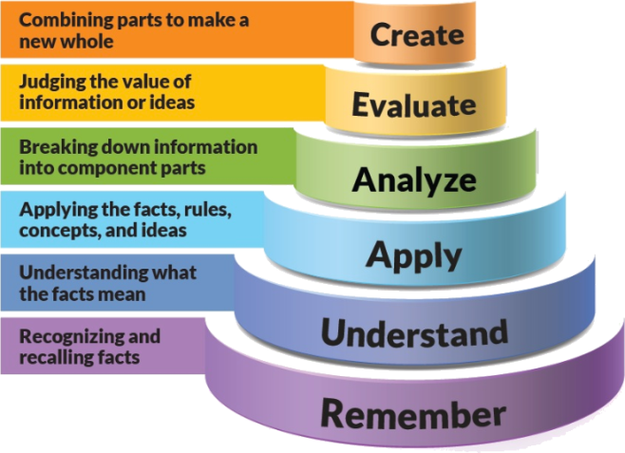

Figure 1: Blooms Taxonomy

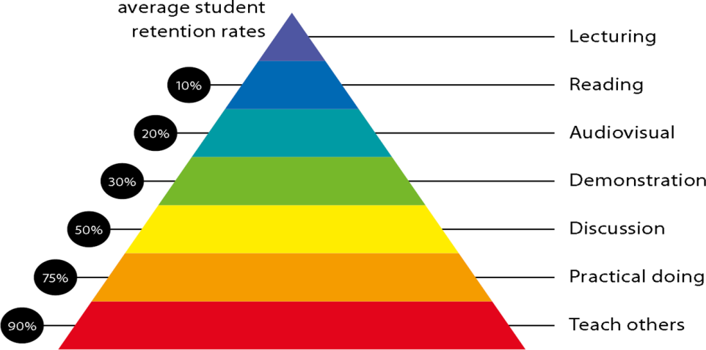

Figure 2: Knowledge retention

# Graduate Qualities and Capabilities covered

(Qualities graduates harness crediting this Course)

|  |  |
| --- | --- |
| **General Graduate Qualities** | **Specific Department of ______Graduate Capabilities** |
| **Informed**  Have a sound knowledge of an area of study or profession and understand its current issues, locally and internationally. Know how to apply this knowledge. Understand how an area of study has developed and how it relates to other areas. | **1 Professional knowledge, grounding & awareness** |
| **Independent learners**  Engage with new ideas and ways of thinking and critically analyze issues. Seek to extend knowledge through ongoing research, enquiry and reflection. Find and evaluate information, using a variety of sources and technologies. Acknowledge the work and ideas of others. | **2 Information literacy, gathering & processing** |
| **Problem solvers**  Take on challenges and opportunities. Apply creative, logical and critical thinking skills to respond effectively. Make and implement decisions. Be flexible, thorough, innovative and aim for high standards. | **4 Problem solving skills** |
| **Effective communicators**  Articulate ideas and convey them effectively using a range of media. Work collaboratively and engage with people in different settings. Recognize how culture can shape communication. | **5 Written communication** |
| **6 Oral communication** |
| **7 Teamwork** |
| **Responsible**  Understand how decisions can affect others and make ethically informed choices. Appreciate and respect diversity. Act with integrity as part of local, national, global and professional communities. | **10 Sustainability, societal & environmental impact** |

# Lecture/tutorial times

***Example:***

**Lecture Tuesday 09:00 – 09:55AM**

**Lecture Friday 11:45 – 12:40PM**

**Lab Tuesday 01.20 – 03.10PM**

# Attendance Requirements

The University norms states that it is the responsibility of students to attend all lectures, tutorials, seminars and practical work as stipulated in the Course outline. Minimum attendance requirement as per university norms is compulsory for being eligible for mid and end semester examinations.

# Details of referencing system to be used in written work

# Text books

|  |  |
| --- | --- |
| Text books | 2009Dennis Roddy, “Satellite Communication”, 4th Ed., McGraw Hill, 2008 |
| T.Pratt, C.Bostian, J.Allnutt, “Satellite Communications” 2nd Ed., Wiley India, |
| Reference Books | Louis J. Ippolito, Jr., “Satellite Communications Systems Engineering”, Wiley, 2008 |
| B.G.Evans, “Satellite Communication Systems”, IET Telecommunication Series 38, 2008 |
| M.Richharia, “Stellite Communication Systems: Design Principles”, McGraw Hill, 1999 |
| Bruce R. Elbert, “The Satellite Communication Applications”, Hand Book, Artech House Bostan London, 1997. |

# Additional Materials

|  |
| --- |
| NPTEL- Lecture  **<https://nptel.ac.in/courses/117105131/>** |

# ASSESSMENT GUIDELINES

Your final course mark will be calculated from the following:

**Example:**

Midterm Exam 40% Objective (1-4)

Presentation 10% Objectives (1-6)

Assignment 10% Objectives (3-6)

**Final exam** (*closed book*) 40% Objectives (1-6)

# SUPPLEMENTARY ASSESSMENT

Students who receive an overall mark less than 40% in mid semester or end semester will be considered for supplementary assessment in the respective components (i.e mid semester or end semester) of semester concerned. Students must make themselves available during the supplementary examination period to take up the respective components (mid semester or end semester) and need to obtain the required minimum 40% marks to clear the concerned components.

# Late Work

Late assignments will not be accepted without supporting documentation. Late submission of the reports will result in a deduction of -% of the maximum mark per calendar day

# Format

All assignments must be presented in a neat, legible format with all information sources correctly referenced. **Assignment material handed in throughout the session that is not neat and legible will not be marked and will be returned to the student.**

# Retention of Written Work

Written assessment work will be retained by the Course coordinator/lecturer for two weeks after marking to be collected by the students.

# University and Faculty Policies

Students should make themselves aware of the University and/or Faculty Policies regarding plagiarism, special consideration, supplementary examinations and other educational issues and student matters.

**Plagi**a**rism** - Plagiarism is not acceptable and may result in the imposition of severe penalties. Plagiarism is the use of another person’s work, or idea, as if it is his or her own - if you have any doubts at all on what constitutes plagiarism, please consult your Course coordinator or lecturer. Plagiarism will be penalized severely.

***Do not copy the work of other students.***

***Do not share your work with other students (except where required for a group activity or assessment)***

# Course schedule

|  |  |  |  |  |  |  |
| --- | --- | --- | --- | --- | --- | --- |
|  | **Week 15** | **Topic & contents** | | **CO Addressed** | | **Teaching Learning Activity (TLA)** |
|  | Weeks 1 | To aware students with theoretical and practical syllabus, assessment scheme for theory (CIE, End sem exam), practical (CIE, End sem exam) and all the details about subject activities has to be carry out throughout the semester | | 1 | | BB,PPT |
| Introduction of satellite communication,  Benefits of satellite communication and historical evolution of communication satellites | |
| Weeks 2 | Satellite communication in India and elements of satellite communication,  Types of satellites and satellite services | | 1 | | BB,PPT |
| Week 3 | Satellite network configurations and satellite frequency bands, Introduction of satellite orbits, orbital parameters, types of orbits and Kepler’s laws | | 1,2 | | BB,PPT |
| Week 4 | Orbital elements, solar time and sidereal time, satellite orbits and orbital perturbations, Satellite launching and Geo launching methods, Problems | | 2 | | BB,PPT |
| Week 5 | Introduction to satellite system and transponder subsystem, Antenna subsystem, altitude and orbit control (AOC) subsystem, and telemetry | | 1,2,3 | | BB,PPT |
|  | Week 6 | Tracking and command subsystem, power subsystem and thermal subsystem, Structural subsystem, reliability and quality assurance | 2,3 | | BB,PPT | |
| Week 7 | Introduction, elements of an earth station, types of earth stations and earth station transmitter and receiver, Redundancy, Reliability and mission control for communication satellites | 2,3 | | BB,PPT | |
| Week 8 | Earth station receiver, Redundancy, Reliability and mission control for communication satellites | 1,2,3 | | BB,PPT | |
| Week 9 | Rain attenuation and depolarization, Cross polarization and propagation impairments, Mitigation techniques | 3,4,5 | | BB,PPT | |
|  | Week 10 | Introduction of satellite communication system model, Noise at the receiver and G/T ratio for earth stations | 1,3,4,5 | | BB,PPT | |
| Week 11 | Uplink equations and downlink equations, Total link and system design examples, System design examples | 3,4,5,6 | | BB,PPT | |
|  | Week 12 | Introduction of frequency division multiple access, SCPC, MCPC , Time division multiple access and SS-TDMA | 2,3,4 | | BB,PPT | |
|  | Week 13 | Acquisition and burst synchronization, spread spectrum multiple access, Demand assigned multiple access and random access | 2,4,5 | | BB,PPT | |
|  | Week 14 | VSAT Systems and voice network configurations, Data Networks, VSAT terminal broadcast services: TVRO | 4,5,6 | | BB,PPT | |
|  | Week 15 | DTH, DVB and HDTV satellite radio ,DAB satellite news gathering satellite broadcast standards | 4,5,6 | | BB,PPT | |

