Name of Institute: Indus Institute of Technology and Engineering (IITE)

Name of Faculty: Divyangna Gandhi

Course code: EC0318
Course name: Network Analysis

Pre-requisites: Fundamental knowledge of electric circuit sources and elements, basic mathematics (integration, differentiation, etc.

Credit points: 03
Offered Semester: 3rd

Course Coordinator (weeks 15)
Full Name: Divyangna Gandhi
Department with sitting location: 2nd Floor, Bhanwar Building, EC Lab 5(Digital and
Networking Lab), IITE - IU
Telephone: 3202
Email: Divyangnagandhi.ec@indusuni.ac.in
Consultation times: 4:00PM to 4:45PM

Course Lecturer (weeks 15)
Full Name: Divyangna Gandhi
Department with sitting location: 2nd Floor, Bhanwar Building, EC Lab 5(Digital and
Networking Lab), IITE - IU
Telephone: 3202
Email: Divyangnagandhi.ec@indusuni.ac.in
Consultation times: 4:00PM to 4:45PM

Students will be contacted throughout the session via mail with important information relating to this course.

Course Objectives
By participating in and understanding all facets of this course a student will:

- Describe, apply and analyze basic network concepts emphasizing series and parallel combination of passive components, source transformation and shifting.
- Describe, apply and analyze use of mesh and nodal techniques for formulating the transfer function of networks.
- Apply and analyze various network theorems in solving the problems related to electrical circuits.
- Describe and analyze two port networks and methods of analyzing the electrical networks.

Course Outcomes (CO)

- Understand and solve the circuits using node and mesh analysis [BT 2].
- Apply concept of different network theorems and use the optimum method to solve the circuit [BT 3].
- Understand the working of capacitor and inductor and how to apply initial conditions [BT 2].
- Apply Laplace transform to solve the circuits [BT 3].
- Understand two port parameters and how to find out different types of them [BT 2].
- Apply concept of source transformation and reduce the complex circuit [BT 3].

Course Outline
basic mathematics
network theorems
Laplace transform
source transformation

Method of delivery
(Face to face lectures, self-study material, Active Learning Techniques)

Study time
(2 Hour’s theory and 1 Hour’s Tut)

CO-PO Mapping (PO: Program Outcomes)

 | PO1 | PO2 | PO3 | PO4 | PO5 | PO6 | PO7 | PO8 | PO9 | PO10 | PO11 | PO12
CO1 | 3 | 1 | 1 | - | - | - | - | - | - | - | - | 1
CO2 | 3 | 2 | 3 | 1 | 3 | - | - | - | - | - | - | -
CO3 | 3 | 2 | 2 | 2 | 3 | - | - | - | - | - | - | -
CO4 | 2 | 2 | 1 | - | - | - | - | - | - | - | - | 1
CO5 | 3 | 2 | 3 | 1 | 3 | - | - | - | - | - | - | -

Blooms Taxonomy and Knowledge retention (For reference)
(Blooms taxonomy has been given for reference)

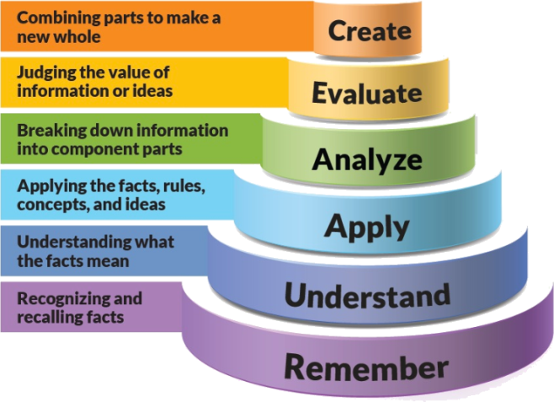
Figure 1: Blooms Taxonomy
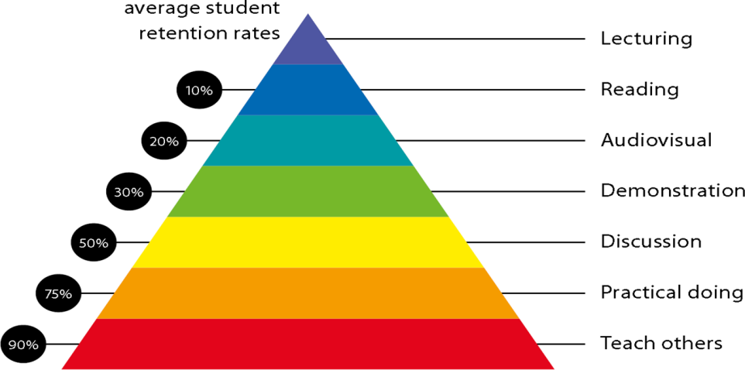
Figure 2: Knowledge retention

Graduate Qualities and Capabilities covered
(Qualities graduates harness crediting this Course)

General Graduate Qualities | Specific Department of ______Graduate Capabilities
Informed  Have a sound knowledge of an area of study or profession and understand its current issues, locally and internationally. Know how to apply this knowledge. Understand how an area of study has developed and how it relates to other areas. | 1 Professional knowledge, grounding & awareness
Independent learners  Engage with new ideas and ways of thinking and critically analyze issues. Seek to extend knowledge through ongoing research, enquiry and reflection. Find and evaluate information, using a variety of sources and technologies. Acknowledge the work and ideas of others. | 2 Information literacy, gathering & processing
Problem solvers  Take on challenges and opportunities. Apply creative, logical and critical thinking skills to respond effectively. Make and implement decisions. Be flexible, thorough, innovative and aim for high standards. | 4 Problem solving skills
Effective communicators  Articulate ideas and convey them effectively using a range of media. Work collaboratively and engage with people in different settings. Recognize how culture can shape communication. | 5 Written communication
 | 6 Oral communication
 | 7 Teamwork
Responsible  Understand how decisions can affect others and make ethically informed choices. Appreciate and respect diversity. Act with integrity as part of local, national, global and professional communities. | 10 Sustainability, societal & environmental impact

Lecture/tutorial times
Example:
Lecture Thursday 09.00 – 09.55AM
Lecture Friday 10:50 – 11:45AM
Tutorial Thursday 02.15 – 03.10PM

Attendance Requirements

The University norms states that it is the responsibility of students to attend all lectures, tutorials, seminars and practical work as stipulated in the Course outline. Minimum attendance requirement as per university norms is compulsory for being eligible for mid and end semester examinations.

Details of referencing system to be used in written work

Books

Text books | - M.E. Van Valkenberg, “Network Analysis”, Prentice Hall of India, 3rd edition, 2000, ISBN: 9780136110958.
 | - K Channa Venkatesh, D. Ganesh Rao, Network Analysis, Cenage Learning
 | - Roy Choudhury, “Networks and Systems”, 2nd edition, 2006, New Age International Publications, ISBN: 9788122427677.
Reference Books | - Hayt, Kemmerly and Durbin “Engineering Circuit Analysis”, TMH 7th edition, 2010.
 | - U A Patel, “Network Analysis And Synthesis”, Mahajan Publication House
 | - J. David Irwin and R. Mark Nelms, “Basic Engineering Circuit Analysis”, John Wiley, 8th edition, 2006.
 | - Charles K Alexander and Mathew N O Sadiku, “ Fundamentals of Electric Circuits”, Tata McGraw-Hill, 3rd edition, 2009.

Additional Materials

NPTEL- Lecture
https://nptel.ac.in/courses/108/104/108104091/

ASSESSMENT GUIDELINES
Your final course mark will be calculated from the following:
Example:
Midterm Exam 40% Objective (1-4)
Quiz 10% Objectives (1-6)
Tutorial/Assignment 10% Objectives (1- 6)
Final exam (closed book) 40% Objectives (1-6)

SUPPLEMENTARY ASSESSMENT

Students who receive an overall mark less than 40% in mid semester or end semester will be considered for supplementary assessment in the respective components (i.e mid semester or end semester) of semester concerned. Students must make themselves available during the supplementary examination period to take up the respective components (mid semester or end semester) and need to obtain the required minimum 40% marks to clear the concerned components.

Late Work
Late assignments will not be accepted without supporting documentation. Late submission of the reports will result in a deduction of -% of the maximum mark per calendar day

Format
All assignments must be presented in a neat, legible format with all information sources correctly referenced. Assignment material handed in throughout the session that is not neat and legible will not be marked and will be returned to the student.

Retention of Written Work
Written assessment work will be retained by the Course coordinator/lecturer for two weeks after marking to be collected by the students.

University and Faculty Policies
Students should make themselves aware of the University and/or Faculty Policies regarding plagiarism, special consideration, supplementary examinations and other educational issues and student matters.

Plagiarism - Plagiarism is not acceptable and may result in the imposition of severe penalties. Plagiarism is the use of another person’s work, or idea, as if it is his or her own - if you have any doubts at all on what constitutes plagiarism, please consult your Course coordinator or lecturer. Plagiarism will be penalized severely.

Do not copy the work of other students.
Do not share your work with other students (except where required for a group activity or assessment)

Course schedule

 | Week 15 | Topic & contents | CO Addressed |  | Teaching Learning Activity (TLA)
 | Weeks 1 | To aware students with theoretical and practical syllabus, assessment scheme for theory (CIE, End sem exam), practical (CIE, End sem exam) and all the details about subject activities has to be carry out throughout the semester | 1 |  | BB,PPT
 |  | Introduction, Scope of the subject
 | Weeks 2 | Electromotive Force, Potential and Voltage, A Voltage Source with a Resistance Connected at its Terminals | 1,2 |  | BB,PPT
 | Week 3 | Circuit elements, Current division rule, Voltage division rule, Classification of Network, KCL and KVL | 1,2,3,4 |  | BB,PPT
 | Week 4 | Node analysis of circuit with independent sources, Node analysis of circuit with dependent sources | 2,3 |  | BB,PPT
 | Week 5 | Super nodes, Mesh analysis of circuit with independent sources, Mesh analysis of circuit with dependent sources | 1,5,6 |  | BB,PPT
 | Week 6 | Super Mesh, Source transformation techniques, Source transformation method and node analysis | 1,5,6 | BB,PPT
 | Week 7 | Linearity of circuit, Superposition Theorem, Superposition Theorem examples, Thevenin's theorem | 5,6 | BB,PPT
 | Week 8 | Thevenin's theorem Examples,Norton's Theorem,Maximum power transfer theorem, Substitution theorem, compensation theorem | 1,2,3 | BB,PPT
 | Week 9 | Solution of Linear Differential Equations, Analysis of first order RC and RL circuit, Superposition and linearity of first order differential equations | 3,4 | BB,PPT
 | Week 10 | Laplace transformations, Notations, S-domain transformation of circuit, Circuit Analysis using Laplace transformation, Scaling and shifting theorem | 1,2,4 | BB,PPT
 | Week 11 | Classifications of the response,Computation of sinusoidal steady state response for stable networks and systems | 1,4 | BB,PPT
 | Week 12 | Switching in RLC circuit, Switched capacitor circuits, Charge conventions | 1,4 | BB,PPT
 | Week 13 | ABCD- Parameters for two port network, Z-parameters for two port network | 4,5,6 | BB,PPT
 | Week 14 | Interconnections of two port networks,H Parameter for two port network | 5,6 | BB,PPT
 | Week 15 | Revision |  | BB,PPT

