Name of Institute: Indus Institute of Technology and Engineering

Name of Faculty: Prof. Bharat Dogra

Course code: AU0510
Course name: Two & Three Wheeler Technology
Pre-requisites: Basics of Automobile systems, Automobile Engines
Credit points: 3
Offered Semester: 5th

Course Coordinator (weeks 01 - 12)

Full Name: Prof. Bharat Dogra
Department with siting location: Automobile Department
Telephone: +91958-686-7929
Email: bharatdogra.am@indusuni.ac.in
Consultation times: 03.50 PM – 04:15 PM (Tuesday and Friday)
09.00 AM – 10.00 AM (Working Saturdays)

Course Lecturer (weeks 01 - 12)
Full name: Prof. Bharat Dogra
Department with siting location: Automobile Department
Telephone: +91958-660-1008
Email: bharatdogra.am@indusuni.ac.in
Consultation times: 03.50 PM – 04:15 PM (Tuesday and Friday)
09.00 AM – 10.00 AM (Working Saturdays)

Students will be contacted throughout the Session via Mail with important information relating to this Course.

Course Objectives
By participating in and understanding all facets of this Course a student will:
1. To make students understand the constructional details of Two & Three Wheelers.
2. Study about operating characteristics and vehicle design aspects of Two & Three Wheelers.

Course Outcomes (CO)
CO 1: Explain and Understand about different types of two and three wheeler.

CO 2: Recognize and Describe the constructional details of Two & Three Wheeler.
CO 3: Classify operating characteristics and vehicle design aspects of Two & Three Wheelers.
CO 4: Develop and explain the maintenance of two and three wheeleR.
CO 5: Demonstrate the factors affecting fuel economy & emission.

CO 6: Elucidate and understand the importance of new technology in two and three wheeler.

Course Outline

UNIT 1
[15 hours]
INTRODUCTION
Development, Classification & layouts of two wheelers (motorcycles, scooters, mopeds) and Three wheelers, applications & capacity – goods & passengers, study of technical specification of Two & Three wheelers.
UNIT 2
[18 hours]
POWER UNIT
Selection of engine for two wheeler & three wheeler, Design considerations for two wheeler & three wheeler power plants, special systems requirements for lubrication, cooling, starting. Recent engine developments.

TRANSMISSION SYSTEMS
Clutch – special requirements, different types used in two & three wheelers, need of primary reduction, belt and chain drive, selection of transmission - gear transmission, gear shift mechanism, belt transmission, automatic transmission (Continuous Variable Transmission - CVT, Epicyclic), final drive & differential for three wheeler, wheel drive.
UNIT 3
[12 hours]
STEERING & SUSPENSION
Steering geometry, steering column construction, steering system for three wheelers, Suspension requirements, design considerations, trailing & leading link, swinging arm, springs & shock absorbers, SNS for suspension Brake.

WHEEL & TIRES
Design consideration of brake, types of brakes – disc, drum, braking mechanism – mechanical, hydraulic & servo, wheel types - spokes, disc, split, special tyre requirements for two & three wheelers.
UNIT 4
[15 hours]
FRAMES & BODY
Types of frame, construction, loads, design consideration, materials, Types of three wheeler bodies, layout, RTO regulations, aerodynamic, aesthetic & ergonomics considerations for body work, side car.

MAINTENANCE
Preventive & brake down maintenance, factors affecting fuel economy & emission.

Method of delivery
- Chalk and talk
- PowerPoint Presentations
- Self-study material

Study time
2 hours per week Lectures and 2 Hours practical’s per week

CO-PO Mapping (PO: Program Outcomes)
CO | PO1 | PO2 | PO3 | PO4 | PO5 | PO6 | PO7 | PO8 | PO9 | PO10 | PO11 | PO12
C0 1 | 2 | 2 | - | 1 | 2 | - | - | - | - | - | - | -
C0 2 | 2 | 2 | - | 3 | 2 | 2 | 2 | - | - | - | - | -
C0 3 | - | 3 | 2 | 3 | 1 | - | - | - | - | - | - | -
C0 4 | 1 | 2 | - | 2 | - | 2 | 2 | - | - | - | - | 2
CO 5 | 1 | 3 | 2 | 3 |  | 2 | 2
CO 6 | 2 | 2 | 3 | 2 | 1 | 2 | 2
AU0503 | 1.6 | 2.3 | 2.3 | 2.3 | 1.5 | 2 | 2 |  |  |  |  | 2

1-Lightly Mapped 2- Moderately Mapped 3- Highly Mapped

Blooms Taxonomy and Knowledge retention (For reference)
(Blooms taxonomy has been given for reference)

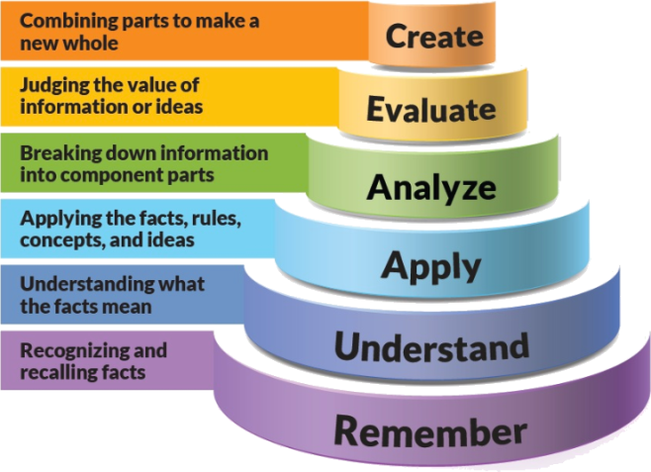
Figure 1: Blooms Taxonomy
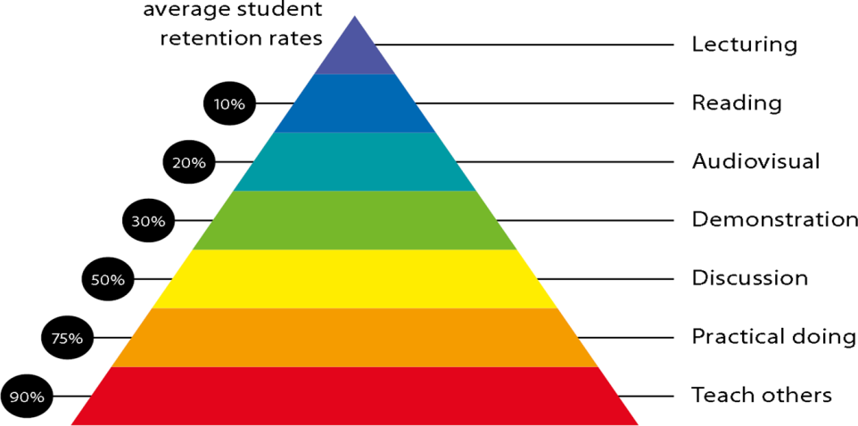
Figure 2: Knowledge retention

Graduate Qualities and Capabilities covered

General Graduate Qualities | Automobile Graduate Capabilities
Informed  Have a sound knowledge of an area of study or profession and understand its current issues, locally and internationally. Know how to apply this knowledge. Understand how an area of study has developed and how it relates to other areas. | 1 Professional knowledge, grounding & awareness
Independent learners  Engage with new ideas and ways of thinking and critically analyze issues. Seek to extend knowledge through ongoing research, enquiry and reflection. Find and evaluate information, using a variety of sources and technologies. Acknowledge the work and ideas of others. | 2 Information literacy, gathering & processing
Problem solvers  Take on challenges and opportunities. Apply creative, logical and critical thinking skills to respond effectively. Make and implement decisions. Be flexible, thorough, innovative and aim for high standards. | 4 Problem solving skills
Effective communicators  Articulate ideas and convey them effectively using a range of media. Work collaboratively and engage with people in different settings. Recognize how culture can shape communication. | 5 Written communication
 | 6 Oral communication
 | 7 Teamwork
Responsible  Understand how decisions can affect others and make ethically informed choices. Appreciate and respect diversity. Act with integrity as part of local, national, global and professional communities. | 10 Sustainability, societal & environmental impact

Lecture/tutorial times
Lecture/Practical | Timings | Room No.
Lecture 1 Tuesday | Slot 1 | LH.6
Lecture 2 Friday | Slot 6 | LH.6
Practical Batch-1 Tuesday | Slot 3.4 | Auto Lab 1
Practical Batch-2 Wednesday | Slot 1-2 | Auto Lab 1

Attendance Requirements

The University norms states that it is the responsibility of students to attend all lectures, tutorials, seminars and practical work as stipulated in the Course outline. Minimum attendance requirement as per university norms is compulsory for being eligible for mid and end semester examinations.

Details of referencing system to be used in written work
- Text Books and Reference Books
- Online Resources

Text books

- Newton Steed, “The Motor Vehicle”, McGraw Hill Book Co. Ltd., New Delhi,2010
- Siegfried Herrmann, “The Motor Vehicle”, Asia Publishing House, Bombay,2011
- Staff & Motor Cycles ,“Two stroke Motor Cycles”, London llefe Books,2003
- Dhruv U Panchal,”Two and three wheelers”, Pearson Publications,2007
- G.B.S. Narang, “Automobile Engineering”, 5th Edition, Khanna Publishers, Delhi,2010
- Irving,P.E., “Motor cycle Engineering”, Temple Press Book, London, 1992.

Additional Materials

- http://www.carbibles.com/suspension_bible_bikes.html - Motorcycle Suspension
- http://www.carbibles.com/brake_bible.html - Brakes
- http://www.carbibles.com/fuel_engine_bible.html - Fuels & Engines

ASSESSMENT GUIDELINES
Your final course mark will be calculated from the following:
1. Theory CIE 60 marks:
a. Attendance 10 Marks
b. Assignments (4 Assignments) 20 Marks
c. Quiz 1, 2, 3 (Average of best 2) 20 Marks
d Presentation (2 Presentations) 10 Marks

2. Practical CIE 60 marks:
a. Attendance 10 Marks
b. Experiment Performance (10 Experiments) 20 Marks
c. File work + Skill Test (Viva after each Practical) 20 Marks
d. Poster/Chart Preparation/ Presentation 10 Marks

SUPPLEMENTARY ASSESSMENT

Students who receive an overall mark less than 40% in mid semester or end semester will be considered for supplementary assessment in the respective components (i.e mid semester or end semester) of semester concerned. Students must make themselves available during the supplementary examination period to take up the respective components (mid semester or end semester) and need to obtain the required minimum 40% marks to clear the concerned components.

Late Work
Late assignments will not be accepted without supporting documentation. Late submission of the reports will result in a deduction of 10% of the maximum mark per calendar day

Format
All assignments must be presented in a neat, legible format with all information sources correctly referenced. Assignment material handed in throughout the session that is not neat and legible will not be marked and will be returned to the student.

Retention of Written Work
Written assessment work will be retained by the Course coordinator/lecturer for two weeks after marking to be collected by the students.

University and Faculty Policies
Students should make themselves aware of the University and/or Faculty Policies regarding plagiarism, special consideration, supplementary examinations and other educational issues and student matters.

Plagiarism - Plagiarism is not acceptable and may result in the imposition of severe penalties. Plagiarism is the use of another person’s work, or idea, as if it is his or her own - if you have any doubts at all on what constitutes plagiarism, please consult your Course coordinator or lecturer. Plagiarism will be penalized severely.

Do not copy the work of other students.
Do not share your work with other students (except where required for a group activity or assessment)
.

Course schedule (subject to change)

 | Week # | Topic & contents |  | CO Addressed |  | Teaching Learning Activity (TLA)
 | Week 1 | INTRODUCTION  Development, Classification & layouts of two wheelers (motorcycles, scooters, mopeds) and Three wheelers |  | CO1 |  | - Chalk and talk  - PowerPoint Presentations
 | Week 2 | Applications & capacity – goods & passengers, study of technical specification of Two & Three wheelers. |  | CO1 |  | - Chalk and talk
 | Week 3 | POWER UNIT  Selection of engine for two wheeler & three wheeler, Design considerations for two wheeler & three wheeler power plants, special systems requirements for lubrication, cooling, starting. Recent engine developments |  | CO1 |  | - Chalk and talk  - PowerPoint Presentations
 | Week 4 | TRANSMISSION SYSTEMS  Clutch – special requirements, different types used in two & three wheelers, need of primary reduction, belt and chain drive |  | CO2 |  | - Chalk and talk  - PowerPoint Presentations
 | Week 5 | Selection of transmission - gear transmission, gear shift mechanism, belt transmission |  | CO3 |  | - Chalk and talk
 | Week 6 | Automatic transmission (Continuous Variable Transmission - CVT, Epicyclic), final drive & differential for three wheeler, wheel drive. | CO3 |  | - Chalk and talk
 | Week 7 | STEERING & SUSPENSION  Steering geometry, steering column construction, steering system for three wheelers, Suspension requirements, design considerations | CO4 |  | - Chalk and talk
 | Week 8 | Trailing & leading link, swinging arm, springs & shock absorbers, SNS for suspension Brake. | CO4 |  | - Chalk and talk  - PowerPoint Presentations
 | Week 9 | WHEEL & TIRES  Design consideration of brake, types of brakes – disc, drum, braking mechanism – mechanical, hydraulic & servo, wheel types - spokes, disc, split, special tyre requirements for two & three wheelers. | CO5 |  | - Chalk and talk  - PowerPoint Presentations
 | Week 10 | FRAMES & BODY  Types of frame, construction, loads, design consideration, materials, Types of three wheeler bodies, layout | CO3 |  | - Chalk and talk  - PowerPoint Presentations
 | Week 11 | RTO regulations, aerodynamic, aesthetic & ergonomics considerations for body work, side car. | CO6 |  | - Chalk and talk  - PowerPoint Presentations
 | Week 12 | MAINTENANCE  Preventive & brake down maintenance, factors affecting fuel economy & emission. | CO6 |  | - Chalk and talk  - PowerPoint Presentations

