Name of Institute: Indus Institute of Technology and Engineering

Name of Faculty: Prof. Bharat Dogra

Course code: AU0716
Course name: Computer Integrated Manufacturing
Pre-requisites: N.A.
Credit points: 4
Offered Semester: 7

Course Coordinator (weeks 01 - 12)

Full Name: Prof. Bharat Dogra
Department with sitting location: Automobile Department
Telephone:+91958-686-7929
Email: bharatdogra.am@indusuni.ac.in
Consultation times:03.50 PM – 04:15 PM (Tuesday and Friday)
09.00 AM – 10.00 AM (Working Saturdays)

Course Lecturer (weeks 01 - 12)
Full name: Prof. Bharat Dogra
Department with siting location: Automobile Department
Telephone: +91958-686-7929
Email: bharatdogra.am@indusuni.ac.in
Consultation times:03.50 PM – 04:15 PM (Tuesday and Friday)
09.00 AM – 10.00 AM (Working Saturdays)

Students will be contacted throughout the Session via Mail with important information relating to this Course.

Course Objectives
By participating in and understanding all facets of this Course a student will:
- Recognize The Importance of CIM In Today Technology And Its Impact On Market Competition.
- Automate Tasks For Preparing Most Appropriate Manufacturing And Assembly Processes And Their Sequences.
- Understand Robot Programming..
- Analyze The Engineering And Economical Aspects Of Automatic Storage And Retrival System

Course Outcomes (CO)

The students should be able to:
- Describe basic concepts of CIM application and benefits.
- Prepare CNC programs for manufacturing of different geometries on milling and lathe machines.
- Prepare logic diagram for different application of automation.
- Classify different components using different techniques of group technology

Course Outline

UNIT 1
[12 hours]
COMPUTER AIDED MANUFACTURING
CAM Concepts, Objectives & scope, Nature & Type of manufacturing system, Evolution, Benefits of CAM, Role of management in CAM, Concepts of Computer Integrated Manufacturing, Impact of CIM on personnel, Role of manufacturing engineers, CIM Wheel to understand basic functions.
NC/CNC MACHINE TOOLS
NC and CNC Technology: Types, Classification, Specification and components, Construction Details, Controllers, Sensors and Actuators, CNC hardware: Re circulating ball screw, anti friction slides, step/servo motors. Axis designation, NC/CNC tooling. Fundamentals of Part programming, Types of format, Part Programming for drilling, lathe and milling machine operations, subroutines, do loops, canned Cycles, parametric sub routines.
UNIT 2
[12 hours]
PROGRAMMABLE LOGIC CONTROLLERS
Relay Device components, Programmable controller architecture, programming a programmable controller, tools for PLC logic design
GROUP TECHNOLOGY AND CAPP
Introduction, part families, part classification and coding systems: OPITZ, PFA, FFA, Cell design, rank order clustering, composite part concepts, Benefits of group technology. Approaches to Process Planning, Different CAPP system, application and benefits
UNIT 3
[12 hours]
FLEXIBLE MANUFACTURING SYSTEM
Introduction & Component of FMS, Needs of FMS, general FMS consideration, Objectives, Types of flexibility and FMS, FMS lay out and advantages. Automated material handling system: Types and Application, Automated Storage and Retrieval System, Automated Guided Vehicles, Cellular manufacturing, Tool Management, Tool supply system, Tool Monitoring System, Flexible Fixturing, Flexible Assembly Systems.
UNIT 4
[12 hours]
ROBOT TECHNOLOGY
Introduction: Robot Anatomy, Laws of Robot, Human System and Robotics, Coordinate system, Specifications of Robot. Power sources, actuators and Transducers, Robotic Sensors, Grippers, Robot Safety, Robot Programming and Robot Applications, Economic Considerations of Robotics system, Robot Kinematics and Dynamics, Robot Arm Dynamics. Concepts of Computer Vision and Machine Intelligence.
INTEGRATED PRODUCTION MANAGEMENT SYSTEM
Introduction, PPC fundamentals, Problems with PPC, MRP-I, MRP-II. Just in Time philosophy: JIT & GT applied to FMS, concepts of Expert System in Manufacturing and Management Information System

Method of delivery
- Chalk and talk
- PowerPoint Presentations
- Self-study material

Study time
3 hours per week Lectures and 2 Hours practical per week

CO-PO Mapping (PO: Program Outcomes)

 | PO1 | PO2 | PO3 | PO4 | PO5 | PO6 | PO7 | PO8 | PO9 | PO10 | PO11 | PO12
CO1 | 1 | 2 | - | 3 | 2 | - | - | - | - | - | - | -
CO2 | 1 | 2 | - | 3 | 2 | - | - | - | - | - | - | -
CO3 | 1 | 3 | - | 2 | 3 | - | - | - | - | - | - | -
CO4 | 1 | 2 | - | 2 | 3 | - | - | - | - | - | - | -

1-Lightly Mapped 2- Moderately Mapped 3- Highly Mapped

Blooms Taxonomyand Knowledge retention(For reference)
(Blooms taxonomy has been given for reference)

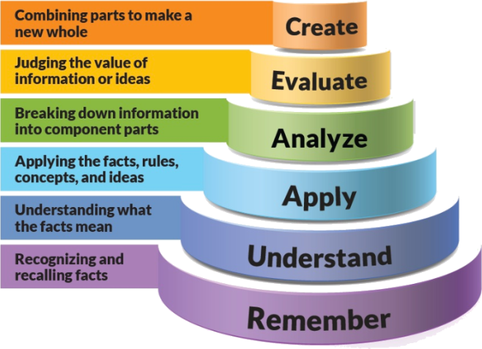
Figure 1: Blooms Taxonomy
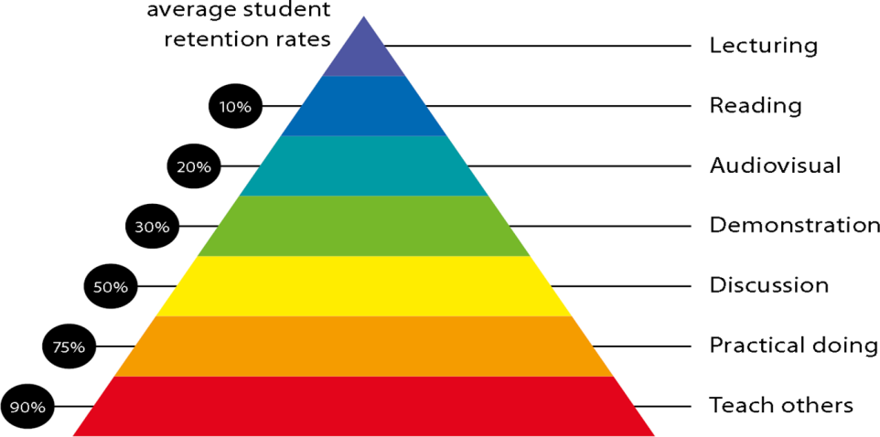
Figure 2: Knowledge retention

Graduate Qualities and Capabilities covered

General Graduate Qualities | Specific Department of ______Graduate Capabilities
Informed  Have a sound knowledge of an area of study or profession and understand its current issues, locally and internationally. Know how to apply this knowledge. Understand how an area of study has developed and how it relates to other areas. | 1 Professional knowledge, grounding & awareness
Independent learners  Engage with new ideas and ways of thinking and critically analyze issues. Seek to extend knowledge through ongoing research, enquiry and reflection. Find and evaluate information, using a variety of sources and technologies. Acknowledge the work and ideas of others. | 2 Information literacy, gathering & processing
Problem solvers  Take on challenges and opportunities. Apply creative, logical and critical thinking skills to respond effectively. Make and implement decisions. Be flexible, thorough, innovative and aim for high standards. | 4 Problem solving skills
Effective communicators  Articulate ideas and convey them effectively using a range of media. Work collaboratively and engage with people in different settings. Recognize how culture can shape communication. | 5 Written communication
 | 6 Oral communication
 | 7 Teamwork
Responsible  Understand how decisions can affect others and make ethically informed choices. Appreciate and respect diversity. Act with integrity as part of local, national, global and professional communities. | 10 Sustainability, societal & environmental impact

Lecture/tutorial times
Lecture/Practical | Timings | Room No.
Lecture
Lecture
Lecture
Practical Batch-1
Practical Batch-2

Attendance Requirements
The University norms states that it is the responsibility of students to attend all lectures, tutorials, seminars and practical work as stipulated in the Course outline. Minimum attendance requirement as per university norms is compulsory for being eligible for mid and end semester examinations.

Details of referencing system to be used in written work
- Text Books and Reference Books
- Online Resources

Text books
- Tien Chien Chang, “Computer Aided Manufacturing”, Pearson, Edition 3, 2006.
- Mikell P Groover, “Automation, Production Systems and Computer Integrated Manufacturing”, Pearson Education, Edition 4, 2015.
- S R Deb, S Deb, “Robotics Technology and Flexible Automation”, McGraw Hill Education Private Limited, Edition 4, 2009.

Additional Materials
- http://www.me.nchu.edu.tw/lab/CIM/www/courses/Computer%20Integrated%20Manufacturing/Chapter2%20-CIM-introduction.pdf – CIM Introduction
- https://www.youtube.com/watch?v=tiarT1YS-lM – Flexible Manufacturing System
- prolog.univie.ac.at/teaching/LVAs/Layout_und_Design/SS09/Skript%20insel.pdf – Group technology and Cellular Manufacturing
- http://nptel.ac.in/courses/112102101/ - Whole Syllabus

LIST OF EXPERIMENTS
No | Title | Learning Outcomes
1. | To study about CIM cases | Evolution of CIM, requirements of CIM and application of CIM
2. | To study about NC in Machine Tool | Basic knowledge and fundamentals of Machine tools and axis system
3. | To perform practical on Manual part programming for Turning | Programming and simulation of work piece produced through turning
4. | To perform practical on Manual part programming for Milling | Programming and simulation of work piece produced through milling
5. | To perform practical on Manual part programming for Parametric subroutine | Programming and simulation of work pieceusing parametric subroutine
6. | To perform practical on APT Program for Turning, Drilling & Milling | Programming and simulation of work pieceusing APT
7. | To study about Grouping of given parts for G. T. | Basic knowledge and fundamentals of group technology and different methods of classification
8. | To study about Flexible Manufacturing System | Basic knowledge and fundamentals of Flexible Manufacturing system and different types of FMS
9. | To study about Robot Technology | Basic knowledge and fundamentals of robot work volume and different grippers used in robot technology
10. | To study about Computer aided Production & Operation Management | Basic knowledge and fundamentals of CAPP and different types of CAPP

ASSESSMENT GUIDELINES
Your final course mark will be calculated from the following:
1. Theory CIE 60 marks:
a. Attendance 10 Marks
b. Assignments 20 Marks
c. Quiz 1, 2, 3 (Average of best 2) 20 Marks
d Presentation 10 Marks

2. Practical CIE 60 marks:
a. Attendance 10 Marks
b. Experiment Performance 20 Marks
c. File work + Skill Test 10 Marks
d. Poster/Chart Preparation 20 Marks

SUPPLEMENTARY ASSESSMENT

Students who receive an overall mark less than 40% in mid semester or end semester will be considered for supplementary assessment in the respective components (i.e mid semester or end semester) of semester concerned. Students must make themselves available during the supplementary examination period to take up the respective components (mid semester or end semester) and need to obtain the required minimum 40% marks to clear the concerned components.

Late Work
Late assignments will not be accepted without supporting documentation. Late submission of the reports will result in a deduction of 10% of the maximum mark per calendar day

Format
All assignments must be presented in a neat, legible format with all information sources correctly referenced. Assignment material handed in throughout the session that is not neat and legible will not be marked and will be returned to the student.

Retention of Written Work
Written assessment work will be retained by the Course coordinator/lecturer for two weeks after marking to be collected by the students.

University and Faculty Policies
Students should make themselves aware of the University and/or Faculty Policies regarding plagiarism, special consideration, supplementary examinations and other educational issues and student matters.

Plagiarism - Plagiarism is not acceptable and may result in the imposition of severe penalties. Plagiarism is the use of another person’s work, or idea, as if it is his or her own - if you have any doubts at all on what constitutes plagiarism, please consult your Course coordinator or lecturer. Plagiarism will be penalized severely.

Do not copy the work of other students.
Do not share your work with other students (except where required for a group activity or assessment)
.

Course schedule (subject to change)

Week # | Topic & contents |  | CO Addressed |  | Teaching Learning Activity (TLA)
Weeks 1 | CAM Concepts, Objectives & scope, Nature & Type of manufacturing system, Evolution, Benefits of CAM, Role of management in CAM, |  | CO1 |  | - Chalk and talk  - PowerPoint Presentations
Weeks 2 | Concepts of Computer Integrated Manufacturing, Impact of CIM on personnel, Role of manufacturing engineers, CIM Wheel to understand basic functions |  | CO1 |  | - Chalk and talk
Week 3 | NC and CNC Technology: Types, Classification, Specification and components, Construction Details, Controllers, Sensors and Actuators, CNC hardware: Re circulating ball screw, anti friction slides, step/servo motors. Axis designation, NC/CNC tooling |  | CO1 CO2 |  | - Chalk and talk  - PowerPoint Presentations
Week 4 | Fundamentals of Part programming, Types of format, Part Programming for drilling, lathe and milling machine operations, subroutines, do loops, canned Cycles, parametric sub routines. |  | CO1 CO2 |  | - Chalk and talk  - PowerPoint Presentations
Week 5 | Relay Device components, Programmable controller architecture, programming a programmable controller, tools for PLC logic design |  | CO1 CO2 |  | - Chalk and talk
Week 6 | Introduction, part families, part classification and coding systems: OPITZ, PFA, FFA, Cell design, rank order clustering, composite part concepts | CO1 CO2 |  | - Chalk and talk
Week 7 | Benefits of group technology. Approaches to Process Planning, Different CAPP system, application and benefits | CO1 CO2 |  | - Chalk and talk
Week 8 | Introduction & Component of FMS, Needs of FMS, general FMS consideration, Objectives, Types of flexibility and FMS, FMS lay out and advantages. Automated material handling system: Types and Application, Automated Storage and Retrieval System | CO4 |  | - Chalk and talk  - PowerPoint Presentations
Week 9 | Automated Guided Vehicles, Cellular manufacturing, Tool Management, Tool supply system, Tool Monitoring System, Flexible Fixturing, Flexible Assembly Systems | CO4 |  | - Chalk and talk  - PowerPoint Presentations
Week 10 | Introduction: Robot Anatomy, Laws of Robot, Human System and Robotics, Coordinate system, Specifications of Robot. | CO3 |  | - Chalk and talk  - PowerPoint Presentations
Week 11 | Power sources, actuators and Transducers, Robotic Sensors, Grippers, Robot Safety, Robot Programming and Robot Applications | CO4 |  | - Chalk and talk  - PowerPoint Presentations
Week 12 | Economic Considerations of Robotics system, Robot Kinematics and Dynamics, Robot Arm Dynamics. Concepts of Computer Vision and Machine Intelligence | CO4 |  | - Chalk and talk  - PowerPoint Presentations
Week 13 | Introduction, PPC fundamentals, Problems with PPC, MRP-I, MRP-II. | CO2, CO3
Week 14 | Just in Time philosophy: JIT & GT applied to FMS | CO3, CO4
Week 15 | concepts of Expert System in Manufacturing and Management Information System | CO3

