Name of Institute: Indus Institute of Management Studies (IIMS)

Name of Faculty: Dr.Rajesh Ojha

Course code: IMB0307
Course name: INDIAN FINANCIAL SYSTEM
Pre-requisites: Graduation
Credit points: 3 Credits
Offered Semester: III

Course Lecturer (Weeks 01 – 15)
Full name: Dr. Rajesh Ojha
Department with sitting location: IIMS , Management
Telephone: (M) 8200991625
Email:rajeshojha.mba@indusuni.ac.in
Consultation times: 4.00pm to 5.00pm

Students will be contacted throughout the Session via Mail with important information relating to this Course.

Course Objectives
By participating in and understanding all facets of this Course a student will:
To enable the students to acquire basic understanding of the structure, organization and functioning of the Financial System in India.
The course also aims at exposing the students to new financial instruments and their implications in the existing regulatory framework.

Course Outcomes (CO)
The students shall be able to:
CO1: Familiarize the structure, organization and working of financial system in India

CO2 : Understand the functioning of different financial institutions in India.

CO3: Understand the functioning of Commercial Banks in India.

CO4 : Understand the functioning of RBI in controlling Financial system in India.

CO5: Understand the different financial services available in India

CO6: Assimilate & Analyse the Importance of Indian Financial System in day to day financial management.

Course Outline
Unit-I
Introduction: (a) Financial system : Meaning, role and functions of a financial system, Organized and unorganized financial system. (b) Components: Financial Assets, Financial Intermediaries, Financial Markets (money and capital markets in India) Relevance of various interest/return rates, Regulatory framework, Financial Instruments (in brief).
Unit-II
Financial Institutions: Achievements and Limitations.
(a) Money market institutions: Meaning, Role of the Central Bank(RBI) in money markets. Commercial banks: Meaning and Functions Indigenous Financial Agencies: Bankers, Money lenders, Discount houses, Accepting houses(only meaning and features)
(b) Capital Market institutions: (Meaning and functions) Merchant Banks, Investment companies, Management Investment companies, Development banks, Mutual Funds.
(c) Special Financial Institutions: Factors for their growth (need)
Objectives and functions of: 1) IDBI (2) IFCI (3) SFCs (4) ICICI (5) EXIM Bank of India
(d) Co-operative Banking Institutions: Meaning, definition, principles, Features and Structure.
(e) Non-Banking Finance Companies: Meaning, Role, Types of NBFC services,Reclassification of NBFC’s. (f) SEBI:Introduction to SEBI ACT 115152, Main Functions of the Board.
Unit-III
(a) Capital Markets: Meaning, Role and importance, Development initiatives and reforms (in brief). Composition: Primary-Secondary
I. Primary Markets: Meaning, instruments, New Issue Market: Features, objectives and functions, Constituents or players, Problems and Recent Developments including the concept of book building. Modes of procuring long term funds: Public issue, Rights issue, Bonus issue, Private placement.
II. Secondary Markets.: Meaning, Functions of the stock exchange, Benefits to the community-investors-companies, Listing of securities and its benefits, Stock market indices, Types of dealings, types of securities traded on the Indian stock exchanges, Comparison of the three exchanges (BSE, NSE, OTCEI)
(b) Money Markets: Meaning, features of organized and unorganized money markets Instruments: Treasury Bills, Certificate of Deposits, Commercial Paper, Call money Commercial bills, Inter-corporate deposits, Inter-bank participation certificates.
Unit-IV
(a) Factoring: Meaning, Types, costs and benefits of factoring, difference between factoring and Forfeiting.
(b) Leasing: Meaning, Definition, advantages to lessor and lessee, types of leases (operating, finance, leveraged, sales and lease-back, leveraged and cross-border.)
(c) Underwriting: Meaning and benefits
(d) Credit Rating Agencies: Meaning and role of such agencies. A brief idea about : CRISIL, CARE ICRA.
(e) Others: A brief idea about : NSDL, STCI.

Method of delivery
Lectures, PPT, Assignments , Group Presentation .

Study time
Three hours per week

CO-PO Mapping (PO: Program Outcomes)

 | PO1 | PO2 | PO3 | PO4 | PO5 | PO6
CO 1 | 3 | 3 | - | 2 | 1 | -
CO 2 | 3 | 3 | - | 2 | 1 | -
CO 3 | 3 | 3 | - | 2 | 1 | -
CO 4 | 3 | 3 | - | 2 | 1 | -
CO 5 | 3 | 3 | - | 2 | 1 | -
CO 6 | - | 3 | - | 3 | - | 3

Blooms Taxonomy and Knowledge retention(For reference)
(Blooms taxonomy has been given for reference)

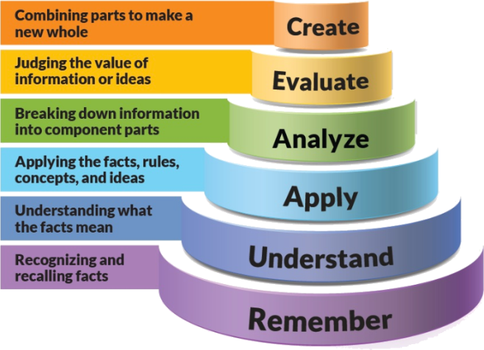
Figure 1: Blooms Taxonomy
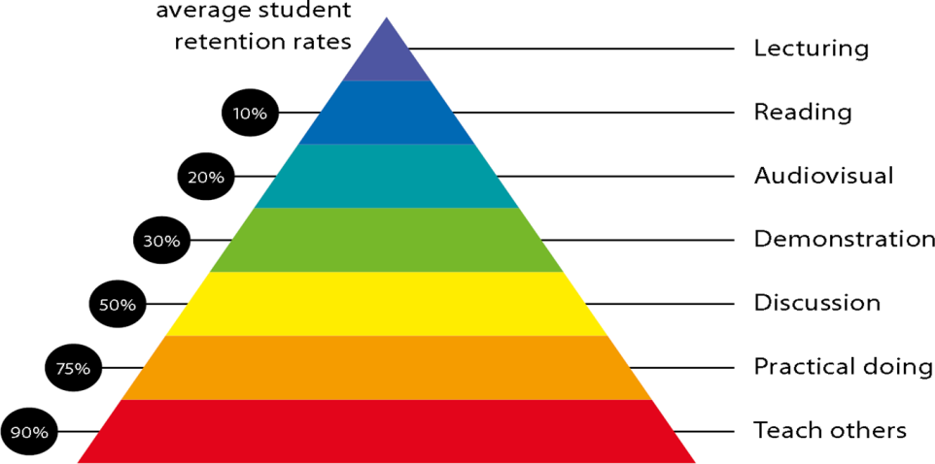
Figure 2: Knowledge retention

Graduate Qualities and Capabilities covered
(Qualities graduates harness crediting this Course)

General Graduate Qualities | Specific Department of ______Graduate Capabilities
Informed  Have a sound knowledge of an area of study or profession and understand its current issues, locally and internationally. Know how to apply this knowledge. Understand how an area of study has developed and how it relates to other areas. | 1 Professional knowledge, grounding & awareness
Independent learners  Engage with new ideas and ways of thinking and critically analyze issues. Seek to extend knowledge through ongoing research, enquiry and reflection. Find and evaluate information, using a variety of sources and technologies. Acknowledge the work and ideas of others. | 2 Information literacy, gathering & processing
Problem solvers  Take on challenges and opportunities. Apply creative, logical and critical thinking skills to respond effectively. Make and implement decisions. Be flexible, thorough, innovative and aim for high standards. | 4 Problem solving skills
Effective communicators  Articulate ideas and convey them effectively using a range of media. Work collaboratively and engage with people in different settings. Recognize how culture can shape communication. | 5 Written communication
 | 6 Oral communication
 | 7 Teamwork
Responsible  Understand how decisions can affect others and make ethically informed choices. Appreciate and respect diversity. Act with integrity as part of local, national, global and professional communities. | 10 Sustainability, societal & environmental impact

Practical work:
- ASSIGNMENT -1 Theory Questions from Unit 1
- ASSIGNMENT -2 Theory Question from Unit 1 & 2
- ASSIGNMENT -3 Group Presentations.

Lecture/tutorial times

As per the Official Time Table Circulated by the IIMS Institute.

Attendance Requirements

The University norms states that it is the responsibility of students to attend all lectures, tutorials, seminars and practical work as stipulated in the Course outline. Minimum
attendance requirement as per university norms is compulsory for being eligible for mid and end semester examinations.

Details of referencing system to be used in written work

Text books
- The Indian Financial System-Dr. Bharti Pathak, Pearson.

Additional Materials (Reference Books)

1. The Indian financial system and Development- Vasant Desai, Himalaya Publishing House.
2. Financial Markets and Institutions-Dr. S. Gurusamy,Tata McGraw Hill
3.Indian Financial System-M.Y.Khan, Mc.Graw Hill
4. Financial Management-Prasanna Chandra,
5. Financial Management-P.V.Kulkarni and Satyaprasad
6. Financial Management- I.M.Pandey, Vikas Publishing House.

ASSESSMENT GUIDELINES
Your final course mark will be calculated from the following:

- Assignment No: 1 - 5 Marks
- Assignment No: 2 - 5 Marks
- Group Presentation - 5 Marks
- Attendance - 5 Marks
- Mid Semester Exams - 40 Marks
- End Semester Exams - 40 Marks

SUPPLEMENTARY ASSESSMENT

Students who receive an overall mark less than 40% in mid semester or end semester will be considered for supplementary assessment in the respective components (i.e mid semester or end semester) of semester concerned. Students must make themselves available during the supplementary examination period to take up the respective components (mid semester or end semester) and need to obtain the required minimum 40% marks to clear the concerned components.

Practical Work Report/Laboratory Report:
A report on the practical work is due the subsequent week after completion of the class by each group.

Late Work
Late assignments will not be accepted without supporting documentation. Late submission of the reports will result in a deduction of -% of the maximum mark per calendar day

Format
All assignments must be presented in a neat, legible format with all information sources correctly referenced. Assignment material handed in throughout the session that is not neat and legible will not be marked and will be returned to the student.

Retention of Written Work
Written assessment work will be retained by the Course coordinator/lecturer for two weeks after marking to be collected by the students.

University and Faculty Policies
Students should make themselves aware of the University and/or Faculty Policies regarding plagiarism, special consideration, supplementary examinations and other educational issues and student matters.

Plagiarism - Plagiarism is not acceptable and may result in the imposition of severe penalties. Plagiarism is the use of another person’s work, or idea, as if it is his or her own - if you have any doubts at all on what constitutes plagiarism, please consult your Course coordinator or lecturer. Plagiarism will be penalized severely.

Do not copy the work of other students.
Do not share your work with other students (except where required for a group activity or assessment)
.

Course schedule(subject to change)
(Mention quiz, assignment submission, breaksetcas well in the table under the Teaching Learning Activity Column)

 | Week # | Topic & contents | CO  Addressed | Teaching Learning Activity (TLA)
 | Weeks 1 | Unit-I Introduction: (a) Financial system : Meaning, role and functions of a financial system, Organized and Un-organised financial system. | CO1 | Lecture
 | Weeks 2 | Unit-1 Components: Financial Assets, Financial Intermediaries, Financial Markets (money and capital markets in India) Relevance of various interest/return rates, Regulatory framework, Financial Instruments (in brief). | CO1 & CO2 | Lecture
 | Week 3 | Unit-II  Financial Institutions: Achievements and Limitations.  (a) Money market institutions: Meaning, Role of the Central Bank(RBI) in money markets. Commercial banks: Meaning and Functions Indigenous Financial Agencies: Bankers, Money lenders, Discount houses, Accepting houses(only meaning and features) | CO2 &CO3 | Lecture  Assignment No: 1
 | Week 4 | Unit-II (b) Capital Market institutions: (Meaning and functions) Merchant Banks, Investment companies, Management Investment companies, Development banks, Mutual Funds. | CO2 &CO3 | Lecture
 | Week 5 | Unit-II  c)Special Financial Institutions: Factors for their growth (need)  Objectives and functions of:  (1) IDBI (2) IFCI (3) SFCs (4) ICICI (5) EXIM Bank of India  (d) Co-operative Banking Institutions: Meaning, definition, principles, Features and Structure. | CO2 CO3 | Lecture
 | Week 6 | Unit -II Non-Banking Finance Companies: Meaning, Role, Types of NBFC services,Reclassification of NBFCs. (f) | CO2 ,C03 | Lecture  MCQ Class Test
 | Week 7 | Unit -II SEBI:Introduction to SEBI ACT 1952, Main Functions of the Board. | CO2 ,C03 | Lecture
 | Week 8 | IUnit-III  (a) Capital Markets: Meaning, Role and importance, Development initiatives and reforms (in brief). Composition: Primary-Secondary | CO2,CO3 | Lecture
 | Week 9 | Unit - III (b) Primary Markets: Meaning, instruments, New Issue Market: Features, objectives and functions, Constituents or players, Problems and Recent Developments including the concept of book building. Modes of procuring long term funds: Public issue, Rights issue, Bonus issue, Private placement. | CO4,C05,CO6 | Lecture  Group Presentations
 | Week 10 | Unit - III (c) Secondary Markets.: Meaning, Functions of the stock exchange, Benefits to the community-investors-companies, Listing of securities and its benefits, Stock market indices, Types of dealings, types of securities traded on the Indian stock exchanges, Comparison of the three exchanges (BSE, NSE, OTCEI) | CO4,C05,CO6 | Lecture
 | Week 11 | Mid Semester Examination | NA | NA
 | Week 12 | Unit - III (d) Money Markets: Meaning, features of organized and unorganized money markets Instruments: Treasury Bills, Certificate of Deposits, Commercial Paper, Call money Commercial bills, Inter-corporate deposits, Inter-bank participation certificates. | CO4,C05,CO6 | Lecture
 | Week 13 | Unit-IV  (a) Factoring: Meaning, Types, costs and benefits of factoring, difference between factoring and Forfeiting.  (b) Leasing: Meaning, Definition, advantages to lessor and lessee, types of leases (operating, finance, leveraged, sales and lease-back, leveraged and cross-border.) | CO4,C05,C06 | Lecture
 | Week 14 | Unit - IV  (c) Underwriting: Meaning and benefits  (d) Credit Rating Agencies: Meaning and role of such agencies.  A brief idea about : CRISIL, CARE ICRA. | CO4,C05,CO6 | Lecture
 | Week 15 | Unit IV e) Others: A brief idea about : NSDL, STCI. | CO4,C05,CO6 | Lecture

