Name of Institute: Indus Institute of Management Studies (IIMS) Name of Faculty: Dr.Rajesh Ojha

Course code: MB0422
Course name: FINANCIAL MARKETS & SERVICES
Pre-requisites: Graduation Credit points: 3 Credits Offered Semester: IV

Course Lecturer (Weeks 01 – 15)
Full name: Dr. Rajesh Ojha
Department with sitting location: IIMS , Management Telephone: (M) 8200991625 Email:rajeshojha.mba@indusuni.ac.in
Consultation times: 4.00pm to 5.00pm

Students will be contacted throughout the Session via Mail with important information relating to this Course.

Course Objectives
By participating in and understanding all facets of this Course a student will:
To enable the students to acquire basic understanding of the structure, organization and functioning of the Financial System in India.
The course also aims at exposing the students to new financial instruments and their implications in the existing regulatory framework.

Course Outcomes (CO)

The students shall be able to:

CO1: Understand the Concept of the Financial System and the Regulatory Bodies .

CO2 : Understand the various financial institutions in India.

CO3: Understand the Capital Market Operations : Primary and Secondary

CO4 : Understand the Money Market Operations & the various money market instruments.

CO5: Understand the Role of Financial Services in the Financial System.

CO6: Understand the Functioning of Specific Financial Services

Course Outline Unit-I
Financial system:

Meaning, Regulatory Structure of the Indian Financial System , Role of Financial Institutions in Economic Development , Functions of Financial Institutions and Objectives of the Financial System

Unit-II

Financial Institutions :
Reserve Bank of India , Commercial Banks , Non Banking Finance Companies , Development Financial Institutions , Insurance Companies - Life Insurance and General Insurance and Merchant Banking .

Unit-III

- Capital Markets:
- Primary Markets: Meaning, instruments, Modes of procuring long term funds: Public issue, Rights issue, Bonus issue, Private placement.

- Secondary Markets.: Meaning, Functions of the stock exchange, Stock market indices, Types of dealings, types of securities traded on the Indian stock exchanges.

- Money Markets: Meaning, Instruments: Treasury Bills, Certificate of Deposits, Commercial Paper, Call money Commercial bills, Inter-corporate deposits, Inter-bank participation certificates.

Unit-IV

Overview of Financial Services Industry. Coverage: Introduction/Concept of Financial Services, and Types of Financial Services. Focus on fee based financial services only.

Unit - V
Financial Services :
Factoring and Forfeiting , Housing Finance Companies , Leasing and Hire Purchase and Venture Capital

Method of delivery
Lectures, PPT, Assignments , Group Presentation .

Study time
Three hours per week

CO-PO Mapping (PO: Program Outcomes)

 | PO1 | PO2 | PO3 | PO4 | PO5 | PO6
CO 1 | 3 | - | 2 | - | 1 | -
CO 2 | 3 | - | 2 | - | 1 | -
CO 3 | 3 | - | 2 | 2 | 1 | -
CO 4 | 3 | - | 2 | 2 | 1 | -
CO 5 | 3 | - | 2 | 2 | 1 | 2
CO 6 | 3 | - | 2 | - | 1 | -

Blooms Taxonomy and Knowledge retention(For reference)
(Blooms taxonomy has been given for reference)

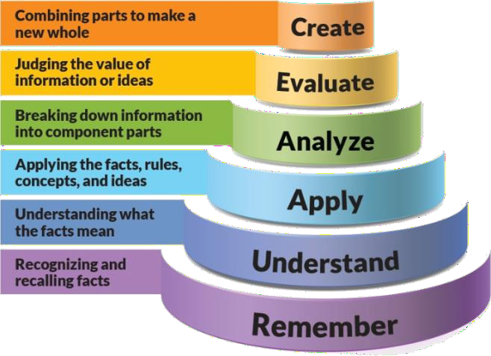
Figure 1: Blooms Taxonomy
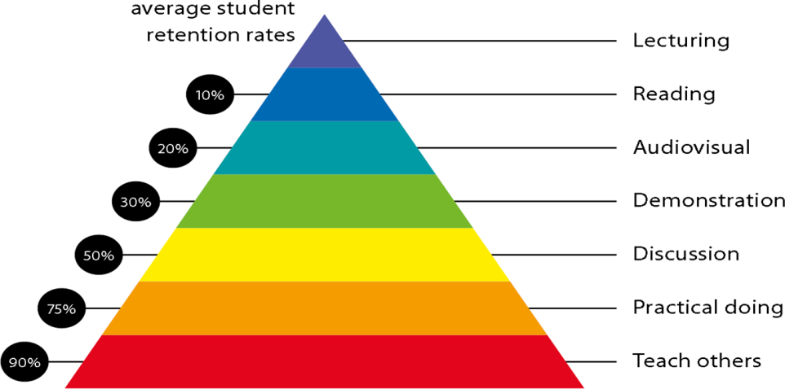
Figure 2: Knowledge retention

Graduate Qualities and Capabilities covered
(Qualities graduates harness crediting this Course)

General Graduate Qualities | Specific Department of Graduate Capabilities
Informed  Have a sound knowledge of an area of study or profession and understand its current issues, locally and internationally. Know how to apply this knowledge.  Understand how an area of study has developed and how it relates to other areas. | 1 Professional knowledge, grounding & awareness

Independent learners  Engage with new ideas and ways of thinking and critically analyze issues. Seek to extend knowledge through ongoing research, enquiry and reflection. Find and evaluate information, using a variety of sources and technologies.  Acknowledge the work and ideas of others. | 2 Information literacy, gathering & processing
Problem solvers  Take on challenges and opportunities. Apply creative, logical and critical thinking skills to respond effectively. Make and implement decisions. Be flexible, thorough, innovative and aim for high standards. | 4 Problem solving skills
Effective communicators  Articulate ideas and convey them effectively using a range of media. Work collaboratively and engage with people in different settings. Recognize how culture can shape communication. | 5 Written communication
 | 6 Oral communication
 | 7 Teamwork
Responsible  Understand how decisions can affect others and make ethically informed choices. Appreciate and respect diversity. Act with integrity as part of local, national, global and professional communities. | 10 Sustainability, societal & environmental impact

Practical work:
  - ASSIGNMENT -1 Theory Questions from Unit 1
  - ASSIGNMENT -2 Theory Question from Unit 1 & 2
  - ASSIGNMENT -3 Group Presentations.

Lecture/tutorial times

As per IIMS Time Table .

Attendance Requirements

The University norms states that it is the responsibility of students to attend all lectures, tutorials, seminars and practical work as stipulated in the Course outline. Minimum attendance requirement as per university norms is compulsory for being eligible for mid and end semester examinations.

Details of referencing system to be used in written work

Text books
1.The Indian financial system and Development- Vasant Desai, Himalaya Publishing House.

Additional Materials (Reference Books)

1. Financial Markets and Institutions-Dr. S. Gurusamy,Tata McGraw Hill 2.Indian Financial System-M.Y.Khan, Mc.Graw Hill
- Financial Management-Prasanna Chandra,
- Financial Management-P.V.Kulkarni and Satyaprasad
- Financial Management- I.M.Pandey, Vikas Publishing House.

ASSESSMENT GUIDELINES
Your final course mark will be calculated from the following:

- Assignment No: 1 - 5 Marks
- MCQ Class Test - 5 Marks
- Group Presentation - 5 Marks
- Attendance - 5 Marks
- Mid Semester Exams - 40 Marks
- End Semester Exams - 40 Marks

SUPPLEMENTARY ASSESSMENT

Students who receive an overall mark less than 40% in mid semester or end semester will be considered for supplementary assessment in the respective components (i.e mid semester or end semester) of semester concerned. Students must make themselves available during the supplementary examination period to take up the respective components (mid semester or end semester) and need to obtain the required minimum 40% marks to clear the concerned components.

Practical Work Report/Laboratory Report:
A report on the practical work is due the subsequent week after completion of the class by each group.

Late Work
Late assignments will not be accepted without supporting documentation. Late submission of the reports will result in a deduction of -% of the maximum mark per calendar day

Format
All assignments must be presented in a neat, legible format with all information sources correctly referenced. Assignment material handed in throughout the session that is not neat and legible will not be marked and will be returned to the student.

Retention of Written Work
Written assessment work will be retained by the Course coordinator/lecturer for two weeks after marking to be collected by the students.

University and Faculty Policies
Students should make themselves aware of the University and/or Faculty Policies regarding plagiarism, special consideration, supplementary examinations and other educational issues and student matters.

Plagiarism - Plagiarism is not acceptable and may result in the imposition of severe penalties. Plagiarism is the use of another person’s work, or idea, as if it is his or her own
- if you have any doubts at all on what constitutes plagiarism, please consult your Course coordinator or lecturer. Plagiarism will be penalized severely.

Do not copy the work of other students.
Do not share your work with other students (except where required for a group activity or assessment)

.

Course schedule(subject to change)

(Mention quiz, assignment submission, breaksetcas well in the table under the Teaching Learning Activity Column)

 | Week # | Topic & contents | CO  Addresse d | Teaching Learning Activity (TLA)
 | Weeks 1 | UNIT- 1  Financial system:  Meaning, Regulatory Structure of the Indian Financial System , Role of Financial Institutions in Economic Development | CO1 | Lecture
 | Weeks 2 | UNIT -1  Functions of Financial Institutions and Objectives of the Financial System | CO1 | Lecture
 | Week 3 | UNIT- 2  Financial Institutions :  Reserve Bank of India , Commercial Banks  , Non Banking Finance Companies , | C03 | Lecture  Assignment No: 1
 | Week 4 | UNIT- 2  Financial Institutions :  Development Financial Institutions , Insurance Companies - Life Insurance and General Insurance and Merchant Banking . | C03 | Lecture
 | Week 5 | UNIT-III  (a)Capital Markets: | CO3 | Lecture

 |  | I. Primary Markets: Meaning, instruments, Modes of procuring long term funds: Public issue, Rights issue, Bonus issue, Private placement.
 | Week 6 | UNIT-III  (a)Capital Markets:  I. Primary Markets: Meaning, instruments, Modes of procuring long term funds: Public issue, Rights issue, Bonus issue, Private placement. | C03 | Lecture
 | Week 7 | UNIT-III  II. Secondary Markets.: Meaning, Functions of the stock exchange, Stock market indices, Types of dealings, types of securities traded on the Indian stock exchanges. | C03 | Lecture
 | Week 8 | UNIT-III  II. Secondary Markets.: Meaning, Functions of the stock exchange, Stock market indices, Types of dealings, types of securities traded on the Indian stock exchanges. | CO3 | Lecture  Assignment No: 2
 | Week 9 | UNIT-III  (b) Money Markets: Meaning, Instruments: Treasury Bills, Certificate of Deposits, Commercial Paper, Call money Commercial bills, Inter-corporate deposits, Inter-bank participation certificates. | CO4 | Lecture
 | Week 10 | UNIT-III  (b) Money Markets: Meaning, Instruments: Treasury Bills, Certificate of Deposits, Commercial Paper, Call money Commercial bills, Inter-corporate deposits, Inter-bank participation certificates. | CO4 | Lecture

 | Week 11 | Mid Semester Examination | NA | NA
 | Week 12 | UNIT -IV  Overview of Financial Services Industry. Coverage: Introduction/Concept of Financial Services, and Types of Financial Services. Focus on fee based financial services only. | C05,CO6 | Lecture
 | Week 13 | UNIT -V  Financial Services :  Factoring and Forfeiting , Housing Finance Companies , Leasing and Hire Purchase and Venture Capital | C05,C06 | Lecture  Assignment No: 3
 | Week 14 | UNIT -V  Financial Services :  Factoring and Forfeiting , Housing Finance Companies , Leasing and Hire Purchase and Venture Capital | C05,CO6 | Lecture
 | Week 15 | Revision |  | Lecture

