Name of Institute: Indus Institute of Management Studies (IIMS) Name of Faculty: Dr Rajesh Ojha

Course code: MB0402
Course name: MANAGEMENT CONTROL SYSTEMS
Pre-requisites: Graduation Credit points : 3 Credits Offered Semester: IV

Course Lecturer (Weeks 01 – 15)
Full name: Dr. Rajesh Ojha
Department with sitting location: IIMS - Management Telephone: (M) 8200991625
Email: rajeshojha.mba@indusuni.ac.in Consultation times: 4.00pm to 5.00pm

Students will be contacted throughout the Session via Mail with important information relating to this Course.

Course Objectives

To inculcate the awareness about control systems in the business management environment

Course Outcomes (CO)

CO1 : Have a Conceptual Understanding of Management Control both formal and informal.

CO2 : Understand the Role of a Controller and the Concept of Responsibility Centre , Profit Centre and Cost Centre.
CO3 : Acquire knowledge of Transfer Pricing and the Various Methods of Transfer Pricing
.
CO4 Understand the Importance of Budgets , Budget Preparation Process and Variance Analysis.
CO5 : Have an understanding of the Various Service Organizations
CO6 : Analyse the Various Issues involved in the operation of Multinational Organizations.

Course Outline
UNIT-I
Boundaries of management control, formal and informal, control system, functions of the controller, responsibility centre, revenue centre expense centre administration and R & D centres and marketing centres

UNIT-II
Business unit as profit centre, other profit centre and measuring profitability
Transfer pricing methods and their objectives, ,Pricing Corporate services administration of transfer prices

UNIT-III
EVA v/s ROI
Budget preparation nature and budget preparation process Variance analysis and limitation of variance analysis

UNIT-IV
Performance measurement and interactive control ,Organizational incentives, incentive compensation plans. Incentives for corporate Officers and Business units managers, Professional , Financial Services organization , Health care Organization Non-profit organizations

UNIT-V
Multinational Organizations, Transfer Pricing Exchange rates Nature of project , Project planning execution and evaluation

Method of delivery
Lectures, Power Point Presentations , Case studies, Assignments and Student Presentations .

Study time
Three hours per week

CO-PO Mapping (PO: Program Outcomes)

 | PO1 | PO2 | PO3 | PO4 | PO5 | PO6
CO 1 | 3 | - | - | - | 1 | -
CO 2 | 3 | 2 | - | - | - | -
CO 3 | 3 | - | 2 | - | 2 | -
CO 4 | 3 | 2 | 2 | - | - | 3
CO 5 | 3 | - | - | - | - | -
CO 6 | 3 | - | - | 3 | 1 | -

Blooms Taxonomy and Knowledge retention(For reference)
(Blooms taxonomy has been given for reference)

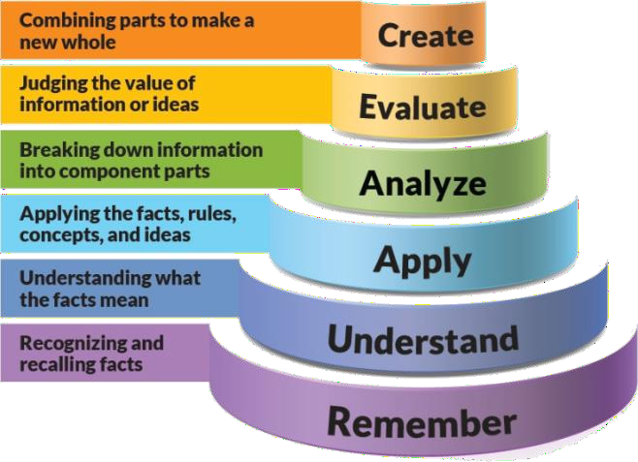
Figure 1: Blooms Taxonomy

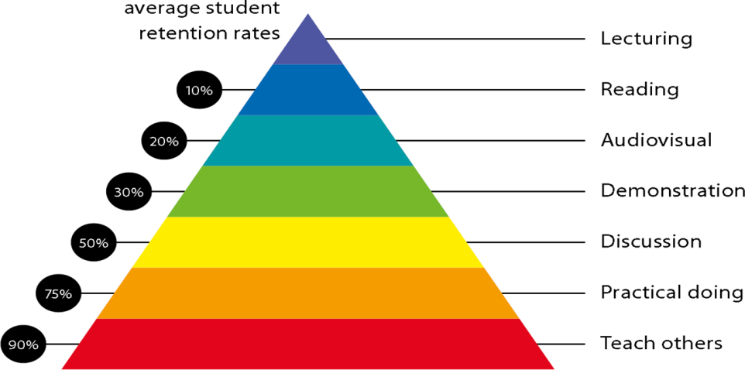
Figure 2: Knowledge retention

Graduate Qualities and Capabilities covered
(Qualities graduates harness crediting this Course)

General Graduate Qualities | Specific Department of Graduate Capabilities
Informed  Have a sound knowledge of an area of study or profession and understand its current issues, locally and internationally. Know how to apply this knowledge.  Understand how an area of study has developed and how it relates to other areas. | 1 Professional knowledge, grounding & awareness
Independent learners  Engage with new ideas and ways of thinking and critically analyze issues. Seek to extend knowledge through ongoing research, enquiry and reflection. Find and evaluate information, using a variety of sources and technologies.  Acknowledge the work and ideas of others. | 2 Information literacy, gathering & processing
Problem solvers  Take on challenges and opportunities. Apply creative, logical and critical thinking skills to respond effectively. Make and  implement decisions. Be flexible, | 4 Problem solving skills

thorough, innovative and aim for high standards.
Effective communicators  Articulate ideas and convey them effectively using a range of media. Work collaboratively and engage with people in different settings. Recognize how culture can shape communication. | 5 Written communication
 | 6 Oral communication
 | 7 Teamwork
Responsible  Understand how decisions can affect others and make ethically informed choices. Appreciate and respect diversity. Act with integrity as part of local, national, global and professional communities. | 10 Sustainability, societal & environmental impact

Practical work:
- ASSIGNMENT -1 Theory Question from Unit No:1
- ASSIGNMENT -2 Theory Question Unit 1 or Unit 2
- ASSIGNMENT -3 Theory Question from Unit 3 or Unit 4

Lecture and Tutorial Times
As per IIMS Time Table .

Attendance Requirements
The University norms states that it is the responsibility of students to attend all lectures, tutorials, seminars and practical work as stipulated in the Course outline. Minimum attendance requirement as per university norms is compulsory for being eligible for mid and end semester examinations.

Details of referencing system to be used in written work Text books
1. Robert N. Anthony, Vijay Govindrajan, Management Control Systems, Tata M/c graw Hill , Special Indian 12 edition

Additional Materials (Reference Books)
- Pro.Mahesh S. Halale, Management control systems, Everest Publishing House, First edition, 2006
- N. Ghosh, Management Control Systems, Prentice hall of India Pvt Ltd, New Delhi Second Printing, 2006
- Subhash Sharma, Management Control systems- text and cases, Tata McgrawHill, 1988

ASSESSMENT GUIDELINES

1. Assignment No: 1 | - | 5 | Marks
2. Assignment No: 2 | - | 5 | Marks
3. Assignment No: 3 | - | 5 | Marks
4. Attendance | - | 5 | Marks
- Mid Semester Exams 40 Marks
- End Semester Exam 40 Marks

Your final course mark will be calculated from the following:

SUPPLEMENTARY ASSESSMENT

Students who receive an overall mark less than 40% in mid semester or end semester will be considered for supplementary assessment in the respective components (i.e mid semester or end semester) of semester concerned. Students must make themselves available during the supplementary examination period to take up the respective components (mid semester or end semester) and need to obtain the required minimum 40% marks to clear the concerned components.

Practical Work Report/Laboratory Report:
A report on the practical work is due the subsequent week after completion of the class by each group.

Late Work
Late assignments will not be accepted without supporting documentation. Late submission of the reports will result in a deduction of -% of the maximum mark per calendar day

Format
All assignments must be presented in a neat, legible format with all information sources correctly referenced. Assignment material handed in throughout the session that is not neat and legible will not be marked and will be returned to the student.

Retention of Written Work
Written assessment work will be retained by the Course coordinator/lecturer for two weeks after marking to be collected by the students.

University and Faculty Policies
Students should make themselves aware of the University and/or Faculty Policies regarding plagiarism, special consideration, supplementary examinations and other educational issues and student matters.

Plagiarism - Plagiarism is not acceptable and may result in the imposition of severe penalties. Plagiarism is the use of another person’s work, or idea, as if it is his or her own
- if you have any doubts at all on what constitutes plagiarism, please consult your Course coordinator or lecturer. Plagiarism will be penalized severely.

Do not copy the work of other students.
Do not share your work with other students (except where required for a group activity or assessment)

.

Course schedule(subject to change)
(Mention quiz, assignment submission, breaksetcas well in the table under the Teaching Learning Activity Column)

 | Week # | Topic & contents | CO  Addressed | Teaching Learning Activity (TLA)
 | Weeks 1 | UNIT I :  Boundaries of management control, formal and informal, control system, functions of the controller, | CO1, | Lecture
 | Weeks 2 | UNIT 1  Responsibility Centre , Revenue Centre , Expense Centre, R & D Centre and Marketing Centre | CO1,CO2 | Lecture
 | Week 3 | UNIT-II  Business unit as profit centre, other profit centre and measuring profitability | CO1, CO2 | Lecture Assignment No:1
 | Week 4 | Unit II  Transfer pricing methods and their objectives, | CO1, CO3 | Lecture
 | Week 5 | Unit II  Pricing Corporate services administration of transfer prices | CO1, CO3 | Lecture
 | Week 6 | UNIT-III  EVA v/s ROI | CO1,CO4 | Lecture

 | Week 7 | Unit III  Budget preparation nature and budget preparation process | CO1,CO4 | Lecture
 | Week 8 | Unit III  Variance analysis and limitation of variance analysis | CO1,CO4 | Lecture  Assignment No:2
 | Week 9 | UNIT-IV  Performance measurement and interactive control , | CO1,CO4 | Lecture
 | Week 10 | UNIT-IV  Organizational incentives, incentive compensation plans. Incentives for corporate Officers and Business units managers | CO1,CO4 | Lecture
 | Week 11 | MID SEM EXAMS | NA | NA
 | Week 12 | UNIT IV  Professional , Financial Services , Health care and Non Profit Organization | CO1,CO5 | Lecture
 | Week 13 | Unit V  Multinational Organizations | CO1,CO6 | Lecture Assignment No: 3
 | Week 14 | Unit V  Transfer Pricing Exchange rates  Nature of project , Project planning execution and evaluation | CO1,CO6 | Lecture

 | Week 15 | REVISION BEFORE ESE |  | Lecture

