Name of Institute: Indus Institute of Management Studies

Name of Faculty: Nirali Dave

Course code: MB0421
Course name: Financial Derivatives
Pre-requisites:
Credit points: 3
Offered Semester: MBA IV

Course Coordinator (weeks 1 - 15)
Full Name: Nirali Parth Dave
Department with siting location: Management
Telephone: 9428609964
Email: niralidave.mba@indusuni.ac.in
Consultation times: 2.00 PM to 4.00 PM

Course Lecturer (weeks 1 - 15)
Full name: Nirali Parth Dave
Department with siting location: Management
Telephone: 9428609964
Email: niralidave.mba@indusuni.ac.in
Consultation times: 2.00 PM to 4.00 PM

Students will be contacted throughout the Session via Mail with important information relating to this Course.
Course Objectives
By participating in and understanding all facets of this Course a student will:

- to equip students with the ability to apply stock market basics to Indian Derivative market. Financial Derivatives are discussed in terms of their valuation, analysis & application for hedging, speculation & arbitrage.
- Students are appraised with the recent innovations in derivatives in India unlike other countries. At the end of the course, they are expected to have learnt the mechanics, valuation & trading strategies of derivative market. They are also required to frame their own trading strategies in this volatile market.
Course Outcomes (CO)

Co1 Have a good understanding of derivative securities
Co2 Acquire knowledge of how forward contracts, futures contracts, swaps and options work, how they are used and how they are priced
Co3 Be able to describe and explain the fundamental features of a range of key financial derivative instruments
Co4 Be able to decide which securities to use for hedging and/or speculative purposes
Co5 Knowledge on different types of trading strategies.
Co6 Knowledge on the exotic options, Greek options and commodity derivatives.

CO- PO Mapping :

 | PO1 | PO2 | PO3 | PO4 | PO5 | PO6
CO 1 | 1 | 2 | - | - | - | 1
CO 2 | - | - | - | - | - | -
CO 3 | 1 | 1 | - | 2 | - | 2
CO 4 | - | 2 | - | 2 | - | -
CO 5 | 3 | - | - | 2 | - | 1
CO6 | - | - | - | - | - | -

Course Outline
Course Content:
Unit- 1 Introduction to risk management ,introduction to derivatives, Derivative market- (derivative exchanges, trading process, margins, clearing and settlement, regulatory framework) , Factors contributing to the growth of derivatives - functions of derivative markets - Exchange traded versus OTC derivatives -traders in derivatives markets - Derivatives market in India .
Unit- 2 Futures and forwards - differences-valuation of futures, valuation of long and short forward contract. Mechanics of buying & selling futures, Margins, Hedging using futures -specification of futures - Commodity futures, Index futures, interest rate futures – arbitrage opportunities.
Unit- 3 Financial Swaps - features and uses of swaps - Mechanics of interest rate swaps – valuation of interest rate swaps – currency swaps – valuation of currency swaps
Unit- 4 Options: Types of options, option pricing, factors affecting option pricing – call and put options on dividend and non-dividend paying stocks put-call parity - mechanics of options -stock options - options on stock index - options on futures – interest rate options. Concept of exotic option. Hedging & Trading strategies involving options, valuation of option: basic model, one step binomial model, Black and Scholes Model, option Greeks. Arbitrage profits in options.
Unit-5
Commodity derivatives: commodity futures market-exchanges for commodity futures in India, Forward Market Commissions and regulation-commodities traded – trading and settlements – physical delivery of commodities
Interest rate markets - Type of rates, Zero rates, Bond pricing, Determining Zero rates, Forward rules, Forward rate agreements (FRA), Treasury bond & Treasury note futures, Interest rate derivatives.

Method of delivery
(Face to face lectures, self study material, Active Learning Techniques)

Study time
( 3 Hours Per Week )

Blooms Taxonomy and Knowledge retention (For reference)
(Blooms taxonomy has been given for reference)

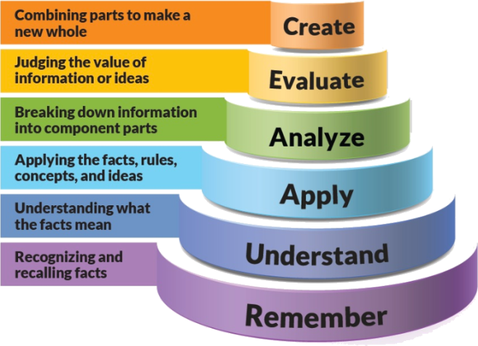
Figure 1: Blooms Taxonomy
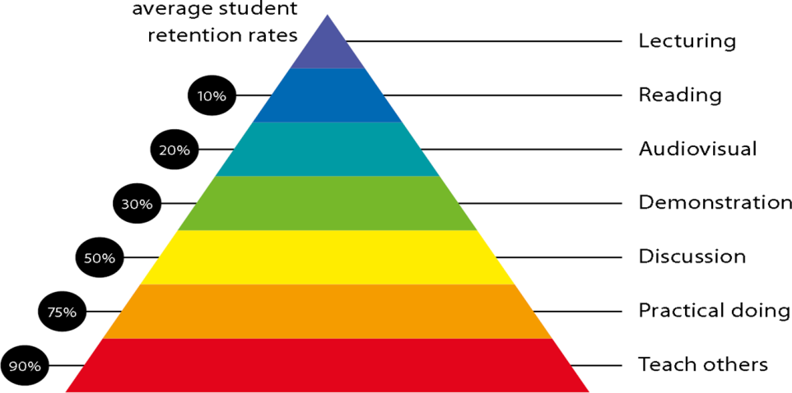
Figure 2: Knowledge retention

Graduate Qualities and Capabilities covered
(Qualities graduates harness crediting this Course)

General Graduate Qualities | Specific Department of Management Graduate Capabilities
Informed  Disciplinary Knowledge  Project Management | 1 Professional knowledge, grounding & awareness
Independent learners  Solution to the problem’s adjustments | 2 Information literacy, gathering & processing
Thinking • critical • creative • practical | 4 Problem solving skills
Responsible  Learning • capacity for life-long learning • flexibility • adaptability | 10 Sustainability, societal & environmental impact

Responsible  Learning • capacity for life-long learning • flexibility • adaptability | 10 Sustainability, societal & environmental impact

Practical work:
(Students Shall be given assignments to demonstrate the following skills)
- ASSIGNMENT -1 Theory and sums questions from unit 1 and unit 2

Lecture/tutorial times

Lecture Monday 2.05-3.05pm LH36

Lecture/Tutorial Wednesday 2.05-3.05pm LH36

Lecture Friday 2.05-3.05pm LH36

Attendance Requirements

The University norms states that it is the responsibility of students to attend all lectures, tutorials, seminars and practical work as stipulated in the Course outline. Minimum attendance requirement as per university norms is compulsory for being eligible for mid and end semester examinations.

Details of referencing system to be used in written work

Text books
- Vohra& Bagri, Futures and Options, Tata McGraw hill, Latest Edition
John C. Hull, Futures and Option Markets, Pearson Education, Latest EditionYour final course
Example:
Assignment 1 15% (week 4) Objective (1-3)
Attendance 5%
Mid semester 40% (due week 11)
Final exam (closed book) 40%

mark will be calculated from the following:
Bloom’s Category Marks (out of 60)  ( Internal Evaluation) | Test  (40) | Assignments  (20) | Attendance (5)
Remember
Understand | 10 | 10
Apply | 10
Analyze | 10
Evaluate | 10
Create |  | 10

SUPPLEMENTARY ASSESSMENT

Students who receive an overall mark less than 50% in mid semester or end semester will be considered for supplementary assessment in the respective components (i.e mid semester or end semester) of semester concerned. Students must make themselves available during the supplementary examination period to take up the respective components (mid semester or end semester) and need to obtain the required minimum 50% marks to clear the concerned components.

Practical Work Report/Laboratory Report:
A report on the practical work is due the subsequent week after completion of the class by each group.

Late Work
Late assignments will not be accepted without supporting documentation. Late submission of the reports will result in a deduction of 5% of the maximum mark per calendar day
Format
All assignments must be presented in a neat, legible format with all information sources correctly referenced. Assignment material handed in throughout the session that is not neat and legible will not be marked and will be returned to the student.

Retention of Written Work
Written assessment work will be retained by the Course coordinator/lecturer for two weeks after marking to be collected by the students.

University and Faculty Policies
Students should make themselves aware of the University and/or Faculty Policies regarding plagiarism, special consideration, supplementary examinations and other educational issues and student matters.

Plagiarism - Plagiarism is not acceptable and may result in the imposition of severe penalties. Plagiarism is the use of another person’s work, or idea, as if it is his or her own - if you have any doubts at all on what constitutes plagiarism, please consult your Course coordinator or lecturer. Plagiarism will be penalized severely.

Do not copy the work of other students.
Do not share your work with other students (except where required for a group activity or assessment)

Course schedule (subject to change)
(Mention quiz, assignment submission, breaks etc as well in the table under the Teaching Learning Activity Column)

 | Week # | Topic & contents |  | CO Addressed |  | Teaching Learning Activity (TLA)
 | Weeks 1 | Introduction to risk management ,introduction to derivatives, Derivative market- (derivative exchanges, trading process, margins, clearing and settlement, regulatory framework) , Factors contributing to the growth of derivatives - functions of derivative markets - Exchange traded versus OTC derivatives -traders in derivatives markets - Derivatives market in India . |  | CO1 |  | Face to face lecture delivery
 | Weeks 2 | Futures and forwards - differences-valuation of futures, valuation of long and short forward contract. Mechanics of buying & selling futures, Margins, |  | CO2 |  | Presentation and face to face lecture delivery
 | Week 3 | Hedging using futures specification of futures Commodity futures, Index futures, interest rate futures – arbitrage opportunities. |  | CO2 |  | Presentation and face to face lecture delivery
 | Week 4 | Financial Swaps - features and uses of swaps - Mechanics of interest rate swaps |  | CO3 |  | Face to face lecture delivery
 | Week 5 | valuation of interest rate swaps – currency swaps – valuation of currency swaps |  | CO3 |  | Face to face lecture delivery
 | Week 6 | valuation of interest rate swaps – currency swaps – valuation of currency swaps |  | CO3 | Face to face lecture delivery
 | Week 7 | Introductions to binomial tree, valuing stock options |  | CO4,CO5 | Lecture delivery
 | Week 8 | Options: Types of options, option pricing, factors affecting option pricing – call and put options on dividend and non-dividend paying stocks put-call parity |  | CO4,CO5 | lecture
 | Week 9 | Mechanics of options -stock options - options on stock index - options on futures – interest rate options. |  | C04 | Presentation and face to face lecture delivery
 | Week 10 | Concept of exotic option. Hedging & Trading strategies involving options, Arbitrage profits in options. |  | C04,CO5 | Presentation and lecture
 | Week 11 | Mid Sem Exam
 | Week 12 | Commodity derivatives: commodity futures market-exchanges for commodity futures in India, |  | C06 | Presentation and face to face lecture delivery
 | Week 13 | Forward Market Commissions and regulation-commodities traded – trading and settlements – physical delivery of commodities |  | C06 | Presentation and face to face lecture delivery
 | Week 14 | Interest rate markets - Type of rates, Zero rates, Bond pricing, Determining Zero rates, |  | C06 | Presentation and face to face lecture delivery
 | Week 15 | Forward rules, Forward rate agreements (FRA), Treasury bond & Treasury note futures, Interest rate derivatives. |  | C06 | Presentation and face to face lecture delivery

