Name of Institute: Indus Institute of Management Studies (IIMS) Name of Faculty: Dr Rajesh Ojha

Course code: IMB0407

Course name: PROJECT MANAGEMENT
Pre-requisites: Graduation Credit points : 4 Credits Offered Semester: IV

Course Lecturer (Weeks 01 – 15)
Full name: Dr. Rajesh Ojha
Department with sitting location: IIMS - Management Telephone: (M) 8200991625
Email: rajeshojha.mba@indusuni.ac.in Consultation times: 4.00pm to 5.00pm

Students will be contacted throughout the Session via Mail with important information relating to this Course.

Course Objectives
The course aims to acquaint the students with the Project management concepts, techniques and practicality of handling a project.

Course Outcomes (CO)

CO1 : Have a Conceptual Understanding of Project Management & its various techniques

CO2 : Understand Project Scheduling and Execution.
CO3 : Understand the Importance of Project Quality Management and the Role of TQM in Project Management
CO4 : Understand Measurement of Performance and Cost Controls in Projects CO5 : Understand the Process of Project Closure and the Role of Project Teams C06 Be Aware of Various Issues involved in International Projects Execution

Course Outline
Unit-I
Project Management Concepts: Concept and characteristics of a project, importance of project management, types of project, project organizational structure, project life cycle, Statement of Work, Work Breakdown Structure.
Project Planning: Project Planning and Scheduling techniques: developing the project network USING CPM/PERT, constructing network diagram, AON basics, Forward Pass and backward pass, Limitations of CPM/PERT, Precedence Diagramming Method, constructing diagram and computations using precedence diagramming method, PERT/CPM simulation, reducing project duration.

Unit-II
Resource Scheduling: Resource allocation method, splitting and multitasking, Multi project resources scheduling
Critical Chain Scheduling: Concept of critical chain scheduling; critical chain scheduling method, application of Critical chain scheduling and limitations

Unit-III
Project Quality Management: Concept of project quality, responsibility for quality in projects, quality management at different stages of project, tools and techniques, Quality Management Systems, TQM in projects.

Project performance Measurement and Control: Monitor and assess project performance, schedule, and cost. Earned value Management, performance measurement. Methods to monitor, evaluate, and control planned cost and schedule performance.

Unit-IV
Project Closure/ Termination: Meaning of closure/ termination, project audit process, termination steps, final closure.

Managing Project Teams: Team development process, team building process, stages in developing high performance project tea pitfalls.

International Projects: Issues in managing international projects, Selection and training of employees, cross cultural considerations
MS Projects

Method of delivery
Lectures, Power Point Presentations , Case studies, Assignments and Student Presentations .

Study time
Four hours per week

CO-PO Mapping (PO: Program Outcomes)

 | PO1 | PO2 | PO3 | PO4 | PO5 | PO6
CO 1 | 3 | - |  | - | - | -
CO 2 | 3 | 2 | 2 | - | - | -
CO 3 | 3 | - | - | - | 2 | -
CO 4 | 3 | - | 2 | - | 2 | 2
CO 5 | 3 | 2 | - | - | - | 2
CO 6 | 3 | - | - | 2 | - | -

Blooms Taxonomy and Knowledge retention(For reference)
(Blooms taxonomy has been given for reference)

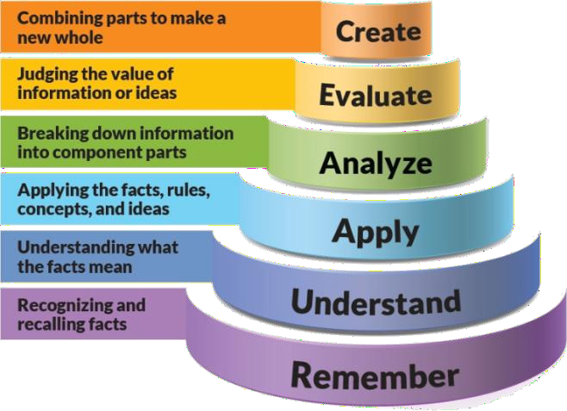

Figure 1: Blooms Taxonomy
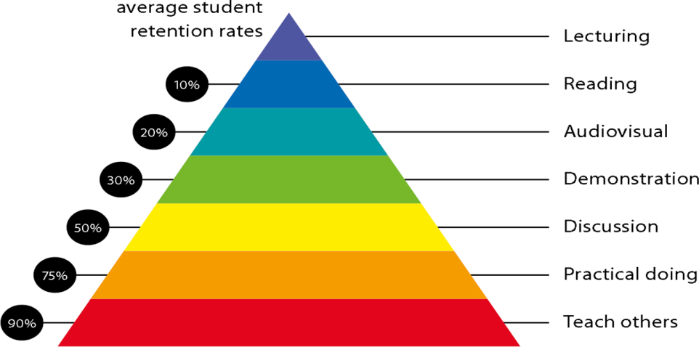
Figure 2: Knowledge retention

Graduate Qualities and Capabilities covered
(Qualities graduates harness crediting this Course)

General Graduate Qualities | Specific Department of Graduate Capabilities
Informed  Have a sound knowledge of an area of study or profession and understand its current issues, locally and internationally. Know how to apply this knowledge.  Understand how an area of study has developed and how it relates to other areas. | 1 Professional knowledge, grounding & awareness

Independent learners  Engage with new ideas and ways of thinking and critically analyze issues. Seek to extend knowledge through ongoing research, enquiry and reflection. Find and evaluate information, using a variety of sources and technologies.  Acknowledge the work and ideas of others. | 2 Information literacy, gathering & processing
Problem solvers  Take on challenges and opportunities. Apply creative, logical and critical thinking skills to respond effectively. Make and implement decisions. Be flexible, thorough, innovative and aim for high standards. | 4 Problem solving skills
Effective communicators  Articulate ideas and convey them effectively using a range of media. Work collaboratively and engage with people in different settings. Recognize how culture can shape communication. | 5 Written communication
 | 6 Oral communication
 | 7 Teamwork
Responsible  Understand how decisions can affect others and make ethically informed choices. Appreciate and respect diversity. Act with integrity as part of local, national, global and professional communities. | 10 Sustainability, societal & environmental impact

Practical work:
- ASSIGNMENT -1 Theory Question from Unit No:1
- ASSIGNMENT -2 Theory Question Unit 1 or Unit 2
- ASSIGNMENT -3 Theory Question from Unit 3 or Unit 4

Lecture and Tutorial Times
As per Time Table of IIMS .

Attendance Requirements
The University norms states that it is the responsibility of students to attend all lectures, tutorials, seminars and practical work as stipulated in the Course outline. Minimum attendance requirement as per university norms is compulsory for being eligible for mid and end semester examinations.

Details of referencing system to be used in written work Text books
- Clifford F Gray, Erik W Larson, “Project Management-The Managerial Process” Tata Mcgraw-
Hill Publishing Co Ltd

Additional Materials (Reference Books)
- Jack Meredith, Samuel J. Mantel Jr. “Project Management- A Managerial Approach” John Wiley and Sons
- John M Nicholas “Project Management For BusinessAnd Technology” Prentice Hall Of India Pvt Ltd
- James P Lewis “Project Planning, Scheduling And Control” Tata Mcgraw-Hill Publishing Co Ltd Project Management Institute Guidelines

ASSESSMENT GUIDELINES

1. Assignment No: 1 | - | 5 | Marks
2. Assignment No: 2 | - | 5 | Marks
3. Assignment No: 3 | - | 5 | Marks
4. Attendance | - | 5 | Marks

- Mid Semester Exams 40 Marks
- End Semester Exam 40 Marks

Your final course mark will be calculated from the following:

SUPPLEMENTARY ASSESSMENT

Students who receive an overall mark less than 40% in mid semester or end semester will be considered for supplementary assessment in the respective components (i.e mid semester or end semester) of semester concerned. Students must make themselves available during the supplementary examination period to take up the respective components (mid semester or end semester) and need to obtain the required minimum 40% marks to clear the concerned components.

Practical Work Report/Laboratory Report:
A report on the practical work is due the subsequent week after completion of the class by each group.

Late Work
Late assignments will not be accepted without supporting documentation. Late submission of the reports will result in a deduction of -% of the maximum mark per calendar day

Format
All assignments must be presented in a neat, legible format with all information sources correctly referenced. Assignment material handed in throughout the session that is not neat and legible will not be marked and will be returned to the student.

Retention of Written Work
Written assessment work will be retained by the Course coordinator/lecturer for two weeks after marking to be collected by the students.

University and Faculty Policies
Students should make themselves aware of the University and/or Faculty Policies regarding plagiarism, special consideration, supplementary examinations and other educational issues and student matters.

Plagiarism - Plagiarism is not acceptable and may result in the imposition of severe penalties. Plagiarism is the use of another person’s work, or idea, as if it is his or her own
- if you have any doubts at all on what constitutes plagiarism, please consult your Course coordinator or lecturer. Plagiarism will be penalized severely.

Do not copy the work of other students.
Do not share your work with other students (except where required for a group activity or assessment)

.

Course schedule(subject to change)

(Mention quiz, assignment submission, breaksetcas well in the table under the Teaching Learning Activity Column)

 | Week # | Topic & contents | CO  Addresse d | Teaching Learning Activity (TLA)
 | Weeks 1 | Unit-I Project Management Concepts: Concept and characteristics of a project, importance of project management, types of project, project organizational structure, project life cycle, Statement of Work, Work Breakdown  Structure. | CO1 | Lecture
 | Weeks 2 | - Unit-1 Project Planning: Project Planning and Scheduling techniques: developing the project network USING CPM/PERT, | CO1,C02 | Lecture
 | Week 3 | Unit-1 Project Planning  - Constructing network diagram, AON basics, Forward Pass and backward pass, Limitations of CPM/PERT, Precedence Diagramming Method, constructing diagram and computations using precedence diagramming method, PERT/CPM simulation, reducing project duration. | CO1,C02 | Lecture Assignment No:1
 | Week 4 | Unit-II  - Resource Scheduling: Resource allocation method, splitting and multitasking, Multi project resources scheduling | CO1, CO2 | Lecture

 | Week 5 | - Unit-II Critical Chain Scheduling: Concept of critical chain scheduling; critical chain scheduling method, application of Critical chain scheduling and limitations | CO1,CO2 | Lecture
 | Week 6 | Unit-III  - Project Quality Management: Concept of project quality, responsibility for quality in projects, quality management at different stages of project, tools and techniques, | CO1, CO3 | Lecture
 | Week 7 | Unit-III  - Project Quality Management:Quality Management Systems, TQM in projects. | CO1, CO3 | Lecture
 | Week 8 | - Unit III Project performance Measurement and Control: Monitor and assess project performance, schedule, and cost. | CO1, C03 | Lecture Assignment no: 2
 | Week 9 | Unit IIIProject performance Measurement and ControlEarned value Management, performance measurement. | CO1, C04 | Lecture
 | Week 10 | - Unit III Project performance Measurement and ControlMethods to monitor, evaluate, and control planned cost and schedule performance. | CO1, C04 | Lecture
 | Week 11 | Mid Semester Examination |  | NA

 | Week 12 | - Unit -IV Project Closure/ Termination: Meaning of closure/ termination, project audit process, termination steps, final closure. | CO1, CO5 | Lecture
 | Week 13 | - Unit IV Managing Project Teams: Team development process, team building process, stages in developing high performance project tea pitfalls. | CO1, CO5 | Lecture  Assignment No: 3
 | Week 14 | - Unit IV International Projects: Issues in managing international projects, Selection and training of employees, cross cultural considerations  - MS Projects | CO1, CO6 | Lecture
 | Week 15 | Revision |  | Lecture

