Name of Institute: Indus Institute of Management Studies (IIMS) Name of Faculty: Dr Rajesh Ojha

Course code: IMB0401

Course name: LEGAL ASPECTS OF BUSINESS
Pre-requisites: Graduation Credit points : 4 Credits Offered Semester: IV

Course Lecturer (Weeks 01 – 15)
Full name: Dr. Rajesh Ojha
Department with sitting location: IIMS - Management Telephone: (M) 8200991625
Email: rajeshojha.mba@indusuni.ac.in Consultation times: 4.00pm to 5.00pm

Students will be contacted throughout the Session via Mail with important information relating to this Course.

Course Objectives
The course is designed to assist the students in understanding basic laws affecting the operations of business enterprises
To inculcate in the students an awareness of legal framework within which the business function. To create awareness in respect of rules and regulations affecting various managerial functions.

Course Outcomes (CO)

CO1 : Understanding basic laws affecting the operations of business enterprises CO2 : Application of various Laws in business practice.
CO3 : To create awareness of the legal framework within which the business function.
CO4 : To create awareness in respect of rules and regulations affecting various managerial functions.
CO5 : Acquire problem solving technique with legal procedure.
CO6 : Identify fundamental legal principal behind contractual Agreements

Course Outline
Unit-I
The Companies Act ,1956 - Meaning and Characteristics of a Company , Type of Companies , Formation of a Company , Doctrine of Corporate Veil.

Unit-II

The Companies Act ,1956 : Memorandum of Association , Articles of Association , Certificate of Incorporation , Certificate of Commencement of Business , Doctrine of Ultra vires and Indoor

Unit-III
The Companies Act ,1956 :Directors , Types of Directors , Kinds of Company Meetings and Winding Up of the Company.

Unit-IV

The Limited Liability Partnership Act, 2008 : Understanding a LLP,
Features of a Limited Liability Partnership . Difference between a LLP, Partnership Firm and Company and other areas of LLP.

Method of delivery
Lectures, Power Point Presentations , Case studies, Assignments and Student Presentations .

Study time
Four hours per week

CO-PO Mapping (PO: Program Outcomes)

 | PO1 | PO2 | PO3 | PO4 | PO5 | PO6
CO 1 | 3 | - | 1 | - | 2 | -
CO 2 | 3 | 2 | 1 | - | 2 | -
CO 3 | 3 | - | 1 | - | 2 | -
CO 4 | 3 | - | 1 | - | 2 | -
CO 5 | 3 | - | 1 | - | 2 | -
CO 6 | 3 | - | 1 | - | 2 | -

Blooms Taxonomy and Knowledge retention(For reference)
(Blooms taxonomy has been given for reference)

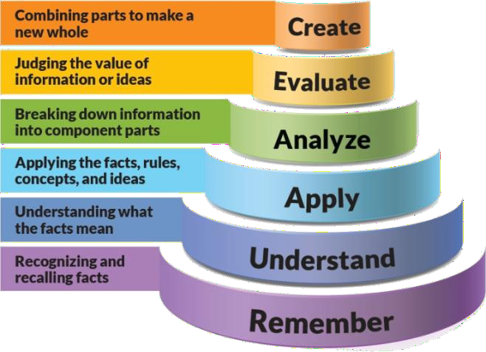
Figure 1: Blooms Taxonomy
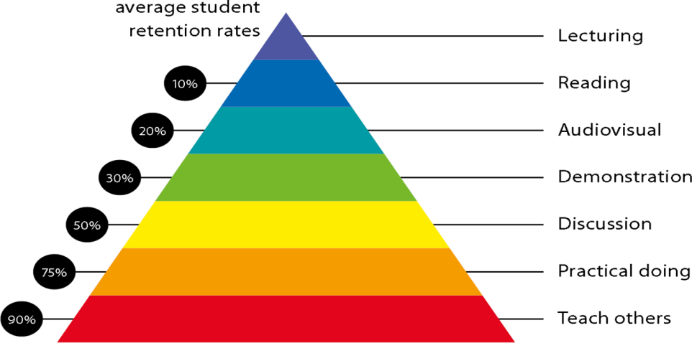
Figure 2: Knowledge retention

Graduate Qualities and Capabilities covered
(Qualities graduates harness crediting this Course)

General Graduate Qualities | Specific Department of Graduate  Capabilities
Informed  Have a sound knowledge of an area of study or profession and understand its current issues, locally and internationally. Know how to apply this knowledge.  Understand how an area of study has developed and how it relates to other areas. | 1 Professional knowledge, grounding & awareness

Independent learners  Engage with new ideas and ways of thinking and critically analyze issues. Seek to extend knowledge through ongoing research, enquiry and reflection. Find and evaluate information, using a variety of sources and technologies.  Acknowledge the work and ideas of others. | 2 Information literacy, gathering & processing
Problem solvers  Take on challenges and opportunities. Apply creative, logical and critical thinking skills to respond effectively. Make and implement decisions. Be flexible, thorough, innovative and aim for high standards. | 4 Problem solving skills
Effective communicators  Articulate ideas and convey them effectively using a range of media. Work collaboratively and engage with people in different settings. Recognize how culture can shape communication. | 5 Written communication
 | 6 Oral communication
 | 7 Teamwork
Responsible  Understand how decisions can affect others and make ethically informed choices. Appreciate and respect diversity. Act with integrity as part of local, national, global and professional communities. | 10 Sustainability, societal & environmental impact

Practical work:
- ASSIGNMENT -1 Theory Question from Unit No:1
- ASSIGNMENT -2 Theory Question Unit 1 or Unit 2
- ASSIGNMENT -3 Theory Question from Unit 3 or Unit 4

Lecture and Tutorial Times
As per IIMS Time Table .

Attendance Requirements
The University norms states that it is the responsibility of students to attend all lectures, tutorials, seminars and practical work as stipulated in the Course outline. Minimum attendance requirement as per university norms is compulsory for being eligible for mid and end semester examinations.

Details of referencing system to be used in written work Text books

1. Ravinder Kumar, Legal Aspects of Business, Cengage Learning, Latest Edition

Additional Materials (Reference Books)

1. K. R. Bulchandani, Business Laws for management, Latest Edition, Himalaya Publishing House, Bombay
2 .N. D. Kapoor, Mercantile Law –Latest Edition Sultan Chand& Company, New Delhi

ASSESSMENT GUIDELINES

1. Assignment No: 1 | - | 5 | Marks
2. Assignment No: 2 | - | 5 | Marks
3. Assignment No: 3 | - | 5 | Marks
4. Attendance | - | 5 | Marks

- Mid Semester Exams 40 Marks
- End Semester Exam 40 Marks

Your final course mark will be calculated from the following:

SUPPLEMENTARY ASSESSMENT

Students who receive an overall mark less than 40% in mid semester or end semester will be considered for supplementary assessment in the respective components (i.e mid semester or end semester) of semester concerned. Students must make themselves

available during the supplementary examination period to take up the respective components (mid semester or end semester) and need to obtain the required minimum 40% marks to clear the concerned components.

Practical Work Report/Laboratory Report:
A report on the practical work is due the subsequent week after completion of the class by each group.

Late Work
Late assignments will not be accepted without supporting documentation. Late submission of the reports will result in a deduction of -% of the maximum mark per calendar day

Format
All assignments must be presented in a neat, legible format with all information sources correctly referenced. Assignment material handed in throughout the session that is not neat and legible will not be marked and will be returned to the student.

Retention of Written Work
Written assessment work will be retained by the Course coordinator/lecturer for two weeks after marking to be collected by the students.

University and Faculty Policies
Students should make themselves aware of the University and/or Faculty Policies regarding plagiarism, special consideration, supplementary examinations and other educational issues and student matters.

Plagiarism - Plagiarism is not acceptable and may result in the imposition of severe penalties. Plagiarism is the use of another person’s work, or idea, as if it is his or her own
- if you have any doubts at all on what constitutes plagiarism, please consult your Course coordinator or lecturer. Plagiarism will be penalized severely.

Do not copy the work of other students.
Do not share your work with other students (except where required for a group activity or assessment)

.

Course schedule(subject to change)

(Mention quiz, assignment submission, breaksetcas well in the table under the Teaching Learning Activity Column)

 | Week # | Topic & contents | CO  Addressed | Teaching Learning Activity (TLA)
 | Weeks 1 | UNIT-1  The Companies Act ,1956 - Meaning and Characteristics of a Company , Type of Companies | CO1, CO2.CO3, CO4,CO5, CO6 | Lecture
 | Weeks 2 | UNIT-1  The Companies Act ,1956 : Type of Companies | CO1, CO2.CO3, CO4,CO5, CO6 | Lecture
 | Week 3 | UNIT -1  The Companies Act ,1956 Formation of a Company , Doctrine of Corporate Veil. | CO1, CO2.CO3, CO4,CO5, CO6 | Lecture Assignment No:1
 | Week 4 | UNIT - 2  The Companies Act ,1956 : Memorandum of Association , Articles of Association | CO1, CO2.CO3, CO4,CO5, CO6 | Lecture
 | Week 5 | UNIT-2  The Companies Act ,1956 : Certificate of Incorporation , Certificate of Commencement of Business , Doctrine of  Ultra vires and Indoor Management . | CO1, CO2.CO3, CO4,CO5, CO6 | Lecture

 | Week 6 | UNIT-3  The Companies Act ,1956 :Directors , Types of Directors , and Winding Up of the Company. | CO1, CO2.CO3, CO4,CO5, CO6 | Lecture
 | Week 7 | UNIT - 3  The Companies Act ,1956 Kinds of Company Meetings | CO1, CO2.CO3, CO4,CO5, CO6 | Lecture
 | Week 8 | UNIT -3  The Companies Act ,1956 : Company Meetings Continued | CO1, CO2.CO3, CO4,CO5, CO6 | Lecture Assignment No: 2
 | Week 9 | UNIT -3  The Companies Act ,1956 : Winding Up of the Company | CO1, CO2.CO3, CO4,CO5, CO6 | Lecture
 | Week 10 | UNIT -3  The Companies Act ,1956 : Winding Up of the Company Continued . | CO1, CO2.CO3, CO4,CO5, CO6 | Lecture
 | Week 11 | Mid Semester Examination | NA | NA
 | Week 12 | The Limited Liability Partnership Act, 2008  : Understanding a LLP,  Features of a Limited Liability Partnership .  . | CO1, CO2.CO3, CO4,CO5, CO6 | Lecture
 | Week 13 | The Limited Liability Partnership Act, 2008 :Difference between a LLP, Partnership Firm and Company and | CO1, CO2.CO3, CO4,CO5, CO6 | Lecture  Assignment No: 3

 | Week 14 | The Limited Liability Partnership Act, 2008 :other areas of LLP |  | Lecture
 | Week 15 | Revision |  | Lecture

