Name of Institute: Indus Institute of Management Studies

Name of Faculty: Dr. Hardik Vipinkumar Bavishi

Course code: MB0412
Course name: Service and Relationship Marketing
Pre-requisites: Marketing Management
Credit points: 3
Offered in semester: IV

Course Coordinator (weeks 01-15)
Full Name: Dr. Hardik Vipinkumar Bavishi
Department with siting location: Bhanwar building, 4th floor, Room 429
Telephone: 9825100242, Ext: 3423
Email: hardikbavishi.mba@indusuni.ac.in
Consultation times: Friday 3 to 5 pm

Course Lecturer (weeks 01-15)
Full Name: Dr. Hardik Vipinkumar Bavishi
Department with siting location: Bhanwar building, 4th floor, Room 429
Telephone: 9825100242, Ext: 3423
Email: hardikbavishi.mba@indusuni.ac.in
Consultation times: Friday 3 to 5 pm

Course Objectives
This course is designed to examine the important and growing role that Services Marketing plays in both consumer and organizational target markets and to discuss the current issues in services marketing and customer service strategies, this course focuses on effective customer relationship management; key service delivery elements; and service recovery strategies that lead to the successful implementation of a customer focus in service-based businesses.

Course Outcomes (CO)
By participating in and understanding all facets of this Course a student will:
CO1: List and define the concepts of service marketing. (BT-1)
CO2: Discuss the 7 Ps of service marketing. (BT-2)
CO3: Apply the knowledge of service quality in increasing quality level of products. (BT-3)
CO4: Analyze the gaps of service quality. (BT-4)
CO5: Appraise the use of various strategies for reducing customer defections (BT-5)
CO6: Develop a blueprint for a service of choice (BT-6)

Course Outline
- Basics of Services Marketing
- Services Marketing Mix
- Expanded Marketing Mix
- Service Quality
- Relationship Management

Method of delivery
Face to face lectures, self-study material, Active Learning Techniques

Study time
3 hours per week

CO-PO Mapping (PO: Program Outcomes)
 | CO1 | CO2 | CO3 | CO4 | CO5 | CO6
PO1 | 3 | 1 |  | 3 |  | 2
PO2 | 2 | 3 | 1 | 2 | 3 | 2
PO3 |  |  | 2 |  |  | 2
PO4 |  |  |  |  |  | 3
PO5 | 1 | 2 |  | 1 | 2 | 1
PO6 |  |  | 3 |  | 1 | 2
1-Lightly Mapped 2- Moderately Mapped 3- Highly Mapped

Blooms Taxonomy and Knowledge retention (For reference)
(Blooms taxonomy has been given for reference)

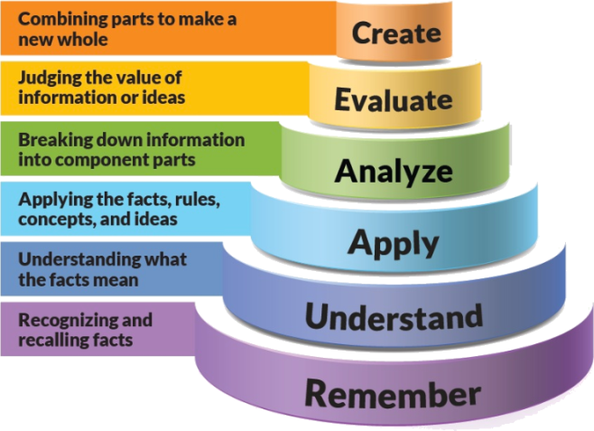
Figure 1: Blooms Taxonomy
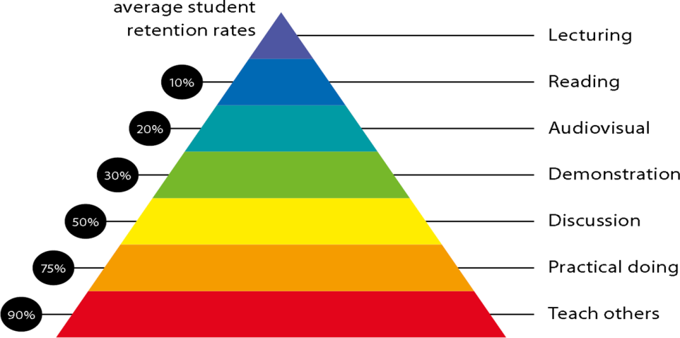
Figure 2: Knowledge retention

Graduate Qualities and Capabilities covered
(Qualities graduates harness crediting this Course)

General Graduate Qualities | Specific Department of ______Graduate Capabilities
Informed  Have a sound knowledge of an area of study or profession and understand its current issues, locally and internationally. Know how to apply this knowledge. Understand how an area of study has developed and how it relates to other areas. | 1 Professional knowledge, grounding & awareness  Develop sound understanding about marketing of services
Independent learners  Engage with new ideas and ways of thinking and critically analyze issues. Seek to extend knowledge through ongoing research, enquiry and reflection. Find and evaluate information, using a variety of sources and technologies. Acknowledge the work and ideas of others. | 2 Information literacy, gathering & processing  Understand how to promote services using the extended service marketing mix
Problem solvers  Take on challenges and opportunities. Apply creative, logical and critical thinking skills to respond effectively. Make and implement decisions. Be flexible, thorough, innovative and aim for high standards. | 4 Problem solving skills  Identify and solve gaps in service quality
Effective communicators  Articulate ideas and convey them effectively using a range of media. Work collaboratively and engage with people in different settings. Recognize how culture can shape communication. | 5 Written communication
 | 6 Oral communication
7 Teamwork
Coordinate with internal and external stakeholders and maintain service relationships
Responsible  Understand how decisions can affect others and make ethically informed choices. Appreciate and respect diversity. Act with integrity as part of local, national, global and professional communities. | 10 Sustainability, societal & environmental impact  Ensure the interest of all stakeholders is taken care of while setting up plans

Practical work:
(Mention what practical work this Course involves)

Lecture/tutorial times
Lecture Monday 01:20 to 02:15 pm Room 404
Lecture Wednesday 01:20 to 02:15 pm Room LH 19
Lecture Friday 02:15 to 03:10 pm Room 403

Attendance Requirements
The University norms states that it is the responsibility of students to attend all lectures, tutorials, seminars and practical work as stipulated in the Course outline. Minimum attendance requirement as per university norms is compulsory for being eligible for mid and end semester examinations.

Details of referencing system to be used in written work
APA 6th edition

Text books
Services Marketing: People, Technology, Strategy - Lovelock Christopher, Wirtz Jochen and Chatterjee Jayanta, Pearson Prentice Hall

Reference books:
- Services Marketing - R. Srinivasan, PHI
- Services Marketing - Apte Govind, Oxford
- Relationship Marketing - Godson Mark, Oxford
- Service Management: Operations, Strategy, Information Technology - Fitzsimmons J.A. and Fitzsimmons M.J, Tata McGraw-Hill
- Services Marketing: Integrating Customer Focus Across the Firm - Zeithaml V. A., Bitner M.J., Gremler D. D., and Pandit A., Tata McGraw Hill

Assessment guidelines
Your final course mark will be calculated from the following:
Assignment 5% (week 8) Outcome (1-3)
Presentation 5%(week 8) Outcome 4 & 5
Project 10% (week 10 Outcome 6
Mid semester 40% (due week 10) Outcome (2-5)
Final exam (closed book) 40% Outcome (1-5)

Supplementary assessment
Students who receive an overall mark less than 40% in mid semester or end semester will be considered for supplementary assessment in the respective components (i.e mid semester or end semester) of semester concerned. Students must make themselves available during the supplementary examination period to take up the respective components (mid semester or end semester) and need to obtain the required minimum 40% marks to clear the concerned components.

Practical Work Report/Laboratory Report:
A report on the practical work is due the subsequent week after completion of the class by each group.

Late Work
Late assignments will not be accepted without supporting documentation. Late submission of the reports will result in a deduction of -% of the maximum mark per calendar day

Format
All assignments must be presented in a neat, legible format with all information sources correctly referenced. Assignment material handed in throughout the session that is not neat and legible will not be marked and will be returned to the student.

Retention of Written Work
Written assessment work will be retained by the Course coordinator/lecturer for two weeks after marking to be collected by the students.

University and Faculty Policies
Students should make themselves aware of the University and/or Faculty Policies regarding plagiarism, special consideration, supplementary examinations and other educational issues and student matters.

Plagiarism - Plagiarism is not acceptable and may result in the imposition of severe penalties. Plagiarism is the use of another person’s work, or idea, as if it is his or her own - if you have any doubts at all on what constitutes plagiarism, please consult your Course coordinator or lecturer. Plagiarism will be penalized severely.

Do not copy the work of other students.
Do not share your work with other students (except where required for a group activity or assessment)

Course schedule (subject to change)

 | Week # | Topic & contents |  | CO Addressed |  | Teaching Learning Activity (TLA)
 | Weeks 1 | Basics of Services Marketing: What are Services? ; Why Study Services? ; Role of services in the economy; Services and Technology - technology in service encounter, emergence of self service, automation in services, Internet services; Distinctions between Services and Goods; Services Marketing Mix; Customer Behaviour in Service Encounter: |  | CO1 |  | PowerPoint, discussions
 | Weeks 2 | Four Categories of Services – People-Processing, Mental-Stimulus Processing, Possession-Processing, and Information-Processing;; |  | CO1 |  | PowerPoint, discussions
 | Week 3 | Customer Decision Making – Pre-purchase Stage, Service-Encounter Stage and Post-Encounter Stage; ; Customer Expectations and Perceptions of Services – Zone of Tolerance |  | CO1 |  | PowerPoint, discussions
 | Week 4 | Services Marketing Mix: Product – Core and Supplementary Elements, Branding Service Products ; |  | CO1, CO3, CO2 |  | PowerPoint, discussions and practical work
 | Week 5 | Price – Role of Non-monetary Costs, Pricing Strategy Pricing and Revenue Management, Yield Management, |  | CO1, CO3, CO2
 | Week 6 | Place – Service Distribution, Role of Customers in Service Delivery, Delivery through Intermediaries, Franchising, Electronic Channels, Self-Service Technologies; | CO3, CO2 |  | PowerPoint, discussions and practical work
 | Week 7 | Promotion – Role of Marketing Communication, Marketing Communication Mix, Integrated Services Marketing Communication | CO3, CO2 |  | PowerPoint, discussions and practical work
 | Week 8 | Expanded Marketing Mix: People – Employees’ Role in Service Delivery, Service Leadership and Culture, | CO3, CO2 |  | PowerPoint, discussions and practical work
 | Week 9 | Process – Service Blueprinting, Service Process Redesign Physical Evidence - Servicescape, Service Environments, | CO1 |  | PowerPoint, discussions
 | Week 10 | Managing Capacity and Demand: Understanding Capacity, Demand Patterns, Strategies for Matching Capacity and Demands | CO6 |  | PowerPoint, discussions
 | Week 11 | Service Quality and Relationship Management: Services Quality: Gaps Model; Measuring and Improving Service Quality; | CO1 |  | PowerPoint, discussions
 | Week 12 | Relationship Management: Defining Customer Relationships; The Basics | CO1, CO5 |  | PowerPoint, discussions
 | Week 13 | External Relationships; Supplier Relations; Internal Relationships | CO4 |  | PowerPoint, discussions
 | Week 14 | Relationship Marketing: Customer Retention; Customer Loyalty; | CO4 |  | PowerPoint, discussions
 | Week 15 | Strategies for reducing Customer Defections; and Customer Relationship Management (CRM) | CO4 |  | PowerPoint, discussions

