Name of Institute: Indus Institute of Management Studies

Name of Faculty: Dr. Hardik Vipinkumar Bavishi

Course code: BC0404
Course name: Entrepreneurship
Pre-requisites: Fundamentals of functional subjects
Credit points: 4
Offered in semester: IV

Course Coordinator (weeks 01-15)
Full Name: Dr. Hardik Vipinkumar Bavishi
Department with siting location: Bhanwar building, 4th floor, Room 429
Telephone: 9825100242, Ext: 3423
Email: hardikbavishi.mba@indusuni.ac.in
Consultation times: Friday 3 to 5 pm

Course Lecturer (weeks 01-15)
Full Name: Dr. Hardik Vipinkumar Bavishi
Department with siting location: Bhanwar building, 4th floor, Room 429
Telephone: 9825100242, Ext: 3423
Email: hardikbavishi.mba@indusuni.ac.in
Consultation times: Friday 3 to 5 pm

Students will be contacted throughout the Session via Mail with important information relating to this Course.

Course Objectives
- To introduce the concept of Entrepreneur and Entrepreneurship in the mind of participants with reference to process of economic and industrial development of the country.
- To involve participants in relevant interrelated field based project work or studies of entrepreneurs’ promotional policies of the government and other developmental agencies, financial institutions including banks and central government policies to develop target group as entrepreneurs.

Course Outcomes (CO)
By participating in and understanding all facets of this Course a student will:
CO1: Awareness of the concept of Entrepreneurship
CO2: Understanding the process of Entrepreneurial ecosystem
CO3: Practical knowledge (skills) of field based project work
CO4: Awareness of the aid provided to entrepreneurs by government
CO5: Understanding of the various elements associated with Entrepreneurship
CO6: Develop a feasible business plan for a start-up

Course Outline
Unit-I
- Entrepreneur and Entrepreneurship
- Indian entrepreneurship
- Women Entrepreneurship
Unit-II
- Factors Affecting Entrepreneurship Growth
- Entrepreneurship Motivation
- Entrepreneurship Competencies
Unit-III
- Micro and Small Enterprises
- Opportunity Identification and Selection
- Formulation of Business Plans
- Project Appraisal.
Unit-IV
- Financing of Enterprise
- Forms of Business Ownership
- Institutional Finance to Entrepreneurs

Method of delivery
Face to face lectures, self-study material, Active Learning Techniques

Study time
5 hours per week

CO-PO Mapping (PO: Program Outcomes)
 | PO1 | PO2 | PO3 | PO4 | PO5 | PO6
CO1 | 3 | 2 |  |  | 1
CO2 | 1 | 3 |  |  | 2
CO3 |  | 1 | 2 |  |  | 3
CO4 | 3 | 2 |  |  | 1
CO5 |  | 3 |  |  | 2 | 1
CO6 | 2 | 2 | 2 | 2 | 1 | 2
WA | 2.25 | 2.17 | 2 | 2 | 1.4 | 2 | 1.97
1-Lightly Mapped 2- Moderately Mapped 3- Highly Mapped

Blooms Taxonomy and Knowledge retention (For reference)
(Blooms taxonomy has been given for reference)

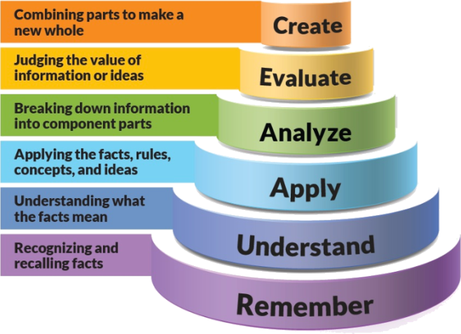
Figure 1: Blooms Taxonomy

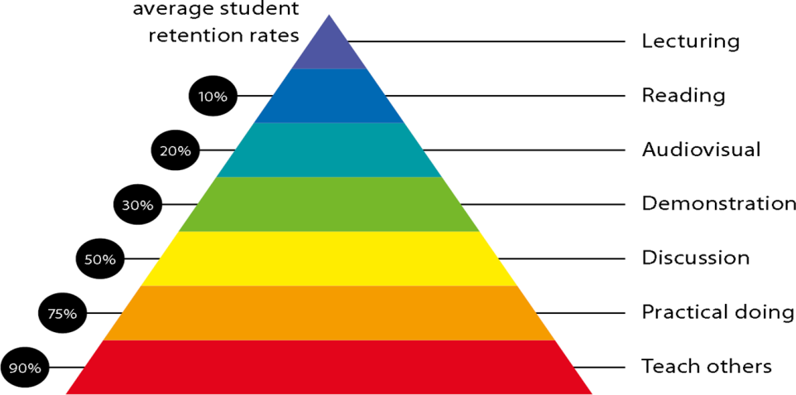
Figure 2: Knowledge retention

Graduate Qualities and Capabilities covered
General Graduate Qualities | Specific Department of Management Graduate Capabilities
Informed  Have a sound knowledge of an area of study or profession and understand its current issues, locally and internationally. Know how to apply this knowledge. Understand how an area of study has developed and how it relates to other areas. | 1 Professional knowledge, grounding & awareness  Awareness regarding the concept of Entrepreneurship and various helping agencies
Independent learners  Engage with new ideas and ways of thinking and critically analyze issues. Seek to extend knowledge through ongoing research, enquiry and reflection. Find and evaluate information, using a variety of sources and technologies. Acknowledge the work and ideas of others. | 2 Information literacy, gathering & processing  Ability to process entrepreneurial concepts in real life situations
Problem solvers  Take on challenges and opportunities. Apply creative, logical and critical thinking skills to respond effectively. Make and implement decisions. Be flexible, thorough, innovative and aim for high standards. | 4 Problem solving skills  Solve routine problems associated with employee motivation, training and business growth
Effective communicators  Articulate ideas and convey them effectively using a range of media. Work collaboratively and engage with people in different settings. Recognize how culture can shape communication. | 5 Written communication
 | 6 Oral communication
7 Teamwork
Ability to work in team and help synergize the productivity level
Responsible  Understand how decisions can affect others and make ethically informed choices. Appreciate and respect diversity. Act with integrity as part of local, national, global and professional communities. | 10 Sustainability, societal & environmental impact  Acknowledge the importance of entrepreneurship on society and economy as a whole

Lecture/tutorial times
Lecture Tuesday 10:50 to 11:45 am Room 427B
Lecture Wednesday 10:50 to 11:45 am Room 427B
Lecture Thursday 10:50 to 11:45 am Room 427B
Lecture Friday 10:50 to 11:45 am Room 427B

Attendance Requirements
The University norms states that it is the responsibility of students to attend all lectures, tutorials, seminars and practical work as stipulated in the Course outline. Minimum attendance requirement as per university norms is compulsory for being eligible for mid and end semester examinations.

Details of referencing system to be used in written work
APA 6th edition

Text books
- Entrepreneurial Development by Dr. S.S. Khanka - S Chand Publication
- Entrepreneurship Development (Obstacles & Solutions) by Dipesh D. Uike - Himalaya Publication

Reference Books
- Entrepreneurship Management by Aruna Kaulgud
- Essentials of Entrepreneurship & Small Business Management by Thomas & Norman
- Dynamics of Entrepreneurship & Management by Vasant Desai.
- Entrepreneurship: Resources & Strategies by Marc J. Dollinger

Web resources
- http://www.dcmsme.gov.in
- www.ediindia.org

Assessment Guidelines
Your final course mark will be calculated from the following:
Assignment 5% (week 4) Outcome (1-3)
Presentation 5% (week 8) Outcome (1-4)
Mid semester 40% (due week 10) Outcome (2-5)
Project 10% (Outcome 6)
Final exam (closed book) 40% Outcome (1-6)

Supplementary Assessment
Students who receive an overall mark less than 40% in mid semester or end semester will be considered for supplementary assessment in the respective components (i.e mid semester or end semester) of semester concerned. Students must make themselves available during the supplementary examination period to take up the respective components (mid semester or end semester) and need to obtain the required minimum 40% marks to clear the concerned components.

Practical Work Report/Laboratory Report
A report on the practical work is due the subsequent week after completion of the class by each group.

Late Work
Late assignments will not be accepted without supporting documentation. Late submission of the reports will result in a deduction of -% of the maximum mark per calendar day.

Format
All assignments must be presented in a neat, legible format with all information sources correctly referenced. Assignment material handed in throughout the session that is not neat and legible will not be marked and will be returned to the student.

Retention of Written Work
Written assessment work will be retained by the Course coordinator/lecturer for two weeks after marking to be collected by the students.

University and Faculty Policies
Students should make themselves aware of the University and/or Faculty Policies regarding plagiarism, special consideration, supplementary examinations and other educational issues and student matters.

Plagiarism - Plagiarism is not acceptable and may result in the imposition of severe penalties. Plagiarism is the use of another person’s work, or idea, as if it is his or her own - if you have any doubts at all on what constitutes plagiarism, please consult your Course coordinator or lecturer. Plagiarism will be penalized severely.

Do not copy the work of other students.
Do not share your work with other students (except where required for a group activity or assessment)

Course schedule (subject to change)
Week # | Topic & contents |  | CO Addressed |  | Teaching Learning Activity (TLA)
Weeks 1 | Entrepreneur and Entrepreneurship, Indian entrepreneurship |  | CO1 |  | Powerpoints, discussions, practical work
Weeks 2 | Women Entrepreneurship |  | CO1 |  | Powerpoints
Week 3 | Factors Affecting Entrepreneurship Growth |  | CO1, CO2 |  | Powerpoints, discussions
Week 4 | Entrepreneurship Motivation |  | CO1 |  | Powerpoints, discussions
Week 5 | Entrepreneurship Competencies |  | CO1 |  | Powerpoints, discussions, practical work
Week 6 | Micro and Small Enterprises | CO2, CO5 |  | Powerpoints
Week 7 | Opportunity Identification and Selection | CO2, CO3 |  | Powerpoints, discussions
Week 8 | Formulation of Business Plans | CO2, CO3, CO6 |  | Discussions, practical work
Week 9 | Formulation of Business Plans | CO2, CO3, CO6 |  | Discussions, practical work
Week 10 | Project Appraisal. | CO1, CO2 |  | Powerpoints, discussions
Week 11 | Project Appraisal. | CO1, CO2 |  | Powerpoints, discussions
Week 12 | Financing of Enterprise | CO4 |  | Powerpoints
Week 13 | Forms of Business Ownership | CO1, CO5 |  | Powerpoints
Week 14 | Institutional Finance to Entrepreneurs | CO4 |  | Powerpoints, website visit
Week 15 | Institutional Finance to Entrepreneurs | CO4 |  | Powerpoints, website visit

