Name of Institute: Indus Institute of Management Studies (IIMS)

Name of Faculty: Mrs Nirali Dave

Course code: BB0405
Course name: Fundamental of Financial Management
Pre-requisites Fundamental of Financial Management
Credit points: 4 Credits
Offered Semester: IMBA 5Y IV

Course Coordinator(1 to 15 weeks)
Full Name: Mrs Nirali Dave
Department with siting location: IIMS
Telephone:9428609964
Email:niralidave.mba@indusuni.ac.in
Consultation times: 2 to 4PM

Course Lecturer(1 to 15 weeks)
Full name: Mrs Nirali Dave
Department with siting location: 4th Floor, Bhanwar Building.
Email: niralidave.mba@indusuni.ac.in
Consultation times: 2 to 4 PM

Students will be contacted throughout the Session via Mail with important information relating to this Course.

Course Objectives
- The objective of this course is to inform the students about the basic concepts of financial management and contemporary theory and policy in order to master the concepts, theories and technique of financial management, what represents the condition of profitable business operations and survival respectively development of business subjects and the economy as a whole.
- Students should acquire the basic knowledge by means of combining theoretical cognitions and practical attitudes to enable them the understanding of financial problems in business practice after completed the studies.
- The purpose of the course is to offer the students relevant, systematic, efficient and actual knowledge of financial management that can be applied in practice with making financial decisions and resolving financial problems.

Course Outcomes (CO)
CO1 To provide introduction to Financial Management. Time value of money, Risk and Return (Capital Asset Pricing Model), Valuation of securities shares and bonds.
CO2 To Make them understand different methods of investment decision .
CO3 To make them understand the cost of capital in wide aspects
CO4 To provide knowledge about dividend policies and various dividend models.
CO5 To enable them to understand working capital management
CO6 To make them understand working capital management in inventory, cash receivables, sources of short term and long term finances.

Course Outline
UNIT -I NATURE AND SCOPE:
Meaning, Scope, Objectives and Importance of Financial Management - Finance Functions (Traditional Vs. Modern Approach) - Profit Maximization.
- TIME VALUE OF MONEY:
Reasons for Time value of money - Compound Value Concept - Present value
Concept - Practical Application of the same

UNIT – II
- INVESTMENT DECISIONS:
Meaning, Significance, Objectives and Importance of Capital Budgeting - Capital budgeting Process - Basic Principles of Capital Expenditure Proposals - Various appraisal Methods: Pay Back Period, Discounted Cash Flow Method, Average Rate of Return.

Unit-III
- CAPITAL STRUCTURE:
Meaning and Significance of Capital Structures - Capital structure and financial structure - Patterns of Capital Structure - Ideal Capital Structure, Features of Ideal Capital Structure - Merits and Demerits of different types of Capital Structure.

Unit-IV
- FINANCING DECISIONS:
Sources of Finance - Equity Shares - Preference Shares –Debentures –Term Loans- Retained earning, - Bridge finance - Government policy on security financing and Term Loan - Operating and Financial Leverage.

Method of delivery
Lectures, and Presentations

Study time
Four hours per week

CO-PO Mapping (PO: Program Outcomes)

 | PO1 | PO2 | PO3 | PO4 | PO5 | PO6
CO 1 | 3 | 1 | 2 | 1 | 3 | 3
CO 2 | 3 | 1 | 2 | 3 | 3 | 2
CO 3 | 3 | 3 | 2 | 3 | 2 | 3
CO 4 | 1 | 1 | 2 | 1 | 2 | 1
CO 5 | 3 | 2 | 1 | 3 | 2 | 1
CO6 | 3 | 2 | 1 | 3 | 1 | 1

Blooms Taxonomyand Knowledge retention(For reference)
(Blooms taxonomy has been given for reference)

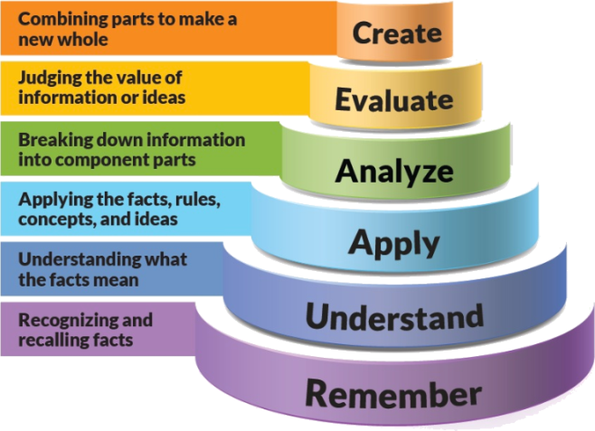
Figure 1: Blooms Taxonomy
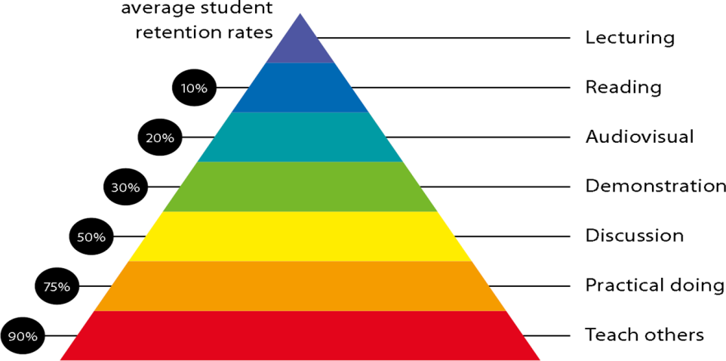
Figure 2: Knowledge retention

Graduate Qualities and Capabilities covered
(Qualities graduates harness crediting this Course)

General Graduate Qualities | Specific Department of ManagementGraduate Capabilities
Informed  Disciplinary Knowledge | 1 Professional knowledge, grounding & awareness
Independent learners  Solution to the problem’s adjustments | 2 Information literacy, gathering & processing
Problem solvers  Thinking • critical • creative • practical | 4 Problem solving skills
Effective communicators  Develop the ability to reflect on issues on hand. Through active participation enhance the skills to communicate verbally and in writing and develop practices expected of today’s professionals. | 5 Written communication
 | 6 Oral communication
 | 7 Teamwork
Responsible  Learning • capacity for life-long learning • flexibility • adaptability | 10 Sustainability, societal & environmental impact

Practical work:
Understand Derivatives followed by Indian Stock Market by assignment/visit.

Lecture/tutorial times:
4 lectures per week

Attendance Requirements

The University norms states that it is the responsibility of students to attend all lectures, tutorials, seminars and practical work as stipulated in the Course outline. Minimum attendance requirement as per university norms is compulsory for being eligible for mid and end semester examinations.

Details of referencing system to be used in written work
Assignment
Case Study

Text books
- •Khan and Jain. Basic Financial Management, McGraw Hill Education
- Prasanna Chandra, Fundamentals of Financial Management. McGraw Hill Education
- Pandey, I.M. Financial Management. Vikas Publications.

.
Reference Books:
- Singh, Surender and Kaur, Rajeev. Fundamentals of Financial Management. Mayur Paperback, New Delhi.
- Levy H. and M. Sarnat . Principles of Financial Management. Pearson Education
- James C. Van Horne and Sanjay Dhamija, Financial Management and Policy, Pearson Education
- Brigham and Houston, Fundamentals of Financial Management, Cengage Learning
- Singh, J.K. Financial Management- text and Problems. Dhanpat Rai and Company, Delhi.
- Rustagi, R.P. Fundamentals of Financial Management. Taxmann Publication Pvt. Ltd.
- Bhabatosh Banerjee, Fundamentals of Financial Management, PHI Learning

ASSESSMENT GUIDELINES
Your final course mark will be calculated from the following:
Assignment 1 10 % (week 2) Objectives (1-2)

Assignment 2 10% Week 9
CIE 40% Objectives (1-2)
Final exam (closed book) 40% Objectives (1-2)

SUPPLEMENTARY ASSESSMENT
Students who receive an overall mark less than 40% in Internal or end semester will be considered for supplementary assessment in the respective components (i.e Internal or end semester) of semester concerned. Students must make themselves available during the supplementary examination period to take up the respective components (mid semester or end semester) and need to obtain the required minimum 40% marks to clear the concerned components.

Practical Work Report/Laboratory Report:
A report on the practical work is due the subsequent week after completion of the class by each group.

Late Work
Late assignments will not be accepted without supporting documentation. Late submission of the reports will result in a deduction of -% of the maximum mark per calendar day

Format
All assignments must be presented in a neat, legible format with all information sources correctly referenced. Assignment material handed in throughout the session that is not neat and legible will not be marked and will be returned to the student.

Retention of Written Work
Written assessment work will be retained by the Course coordinator/lecturer for two weeks after marking to be collected by the students.

University and Faculty Policies
Students should make themselves aware of the University and/or Faculty Policies regarding plagiarism, special consideration, supplementary examinations and other educational issues and student matters.

Plagiarism - Plagiarism is not acceptable and may result in the imposition of severe penalties. Plagiarism is the use of another person’s work, or idea, as if it is his or her own - if you have any doubts at all on what constitutes plagiarism, please consult your Course coordinator or lecturer. Plagiarism will be penalized severely.

Do not copy the work of other students.
Do not share your work with other students (except where required for a group activity or assessment)
.

Courseschedule(subject to change)

 | Week # | Topic & contents | CO Addressed
 | Week 1 | Introduction  Nature, scope and objective of Financial Management, Time value of money, | CO1
 | Weeks2 | .  Meaning, Scope, Objectives and Importance of Financial Management - Finance Functions (Traditional Vs. Modern Approach) - Profit Maximization. | CO1
 | Week 3 | Investment Decisions  The Capital Budgeting Process, Cash flow Estimation, Payback Period Method, Accounting Rate of Return, | CO2
 | Week 4 | Discounting Cash flow Method | CO2
 | Week 5 | Sums on Payback Period Method and Accounting Rate of Return | CO3
 | Week 6 | Meaning, Significance, Objectives and Importance of Capital Budgeting - Capital budgeting Process - Basic Principles of Capital Expenditure Proposals | CO4
 | Week 7 | Meaning and Significance of Capital Structures - Capital structure and financial structure | CO4
 | Week8 | Patterns of Capital Structure - Ideal Capital Structure, Features of Ideal Capital Structure | Co5
 | Week 9 | Patterns of Capital Structure - Ideal Capital Structure, Features of Ideal Capital Structure | CO5
 | Week 10 | Merits and Demerits of different types of Capital Structure.  Sums on Operating and Financial Leverage | CO5
 | Week 11 | Mid Sem Exams | CO5,6
 | Week 12 | Sums on Operating and Financial Leverage, Ideal Capital Structure
 | Week 13 | Sources of Finance - Equity Shares - Preference Shares –Debentures –Term Loans- Retained earning, | CO5,6
 | Week 14 | Bridge finance - Government policy on security financing and Term Loan - Operating and Financial Leverage. | CO5,6
 | Week 15 | Revision | CO5,6

