### Name of Institute: Indus Institute of Technology and Engineering (IITE)

### Name of Faculty: Divyangna Gandhi

**Course code: EC0620**

**Course name: Optical Communication**

Pre-requisites: Basics of electromagnetic waves, Mode theory of waveguide. Basics of Communication

Credit points: 04

Offered Semester: 6th

**Course Coordinator (weeks 15)**

Full Name: Divyangna Gandhi

Department with sitting location: 2nd Floor, Bhanwar Building, EC Lab 5(Digital and

Networking Lab), IITE - IU

Telephone: 3202

Email: [Divyangnagandhi.ec@indusuni.ac.in](mailto:Divyangnagandhi.ec@indusuni.ac.in)

Consultation times: 4:00PM to 4:45PM

**Course Lecturer (weeks 15)**

Full Name: Divyangna Gandhi

Department with sitting location: 2nd Floor, Bhanwar Building, EC Lab 5(Digital and

Networking Lab), IITE - IU

Telephone: 3202

Email: [Divyangnagandhi.ec@indusuni.ac.in](mailto:Divyangnagandhi.ec@indusuni.ac.in)

Consultation times: 4:00PM to 4:45PM

Students will be contacted throughout the session via mail with important information relating to this course.

# Course Objectives

By participating in and understanding all facets of this course a student will:

* To comprehend the basic elements of optical fiber transmission link, fiber modes and structure configurations.
* To visualize the significance of the different kind of losses, signal distortion in optical wave guides, signal degradation factors
* To analyze the performance of both digital and analogue optical fiber systems
* Estimate the losses and analyze the propagation characteristics of an optical signal in different types of fibers
* To understand the basic operating principles of light sources and detectors
* To compare the various optical source materials, LED structures, quantum efficiency as well as structures and figure of merit of Laser diodes.
* To analyze the system performance of optical transmitters and receivers
* To understand the basic operating principles of amplifiers.
* To be familiar with different optical components like optical couplers, filters, optical mux/demux waveguide grating, optical add drop multiplexer (OADM), optical circulators, attenuators, optical cross connects.
* To analyze and integrate fiber optical network components in variety of networking schemes, SONET/ SDH and operational principles WDM.
* To design a simple optical communication link and solve the main issues in designing optical communication system.

# Course Outcomes (CO)

1. Define the basic elements of optical fiber transmission link and principle of OC

2. Explain the basic operating principle of light source and detector and summarize the various optical source materials

3. Calculate the losses and examine the performance of digital and analog optical communication systems

4. Illustrate the fiber optical network components in variety of networking schemes like SONET/ SDH

5. Compare different types of amplifiers and receiver noises

6. Design a simple optical communication link and solve the main issues in designing optical communication system

# Course Outline

Basic foundation of fiber optic communication,

Attenuation and power penalty in a link

LED LASER and Optical receiver

SOA, EDFA and Raman Amplifiers

Optical components

DWDM systems, SONET/ SDH

# Method of delivery

(Offline/Online lectures, self-study material, Active Learning Techniques)

# Study time

(3 Hour’s theory and 2 Hour’s Lab per week)

# CO-PO Mapping (PO: Program Outcomes)

|  |  |  |  |  |  |  |  |  |  |  |  |  |
| --- | --- | --- | --- | --- | --- | --- | --- | --- | --- | --- | --- | --- |
| **PO CO** | **PO** | | | | | | | | | | | |
| **1** | **2** | **3** | **4** | **5** | **6** | **7** | **8** | **9** | **10** | **11** | **12** |
| **1** | √ |  |  |  |  |  |  |  |  |  |  |  |
| **2** | √ |  |  |  |  |  | √ |  |  |  |  |  |
| **3** |  | √ |  | √ |  |  |  |  |  |  |  |  |
| **4** |  | √ | √ | √ | √ |  | √ |  |  |  |  |  |
| **5** |  | √ |  |  |  |  | √ |  |  |  |  |  |
| **6** |  | √ |  |  | √ |  |  |  |  |  |  |  |

# Blooms Taxonomy and Knowledge retention (For reference)

(Blooms taxonomy has been given for reference)

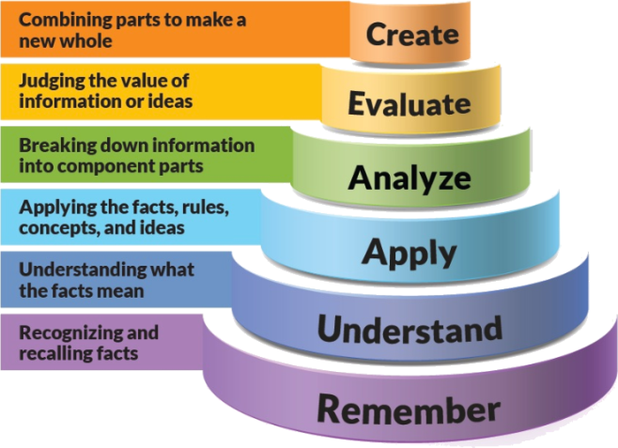

Figure 1: Blooms Taxonomy

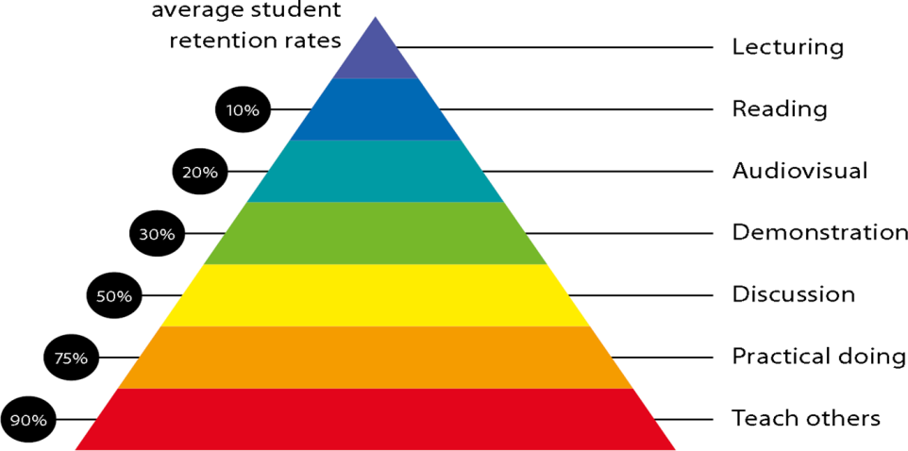

Figure 2: Knowledge retention

# Graduate Qualities and Capabilities covered

(Qualities graduates harness crediting this Course)

|  |  |
| --- | --- |
| **General Graduate Qualities** | **Specific Department of ______Graduate Capabilities** |
| **Informed**  Have a sound knowledge of an area of study or profession and understand its current issues, locally and internationally. Know how to apply this knowledge. Understand how an area of study has developed and how it relates to other areas. | **1 Professional knowledge, grounding & awareness** |
| **Independent learners**  Engage with new ideas and ways of thinking and critically analyze issues. Seek to extend knowledge through ongoing research, enquiry and reflection. Find and evaluate information, using a variety of sources and technologies. Acknowledge the work and ideas of others. | **2 Information literacy, gathering & processing** |
| **Problem solvers**  Take on challenges and opportunities. Apply creative, logical and critical thinking skills to respond effectively. Make and implement decisions. Be flexible, thorough, innovative and aim for high standards. | **4 Problem solving skills** |
| **Effective communicators**  Articulate ideas and convey them effectively using a range of media. Work collaboratively and engage with people in different settings. Recognize how culture can shape communication. | **5 Written communication** |
| **6 Oral communication** |
| **7 Teamwork** |
| **Responsible**  Understand how decisions can affect others and make ethically informed choices. Appreciate and respect diversity. Act with integrity as part of local, national, global and professional communities. | **10 Sustainability, societal & environmental impact** |

# Lecture/tutorial times

***Example:***

**Lecture Wednesday 09.00 – 09.55AM Room B225**

**Lecture** **Thursday 09.55 – 10.50AM Room B225**

**Lecture Thursday 01:20 – 02.15PM Room B225**

**Lab Monday 11:00 - 12:50PM EC Lab 5**

# Attendance Requirements

The University norms states that it is the responsibility of students to attend all lectures, tutorials, seminars and practical work as stipulated in the Course outline. Minimum attendance requirement as per university norms is compulsory for being eligible for mid and end semester examinations.

# Details of referencing system to be used in written work

# Text books

|  |  |
| --- | --- |
| Text books | Optical Fiber Communications by Gerd Keiser, 5th Edition (Mc Graw Hill) |
| Optical Fiber Communication by John M. Senior (PHI/Pearson) |
| Reference Books | Fiber Optics and Optoelectronics by R P Khare ,2004 |
| Fiber optic Communication Systems by G. Agrawal (John Wiley and sons) |
| Fiber optical communication Technology by Djafar Mymbaev & Lowell L, Scheiner. (Pearson) |

# Additional Materials

|  |
| --- |
| NPTEL- Lecture  http://www.nptel.ac.in/downloads/117101054/  <http://nptel.ac.in/courses/117101002/>  www.nptel.iitm.ac.in/foc |

# ASSESSMENT GUIDELINES

Your final course mark will be calculated from the following:

**Example:**

Midterm Exam 40% Objectives (1-6)

Presentation 5% Objectives (2-5)

Attendance 5%

Assignment 10% Objectives (2-5)

**Final exam** (*closed book*) 40% Objectives (1-6)

# SUPPLEMENTARY ASSESSMENT

Students who receive an overall mark less than 40% in mid semester or end semester will be considered for supplementary assessment in the respective components (i.e mid semester or end semester) of semester concerned. Students must make themselves available during the supplementary examination period to take up the respective components (mid semester or end semester) and need to obtain the required minimum 40% marks to clear the concerned components.

# Late Work

Late assignments will not be accepted without supporting documentation. Late submission of the reports will result in a deduction of -% of the maximum mark per calendar day

# Format

All assignments must be presented in a neat, legible format with all information sources correctly referenced. **Assignment material handed in throughout the session that is not neat and legible will not be marked and will be returned to the student.**

# Retention of Written Work

Written assessment work will be retained by the Course coordinator/lecturer for two weeks after marking to be collected by the students.

# University and Faculty Policies

Students should make themselves aware of the University and/or Faculty Policies regarding plagiarism, special consideration, supplementary examinations and other educational issues and student matters.

**Plagi**a**rism** - Plagiarism is not acceptable and may result in the imposition of severe penalties. Plagiarism is the use of another person’s work, or idea, as if it is his or her own - if you have any doubts at all on what constitutes plagiarism, please consult your Course coordinator or lecturer. Plagiarism will be penalized severely.

***Do not copy the work of other students.***

***Do not share your work with other students (except where required for a group activity or assessment)***

# Course schedule

|  |  |  |  |  |  |  |
| --- | --- | --- | --- | --- | --- | --- |
|  | **Week 15** | **Topic & contents** | | **CO Addressed** | | **Teaching Learning Activity (TLA)** |
|  | Weeks 1 | To aware students with theoretical and practical syllabus, assessment scheme for theory (CIE, End sem exam), practical (CIE, End sem exam) and all the details about subject activities has to be carry out throughout the semester | | 1 | | BB,PPT |
| Introduction to Optical Fiber Communication | |
| Weeks 2 | Optical Fiber Waveguide and Structures | | 1,2 | | BB,PPT |
| Week 3 | Optical laws, Transmission Characteristics of Optical Fibers | | 1,2, | | BB,PPT |
| Week 4 | Problems | | 1,2 | | BB,PPT,Tut |
| Week 5 | Optical Source: LED | | 1,2,3 | | BB,PPT |
|  | Week 6 | Optical Source: LASER | 1,2,3 | | BB,PPT | |
| Week 7 | Power Launching and coupling | 3 | | BB,PPT | |
| Week 8 | Optical Detectors | 2 | | BB,PPT | |
| Week 9 | Problems | 1,2,3 | | BB,PPT | |
|  | Week 10 | Optical Receiver | 3,4,5 | | BB,PPT | |
| Week 11 | Optical Amplifiers | 4,5 | | BB,PPT | |
|  | Week 12 | Problems | 1,2,3,4 | | BB,PPT,Tut | |
|  | Week 13 | Optical components | 4,5 | | BB,PPT, Seminar | |
|  | Week 14 | WDM and Optical Networks | 4,5,6 | | BB,PPT, Seminar | |
|  | Week 15 | Free Space Optical Communication | 4,6 | | BB,PPT, Seminar | |

**2nd Year**

**Differential Equations and Integral Transforms**

**SH0301**

**Control theory**

**EC0305**

**Analog electronics**

**EC0304**

**Human values & professional Ethics**

**SH0307**

**Object oriented computer programming**

**EC0302**

**Network analysis**

**EC0303**

**Digital logic design**

**EC0301**

***4th Semester***

**Linear Integrated Circuits**

**EC0401**

**Electromagnetics**

**EC0404**

**Complex Analysis and Numerical Methods**

**SH0401**

**Digital systems design**

**EC0405**

**Cyber security & Intellectual Property Rights**

**CE0407**

**Microprocessor & computer architecture**

**EC0402**

**Signals & systems**

**EC0403**

**3rd Year**

***6th Semester***

**4th Year**

***8th Semester***

**Digital signal processing**

**EC0501**

**Microcontroller and interfacing**

**EC0503**

**Analog communication systems**

**EC0504**

**Electronics measurements and instrumentation**

**EC0502**

**Technical Communication and Soft Skills**

**SH0507**

**Microwave engineering**

**EC0505**

**Probability and random process**

**EC0506**

**Digital Communication**

**EC0601**

**Antenna & Wave Propagation**

**EC0602**

**Wireless communication**

**EC0603**

**VLSI Design**

**EC0604**

**Advanced Technical Communication And Soft Skills**

**SH0607**

**Power Electronics EC0606**

**Video Engineering EC0605**

**Elective II**

**Elective I**

**Radar and Navigation EC0607**

**Advanced Processor EC0608**

**Error Correcting Codes EC0609**

**Embedded System**

**EC0701**

**Satellite communication**

**EC0702**

**Image and Video Processing EC0703**

**Data Communication Networks**

**EC0704**

**Disaster Management**

**CV0712**

**Elective III**

**Advanced Mobile Communication EC0706**

**Cryptography and Network Security EC0707**

**Raspberry pi platform and python programming for raspberry pi by coursera (MOOC Course) EC0708**

**Project**

**EC0801**

**Basic Electronics**

***7th Semester***

***5th Semester***

***3rd Semester***

**1st Year**