Name of Institute: IICT

Name of Faculty: Prof. Zalak Patel

Course code: IMCA0209
Course name: Microprocessor
Pre-requisites: Computer Fundamentals , Digital Logic
Credit points: 04
Offered Semester: 2nd

Course Coordinator (weeks 15)
Full Name: Zalak Patel
Department with siting location: 2nd Floor, EC lab 4, Bhanwar Building
Telephone: 7878452549
Email: zalakpatel.ec@indusuni.ac.in
Consultation times: Monday,Tuesday 3:45 to 4:15pm, All working Saturdays

Course Lecturer (weeks 15)
Full Name: Zalak Patel
Department with siting location: 2nd Floor, EC lab 4, Bhanwar Building
Telephone: 7878452549
Email: zalakpatel.ec@indusuni.ac.in
Consultation times: Monday,Tuesday 3:45 to 4:15pm, All working Saturdays

Students will be contacted throughout the Session via Mail with important information relating to this Course.

Course Objectives
By participating in and understanding all facets of this Course a student will:

- To understand basic architecture of 8085 & 8086 bit microprocessor.
- To understand interfacing of microprocessors with memory and peripheral chips involving System design.
- To understand techniques for faster execution of instructions and improve speed of operation and performance of microprocessors.

Course Outcomes (CO)

After completion this course the student will be able to

- Identify a detailed s/w & h/w structure of the Microprocessor.
- Understand the 8085/8086 microprocessor architecture.
- Gain Knowledge of the 8085/8086 microprocessor instruction set and ability to utilize it in programming.
- Understanding of the Intel 8086real mode memory addressing.
- Ability to interface various devices to the microprocessor.

Course Outline

UNIT-I
[12 Hours]
INTRODUCTION TO MICROPROCESSOR:
Microprocessor System, Bus Organization, Microprocessor Architecture, Microprocessor Operation.

8085 MICROPROCESSOR ARCHITECTURE:
8085 Architecture , Address, Data and Control Bus, Pin Functions, Demultiplexing of bus, Generation of Control Signals, Instruction Cycle , Machine Cycle .

UNIT-II
[12 Hours]
8085 INSTRUCTION SET:
Addressing Modes, Data Transfer Instructions, Arithmetic Instructions, Logical Instructions, Branching Instructions, Writing Assembly Language Programs.

8085 MEMORY AND I/O INTERFACING:
Memory interfacing, Decoding Methods ,Basic Interfacing Concepts, Interfacing Output Devices ,Interfacing Input Devices, Memory Mapped I/O and Peripheral Mapped I/O

UNIT-III
[12 Hours]
8086 MICROPROCESSOR ARCHITECTURE:
Intel 8086 processor, concept of pipelining ,memory segmentation, logical address, offset address and physical address; Bus Interface Unit (BIU); Execution Unit (EU), segment registers.

INTERRUPTS OF 8086 MICROPROCESSOR :
Advantage of Interrupts, Classification of Interrupts, Interrupts of 8086

UNIT-IV
[12 Hours]
8086 MICROPROCESSORHARDWARE SPECIFICATION:
8086 Pin Descriptions, Minimum mode and Maximum Mode operations, Memory Interfacing with 8086.

8086 INSTRUCTION SET:
Data movement instructions, Arithmetic and logic instructions, Program control instructions, string instruction, assembly language programming, Addressing Modes.

Method of delivery
(Face to face lectures, PPT, Chalkboard)

Study time
(9 hours per week including class attendance)

CO-PO Mapping (PO: Program Outcomes)
 | PO1 | PO2 | PO3 | PO4 | PO5 | PO6 | PO7 | PO8 | PO9 | PO10 | PO11 | PO12
CO1 | 3 | 1 | 1 | - | 3 | 2 | - | - | 1 | - | - | 1
CO2 | 3 | 3 | 3 | 1 | 3 | 1 | - | - | - | - | - | -
CO3 | 1 | 2 | 3 | 1 | 3 | 2 | - | - | - | - | - | -
CO4 | 1 | 1 | 3 | 2 | 2 | - | - | - | - | - | - | 2
CO5 | 2 | 3 | 1 | 2 | 1 |  |  |  | 1 |  |  | 2

Blooms Taxonomy and Knowledge retention (For reference)
(Blooms taxonomy has been given for reference)

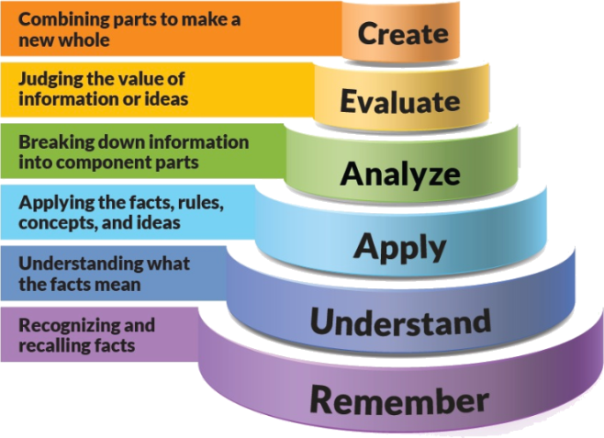
Figure 1: Blooms Taxonomy
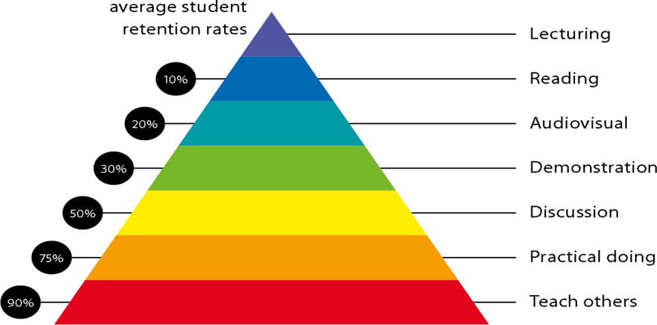
Figure 2: Knowledge retention

Graduate Qualities and Capabilities covered
(Qualities graduates harness crediting this Course)

General Graduate Qualities | Specific Department of __Electrical Graduate Capabilities
Informed  Have a sound knowledge of an area of study or profession and understand its current issues, locally and internationally. Know how to apply this knowledge. Understand how an area of study has developed and how it relates to other areas. | 1 Professional knowledge, grounding & awareness
Independent learners  Engage with new ideas and ways of thinking and critically analyze issues. Seek to extend knowledge through ongoing research, enquiry and reflection. Find and evaluate information, using a variety of sources and technologies. Acknowledge the work and ideas of others. | 2 Information literacy, gathering & processing
Problem solvers  Take on challenges and opportunities. Apply creative, logical and critical thinking skills to respond effectively. Make and implement decisions. Be flexible, thorough, innovative and aim for high standards. | 4 Problem solving skills
Effective communicators  Articulate ideas and convey them effectively using a range of media. Work collaboratively and engage with people in different settings. Recognize how culture can shape communication. | 5 Written communication
 | 6 Oral communication
 | 7 Teamwork
Responsible  Understand how decisions can affect others and make ethically informed choices. Appreciate and respect diversity. Act with integrity as part of local, national, global and professional communities. | 10 Sustainability, societal & environmental impact

Practical work: Not applicatble

Lecture/tutorial times
Example:
Lecture
Monday : 9:00 - 9:50
Tuesday: 9:00 - 9:50
Thursday : 9:00 - 9:50
Friday: 02:10-03:00

Attendance Requirements

The University norms states that it is the responsibility of students to attend all lectures, tutorials, seminars and practical work as stipulated in the Course outline. Minimum attendance requirement as per university norms is compulsory for being eligible for mid and end semester examinations.

Details of referencing system to be used in written work

Text books

- Microprocessor Architecture Programming and Applications with 8085, Ramesh Gaonkar, Penram International Publishing Pvt. Ltd.

- Microprocessor 8086: Architecture, Programming and Interfacing, PHI Publication 2011, BY Sunil Mathur, ISBN: 9788120340879

Additional Materials

Reference books
- 8085 Microprocessor Programming and Interfacing by K. Udaya kumar & B.S Uma shankar, Pearson Education.

- The 8088 and 8086 Microprocessors, Programming, Interfacing, Software, Hardware and Applications, Fourth Edition, By Walter A Triebel and Avtar Singh, Pearson Education, ISBN 13: 9780130930811

- Hall, D. V., “Microprocessors and Interfacing –Programming and Hardware”, Tata McGraw-Hill Publishing Company Limited.

Web Resource
- Microprocessor and Microcontroller course on NPTEL (Video) (https://nptel.ac.in/courses/108105102/59)
- Microprocessor and Microcontroller course on NPTEL (Web)
(https://nptel.ac.in/downloads/106108100/)
- Architecture of Advanced Microprocessor (Web)
(https://nptel.ac.in/courses/117104072/29)

Your final course mark will be calculated from the following:
Theory:
MSE (40 Marks)
Quiz (10 Marks)
Programming Assignment of Software of 8085 (10 Marks)

ESE (40 Marks)

SUPPLEMENTARY ASSESSMENT

Students who receive an overall mark less than 40% in mid semester or end semester will be considered for supplementary assessment in the respective components (i.e mid semester or end semester) of semester concerned. Students must make themselves available during the supplementary examination period to take up the respective components (mid semester or end semester) and need to obtain the required minimum 40% marks to clear the concerned components.

Practical Work Report/Laboratory Report:
A report on the practical work is due the subsequent week after completion of the class by each group.

Late Work
Late assignments will not be accepted without supporting documentation. Late submission of the reports will result in a deduction of -% of the maximum mark per calendar day

Format
All assignments must be presented in a neat, legible format with all information sources correctly referenced. Assignment material handed in throughout the session that is not neat and legible will not be marked and will be returned to the student.

Retention of Written Work
Written assessment work will be retained by the Course coordinator/lecturer for two weeks after marking to be collected by the students.

University and Faculty Policies
Students should make themselves aware of the University and/or Faculty Policies regarding plagiarism, special consideration, supplementary examinations and other educational issues and student matters.

Plagiarism - Plagiarism is not acceptable and may result in the imposition of severe penalties. Plagiarism is the use of another person’s work, or idea, as if it is his or her own - if you have any doubts at all on what constitutes plagiarism, please consult your Course coordinator or lecturer. Plagiarism will be penalized severely.

Do not copy the work of other students.
Do not share your work with other students (except where required for a group activity or assessment)
.

Course schedule (subject to change)
(Mention quiz, assignment submission, breaks etc as well in the table under the Teaching Learning Activity Column)

 | Week # | Topic & contents |  | CO Addressed |  | Teaching Learning Activity (TLA)
 | Weeks 1 | INTRODUCTION TO MICROPROCESSOR:  Microprocessor System, Bus Organization, Microprocessor Architecture, Microprocessor Operation. |  | 1 |  | BB,PPT
 | Weeks 2 | 8085 MICROPROCESSOR ARCHITECTURE:  8085 Architecture , Address, Data and Control Bus, Pin Functions, Demultiplexing of bus |  | 1,2 |  | BB,PPT
 | Week 3 | 8085 MICROPROCESSOR ARCHITECTURE:  Generation of Control Signals, Instruction Cycle , Machine Cycle |  | 1,2 |  | BB,PPT
 | Week 4 | 8085 INSTRUCTION SET:  Addressing Modes, Data Transfer Instructions, Arithmetic Instructions, Logical Instructions, Branching Instructions, |  | 3 |  | BB,PPT  (Lab Demonstration)
 | Week 5 | Writing Assembly Language Programs. |  | 3,5 |  | BB,PPT
 | Week 6 | 8085 MEMORY AND I/O INTERFACING:  Memory interfacing, Decoding Methods ,Basic Interfacing Concepts, Interfacing Output Devices | 2,5 |  | BB,PPT  Quiz-1
 | Week 7 | 8085 MEMORY AND I/O INTERFACING:  Interfacing Input Devices,Memory Mapped I/O and Peripheral Mapped I/O | 2,5 |  | BB,PPT
 | Week 8 | 8086 MICROPROCESSOR ARCHITECTURE:  Intel 8086 processor, concept of pipelining ,memory segmentation, logical address, offset address and physical address | 2,4 |  | BB,PPT
 | Week 9 | 8086 MICROPROCESSOR ARCHITECTURE:  BusInterface Unit (BIU); Execution Unit (EU), segment registers. | 2,4 |  | BB,PPT  (Software Demonstration)
 | Week 10 | INTERRUPTS OF 8086 MICROPROCESSOR :  Advantage of Interrupts, Classification of Interrupts, Interrupts of 8086 | 2,4 |  | BB,PPT
 | Week 11 | 8086 MICROPROCESSORHARDWARE SPECIFICATION:  8086 Pin Descriptions, Minimum mode and Maximum Mode operations | 1,2 |  | BB,PPT
 | Week 12 | 8086 MICROPROCESSORHARDWARE SPECIFICATION:  Memory Interfacing with 8086. | 2,5 |  | BB,PPT
 | Week 13 | 8086 INSTRUCTION SET:  Data movement instructions, Arithmetic and logic instructions, Program control instructions, string instruction, Addressing Modes. | 3 |  | BB,PPT  Programming Assignment
 | Week 14 | 8086 INSTRUCTION SET:  Assembly language programming | 3,5 |  | BB,PPT  (Software  Demonstration)
 | Week 15 | Seminar Presentation |  |  | BB,PPT

