Department Vision Statement
To pursue global standards of excellence in all our endeavors in teaching, research, consultancy and continuing education focusing on automobile engineering and allied areas. To remain accountable in our core and support function through processes of self-evaluation and continuous improvement.

Department Mission
The mission of the Department is
M1. To create the atmosphere where students, dynamic faculties, a sensitive administration, functioning within an atmosphere of innovative research, emphasizing academic cooperation and global collaboration
M2. To provide goal driven engineers with problem solving abilities and interpersonal skills
M3. To nurture graduates to be civically engaged individuals who recognize their responsibilities and role in the world.
M4. To provide industrial exposure and interface in terms of technology, automobile safety and future trends.

PROGRAM SPECIFIC OUTCOMES (PSOs)
PSO 1 Pursue a successful career in the field of Automobile Engineering or a related field utilizing his/her education and contribute to the profession as an excellent employee, or as an entrepreneur.
PSO 2 Be aware of the developments in the field of Automobile Engineering by continuously enhancing their knowledge informally.
PSO 3 Identify various short comings in the field of Automobile engineering and develop new innovative solutions and products to solve the same.
PSO 4 Be able to work effectively in multidisciplinary and multicultural environments contributing positively to the needs of an individual & society at large.
PSO 5 Be able to apply the knowledge of basic sciences, engineering fundamentals to solve problems in challenging interdisciplinary automotive field
Program Outcomes (POs)
Engineering Graduates will be able to:
PO1. Engineering knowledge: Apply the knowledge of mathematics, science, engineering fundamentals, and an engineering specialization to the solution of complex engineering problems.
PO2. Problem analysis: Identify, formulate, review research literature, and analyze complex engineering problems reaching substantiated conclusions using first principles of mathematics, natural sciences, and engineering sciences.
PO3. Design/development of solutions: Design solutions for complex engineering problems and design system components or processes that meet the specified needs with appropriate consideration for the public health and safety, and the cultural, societal, and environmental considerations.
PO4. Conduct investigations of complex problems: Use research-based knowledge and research methods including design of experiments, analysis and interpretation of data, and synthesis of the information to provide valid conclusions.
PO5. Modern tool usage: Create, select, and apply appropriate techniques, resources, and modern engineering and IT tools including prediction and modeling to complex engineering activities with an understanding of the limitations.
PO6. The engineer and society: Apply reasoning informed by the contextual knowledge to assess societal, health, safety, legal and cultural issues and the consequent responsibilities relevant to the professional engineering practice.
PO7. Environment and sustainability: Understand the impact of the professional engineering solutions in societal and environmental contexts, and demonstrate the knowledge of, and need for sustainable development.
PO8. Ethics: Apply ethical principles and commit to professional ethics and responsibilities and norms of the engineering practice.
PO9. Individual and team work: Function effectively as an individual, and as a member or leader in diverse teams, and in multidisciplinary settings.
PO10. Communication: Communicate effectively on complex engineering activities with the engineering community and with society at large, such as, being able to comprehend and write effective reports and design documentation, make effective presentations, and give and receive clear instructions.
PO11. Project management and finance: Demonstrate knowledge and understanding of the engineering and management principles and apply these to one’s own work, as a member and leader in a team, to manage projects and in multidisciplinary environments.
PO12. Life-long learning: Recognize the need for, and have the preparation and ability to engage in independent and life-long learning in the broadest context of technological change.

A.Y.2019-2020
SEMESTER-4th
MODERN VEHICLE TECHNOLOGY (AU0422)
Course Outcomes

CO 1: To Understand and have knowledge about different aspects related to body and chassis. [BT-1]
CO 2: To understand various safety provisions. [BT-2]
CO 3: To Understand different types of chassis and able to select the section of same.
[BT-4]
CO 4: To know and explain the present technology which will be boon for the future generation [BT-6]
CO 5: Gain knowledge about various modern suspension and braking systems. [BT-2]
CO 6: Gain knowledge about Automated tracks for safe and fast travel. [BT-5]
BT Level | Level Descriptor | Verbs for Cos
1 | Remember | List, Define, state, show, identify, describe, tell, duplicate, Tabulate, quote, label, name, recite, recall, repeat ,reproduce, who,when, where, arrange, order, match
2 | Understand | Describe, Explain, defend, express, differentiate, interpret, discuss, summarize, restate, recognize, paraphrase, contrast, translate
3 | Apply | Calculate,solve, predict, apply, illustrate, use, determine, show, demonstrate, model, experiment, examine, modify, operate, sketch
4 | Analyse | Analyse, diagram illustrate, infer, outline, breakdown, categorize, select, choose, classify, compare/contrast, subdivide, experiment, test
5 | Evaluate | Assess,decide,evaluate,choose, rank, grade, test, rate, measure, defend,estimate, recommend, convince, argue, support, conclude, judge, justify, compare, predict
6 | Create | Design, formulate, assemble, develop,built, innovate, create, compose, setup, generate, prepare, derived, modify, invent, integrate, synthesize, construct

COURSE OUTCOME (CO) and PROGRAM OUTCOME (PO) Matrix
- Low, 2-Medium, 3- High)
CO | PO1 | PO2 | PO3 | PO4 | PO5 | PO6 | PO7 | PO8 | PO9 | PO10 | PO11 | PO12
C0 1 | 2 | 2 | - | 1 | 2 | - | - | - | - | - | - | -
C0 2 | 2 | 2 | - | 3 | 2 | 2 | 2 | - | - | - | - | -
C0 3 | - | 3 | 2 | 3 | 1 | - | - | - | - | - | - | -
C0 4 | 1 | 2 | - | 2 | - | 2 | 2 | - | - | - | - | 2
CO 5 | 1 | 3 | 2 | 3 |  | 2 | 2
CO 6 | 2 | 2 | 3 | 2 | 1 | 2 | 2
AU0422 | 1.6 | 2.3 | 2.3 | 2.3 | 1.5 | 2 | 2 |  |  |  |  | 2

COURSE OUTCOME AND PROGRAM SPECIFIC OUTCOME MATRIX
MODERN VEHICLE TECHNOLOGY (AU0422)
CO | PSO1 | PSO2 | PSO3
CO 1 | 3 | 2 | 2
CO2 | 2 | 3 | 3
CO 3 | 1 | 3 | 3
CO 4 | 1 | 3 | 3
CO 5 | 2 | 2 | 1
CO 6 | 3 | 2 | 2
AU0422 | 2 | 2.5 | 2.3

Assessment Process:

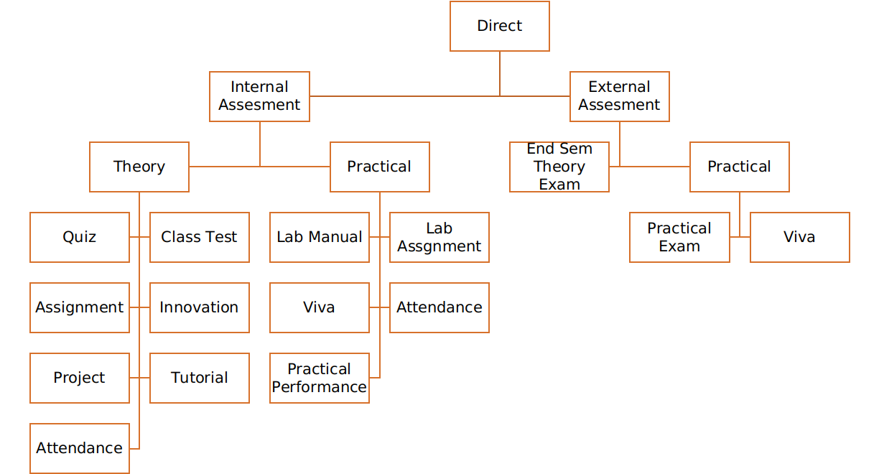
Direct Assessment method – The knowledge and skills learnt by the students are assessed directly from their performance through internal assessment and external assessment processes.
External assessment- Performance of student is recorded in university theory exams, laboratory exams and project evaluation.
Internal assessment- Performance of student is recorded through class assignments and tutorials, internal assessment tests, laboratory assignments, seminars and project progress review and evaluation.
T

Attainment of Course Outcomes (CO’s)
For End Semester Theory and Practical Exams
- Attainment Level 1: If < 45% students scoring ≥60% marks
- Attainment Level 2: If >45-75% students scoring ≥60% marks
- Attainment Level 3: If >75-100% students scoring ≥60% marks
For Internal Theory and Practical Exams
- Attainment Level 1: If <45% students scoring ≥75% marks
- Attainment Level 2: If >45-75% students scoring ≥75% marks
- Attainment Level 3: If >75-100% students scoring ≥75% marks

Weights of Attainments are assigned as per University Evaluation criteria as below for A.Y. 2019-20
1. For all courses except courses marked with (*)
INDUS University End Sem Examinations : Weightage: 40%
Internal Assessment : Weightage: 60%
2. Courses marked with (*)
INDUS University External Examinations : Weightage: 0%
Internal Assessment : Weightage: 100%
Internal Component with COs mapping
SR NO | INTERNAL COMPONENT | CO MAPPED
1 | File Work/Assignments | CO1, CO2, CO3, CO4,CO5,CO6
2 | Class Test | CO1, CO2, CO3, CO4,CO5,CO6
3 | Poster/Chart Preparation | CO2, CO3, CO4
4 | Presentation | CO1, CO2, CO3, CO4,CO5,CO6

Course Attainment

Academic Year 2019-2020

Course Name with Code | MODERN VEHICLE TECHNOLOGY (AU0422)
Class | 4th Semester, Automobile
Faculty Name | J.D.Kamdar

CO Attainment  Internal component | 1 | 2 | 3 | 4 | Internal assessment component total (1 to 5)
CO 1 | 2 | 1 | - | 2 | 1.67
CO 2 | 3 | 2 | 2 | 2 | 2.25
CO 3 | 2 | 3 | - | 3 | 2.67
CO 4 | 3 | 3 | 2 | 2 | 2.5
CO 5 | 3 | 2 | 2 | 2 | 2.25
CO 6 | 3 | 2 | 2 | 2 | 2.25
Indirect Attainment from the student’s feedback for each COs
S.N. | Course Outcome | L | M | H
1 | To Understand and have knowledge about different aspects related to body and chassis. [BT-1] | - | 2.4
2 | To understand various safety provisions. [BT-2] | - | 2.5
3 | To Understand different types of chassis and able to select the section of same. [BT-4] | - | 2.3
4 | To know and explain the present technology which will be boon for the future generation [BT-6] | - | 2.4
5 | Gain knowledge about various modern suspension and braking systems. [BT-2] |  | 2.5
6 | Gain knowledge about Automated tracks for safe and fast travel. [BT-5] |  | 2.2
- Low(L), 2-Medium(M), 3- High(H)

% CO Attainment | Internal Exam | Internal Exam  *0.6 | End sem Exam | End sem Exam*0.4 | Direct Attainment (DA) | Indirect Attainment (IA) | Overall = 0.8*DA +  0.2*IA
CO 1 | 1.67 | 1.002 | 3 | 1.2 | 2.202 | 2.4 | 2.7216
CO 2 | 2.25 | 1.35 | 3 | 1.2 | 2.55 | 2.5 | 2.78
CO 3 | 2.67 | 1.602 | 3 | 1.2 | 2.802 | 2.3 | 2.7016
CO 4 | 2.5 | 1.5 | 3 | 1.2 | 2.7 | 2.4 | 2.76
CO 5 | 2.25 | 1.35 | 3 | 1.2 | 2.55 | 2.5 | 2.78
CO 6 | 2.25 | 1.35 | 3 | 1.2 | 2.55 | 2.2 | 2.72
 | Overall Course Attainment |  |  |  |  |  | 2.74
 | Set Target for the course |  |  |  |  |  | 2.8
 | Course Attainment Status(Yes/No) |  |  |  |  |  | YES

Best Performing CO: | CO3
Least Performing CO | CO2

observations:

1 | The subject is very much related to new technologies in automotive field so focus is more on CO3 & CO4
2 | The new technologies regarding automated track is also made learn for the present scenarios

Plan of Action:

1 | The teaching with more amount of practical approach will be inculcated for the subject
2 | Many new technologies will be compared with each other to define the efficient one for future purpose

Faculty Signature

Attainment of Program Outcomes and Program Specific Outcomes
In the Outcome Based Education, assessment is done through one or more than one processes, carried out by the department, that identify, collect, and prepare data to evaluate the achievement of course outcomes (CO’s) and eventually program outcomes (PO’s).
PO Assessment Process
Direct assessment method –The knowledge and skills learnt by the student are assessed directly from their performance through internal assessment and external assessment processes.
External assessment- Performance of student is recorded in university theory exams, laboratory exams and project evaluation.
Internal assessment- Performance of student is recorded through class assignments and tutorials, internal assessment tests, laboratory assignments, seminars and project progress review and evaluation.
These methods provide a sampling of what students know and/or can do and provide strong evidence of student learning.
 |  | PO Attainment (Range 1-3)
Course Code |  |  | PO1 |  | PO2 | PO3 |  | PO4 |  |  | PO5 |  | PO6 | PO7 | PO8 | PO9 | PO10 | PO11 | PO12
AU0422 |  |  | 1.6 |  | 2.3 | 2.3 |  | 2.3 |  |  | 1.5 |  | 2 | 2 |  |  |  |  | 2
PO Direct Attainment Level (Average)
PO Direct Attainment Level(80%)
Indirect Attainment (20%)
PO Attainment
 | PSO Attainment (Range 1-3)
 | Course Code |  |  | PSO1 |  |  | PSO2 |  |  | PSO3
 | AU0422 |  |  | 2 |  |  | 2.5 |  |  | 2.3
 | PSO Direct Attainment Level(80%)
 | PSO Indirect Attainment (20%)
 | PSO Attainment

