### Name of Institute: Indus Institute of Technology and Engineering (IITE)

### Name of Faculty: Divyangna Gandhi

**Course code: EC0423**

**Course name: Microprocessor & Microcontroller**

Pre-requisites: Digital Electronics, Microprocessor and Computer Architecture

Credit points: 04

Offered Semester: 4th

**Course Coordinator (weeks 15)**

Full Name: Divyangna Gandhi

Department with sitting location: 2nd Floor, Bhanwar Building, EC Lab 5(Digital and

Networking Lab), IITE - IU

Telephone: 3202

Email: [Divyangnagandhi.ec@indusuni.ac.in](mailto:Divyangnagandhi.ec@indusuni.ac.in)

Consultation times: 4:00PM to 4:45PM

**Course Lecturer (weeks 15)**

Full Name: Divyangna Gandhi

Department with sitting location: 2nd Floor, Bhanwar Building, EC Lab 5(Digital and

Networking Lab), IITE - IU

Telephone: 3202

Email: [Divyangnagandhi.ec@indusuni.ac.in](mailto:Divyangnagandhi.ec@indusuni.ac.in)

Consultation times: 4:00PM to 4:45PM

Students will be contacted throughout the session via mail with important information relating to this course.

# Course Objectives

By participating in and understanding all facets of this course a student will:

1) To introduce students to the architecture and operation of microprocessor & microcontrollers.

2) To familiarize students with programming of microcontroller.

3) To introduce students to Embedded C programming

4) To familiarize students to interface various peripherals to the microcontroller.

5) To provide strong foundation for designing real world application using microcontroller.

# Course Outcomes (CO)

1) Asses and solve basic binary math operations using microcontroller.

2) Apply knowledge and demonstrate programming proficiency using various addressing modes and data transfer instructions of the target microcontroller.

3) Compare accepted standards and guidelines to select appropriate microcontroller to meet the specified performance requirement.

4) Analyze assembly and C language programs of a microcontroller

5) Design electrical circuitry for interfacing various peripherals to the microcontroller.

6) Evaluate assembly and C language programs and download the machine code that will provide solutions to the real-world problems.

# Course Outline

Microprocessor architecture and interrupts,

Microcontroller architecture-of MCS -51

Interface I/O devices

C programming of 8051

Design microcontroller based system

Method of delivery

(lectures, self-study material, Active Learning Techniques)

# Study time

(3 Hour’s theory and 2 Hour’s Lab per week)

**CO-PO Mapping (PO: Program Outcomes)**

|  |  |  |  |  |  |  |  |  |  |  |  |  |
| --- | --- | --- | --- | --- | --- | --- | --- | --- | --- | --- | --- | --- |
| **PO CO** | **PO** | | | | | | | | | | | |
| **1** | **2** | **3** | **4** | **5** | **6** | **7** | **8** | **9** | **10** | **11** | **12** |
| **1** | √ |  |  |  |  | √ | √ | √ |  |  |  |  |
| **2** | √ |  |  |  |  | √ | √ | √ |  |  |  |  |
| **3** |  | √ |  |  |  |  |  |  |  |  |  |  |
| **4** |  | √ |  | √ | √ |  |  |  |  | √ |  |  |
| **5** | √ | √ | √ | √ |  |  |  |  |  | √ |  |  |
| **6** | √ |  | √ | √ | √ |  |  |  |  |  |  |  |

# Blooms Taxonomy an

# d Knowledge retention (For reference)

(Blooms taxonomy has been given for reference)

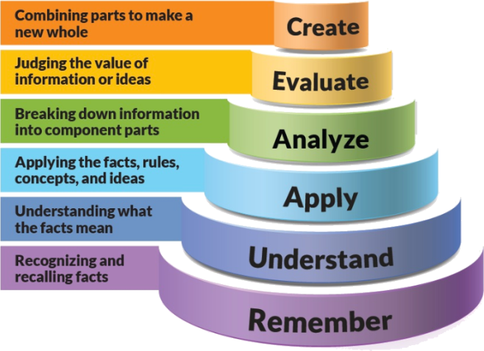

Figure 1: Blooms Taxonomy

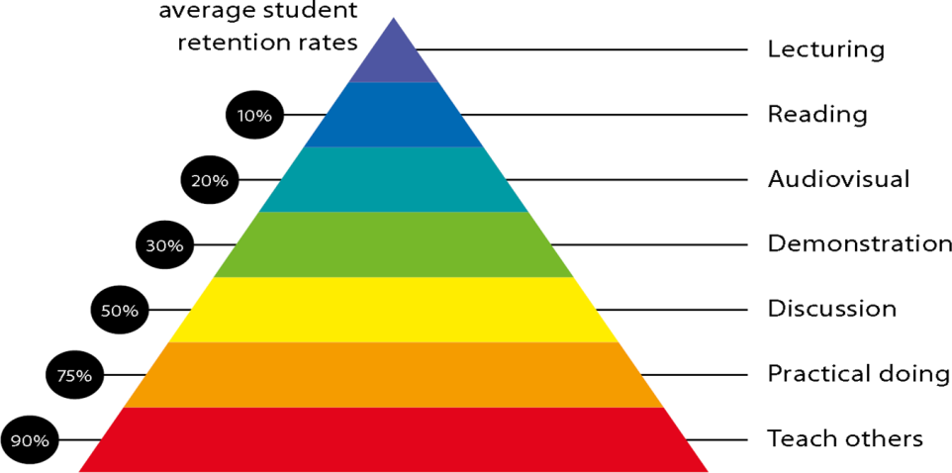

Figure 2: Knowledge retention

# Graduate Qualities and Capabilities covered

(Qualities graduates harness crediting this Course)

|  |  |
| --- | --- |
| **General Graduate Qualities** | **Specific Department of ______Graduate Capabilities** |
| **Informed**  Have a sound knowledge of an area of study or profession and understand its current issues, locally and internationally. Know how to apply this knowledge. Understand how an area of study has developed and how it relates to other areas. | **1 Professional knowledge, grounding & awareness** |
| **Independent learners**  Engage with new ideas and ways of thinking and critically analyze issues. Seek to extend knowledge through ongoing research, enquiry and reflection. Find and evaluate information, using a variety of sources and technologies. Acknowledge the work and ideas of others. | **2 Information literacy, gathering & processing** |
| **Problem solvers**  Take on challenges and opportunities. Apply creative, logical and critical thinking skills to respond effectively. Make and implement decisions. Be flexible, thorough, innovative and aim for high standards. | **4 Problem solving skills** |
| **Effective communicators**  Articulate ideas and convey them effectively using a range of media. Work collaboratively and engage with people in different settings. Recognize how culture can shape communication. | **5 Written communication** |
| **6 Oral communication** |
| **7 Teamwork** |
| **Responsible**  Understand how decisions can affect others and make ethically informed choices. Appreciate and respect diversity. Act with integrity as part of local, national, global and professional communities. | **10 Sustainability, societal & environmental impact** |

# Lecture/tutorial times

***Example:***

**Lecture** **Thursday 03.10 – 04.05AM Room B-225**

**Lecture** **Thursday 10.50 – 11.45AM Room B-225**

**Lecture Friday 11:45 – 12.40PM Room B-225**

**Lab Wednesday 03:10 - 05:00PM EC Lab 5**

# Attendance Requirements

The University norms states that it is the responsibility of students to attend all lectures, tutorials, seminars and practical work as stipulated in the Course outline. Minimum attendance requirement as per university norms is compulsory for being eligible for mid and end semester examinations.

# Details of referencing system to be used in written workText books

|  |  |
| --- | --- |
| Text books | 1. Microprocessor Architecture, Programming, and Applications with the 8085, By Romesh Gaonkar, Penram International Publishing (India) LTD. |
| The 8051 Microcontroller and Embedded Systems Using Assembly and C, 2/e by Muhammad  Ali Mazidi, Janice Gillispie Mazidi and Rolin McKinlay ( Second Edition , Pearson Education) |
| The Definitive Guide to ARM® Cortex®-M3 and Cortex®-M4 Processors, by Joseph Yiu,  Publisher: Elsevier, ISBN: 9789351071754, 9351071758 |
| Reference book | The 8051 Microcontroller & Embedded Systems using Assembly and C By K. J. Ayala, D. V.  Gadre (Cengage Learning, India Edition). |
| Using the MCS-51 Microcontrollers By Han Way Huang Oxford Uni Press |
| Programming and Customizing the 8051 Microcontroller by Myke Predko Tata Mcgraw Hill. |

# Additional Materials

|  |
| --- |
| NPTEL- Lecture  1. Microcontroller Course  (http://nptel.ac.in/courses/Webcoursecontents/IITKANPUR/microcontrollers/micro/ui/TOC.htm)  2. Microcontroller & Microprocessor Course:  https://nptel.ac.in/courses/108/105/108105102/ |

# ASSESSMENT GUIDELINES

Your final course mark will be calculated from the following:

**Example:**

Midterm Exam 40% Objective (1-6)

Presentation 5% Objectives (2-5)

Attendance 5%

Assignment 10% Objectives (2-5)

**Final exam** (*closed book*) 40% Objectives (1-6)

# SUPPLEMENTARY ASSESSMENT

Students who receive an overall mark less than 40% in mid semester or end semester will be considered for supplementary assessment in the respective components (i.e mid semester or end semester) of semester concerned. Students must make themselves available during the supplementary examination period to take up the respective components (mid semester or end semester) and need to obtain the required minimum 40% marks to clear the concerned components.

# Late Work

Late assignments will not be accepted without supporting documentation. Late submission of the reports will result in a deduction of -% of the maximum mark per calendar day

# Format

All assignments must be presented in a neat, legible format with all information sources correctly referenced. **Assignment material handed in throughout the session that is not neat and legible will not be marked and will be returned to the student.**

# Retention of Written Work

Written assessment work will be retained by the Course coordinator/lecturer for two weeks after marking to be collected by the students.

# University and Faculty Policies

Students should make themselves aware of the University and/or Faculty Policies regarding plagiarism, special consideration, supplementary examinations and other educational issues and student matters.

**Plagi**a**rism** - Plagiarism is not acceptable and may result in the imposition of severe penalties. Plagiarism is the use of another person’s work, or idea, as if it is his or her own - if you have any doubts at all on what constitutes plagiarism, please consult your Course coordinator or lecturer. Plagiarism will be penalized severely.

***Do not copy the work of other students.***

***Do not share your work with other students (except where required for a group activity or assessment)***

# Course schedule

|  |  |  |  |  |  |  |
| --- | --- | --- | --- | --- | --- | --- |
|  | **Week 15** | **Topic & contents** | | **CO Addressed** | | **Teaching Learning Activity (TLA)** |
|  | Weeks 1 | To aware students with theoretical and practical syllabus, assessment scheme for theory (CIE, End sem exam), practical (CIE, End sem exam) and all the details about subject activities has to be carry out throughout the semester | | 1,2 | | BB,PPT |
| Introduction to Microprocessor  based systems | |
| Weeks 2 | 8085 architectures, pin functions of  8085 | | 1,2 | | BB,PPT |
| Week 3 | Instruction set of 8085  processor | | 2,3 | | BB,PPT |
| Week 4 | Introduction to 8051  microcontroller, it  architecture, Registers,  Memory organization | | 1,2,3 | | BB,PPT |
| Week 5 | Instruction set of 8051,  addressing modes of 8051 | | 1,2,3 | | BB,PPT,Assignment |
|  | Week 6 | Embedded C programming of  8051 | 1,2,3 | | BB,PPT | |
| Week 7 | Timer / Counter programming  of 8051 in assembly and C | 3,4,5 | | BB,PPT | |
| Week 8 | Serial port programming of  8051 in assembly and C | 3,4,5 | | BB,PPT | |
| Week 9 | Interrupt programming of  8051 in assembly and C | 3,4,5 | | BB,PPT | |
|  | Week 10 | Interfacing of Peripherals such  as LED, Switch, 7 Segment  Display and LCD | 4,5,6 | | BB,PPT | |
| Week 11 | Interfacing of A/D and D/A  Converter, DC Motor and  Stepper motor interfacing | 4,5 | | BB,PPT, Assignment | |
|  | Week 12 | Introduction to Cortex-M  family, Advantages of Cortex-  M, Application of ARM Cortex- | 1,2,3 | | BB,PPT,Seminar | |
|  | Week 13 | Architecture of Cortex - M  processor, Introduction to  Instruction set | 3,4,5 | | BB,PPT, Seminar | |
|  | Week 14 | programming of ARM Cortex-M processor | 4,5,6 | | BB,PPT, Seminar | |
|  | Week 15 | Revision |  | | BB,PPT | |

**2nd Year**

**Differential Equations and Integral Transforms**

**SH0301**

**Control theory**

**EC0305**

**Analog electronics**

**EC0304**

**Human values & professional Ethics**

**SH0307**

**Object oriented computer programming**

**EC0302**

**Network analysis**

**EC0303**

**Digital logic design**

**EC0301**

***4th Semester***

**Linear Integrated Circuits**

**EC0401**

**Electromagnetics**

**EC0404**

**Complex Analysis and Numerical Methods**

**SH0401**

**Digital systems design**

**EC0405**

**Cyber security & Intellectual Property Rights**

**CE0407**

**Microprocessor & computer architecture**

**EC0402**

**Signals & systems**

**EC0403**

**3rd Year**

***6th Semester***

**4th Year**

***8th Semester***

**Digital signal processing**

**EC0501**

**Microcontroller and interfacing**

**EC0503**

**Analog communication systems**

**EC0504**

**Electronics measurements and instrumentation**

**EC0502**

**Technical Communication and Soft Skills**

**SH0507**

**Microwave engineering**

**EC0505**

**Probability and random process**

**EC0506**

**Digital Communication**

**EC0601**

**Antenna & Wave Propagation**

**EC0602**

**Wireless communication**

**EC0603**

**VLSI Design**

**EC0604**

**Advanced Technical Communication And Soft Skills**

**SH0607**

**Power Electronics EC0606**

**Video Engineering EC0605**

**Elective II**

**Elective I**

**Radar and Navigation EC0607**

**Advanced Processor EC0608**

**Error Correcting Codes EC0609**

**Embedded System**

**EC0701**

**Satellite communication**

**EC0702**

**Image and Video Processing EC0703**

**Data Communication Networks**

**EC0704**

**Disaster Management**

**CV0712**

**Elective III**

**Advanced Mobile Communication EC0706**

**Cryptography and Network Security EC0707**

**Raspberry pi platform and python programming for raspberry pi by coursera (MOOC Course) EC0708**

**Project**

**EC0801**

**Basic Electronics**

***7th Semester***

***5th Semester***

***3rd Semester***

**1st Year**