### Name of Institute: Indus Institute of Technology and Engineering (IITE)

### Name of Faculty: Divyangna Gandhi

**Course code: EC0422**

**Course name: Modern Communication Trends**

Pre-requisites: Analog Communication and Digital Communication

Credit points: 03

Offered Semester: 4th

**Course Coordinator (weeks 15)**

Full Name: Divyangna Gandhi

Department with sitting location: 2nd Floor, Bhanwar Building, EC Lab 5(Digital and

Networking Lab), IITE - IU

Telephone: 3202

Email: [Divyangnagandhi.ec@indusuni.ac.in](mailto:Divyangnagandhi.ec@indusuni.ac.in)

Consultation times: 4:00PM to 4:45PM

**Course Lecturer (weeks 15)**

Full Name: Divyangna Gandhi

Department with sitting location: 2nd Floor, Bhanwar Building, EC Lab 5(Digital and

Networking Lab), IITE - IU

Telephone: 3202

Email: [Divyangnagandhi.ec@indusuni.ac.in](mailto:Divyangnagandhi.ec@indusuni.ac.in)

Consultation times: 4:00PM to 4:45PM

Students will be contacted throughout the session via mail with important information relating to this course.

# Course Objectives

By participating in and understanding all facets of this course a student will:

1. To understand the basic concepts of modulation techniques including amplitude modulation frequency modulation (FM) and phase modulation (PM) that are widely used in analogue communication systems.
2. To understand the basic concepts of a digital communication system including sampling theorem, pulse code modulation (PCM) and principles of digital data transmission, and basic techniques.
3. To study the concept of cellular system design.
4. To understand mobile technologies like GSM and CDMA.
5. To learn the basic elements of optical fiber transmission link, fiberglass modes, configurations and structures
6. To learn various optical sources, LED/LASER structures, receivers (PIN, APD), and noise performance
7. To provide understanding of different concepts used in a satellite communication system.

# Course Outcomes (CO)

1. Use of different modulation and demodulation techniques used in analog & Digital communication.
2. Apply the sampling theorem to digitize the analog signal and recover original signal without any distortion.
3. Understand evolution of mobile communication generations 2G, 2.5G, and 3G with their characteristics and limitations.
4. Understand emerging technologies required for fourth generation mobile system such as SDR, MIMO etc.
5. Apply the fundamental principles of optics and light wave to design optical fiber communication systems.
6. Understands the basics of satellite communication and its different applications

# Course Outline

**UNIT-I**

**Principles of modern communication system**                    [7 hours]

Introduction, Communication Process, Channel Effect, Signal to noise ration & capacity, Amplitude modulation, Angle modulation, Sampling theorem, Pulse code modulation, Digital modulation techniques

**UNIT-II**

**Wireless communication system** [8 hours]

Introduction to Wireless Communication System-Evolution of mobile communications, the Cellular Concept System Design Fundamentals-Cellular system, Hexagonal geometry cell and concept of frequency reuse, Channel Assignment Strategies Distance to frequency reuse ratio, Channel & co-channel interference reduction factor, S/I ratio consideration and calculation for Minimum Co-channel and adjacent interference, Handoff Strategies, Umbrella Cell Concept, Trunking and Grade of Service, Improving Coverage & Capacity in Cellular System-cell splitting, Cell sectorization, Repeaters, Micro cell zone concept, GSM,CDMA,OFDM & MIMO.

**UNIT-III**

**Optical communication** [7hours]

Evolution of Light wave systems, System components, Optical fibers – Step Index & Graded index -Mode theory, Numerical Aperture Fiber Losses, Optical transducer (LED, LASER, PIN and APD), FSO – Introduction, Block diagram, Application Advantages & Limitation, Comparison of FSO with Fiber optics & other technologies.

**UNIT-IV**

**Satellite Communication** [8 hours]

Introduction to Satellite Communication, - Benefits of Satellite Communication, Types of

Satellites, Satellite Services, satellite frequency bands, Satellite Orbits and Orbital Parameters- Types of orbits, Kepler’s Law, Orbital elements, Satellite orbits, Satellite Location from an Earth Station, Modern Developments and Future Trends- Micro- and Nanosatellites, Satellite Laser Communication, Software-defined Radio Technology.

# Method of delivery

(lectures, self-study material, Active Learning Techniques)

# Study time

(3 Hour’s theory per week)

**CO-PO Mapping (PO: Program Outcomes)**

|  |  |  |  |  |  |  |  |  |  |  |  |  |
| --- | --- | --- | --- | --- | --- | --- | --- | --- | --- | --- | --- | --- |
| **PO CO** | **PO** | | | | | | | | | | | |
| **1** | **2** | **3** | **4** | **5** | **6** | **7** | **8** | **9** | **10** | **11** | **12** |
| **1** | √ |  |  |  |  | √ | √ | √ |  |  |  |  |
| **2** | √ |  |  |  |  | √ | √ | √ |  |  |  |  |
| **3** |  | √ |  |  |  |  |  |  |  |  |  |  |
| **4** |  | √ |  | √ | √ |  |  |  |  | √ |  |  |
| **5** | √ | √ | √ | √ |  |  |  |  |  | √ |  |  |
| **6** | √ |  | √ | √ | √ |  |  |  |  |  |  |  |

# Blooms Taxonomy an

# d Knowledge retention (For reference)

(Blooms taxonomy has been given for reference)

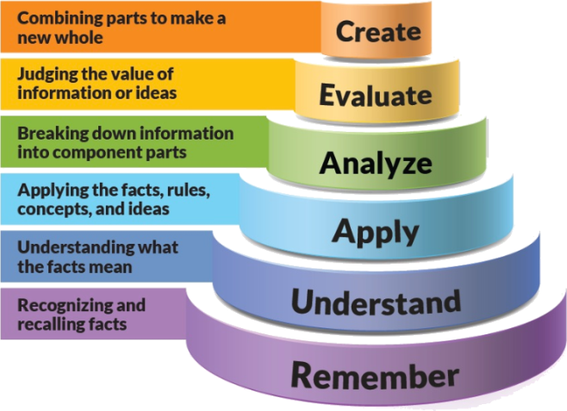

Figure 1: Blooms Taxonomy

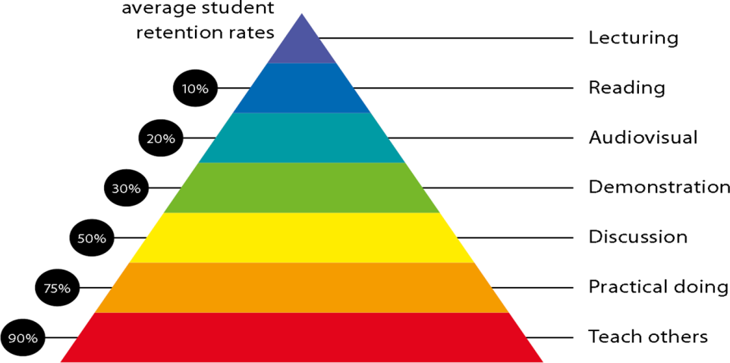

Figure 2: Knowledge retention

# Graduate Qualities and Capabilities covered

(Qualities graduates harness crediting this Course)

|  |  |
| --- | --- |
| **General Graduate Qualities** | **Specific Department of ______Graduate Capabilities** |
| **Informed**  Have a sound knowledge of an area of study or profession and understand its current issues, locally and internationally. Know how to apply this knowledge. Understand how an area of study has developed and how it relates to other areas. | **1 Professional knowledge, grounding & awareness** |
| **Independent learners**  Engage with new ideas and ways of thinking and critically analyze issues. Seek to extend knowledge through ongoing research, enquiry and reflection. Find and evaluate information, using a variety of sources and technologies. Acknowledge the work and ideas of others. | **2 Information literacy, gathering & processing** |
| **Problem solvers**  Take on challenges and opportunities. Apply creative, logical and critical thinking skills to respond effectively. Make and implement decisions. Be flexible, thorough, innovative and aim for high standards. | **4 Problem solving skills** |
| **Effective communicators**  Articulate ideas and convey them effectively using a range of media. Work collaboratively and engage with people in different settings. Recognize how culture can shape communication. | **5 Written communication** |
| **6 Oral communication** |
| **7 Teamwork** |
| **Responsible**  Understand how decisions can affect others and make ethically informed choices. Appreciate and respect diversity. Act with integrity as part of local, national, global and professional communities. | **10 Sustainability, societal & environmental impact** |

# Lecture/tutorial times

***Example:***

**Lecture** **Monday 09.55 – 10.50AM Room LH-22**

**Lecture Tuesday 02:15 – 03.10PM Room LH-22**

**Lecture Friday 01:20 - 2:15PM Room LH-22**

# Attendance Requirements

The University norms states that it is the responsibility of students to attend all lectures, tutorials, seminars and practical work as stipulated in the Course outline. Minimum attendance requirement as per university norms is compulsory for being eligible for mid and end semester examinations.

# Details of referencing system to be used in written workText books

|  |  |
| --- | --- |
| Text books | 1. Modern Digital and Analog Communication Systems by B.P.Lathi 4th edition , Oxford |
| 1. Wireless Communications: Principles and Practice by Theodore Rappaport 2nd edition Pearson. |
| 1. Optical Fiber communication by Gerd keiser 4th edition TMH. |
| 1. Satellite communication by R.N.Mutagi, 1st edition Oxford university press. |
| Reference book | 1. Satellite communication by dennis Roddy 4th edition TMH |
| 1. Optical Fiber communication principles & practice by John M. Senior 4th edition pearson |
| 1. Wireless Communications by T.L.singal 1st edition TMH |

# Additional Materials

|  |
| --- |
| NPTEL- Lecture  1. http://nptel.ac.in/courses/117105144  2. http://nptel.ac.in/courses/11710206  3. http://nptel.ac.in/downloads/117101054/  4. http://nptel.ac.in/courses/117105131 |

# ASSESSMENT GUIDELINES

Your final course mark will be calculated from the following:

**Example:**

Midterm Exam 40% Objective (1-6)

Presentation 5% Objectives (2-5)

Attendance 5%

Assignment 10% Objectives (2-5)

**Final exam** (*closed book*) 40% Objectives (1-6)

# SUPPLEMENTARY ASSESSMENT

Students who receive an overall mark less than 40% in mid semester or end semester will be considered for supplementary assessment in the respective components (i.e mid semester or end semester) of semester concerned. Students must make themselves available during the supplementary examination period to take up the respective components (mid semester or end semester) and need to obtain the required minimum 40% marks to clear the concerned components.

# Late Work

Late assignments will not be accepted without supporting documentation. Late submission of the reports will result in a deduction of -% of the maximum mark per calendar day

# Format

All assignments must be presented in a neat, legible format with all information sources correctly referenced. **Assignment material handed in throughout the session that is not neat and legible will not be marked and will be returned to the student.**

# Retention of Written Work

Written assessment work will be retained by the Course coordinator/lecturer for two weeks after marking to be collected by the students.

# University and Faculty Policies

Students should make themselves aware of the University and/or Faculty Policies regarding plagiarism, special consideration, supplementary examinations and other educational issues and student matters.

**Plagi**a**rism** - Plagiarism is not acceptable and may result in the imposition of severe penalties. Plagiarism is the use of another person’s work, or idea, as if it is his or her own - if you have any doubts at all on what constitutes plagiarism, please consult your Course coordinator or lecturer. Plagiarism will be penalized severely.

***Do not copy the work of other students.***

***Do not share your work with other students (except where required for a group activity or assessment)***

# Course schedule

|  |  |  |  |  |  |  |
| --- | --- | --- | --- | --- | --- | --- |
|  | **Week 15** | **Topic & contents** | | **CO Addressed** | | **Teaching Learning Activity (TLA)** |
|  | Weeks 1 | To aware students with theoretical and practical syllabus, assessment scheme for theory (CIE, End sem exam), practical (CIE, End sem exam) and all the details about subject activities has to be carry out throughout the semester | | 1,2  1,2 | | BB,PPT |
| Communication Process, Channel Effect, Signal to noise ration & capacity | |
| Weeks 2 | Amplitude modulation, Angle modulation, Sampling theorem | | 1,2 | | BB,PPT |
| Week 3 | Pulse code modulation, Digital  modulation techniques | | 3,4 | | BB,PPT |
| Week 4 | Introduction to Wireless Communication System-Evolution of mobile communications, The Cellular Concept System Design Fundamentals-Cellular system, Hexagonal geometry cell and concept of frequency reuse, | | 3,4 | | BB,PPT |
| Week 5 | Channel Assignment Strategies,  Channel & co-channel interference reduction factor, S/I ratio consideration and calculation for minimum Co-channel and adjacent interference, Handoff Strategies | | 1,2 | | BB,PPT |
|  | Week 6 | Umbrella Cell Concept, Trunking and Grade of Service, Improving Coverage & Capacity in Cellular System-cell splitting, Cell sectorization, Repeaters, Micro cell zone concept | 3,4 | | BB,PPT | |
| Week 7 | GSM,CDMA,OFDM & MIMO | 3,4 | | BB,PPT | |
| Week 8 | Evolution of Light wave systems, System components, Optical fibers – Step Index & Graded index -Mode theory, Numerical Aperture Fiber Losses | 4,5 | | BB,PPT | |
| Week 9 | Optical transducer (LED, LASER, PIN  and APD),FSO – Introduction ,Block diagram, Application Advantages & Limitation, Comparison of FSO with Fiber optics & other technologies | 5 | | BB,PPT | |
|  | Week 10 | Ground wave propagation, terrain and earth curvature effects, tropospheric propagation, fading, diffraction and scattering, Space wave propagation. | 4,5 | | BB,PPT | |
| Week 11 | Satellite Orbits and Orbital Parameters-  Types of orbits, Kepler’s Law, Orbital elements ,Satellite orbits | 1,2 | | BB,PPT | |
|  | Week 12 | Satellite Location from an Earth Station, Modern Developments and Future Trends- Micro- and Nanosatellites | 2,3 | | BB,PPT | |
|  | Week 13 | Satellite Laser Communication, Software-defined Radio Technology | 4,5 | | BB,PPT | |
|  | Week 14 | Satellite Orbits and Orbital Parameters-  Types of orbits, Kepler’s Law, Orbital elements ,Satellite orbits | 5,6 | | BB,PPT | |
|  | Week 15 | Revision |  | | BB,PPT | |

**2nd Year**

**Differential Equations and Integral Transforms**

**SH0301**

**Control theory**

**EC0305**

**Analog electronics**

**EC0304**

**Human values & professional Ethics**

**SH0307**

**Object oriented computer programming**

**EC0302**

**Network analysis**

**EC0303**

**Digital logic design**

**EC0301**

***4th Semester***

**Linear Integrated Circuits**

**EC0401**

**Electromagnetics**

**EC0404**

**Complex Analysis and Numerical Methods**

**SH0401**

**Digital systems design**

**EC0405**

**Cyber security & Intellectual Property Rights**

**CE0407**

**Microprocessor & computer architecture**

**EC0402**

**Signals & systems**

**EC0403**

**3rd Year**

***6th Semester***

**4th Year**

***8th Semester***

**Digital signal processing**

**EC0501**

**Microcontroller and interfacing**

**EC0503**

**Analog communication systems**

**EC0504**

**Electronics measurements and instrumentation**

**EC0502**

**Technical Communication and Soft Skills**

**SH0507**

**Microwave engineering**

**EC0505**

**Probability and random process**

**EC0506**

**Digital Communication**

**EC0601**

**Antenna & Wave Propagation**

**EC0602**

**Wireless communication**

**EC0603**

**VLSI Design**

**EC0604**

**Advanced Technical Communication And Soft Skills**

**SH0607**

**Power Electronics EC0606**

**Video Engineering EC0605**

**Elective II**

**Elective I**

**Radar and Navigation EC0607**

**Advanced Processor EC0608**

**Error Correcting Codes EC0609**

**Embedded System**

**EC0701**

**Satellite communication**

**EC0702**

**Image and Video Processing EC0703**

**Data Communication Networks**

**EC0704**

**Disaster Management**

**CV0712**

**Elective III**

**Advanced Mobile Communication EC0706**

**Cryptography and Network Security EC0707**

**Raspberry pi platform and python programming for raspberry pi by coursera (MOOC Course) EC0708**

**Project**

**EC0801**

**Basic Electronics**

***7th Semester***

***5th Semester***

***3rd Semester***

**1st Year**