### Name of Institute: Institute of Technology & Engineering

### Name of Faculty: Prof. Miloni Ganatra

**Course code: EC0117**

**Course name: Electronics Simulation & Design Lab**

Pre-requisites: Semiconductor Physics

Credit points: III

Offered Semester: I

**Course Coordinator (weeks 15)**

Full Name: Miloni Ganatra

Department with sitting location: 2nd Floor, EEE lab 2 , Bhanwar Building

Telephone: 9974592124

Email: miloniganatra.ee@indusuni.ac.in

Consultation times: Monday,Tuesday 3:45 to 4:15pm ,All working Saturdays

**Course Lecturer (weeks 15)**

Full Name: Miloni Ganatra

Department with siting location: 2nd Floor, EEE lab 2 , Bhanwar Building

Telephone: 9974592124

Email: miloniganatra.ee@indusuni.ac.in

Consultation times: Monday,Tuesday 3:45 to 4:15pm,All working Saturdays

Students will be contacted throughout the session via mail with important information relating to this course.

# Course Objectives

By participating in and understanding all facets of this Course a student will be able:

1. To describe the concepts of semiconductor physics.

2. To analyze and recognize basic electronic components and devices used for different electronic functions.

3. To analyze the design and test basic electronic circuits using active components.

4. To describe problem solving techniques in simple electronic circuits

# Course Outcomes (CO)

1. Develop skill in selection and use of commonly used tools, equipment, components in a given situation.

2. Develop skill in wiring, soldering and de-soldering works

3. Develop skill in tracing circuits of simple (analog and digital) electronic assembly.

4. Student gets hands-on assembling, testing, assembling, dismantling, fabrication and repairing systems by making use of the various tools and instruments available in the Electronics Workshop.

**Course Outline**

|  |  |  |
| --- | --- | --- |
| **Sr. No** | **Title** | **Learning Outcomes** |
| 1. | Subtopic 1-Introduction to Basic electronic components/  Testing /Soldering |  |
| 1.1 | Study of various types of Active & Passive Components based on their ratings and to draw symbols of various  electronic components on drawing sheets. | To identify different active and passive  components and to make a comparative analysis. |
| 1.2 | Familiarization/Application of testing instruments and commonly used equipments.[Multimeter, Function generator, Power supply, CRO etc] | To learn the use of voltage source and testing/ measuring instruments. |
| 1.3 | Measuring/Testing of electronic components [Resistor, Capacitor, Diode, Transistor, UJT and JFET using multimeter] | Compare the measured values with the calculated values by using measuring/testing instruments |
| 1.4 | Sketch, mount and test at least six from following electronic circuit on bread board:   * T type attenuator * π-type attenuator * Forward/reverse biased PN Junction diode * Transistor as a switch * Opto coupler using LED & Photo diode * Light operated relay * Diode clipper * Diode clamper * (j) +/- 5V Regulated power supply with LED indication | To design and test various electronic circuits using  commonly used workshop tools. |

|  |  |  |
| --- | --- | --- |
| 1.5 | Soldering shop: Inter-connection methods and soldering practice using general purpose PCB for any two following electronic circuits with all safety precautions.   * Fabrication of DC regulated power supply/ Variable power supply using LM317 * Forward/reverse biased PN Junction diode * Zener diode as shunt regulator * Half wave Rectifier, Full wave & Bridge rectifier * Light operated relay * Diode clipper * Diode clamper * Low pass filter, High pass filter * Band pass filter, Band reject filter | To learn the soldering techniques with necessary safety for building and wiring electronic circuits. |
| 1.6 | De-solder any two electronic circuits from the following list with all safety precautions   * Fabrication of DC regulated power supply/ Variable power supply using LM317 * Forward/reverse biased PN Junction diode * Zener diode as shunt regulator * Half wave Rectifier, Full wave & Bridge rectifier * Light operated relay * Diode clipper * Diode clamper * Low pass filter, High pass filter * Band pass filter, Band reject filter | To de-solder the electronic circuit using de-solder pump, De-solder wick etc. |
| 2. | Subtopic 2-PCB Design |  |
| 2.1 | Identification of various types of Printed Circuit Boards (PCB) | To learn different PCB’s. |
| 2.2 | Introduction to PCB design software | To learn the PCB design software. |
| 2.3. | PCB Lab: a. Artwork & printing of a simple PCB.  b. Etching & drilling of PCB. | To learn the basic steps involved in PCB designing. |

|  |  |  |
| --- | --- | --- |
| 2.4 | 1. To prepare layout (manually) of a given circuit on paper. 2.To draw schematic and layout of given electronic circuit using any PCB design software:  Fixed voltage power supply with transformer,  rectifier diode, capacitor filter, zener/IC regulator.  LED blinking circuit using a stable multi-vibrator with transistor BC 107.  Square wave generation using IC 555 timer in IC base.  Sine wave generation using IC 741 OP-AMP in IC base.  RC coupled amplifier with transistor BC 107.  AND , NAND gates in diode transistor logic. | To design PCB layout manually.  To draw the schematic and layout of given electronic  circuit using any simple PCB design software. |
| 2.5 | Trace electronic circuit from the given PCB layout of an electronic circuit. | To trace circuit from given PCB  layout on the PCB. |
| 3. | Subtopic 3- Simulation using EDA software (PSpice, MultiSim, Proteus or CircuitLab) |  |
| 3.1 | Design and simulation of function generator to generate sine wave, square wave and ramp signal. | To design and simulate function generator using EDA software. |
| 3.2 | Verification of Network Theorems: Thevenins, Nortons and Maximum power Transfer. | To design, simulate and verify network theorems using  EDA software. |
| 4. | Subtopic 4- Mini Project- (Any one) with brief Project Report |  |
| 4.1 | [Simple Microphone to Speaker Amplifier Circuit](https://circuitdigest.com/electronic-circuits/simple-microphone-to-speaker-circuit) | To fabricate PCB & build the given circuit on the PCB.  To test the assembled circuit on PCB.  To prepare project report in proper format. |
| 4.2 | AC to DC converter circuit |
| 4.3 | [Soft Start Circuit for Power Supply](https://circuitdigest.com/electronic-circuits/soft-start-circuit-for-power-supply) |
| 4.4 | [Voltage Regulator Circuits](https://circuitdigest.com/electronic-circuits/voltage-regulators) |
| 4.5 | [Way Light Switch](https://circuitdigest.com/electronic-circuits/2-way-light-switch) |
| 4.6 | [Temperature Controlled DC Fan using Thermistor](https://circuitdigest.com/electronic-circuits/temperature-controlled-dc-fan-using-thermistor) |
| 4.7 | [Automatic Street Light Controller Circuit Using Relay and](https://circuitdigest.com/electronic-circuits/automatic-street-light-controller-circuit) LDR |
| 4.8 | Music Operated Dancing LEDs |
| 4.9 | [Door Bell using IC 555](https://circuitdigest.com/electronic-circuits/doorbell-circuit) |
| 4.10 | [Water Level Indicator Alarm](https://circuitdigest.com/electronic-circuits/water-level-indicator-alarm-circuit) |

**Text Books:**

1. Printed Circuit Boards: Design and Technology Bossart TMH, 2008 or latest edition
2. Modern World Transistor Data & Its Equivalent Lotia, M. B P B, 2008
3. Muhammed H Rashid, “Introduction to PSpice using OrCAD for circuits and electronics”, 3rd Edition, Prentice Hall, 2003.
4. Electronic Formulas, Tables Symbols Sharma, M.C B P B, 2008
5. Everyday Electronics Data Book Mike Tooley B P B, 2015

**Reference Books:**

1. Build Your Own Printed Circuit Board Al Williams Mc GrawHill, 2003 or latest edition Reference Book
2. Making Printed Circuit Boards Jan Axelsen Mc GrawHill, 1993 or latest edition
3. Hobby Electronics Project Special BPB B P B, 2011

**Web Resources**

1. http://eecs.vanderbilt.edu/courses/ee213/Breadboard.htm
2. http://eecs.vanderbilt.edu/courses/ee213/Breadboard.htm
3. http://wiring.org.co/learning/tutorials/breadboard/index.html
4. <http://www.kpsec.freeuk.com>
5. http://courses.engr.illinois.edu/ece343/breadboard.html

**Method of delivery**

Lectures, Power Point Slides, Tutorial, Quiz, Test

# Study time

2 Hour Lecture, 4 Hours of Lab

# CO-PO Mapping (PO: Program Outcomes)

|  |  |  |  |  |  |  |  |  |  |  |  |  |
| --- | --- | --- | --- | --- | --- | --- | --- | --- | --- | --- | --- | --- |
| **PO CO** | **PO** | | | | | | | | | | | |
| **1** | **2** | **3** | **4** | **5** | **6** | **7** | **8** | **9** | **10** | **11** | **12** |
| **1** | √ |  |  |  |  | √ | √ | √ |  |  |  |  |
| **2** | √ |  | √ |  |  | √ | √ | √ |  |  |  |  |
| **3** |  | √ |  | √ |  |  |  |  |  | √ |  |  |
| **4** |  | √ | √ | √ |  |  |  |  |  | √ |  |  |

(Blooms taxonomy has been given for reference)

# Blooms Taxonomy and Knowledge retention (For reference)

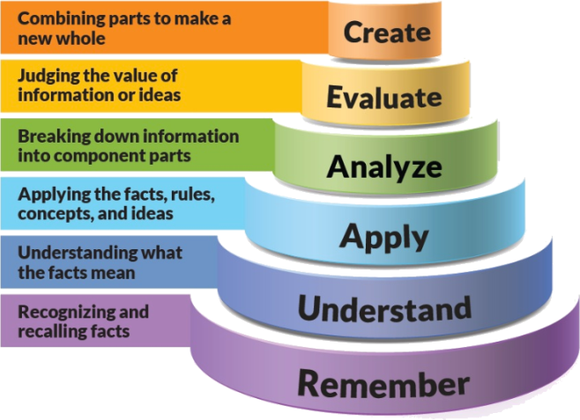

Figure 1: Blooms Taxonomy

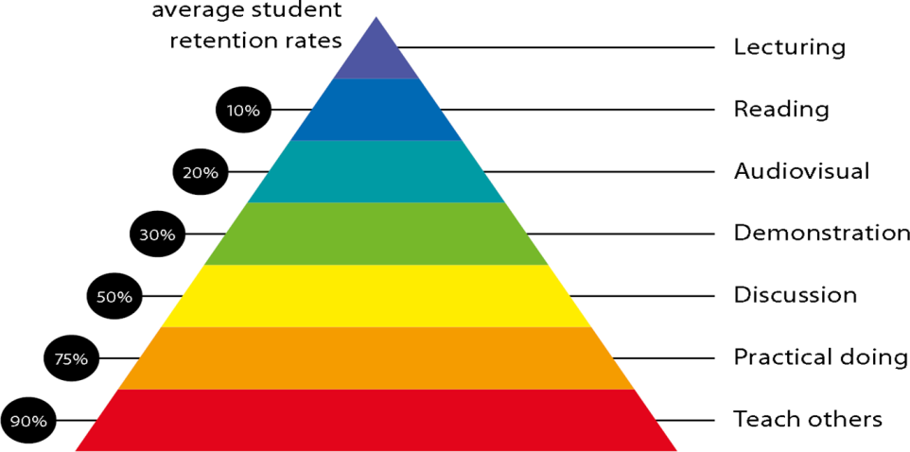

Figure 2: Knowledge retention

# Graduate Qualities and Capabilities covered

(Qualities graduates harness crediting this Course)

|  |  |
| --- | --- |
| **General Graduate Qualities** | **Specific Department of ______Graduate Capabilities** |
| **Informed**  Have a sound knowledge of an area of study or profession and understand its current issues, locally and internationally. Know how to apply this knowledge. Understand how an area of study has developed and how it relates to other areas. | **1 Professional knowledge, grounding & awareness** |
| **Independent learners**  Engage with new ideas and ways of thinking and critically analyze issues. Seek to extend knowledge through ongoing research, enquiry and reflection. Find and evaluate information, using a variety of sources and technologies. Acknowledge the work and ideas of others. | **2 Information literacy, gathering & processing** |
| **Problem solvers**  Take on challenges and opportunities. Apply creative, logical and critical thinking skills to respond effectively. Make and implement decisions. Be flexible, thorough, innovative and aim for high standards. | **4 Problem solving skills** |
| **Effective communicators**  Articulate ideas and convey them effectively using a range of media. Work collaboratively and engage with people in different settings. Recognize how culture can shape communication. | **5 Written communication** |
| **6 Oral communication** |
| **7 Teamwork** |
| **Responsible**  Understand how decisions can affect others and make ethically informed choices. Appreciate and respect diversity. Act with integrity as part of local, national, global and professional communities. | **10 Sustainability, societal & environmental impact** |

# Practical work:

4 Hours of Lab

|  |  |
| --- | --- |
| Sr. No. | Experiment |
| 1 | Study of various types of Active & Passive Components |
| 2 | Familiarization/Application of testing instruments and commonly used equipments |
| 3 | To Study V-I Characteristics of P-N Junction diode |
| 4 | To study Clipper Circuit |
| 5 | To Study Clamper Circuit |
| 6 | To Study Half Wave Rectifier Circuit |
| 7 | To Study Full Wave Rectifier Circuit |
| 8 | To verify Thevenions Theorem in Multisim |
| 9 | To verify Nortons Theorem in Multisim |
| 10 | To Study Printed Circuit Design |

# Lecture/tutorial times

Theory:

Monday : 1:20-2:15

Tuesday : 2:15 -3:10

Laboratory:

Wednesday : 9:00-10:50

Friday : 1:20- 3:10

# Attendance Requirements

The University norms states that it is the responsibility of students to attend all lectures, tutorials, seminars and practical work as stipulated in the course outline. Minimum attendance requirement as per university norms is compulsory for being eligible for semester examinations.

# ASSESSMENT GUIDELINES

Your final course mark will be calculated from the following:

MSE-40 Marks

Seminar Presentation-10 Marks

Quiz-10 Marks

Final exam (closed book): 40 Marks

# SUPPLEMENTARY ASSESSMENT

Students who receive an overall mark less than 40% in internal component or less than 40% in the end semester will be considered for supplementary assessment in the respective components (i.e internal component or end semester) of semester concerned. Students must make themselves available during the supplementary examination period to take up the respective components (internal component or end semester) and need to obtain the required minimum 40% marks to clear the concerned components.

# Practical Work Report/Laboratory Report:

A report on the practical work is due the subsequent week after completion of the class by each group

# Late Work

Late assignments will not be accepted without supporting documentation. Late submission of the reports will result in a deduction of -% of the maximum mark per calendar day

# Format

All assignments must be presented in a neat, legible format with all information sources correctly referenced. **Assignment material handed in throughout the session that is not neat and legible will not be marked and will be returned to the student.**

# Retention of Written Work

Written assessment work will be retained by the Course coordinator/lecturer for two weeks after marking to be collected by the students.

# University and Faculty Policies

Students should make themselves aware of the University and/or Faculty Policies regarding plagiarism, special consideration, supplementary examinations and other educational issues and student matters.

**Plagi**a**rism** - Plagiarism is not acceptable and may result in the imposition of severe penalties. Plagiarism is the use of another person’s work, or idea, as if it is his or her own - if you have any doubts at all on what constitutes plagiarism, please consult your Course coordinator or lecturer. Plagiarism will be penalized severely.

***Do not copy the work of other students.***

***Do not share your work with other students (except where required for a group activity or assessment)***

***.***

# Course schedule (subject to change)

|  |  |  |  |  |
| --- | --- | --- | --- | --- |
|  | **Week #** | **Topic & contents** | **CO Addressed** | **Teaching Learning Activity (TLA)** |
|  | Weeks 1 | Subtopic 1-Introduction to Basic electronic components/ Testing /Soldering | 1 | PPT,BB |
| Weeks 2 | Study of various types of Active & Passive Components based on their ratings  Application of testing instruments | 1 | PPT,BB |
| Week 3 | Measuring/Testing of electronic components [Resistor, Capacitor, Diode, Transistor, UJT and JFET using] | 1,2 | PPT,BB |
| Week 4 | |  | | --- | | Sketch, mount and test at least six from following electronic circuit on bread board:  T type attenuator, π-type attenuator, Forward/reverse biased PN Junction diode | | 2 | PPT,BB |
| Week 5 | Transistor as a switch, Opto coupler using LED & Photo diode, Light operated relay, Diode clipper, Diode clamper | 2 | PPT,BB |
|  | |  | | |
|  | Week 6 | Soldering shop: Inter-connection methods and soldering, | 2 | PPT,BB |
| Week 7 | practice using general purpose PCB for any two following, electronic circuits with all safety precautions |  | PPT,BB |
| Week 8 | De-solder electronic circuits | 3 | PPT,BB |
| Week 9 | Identification of various types of Printed Circuit Boards, Introduction to PCB design software | 4 | PPT,BB |
|  | Week 10 | Trace electronic circuit from the given PCB layout of an, electronic circuit | 4 | PPT,BB |
| Week 11 | Verification of Network Theorems: Thevenins, Nortons and, Maximum power Transfer | 4 | PPT,BB |
|  | Week 12 | Design and simulation of function generator to generate sine, wave, square wave and ramp signal | 4 | PPT,BB |

**Program map for B.Tech (Electronics & Communication Engineering)**

