Name of Institute: Indus Institute of Technology and Engineering

Name of Faculty: Prof. Miloni Ganatra

Course code: EC0419
Course name: Digital System Design using HDL
Pre-requisites: Digital Logic Design
Credit points: 03
Offered Semester: 4th

Course Coordinator (weeks 15)
Full Name: Miloni Ganatra
Department with sitting location: 2nd Floor, EEE lab 2 , Bhanwar Building
Telephone: 9974592124
Email: miloniganatra.ee@indusuni.ac.in
Consultation times: Monday,Tuesday 3:45 to 4:15pm ,All working Saturdays

Course Lecturer (weeks 15)
Full Name: Miloni Ganatra
Department with siting location: 2nd Floor, EEE lab 2 , Bhanwar Building
Telephone: 9974592124
Email: miloniganatra.ee@indusuni.ac.in
Consultation times: Monday,Tuesday 3:45 to 4:15pm,All working Saturdays

Students will be contacted throughout the Session via Mail with important information relating to this Course.

Course Objectives
By participating in and understanding all facets of this Course a student will:

- To familiarize the students with the conventions of the Verilog HDL programming,
- To familiarize the students with algorithmic levels of abstraction for modeling of digital hardware systems.
- To familiarize the students with the concept of test-benches to create testing behavioral environments for simulation based verification.
- This course aims to provide students with the understanding of the different technologies related to HDLs, construct, compile and execute Verilog HDL programs using provided software tools

Course Outcomes (CO)

After completion this course the student will be able to

- To understand the constructs and conventions of the Verilog HDL programming.
- To understand the structural, register-transfer level (RTL), and algorithmic levels of abstraction for modelling digital hardware systems.
- To design and modeling of combinational and sequential digital systems
- To apply the concept of test-benches to create testing behavioural environments for simulation based verification.
- To learn architecture of various reconfigurable devices.

Course Outline
UNIT-I
[12 hours]
Introduction to Verilog HDL: Verilog as HDL, Levels of Design Description, Concurrency, Simulation and Synthesis, Function Verification, System Tasks, Programming Language Interface, Module, Simulation and Synthesis Tools

Verilog Language Concept:
Code format, Logic Value system , Wires & variables ,Modules ,Module Port ,Names ,Numbers ,Arrays ,Verilog Operators & data Types ,Array Indexing

UNIT-II
[12 hours]
Gate Level Modeling:
Introduction, Gate level Primitive, Module Structure, Instances of Primitives, Gate Delays, Designing Using Primitives.

Modeling at Dataflow Level:
Introduction, Continuous Assignment Structure, Delays and Continuous Assignments, Assignment to Vector, Operators.

UNIT-III

[12hours]

Behavioral Modeling:
Structured procedures, initial and always, blocking and non blocking statements, delay control, generate statement, event control, conditional statements, multiway branching, loops, sequential and parallel blocks.

Functions, tasks, and user defined primitives: Introduction, Function, Tasks, User- Defined Primitives (UDP)

Component Test & Verification:
Test Bench - Combinational Circuits Testing, Sequential Circuit Testing, Design Verification, Assertion Verification

UNIT-IV
[12hours]

Reconfigurable Device Architectures:

Classification of FPGA, Basic architecture of CPLD and FPGA, Xilinx’s CPLD and FPGA architecture.

Method of delivery
(Face to face lectures,PPT, Chalkboard)

Study time
(9 hours per week including class attendance)

CO-PO Mapping (PO: Program Outcomes)
 | PO1 | PO2 | PO3 | PO4 | PO5 | PO6 | PO7 | PO8 | PO9 | PO  10 | PO  11 | PO  12
CO1 | 3 | 1 | 1 | - | 3 | 2 | - | - | 1 | - | - | -
CO2 | 3 | 3 | 3 | 1 | 3 | 1 | - | - | - | - | - | -
CO3 | 1 | 2 | 3 | 1 | 3 | 2 | - | - | - | - | - | -
CO4 | 1 | 1 | 3 | 2 | 2 | - | - | - | - | - | - | -
CO5 | 1 | 2 | 1 | 3 |  |  |  |  | 1

Blooms Taxonomy and Knowledge retention (For reference)
(Blooms taxonomy has been given for reference)

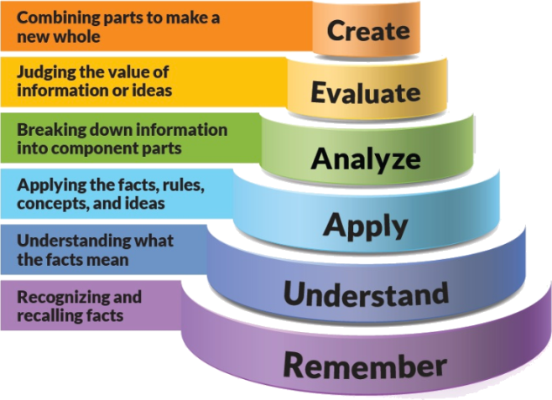
Figure 1: Blooms Taxonomy
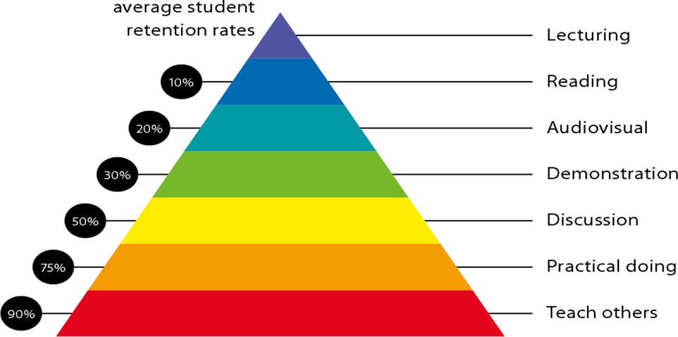
Figure 2: Knowledge retention

Graduate Qualities and Capabilities covered
(Qualities graduates harness crediting this Course)

General Graduate Qualities | Specific Department of __Electrical Graduate Capabilities
Informed  Have a sound knowledge of an area of study or profession and understand its current issues, locally and internationally. Know how to apply this knowledge. Understand how an area of study has developed and how it relates to other areas. | 1 Professional knowledge, grounding & awareness
Independent learners  Engage with new ideas and ways of thinking and critically analyze issues. Seek to extend knowledge through ongoing research, enquiry and reflection. Find and evaluate information, using a variety of sources and technologies. Acknowledge the work and ideas of others. | 2 Information literacy, gathering & processing
Problem solvers  Take on challenges and opportunities. Apply creative, logical and critical thinking skills to respond effectively. Make and implement decisions. Be flexible, thorough, innovative and aim for high standards. | 4 Problem solving skills
Effective communicators  Articulate ideas and convey them effectively using a range of media. Work collaboratively and engage with people in different settings. Recognize how culture can shape communication. | 5 Written communication
 | 6 Oral communication
 | 7 Teamwork
Responsible  Understand how decisions can affect others and make ethically informed choices. Appreciate and respect diversity. Act with integrity as part of local, national, global and professional communities. | 10 Sustainability, societal & environmental impact

Practical work:

List of Lab Experiment:

- Introduction to Basic Syntax of Verilog and Gate level Modelling through implementation of half adder at gate level and its simulation & synthesize using Xilinx ISE tools.
- Design following Combinational & Sequential Circuits using Data Flow/Behavioural Verilog Coding, Consolidation of the concepts of Test Bench module & simulate and synthesize using Xilinx ISE tools.
- Half Adder,Full Adder ,Half Subtractor & Full Subtractor
- 4 bit magnitude Comparator
- 4:1 ,8:1 Multiplexer
- 3-8 ,4-16 decoder
- 8-3 ,16-4 Encoder
- BCD to seven Segment Decoder in VHDL (common anode & common Cathode)
- JK,RS,T,D Flip flop (+ve and –ve edge triggering) & JK,RS,T,D Latch using if & Case Statement
- 1-4 Demux with enable input.
- Design of 4 Bit Binary to BCD Converter using sequential statement.
- Prepare a module to generate 2's,9’s complement of a 4-bit number.
- 8 bit odd/even parity checker/generator.
- Implement Binary to Gray converter.
- Implement BCD to XS-3 code converter
- Implement binary to BCD code converter
- Implement to GRAY to BINARY code converter using VHDL.
- 4-bit Serial In Parallel Out (SIPO) Shift Register using variable
- 4-bit Parallel In Parallel Out (PIPO) Shift Register using
variable
- Up Counter (Program for 4-bit binary counter using behavior
description)
- Down Counter (Program for 4-bit binary counter using
behavior description)
- Up/Down Counter (Program for 4-bit binary counter using
behavior description)

- Design following Combinational & Sequential Circuits using Data Flow/Behavioural Verilog Coding, Consolidation of the concepts of Test Bench module & simulate and synthesize using Xilinx ISE tools.
- 4 bit Asynchronous counter using Structural Modeling (use D Flip Flop as a component) .
- 4 bit Synchronous counter using Structural Modeling (use D Flip Flop as UDP) .
- Mod 5 Counter (up,Down,Up/Down) (using T or J-K flip flop as UDP)
- Full adder with structural style of coding. (Use half adder & OR gate as UDP)
- 4 to 1 Mux Implementation (use 2 to 1 Mux as UDP)
- program for 4-16 decoder using structural Modelling (use 3-8 decoder as UDP)
- A master-slave D ,JK,RS,T Flip flop ( use D ,JK,RS,T flip flop as UDP)
- 4 bit parallel adder. (4-bit Ripple Carry Adder) using structural modeling (use full adder as UDP)

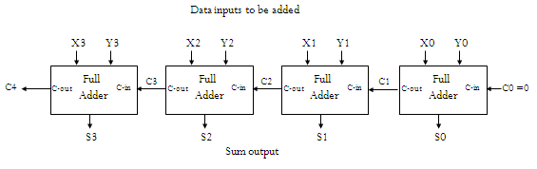

Lecture/tutorial times
Lecture
Monday- 11:00 PM-11:55 AM
Tuesday- 1:30 PM- 2:25 PM

Practical
Wednesday- 11-00 PM-12-50PM

Attendance Requirements

The University norms states that it is the responsibility of students to attend all lectures, tutorials, seminars and practical work as stipulated in the Course outl

Minimum attendance requirement as per university norms is compulsory for being eligible for mid and end semester examinations.

Details of referencing system to be used in written work

Text books

- Zainalabdien Navabi, Verliog Digital System Design,TMH, 2nd Edition.
- Verilog HDL - Samir Palnitkar, 2nd Edition, Pearson Education, 2009.

Additional Materials

Reference books
- Fundamentals of Digital Logic with Verilog Design - Stephen Brown,Zvonkoc Vranesic, TMH, 2nd Edition.
- Advanced Digital Logic Design using Verilog, State Machines & Synthesis for FPGA - Sunggu Lee, Cengage Learning, 2012.
- T.R. Padmanabhan, B Bala Tripura Sundari, Design Through Verilog HDL, Wiley 2009.
- Advanced Digital Design with Verilog HDL - Michel D. Ciletti, PHI,2009.

Web Resource

- Digital system Design course on NPTEL (http://nptel.ac.in/courses/117108040) 3.
- Online free course on Verilog-HDL (http://vol.verilog.com/) 4.
- Online free course on Verilog-HDL by ALTERA (https://www.altera.com/support/training/course/ohdl1120.html) 5. EDAPlayground - Online
- Verilog/VHDL complier (https://www.edaplayground.com/)

ASSESSMENT GUIDELINES

Your final course mark will be calculated from the following:
Theory:
Class Test/Quiz (10 Marks)
Seminar Presentation (10 Marks)
MSE (40 Marks)
ESE (40 Marks)

Practical:
Mini Project (20 Marks)
Practical Performance + Lab manual (40 Marks)
ESE (40 Marks)

SUPPLEMENTARY ASSESSMENT

Students who receive an overall mark less than 40% in mid semester or end semester will be considered for supplementary assessment in the respective components (i.e mid semester or end semester) of semester concerned. Students must make themselves available during the supplementary examination period to take up the respective components (mid semester or end semester) and need to obtain the required minimum 40% marks to clear the concerned components.

Practical Work Report/Laboratory Report:
A report on the practical work is due the subsequent week after completion of the class by each group.

Late Work
Late assignments will not be accepted without supporting documentation. Late submission of the reports will result in a deduction of -% of the maximum mark per calendar day

Format
All assignments must be presented in a neat, legible format with all information sources correctly referenced. Assignment material handed in throughout the session that is not neat and legible will not be marked and will be returned to the student.

Retention of Written Work
Written assessment work will be retained by the Course coordinator/lecturer for two weeks after marking to be collected by the students.

University and Faculty Policies
Students should make themselves aware of the University and/or Faculty Policies regarding plagiarism, special consideration, supplementary examinations and other educational issues and student matters.

Plagiarism - Plagiarism is not acceptable and may result in the imposition of severe penalties. Plagiarism is the use of another person’s work, or idea, as if it is his or her own - if you have any doubts at all on what constitutes plagiarism, please consult your Course coordinator or lecturer. Plagiarism will be penalized severely.

Do not copy the work of other students.
Do not share your work with other students (except where required for a group activity or assessment)
.

Course schedule (subject to change)

 | Week # | Topic & contents |  | CO Addressed |  | Teaching Learning Activity (TLA)
 | Weeks 1 | Introduction to Verilog HDL: Verilog as HDL, Levels of Design Description, Concurrency, Simulation and Synthesis, Function Verification, |  | 1,2 |  | BB,PPT
 | Weeks 2 | Introduction to Verilog HDL:  System Tasks, Programming Language Interface, Module, Simulation and Synthesis Tools |  | 1,2 |  | BB,PPT
 | Week 3 | Verilog Language Concept:  Code format, Logic Value system , Wires & variables |  | 1,2 |  | BB,PPT
 | Week 4 | Verilog Language Concept:  Modules ,Module Port ,Names ,Numbers, Arrays ,Verilog Operators & data Types ,Array Indexing |  | 1,2 |  | BB,PPT
 | Week 5 | Gate Level Modeling:  Introduction, Gate level Primitive, Module Structure |  | 2,3 |  | BB,PPT
 | Week 6 | Gate Level Modeling:  Instances of Primitives, Gate Delays, Designing Using Primitives | 2,3 |  | BB,PPT
 | Week 7 | Modeling at Dataflow Level:  Introduction, Continuous Assignment Structure, Delays and Continuous Assignments, Assignment to Vector, Operators. | 2,3 |  | BB,PPT
 | Week 8 | Behavioral Modeling:  Structured procedures, initial and always, blocking and non blocking statements, delay control | 2,3 |  | BB,PPT
 | Week 9 | Behavioral Modeling:  generate statement, event control, conditional statements, multiway branching, loops, sequential and parallel blocks. | 2,3 |  | BB,PPT
 | Week 10 | Functions, tasks, and user defined primitives: Introduction, Function, Tasks, User- Defined Primitives (UDP) | 3,4 |  | BB,PPT
 | Week 11 | Component Test & Verification:  Test Bench - Combinational Circuits Testing | 3,4 |  | BB,PPT
 | Week 12 | Component Test & Verification:  Test Bench - Sequential Circuit Testing | 3,4 |  | BB,PPT
 | Week 13 | Component Test & Verification:  Design Verification, Assertion Verification | 3,4 |  | BB,PPT
 | Week 14 | Reconfigurable Device Architectures:  Classification of FPGA, Basic architecture of CPLD and FPGA | 5 |  | BB,PPT
 | Week 15 | Reconfigurable Device Architectures:  Xilinx’s CPLD and FPGA architecture. | 5 |  | BB,PPT

Program map for B.Tech (Electronics & Communication Engineering)

