### Name of Institute: Indus Institute of Technology & Engineering

### Name of Faculty: Prof. Zalak Patel

**Course code: DC0202**

**Course name: Antenna Theory**

Pre-requisites: Electromagnetic, Microwave Engineering

Credit points: 04

Offered Semester: 6th

**Course Coordinator (weeks 15)**

Full Name: Prof. Zalak Patel

Department with sitting location: EC (Antenna & Microwave Lab), Bhanwar Building

Telephone: 3203

Email: zalakpatel.ec@indusuni.ac.in

Consultation times: 3:30 to 4:15 PM

**Course Lecturer (weeks 15)**

Full Name: Prof. Zalak Patel

Department with sitting location: EC (Antenna & Microwave Lab), Bhanwar Building

Telephone: 3203

Email: zalakpatel.ec@indusuni.ac.in

Consultation times: 3:30 to 4:15 PM

Students will be contacted throughout the Session via Mail with important information relating to this Course.

# Course Objectives

By participating in and understanding all facets of this Course a student will:

1. The objective of this subject is to deliver an in-depth knowledge of the basic antennas and their applications.
2. To give the practical design consideration and simulation of various antennas for different applications.
3. To cover the basic theoretical concepts for the radio wave propagation.

# Course Outcomes (CO)

After completion of this course, expected outcome from the students,

1. To understand the different types of antennas and the radiation mechanism.
2. To evaluate the fundamental parameters of antennas and arrays of antennas.
3. To acquire ability to design various types of linear and planar antennas.
4. To understand the atmospheric and terrestrial effects on radio wave propagation.

# Course Outline

(Key in topics to be dealt)

**UNIT-I**

**[12 hours]**

**Overview of Electromagnetic:**

Maxwell’s equations, Radiation integrals & auxiliary potential function, Electromagnetic potential, Boundary value problems, Plane, cylindrical and Spherical waves, electromagnetic theorems, overview of Antennas parameters, Field zones, Dipole antennas.

**UNIT-II**

**[10 hours]**

**Arrays of Antennas:**

Two-element array, N-element linear array, array/space factor, broadside array, end-fire array, binomial array, Dolph-Tschebyscheff array, planar array, slotted waveguide array, microstrip array, helical array, active phased array and adaptive arrays.

**UNIT-III**

**[10 hours]**

**Aperture antennas:** Field equivalence principle: Huygens principle, radiation equations, rectangular apertures, circular apertures, Babinet’s principle, introduction to diffraction of fields

**Horn antennas:** E-plane sectoral horn, aperture fields, radiated fields, directivity, H-plane sectoral horn, aperture fields, radiated fields, directivity, pyramidal horn, conical horn, corrugated horn, phase centre calculation in horn antennas.

**UNIT-IV**

**[13 hours]**

**Reflector antennas:**

Plane reflector, corner reflector, parabolic reflector, front fed parabolic reflector, dual symmetrical and offset reflectors (Cassegrain & Gregorian antenna).

**Advancement of antenna types:**

Microstrip antennas, helical antennas, Fractal antenna, electronic bandgap antenna, Metamaterials, fractal antennas, surface wave antenna.

# Method of delivery

(Face to face lectures, self study material, Active Learning Techniques)

# Study time

(5 hours per week including class attendance)

# CO-PO Mapping (PO: Program Outcomes)

|  |  |  |  |  |  |  |  |  |  |  |  |  |
| --- | --- | --- | --- | --- | --- | --- | --- | --- | --- | --- | --- | --- |
| **PO CO** | **PO** | | | | | | | | | | | |
| **1** | **2** | **3** | **4** | **5** | **6** | **7** | **8** | **9** | **10** | **11** | **12** |
| **1** | √ |  |  |  |  | √ | √ | √ |  |  |  |  |
| **2** | √ |  |  |  |  | √ | √ | √ |  |  |  |  |
| **3** |  | √ |  | √ |  |  |  |  |  | √ |  |  |
| **4** |  | √ |  | √ |  |  |  |  |  | √ |  |  |

# Blooms Taxonomy and Knowledge retention(For reference)

(Blooms taxonomy has been given for reference)

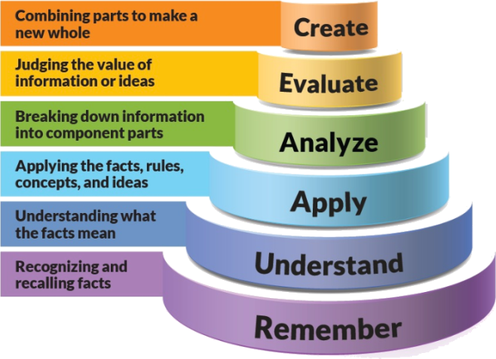

Figure 1: Blooms Taxonomy

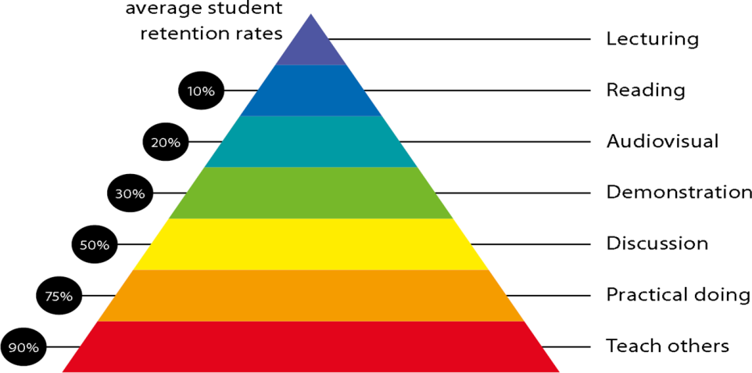

Figure 2: Knowledge retention

# Graduate Qualities and Capabilities covered

(Qualities graduates harness crediting this Course)

|  |  |
| --- | --- |
| **General Graduate Qualities** | **Specific Department of ______Graduate Capabilities** |
| **Informed**  Have a sound knowledge of an area of study or profession and understand its current issues, locally and internationally. Know how to apply this knowledge. Understand how an area of study has developed and how it relates to other areas. | **1 Professional knowledge, grounding & awareness** |
| **Independent learners**  Engage with new ideas and ways of thinking and critically analyze issues. Seek to extend knowledge through ongoing research, enquiry and reflection. Find and evaluate information, using a variety of sources and technologies. Acknowledge the work and ideas of others. | **2 Information literacy, gathering & processing** |
| **Problem solvers**  Take on challenges and opportunities. Apply creative, logical and critical thinking skills to respond effectively. Make and implement decisions. Be flexible, thorough, innovative and aim for high standards. | **4 Problem solving skills** |
| **Effective communicators**  Articulate ideas and convey them effectively using a range of media. Work collaboratively and engage with people in different settings. Recognize how culture can shape communication. | **5 Written communication** |
| **6 Oral communication** |
| **7 Teamwork** |
| **Responsible**  Understand how decisions can affect others and make ethically informed choices. Appreciate and respect diversity. Act with integrity as part of local, national, global and professional communities. | **10 Sustainability, societal & environmental impact** |

# Practical work:

(Mention what practical work this Course involves)

|  |  |  |
| --- | --- | --- |
| **Experiment. No.** | **Title** | **Learning Outcomes** |
| 1 | To study the variation of field strength with respect to distance from transmitting antenna. | To understand the relationship between the field strength and distance from the transmitting antenna. |
| 2 | Demonstrate that the transmitting and receiving radiation pattern of an antenna are equal; therefore confirm the reciprocity theorem of antennas. | To understand the reciprocity theorem for Antennas and their radiation patterns. |
| 3 | To plot the radiation pattern of an Omnidirectional antenna. | To acquire the basic understanding of Omnidirectional antennas and to plot its radiation pattern on polar graph. |
| 4 | To plot radiation pattern of directional antenna. | To acquire the basic understanding of Omnidirectional antennas and to plot its radiation pattern on polar graph. |
| 5 | To study and plot the radiation pattern of the helical antennas and measure Gain and Beam width. | To calculate the gain and beamwidth of helical antenna from its measured radiation pattern. |
| 6 | To study and plot the radiation pattern of the Broadside array and measure Gain and Beam width. | To calculate the gain and beamwidth of broadside array antenna from its measured radiation pattern. |
| 7 | Design and simulate dipole antenna in HFSS. | To determine the design parameters of dipole antenna and to observe its far field radiation pattern. |
| 8 | Design and simulate conical horn antenna in HFSS. | To determine the design parameters of conical horn antenna and to observe its far field radiation pattern. |
| 9 | Design and simulate Microstrip antenna in HFSS. | To determine the design parameters of Microstrip patch antenna and to observe its far field radiation pattern. |
| 10 | Mini Project |  |

# Lecture/tutorial times

**Lecture Monday 9.55 – 10.55 am Room LH 22**

**Lecture Tuesday 1.30 – 2.25 pm Room LH 22**

**Lecture Friday 9.00 -- 9.55 pm Room LH 22**

**Tutorial Tuesday 11.00 – 12.50 pm EC lab 4**

**Tutorial Friday 2.25 – 4.15 pm EC lab 4**

**Practical Thursday 9.00 – 10.55 am EC lab 4**

**Practical Friday 11.00 – 12.50 pm EC lab 4**

# Attendance Requirements

The University norms states that it is the responsibility of students to attend all lectures, tutorials, seminars and practical work as stipulated in the Course outline. Minimum attendance requirement as per university norms is compulsory for being eligible for mid and end semester examinations.

# Details of referencing system to be used in written work

# Text books

1. **Antenna Theory: Analysis and Design, 3rd Edition, C A Balanis, Wiley Publication.**
2. Antennas, J D Krauss, Mcgraw-Hill Higher Education.

# Additional Materials

**Reference Books**

1. Electromagnetic Wave and Radiating Systems, Edward C. & Balmain, Keith G. Jordan. Prentice Hall of India.
2. Electronic and Radio Engineering, F.E. Terman, McGraw-Hill, 4th edition, 1955.

**Web Resources**

1. http://nptel.ac.in/courses/117107035/

# https://www.tutorialspoint.com/antenna_theory/

1. http://www.radio-electronics.com/info/antennas/
2. <http://nptel.ac.in/courses/108101092/>

# ASSESSMENT GUIDELINES

Your final course mark will be calculated from the following:

**Example:**

**Class Test/Assignment 20% (week 6) objective (1-4)**

**Seminar 10% (week 8) objective (1-4)**

**Mid semester 30% (due week 10) objectives (2-5)**

**Final exam (*closed book*) 40% objectives (1-5)**

# SUPPLEMENTARY ASSESSMENT

Students who receive an overall mark less than 40% in mid semester or end semester will be considered for supplementary assessment in the respective components (i.e mid semester or end semester) of semester concerned. Students must make themselves available during the supplementary examination period to take up the respective components (mid semester or end semester) and need to obtain the required minimum 40% marks to clear the concerned components.

# Practical Work Report/Laboratory Report:

A report on the practical work is due the subsequent week after completion of the class by each group.

# Late Work

Late assignments will not be accepted without supporting documentation. Late submission of the reports will result in a deduction of -% of the maximum mark per calendar day

# Format

All assignments must be presented in a neat, legible format with all information sources correctly referenced. **Assignment material handed in throughout the session that is not neat and legible will not be marked and will be returned to the student.**

# Retention of Written Work

Written assessment work will be retained by the Course coordinator/lecturer for two weeks after marking to be collected by the students.

# University and Faculty Policies

Students should make themselves aware of the University and/or Faculty Policies regarding plagiarism, special consideration, supplementary examinations and other educational issues and student matters.

**Plagi**a**rism** - Plagiarism is not acceptable and may result in the imposition of severe penalties. Plagiarism is the use of another person’s work, or idea, as if it is his or her own - if you have any doubts at all on what constitutes plagiarism, please consult your Course coordinator or lecturer. Plagiarism will be penalized severely.

***Do not copy the work of other students.***

***Do not share your work with other students (except where required for a group activity or assessment)***

***.***

# Course schedule (Antenna & Wave Propagation)

**(Mention quiz, assignment submission, breaks etc as well in the table under the Teaching Learning Activity Column)**

|  |  |  |  |  |  |  |  |
| --- | --- | --- | --- | --- | --- | --- | --- |
|  | **Week #** | **Topic & contents** | | | **CO Addressed** | | **Teaching Learning Activity (TLA)** |
|  | Weeks 1 | Definitions, Types of Antennas & applications, Current distribution on a thin wire antenna, Radiation mechanism, Antenna Performance parameters. | | | 1 | | BB, PPT |
| Weeks 2 | Radiation pattern, antenna field zones, radiation power density, radiation intensity, directivity, gain, antenna efficiency, half-power beamwidth, first null beamwidth, beam efficiency. | | | 1,2 | | BB, PPT |
| Week 3 | Bandwidth, polarization, input impedance, antenna radiation efficiency, antenna effective area, Friss transmission equation. | | | 1,2 | | BB, PPT |
| Week 4 | Vector potential A and F for Electric & Magnetic current sources J & M, E and H field for electric and magnetic current sources, | | | 2 | | BB, PPT |
| Week 5 | Far field radiation, reciprocity theorem, Radiation form current element and dipole, radiation patterns of different dipoles. | | | 2 | | BB, PPT |
|  | | |  | | | | |
|  | Week 6 | Derivation of radiation power density, radiation resistance & directivity of infinitesimal & small dipole antenna. | | 2 | | BB, PPT | |
| Week 7 | Two-element array, N-element linear array- Uniform amplitude & spacing, array/space factor. | | 2 | | BB, PPT | |
| Week 8 | Broadside array, end-fire array, N-element linear array- Uniform spacing & non uniform amplitude, | | 2 | | PPT | |
| Week 9 | Planar array, introduction to active phased (scanning) array and adaptive arrays. | | 2 | | BB, PPT | |
|  | Week 10 | Huygen’s Field Equivalence Principle, Babinet’s principle, Slot Antennas, Helical Antennas, Loop Antennas. | | 3 | | BB, PPT | |
| Week 11 | E-plane sectoral horn, aperture fields, H-plane sectoral horn, aperture fields, pyramidal horn, conical horn, corrugated horn. | | 3 | | BB, PPT | |
|  | Week 12 | Plane reflector, corner reflector, parabolic reflector, front fed parabolic reflector, dual symmetrical and offset reflectors (Cassegrain & Gregorian antenna). | | 3 | | BB, PPT | |
|  | Week 13 | Basics of microstrip antennas, different types, advantages and disadvantages & applications, Circular Polarized patch antenna | | 4 | | BB, PPT | |
|  | Week 14 | Fractal antenna, electronic bandgap antenna, Metamaterials, fractal antennas, surface wave antenna. | | 4 | | BB, PPT | |
|  | Week 15 | Mini project/seminar | | 4 | | BB, PPT | |
|  |  |  | |  | |  | |

**PROGRAM MAP FOR B.Tech. (ELECTRONICS & COMMUNICATION ENGINEERING)**

