Name of Institute: Institute of Technology and Engineering
Name of Faculty: Zalak Patel
Course code:EC0216
Course name: Electronics Instrumentation
Pre-requisites: Students are expected to have basic knowledge of analog and digital electronics.
Credit points: 3
Offered Semester: 1st
Course coordinator and lecturer (weeks 01 - 12)
Full name: Zalak Patel
Department with sitting location: 2nd floor EC lab-4
Telephone:
Email: zalakpatel.ec@indusuni.ac.in
Consultation times: Monday to Friday, 4 PM to 5 PM
Students will be contacted throughout the session via mail with important information relating to this course.
Course Objectives
By participating in and understanding all facets of this course a student will:
In the field of Electronics, it is essential to know the functional aspects of several instruments useful in the process of signal measurement. Prior to the measurement, the process of signal conversion to equivalent electrical quantity and conversion of electrical quantify in one or the other forms are important steps. The fundamentals of signal measurement in analog as well as digital domains both need to be emphasized for modern instruments.
Course Outcomes (CO)
After successful completion of the course students should be able to:
CO1. Evaluate the performance parameters of electronic and communication systems
CO2. Prepare test plans to verify the specifications
CO3. Design test procedures for verification of system/sub-system specifications
CO4. Design custom test instruments capacitance.
CO5. Apply the knowledge about transducers effectively. To understand signal converters for the signal measurement.

 | Course Outline
 | Measurement Standards
 | Instrument for Generation and Analysis of Waveforms
 | Sensors and Transducers
 | Signal Sources
 | Interfaces
 | Virtual Instruments
 | Method of delivery
 | Face to face lectures, self-study material, Active Learning Techniques, seminars, group discussion
 | Study time
 | (3 hours per week including class attendance)
 | CO-PO Mapping (PO: Program Outcomes)
CO/  PO |  | PO1 | PO2 | PO3 | PO4 | PO5 | PO6 | PO7 | PO8 | PO9 | PO10 | PO11 | PO12
CO1 |  | 3 | 2 | 1 | 2 | 2 | 3 | 1 | 1 | 1 | 1 | 1 | 2
CO2 |  | 2 | 1 | 3 | 1 | 1 | 1 | 2 | 2 | 1 | 3 | 2 | 2
CO3 |  | 3 | 2 | 2 | 2 | 2 | 3 | 3 | 3 | 2 | 3 | 3 | 2
CO4 |  | 2 | 1 | 1 | 2 | 1 | 1 | 2 | 2 | 2 | 2 | 3 | 3
CO5 |  | 2 | 3 | 2 | 1 | 1 | 3 | 2 | 2 | 2 | 3 | 1 | 2
Where
- Low
- Medium
- High

Blooms Taxonomy and Knowledge retention (For reference)
(Blooms taxonomy has been given for reference)
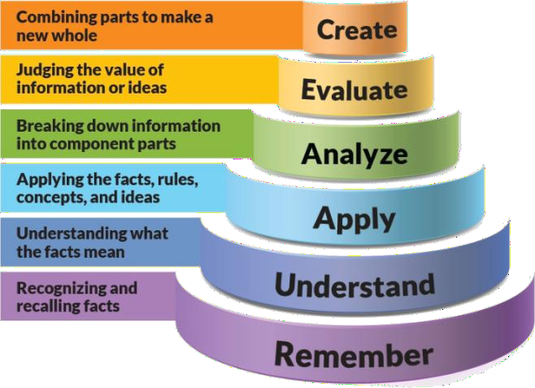
Figure 1: Blooms Taxonomy
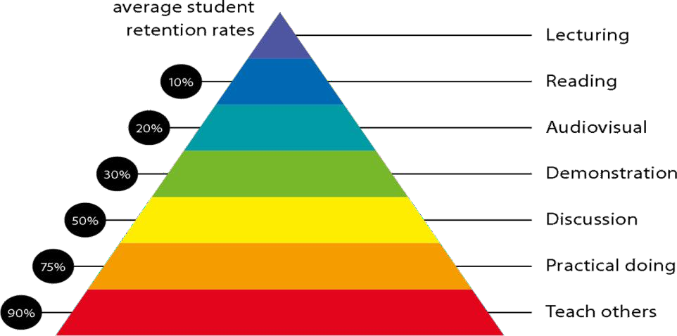
Figure 2: Knowledge retention

Graduate Qualities and Capabilities covered
(Qualities graduates harness crediting this Course)

General Graduate Qualities | Specific Department of  Graduate Capabilities
Informed  Have a sound knowledge of an area of study or profession and understand its current issues, locally and internationally. Know how to apply this knowledge. Understand how an area of study has developed  and how it relates to other areas. | 1 Professional knowledge, grounding & awareness
Independent learners  Engage with new ideas and ways of thinking and critically analyze issues. Seek to extend knowledge through ongoing research, enquiry  and reflection. Find and evaluate information, using a variety of | 2 Information literacy, gathering & processing
sources and technologies. Acknowledge the work and ideas of others.
Problem solvers  Take on challenges and opportunities. Apply creative, logical and critical thinking skills to respond effectively. Make and implement decisions. Be flexible, thorough, innovative and aim for high  standards. | 4 Problem solving skills
Effective communicators Articulate ideas and convey them effectively using a range of media. Work collaboratively and engage with people in different settings.  Recognize how culture can shape communication. | 5 Written communication
 | 6 Oral communication
 | 7 Teamwork
Responsible  Understand how decisions can affect others and make ethically informed choices. Appreciate and respect diversity. Act with integrity as part of local, national, global and  professional communities. | 10 Sustainability, societal & environmental impact

Lecture/tutorial times
(Give lecture times in the format below)
Sr.No | Subject | Day | Time | Lecture tutorial
1 | Electronic Instrumentation | Monday | 9:00 to 10:00 AM | Lecture
2 | Electronic Instrumentation | Tuesday | 12:20 to 1:20 PM | Lecture
3 | Electronic Instrumentation | Friday | 11:10 to 12:10 PM | Lecture

Attendance Requirements

The University norms states that it is the responsibility of students to attend all lectures, tutorials, seminars and practical work as stipulated in the course outline. Minimum attendance requirement as per university norms is compulsory for being eligible for semester examinations.

Details of referencing system to be used in written work
1.
=
Oliver and Cage, “Electronic Measurements and Instrumentation”, McGraw Hill
2. | H.Kalsi, “Electronic Instrumentation”, McGraw Hill India, 2004
3. | Banerjee, Gopal Krishna, “Electrical and Electronic Measurements”, PHI Learning, 2012
4. | HP Application Notes, Agilent Application Notes
5. | “A. K. Sawhney”, “Electrical & Electronic Measurement & Instruments”,  Dhanpat Rai & Co. Publications, 2005.

Text books
1.
David A. Bell, “Electronic Instrumentation and Measurements”, 3rd Ed, Oxford University Press, 2013.

ASSESSMENT GUIDELINES
Your final course mark will be calculated from the following:

CIE Theory
Attendance | 5%
Seminar | 5%
Assignment | 10%
Midsem Exam | 40%
Final Exam | 40%

SUPPLEMENTARY ASSESSMENT

Students who receive an overall mark less than 40% in internal component or less than 40% in the end semester will be considered for supplementary assessment in the respective components (i.e internal component or end semester) of semester concerned. Students must make themselves available during the supplementary examination period to take up the respective components (internal component or end semester) and need to obtain the required minimum 40% marks to clear the concerned components.

Practical Work Report/Laboratory Report:
A report on the practical work is due the subsequent week after completion of the class by each group.

Late Work
Late assignments will not be accepted without supporting documentation. Late submission of the reports will result in a deduction of -% of the maximum mark per calendar day.

Format
All assignments must be presented in a neat, legible format with all information sources correctly referenced. Assignment material handed in throughout the session that is not neat and legible will not be marked and will be returned to the student.

Retention of Written Work
Written assessment work will be retained by the Course coordinator/lecturer for two weeks after marking to be collected by the students.

University and Faculty Policies
Students should make themselves aware of the University and/or Faculty Policies regarding plagiarism, special consideration, supplementary examinations and other educational issues and student matters.

Plagiarism - Plagiarism is not acceptable and may result in the imposition of severe penalties. Plagiarism is the use of another person’s work, or idea, as if it is his or her own - if you have any doubts at all on what constitutes plagiarism, please consult your Course coordinator or lecturer. Plagiarism will be penalized severely.

Do not copy the work of other students.
Do not share your work with other students (except where required for a group activity or assessment)

Course schedule (subject to change)

(Mention quiz, assignment submission, breaks etc as well in the table under the Teaching Learning Activity Column)

 | Week # | Topic & contents |  | CO  Addressed | Teaching Learning  Activity (TLA)
 | Weeks 1 | Basics: Parameters, Units of measurements, Accuracy, Resolution, Precision |  | CO1 | Pre-requisites activities
 | Weeks 2 | Sensors and Transducers: Various types of sensors, Signal Conditioners |  | CO1 | Tutorials, assignment
 | Week 3 | Sensors and Transducers: Data Acquisition systems |  | CO3 | Quiz-time, assignment
 | Week 4 | Analog measurements: Voltage, Current and Power, Impedance, Resistance, Capacitance, Inductance, Time and Phase |  | CO3 | Tutorials, assignment
 | Week 5 | Analog measurements: Gain and loss, Frequency, Frequency response, Noise power, Noise figure, Non-linearity, Group Delay, Distortion, Video Measurements |  | CO2 | Quiz-time, assignment
 | Week 6 | Digital measurements: Jitter, BER, Eye diagram |  | CO2 |  | Tutorials, assignment, class test-1
 | Week 7 | Signal Sources: Audio and RF Oscillators, Data Generators, Pattern Generators, Video Signal Generator |  | CO4 |  | Quiz-time, assignment
 | Week 8 | Measuring Instruments: DVM, Oscilloscopes, DSO |  | CO4 |  | Tutorials, assignment
 | Week 9 | Measuring Instruments: Spectrum Analyzer, Logic Analyzer, Distortion Analyzer, Network Analyzer, TDR,  RF Power Meters |  | CO4 |  | Tutorials, assignment
 | Week 10 | Interfaces: GPIB, HPIB |  | CO5 |  | Quiz-time, assignment
 | Week 11 | Interfaces: USB, PCI |  | CO5 |  | Tutorials, assignment, class test-4
 | Week 12 | Virtual Instruments: Software based instrumentation, PC based instrumentation | CO5 |  |  | Quiz-time, assignment

