### Name of Institute: Indus Institute of Technology and Engineering.

### Name of Faculty: Prof. Zalak Patel

**Course code: EC0618**

**Course name: Digital Communication**

Pre-requisites: Signals and Systems, Analog Communication, Probability theory

Credit points: 4

Offered Semester: 6th

**Course Coordinator (weeks 01 - 14)**

Full Name: Prof. Zalak Patel

Department with siting location: EC Lab-4, 2nd floor Bhanwar building

Telephone: 3203 (Extn. No)

Email: zalakpatel.ec@indusuni.ac.in

Consultation times: 4:00 to 5:00 PM

**Course Lecturer (weeks 01 - 14)**

Full Name: Prof. Zalak Patel

Department with siting location: EC Lab-4, 2nd floor Bhanwar building

Telephone: 3203 (Extn. No)

Email: zalakpatel.ec@indusuni.ac.in

Consultation times: 4:00 to 5:00 PM

Students will be contacted throughout the Session via Mail with important information relating to this Course.

# Course Objectives

1. The objectives of this course are to introduce the basic principles that underlie the analysis and successful design of a digital communication system.
2. Emphasis is placed on understanding system design goals and to optimize the tradeoff among basic system parameters such as signal-to-noise ratio, bandwidth, etc.
3. To analyze error performance of a digital communication system in presence of noise and other interferences.

# Course Outcomes (CO)

By participating in and understanding all facets of this Course a student will be able to:

|  |
| --- |
| 1. Student will understand the advantages of digital systems over analog counterparts and calculate the mean and variance of some common continuous and discrete distributions |

1. Identify and explain the techniques used for waveform coding viz. Pulse Amplitude Modulation (PAM) and Pulse Code Modulation (PCM).
2. Identify various types of error introduced in the processes viz. sampling, quantizing, and Describe Inter Symbol Interference (ISI), adaptive equalization techniques.
3. Describe different digital modulation schemes, and compare advantages/ Disadvantages of each as applied to baseband signal.
4. Identify the presence of error bits signal, and calculate unknown phase of noise in the received signal.

# Course Outline

* Introduction of digital communication
* Probability & random Process
* Information Theory
* Error control coding
* Baseband modulation
* Digital Modulation & demodulation

# Method of delivery

* 3 lectures per week. (Black board ,Chalk , PPT)
* 2 hours of lab per week
* Understanding of design techniques using simulations.
* Self-study material
* NPTEL notes

# Study time

3 hours per week Lectures and 2 Hours practical per week

# CO-PO Mapping (PO: Program Outcomes)

|  |  |  |  |  |  |  |  |  |  |  |  |  |
| --- | --- | --- | --- | --- | --- | --- | --- | --- | --- | --- | --- | --- |
|  | **PO1** | **PO2** | **PO3** | **PO4** | **PO5** | **PO6** | **PO7** | **PO8** | **PO9** | **PO10** | **PO11** | **PO12** |
| **CO1** | √ | √ | √ | √ | √ |  |  |  |  |  |  |  |
| **CO2** | √ | √ | √ | √ | √ |  |  |  |  |  |  | √ |
| **CO3** | √ | √ | √ | √ | √ |  |  |  |  |  |  | √ |
| **CO4** | √ | √ | √ | √ | √ | √ | √ | √ |  |  |  | √ |
| **CO5** | √ | √ | √ | √ | √ | √ | √ |  |  |  |  | √ |

# Blooms Taxonomy and Knowledge retention (For reference)

(Blooms taxonomy has been given for reference)

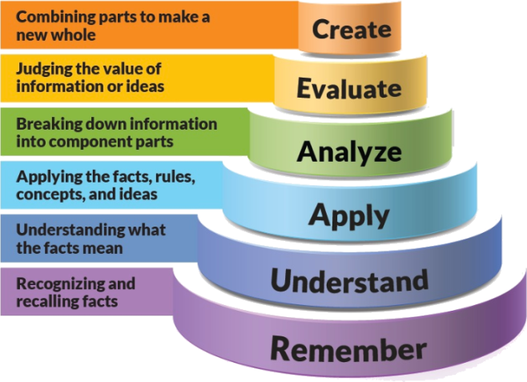

Figure 1: Blooms Taxonomy

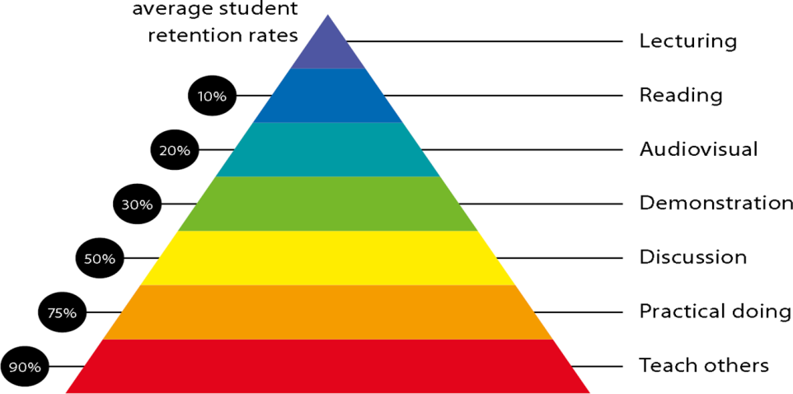

Figure 2: Knowledge retention

# Graduate Qualities and Capabilities covered

(Qualities graduates harness crediting this Course)

|  |  |
| --- | --- |
| **General Graduate Qualities** | **Specific Department of ______Graduate Capabilities** |
| **Informed**  Have a sound knowledge of an area of study or profession and understand its current issues, locally and internationally. Know how to apply this knowledge. Understand how an area of study has developed and how it relates to other areas. | **1 Professional knowledge, grounding & awareness** |
| **Independent learners**  Engage with new ideas and ways of thinking and critically analyze issues. Seek to extend knowledge through ongoing research, enquiry and reflection. Find and evaluate information, using a variety of sources and technologies. Acknowledge the work and ideas of others. | **2 Information literacy, gathering & processing** |
| **Problem solvers**  Take on challenges and opportunities. Apply creative, logical and critical thinking skills to respond effectively. Make and implement decisions. Be flexible, thorough, innovative and aim for high standards. | **4 Problem solving skills** |
| **Effective communicators**  Articulate ideas and convey them effectively using a range of media. Work collaboratively and engage with people in different settings. Recognize how culture can shape communication. | **5 Written communication** |
| **6 Oral communication** |
| **7 Teamwork** |
| **Responsible**  Understand how decisions can affect others and make ethically informed choices. Appreciate and respect diversity. Act with integrity as part of local, national, global and professional communities. | **10 Sustainability, societal & environmental impact** |

# Practical work:

Practical work in this course starts with the sampling, Lines codes & digital modulation techniques. At the end of this course student will be able design the different basic block of communication as minor project with laboratory practical.

# Lecture/tutorial times

(Give lecture times in the format below)

|  |  |  |  |  |
| --- | --- | --- | --- | --- |
| **Sr. No.** | **Pedagogy** | **Day** | **Time** | **Place** |
| **1** | Lecture | Monday | 10:00 to11:00 AM | Online |
| **2** | Lecture | Wednesday | 12:20 to 1:20 PM |
| **3** | Lecture | Thursday | 12:20 to 1:20 PM |
| **4** | Practical | Tuesday | 11:00 to 1:00 PM |  |

# Attendance Requirements

The University norms states that it is the responsibility of students to attend all lectures, tutorials, seminars and practical work as stipulated in the Course outline. Minimum attendance requirement as per university norms is compulsory for being eligible for mid and end semester examinations.

# Details of referencing system to be used in written work

# Text books

1. Digital Communications by Simon Haykin, Wiley India.
2. Digital and analog communication system by B.P.Lathi, Zhi Ding (International 4th Edition), OXFORD university press.
3. Digital communication-Theory, Techniques and Applications by R. N. Mutagi, 2nd edition, OXFORD university press.

# Additional Materials

NPTEL Course: Digital Communication

Link: https://nptel.ac.in/courses/117101051/

# ASSESSMENT GUIDELINES

Your final course mark will be calculated from the following:

1. **Theory CIE 60 marks:**

**a**. Attendance 10 Marks

**b**. Midsem exam 40 Marks

**c.** Quiz/Presentation 10 Marks

**2. Practical CIE 60 marks:**

**a**. Attendance 10 Marks

**b.** Experiment Performance 30 Marks

**c**. File work + Skill Test 20 Marks

# SUPPLEMENTARY ASSESSMENT

Students who receive an overall mark less than 40% in mid semester or end semester will be considered for supplementary assessment in the respective components (i.e mid semester or end semester) of semester concerned. Students must make themselves available during the supplementary examination period to take up the respective components (mid semester or end semester) and need to obtain the required minimum 40% marks to clear the concerned components.

# Practical Work Report/Laboratory Report:

A report on the practical work is due the subsequent week after completion of the class by each group.

# Late Work

Late assignments will not be accepted without supporting documentation. Late submission of the reports will result in a deduction of -20% of the maximum mark per calendar day

# Format

All assignments must be presented in a neat, legible format with all information sources correctly referenced. **Assignment material handed in throughout the session that is not neat and legible will not be marked and will be returned to the student.**

# Retention of Written Work

Written assessment work will be retained by the Course coordinator/lecturer for two weeks after marking to be collected by the students.

# University and Faculty Policies

Students should make themselves aware of the University and/or Faculty Policies regarding plagiarism, special consideration, supplementary examinations and other educational issues and student matters.

**Plagi**a**rism** - Plagiarism is not acceptable and may result in the imposition of severe penalties. Plagiarism is the use of another person’s work, or idea, as if it is his or her own - if you have any doubts at all on what constitutes plagiarism, please consult your Course coordinator or lecturer. Plagiarism will be penalized severely.

***Do not copy the work of other students.***

***Do not share your work with other students (except where required for a group activity or assessment).***

# Course schedule (subject to change)

**(Mention quiz, assignment submission, breaks etc as well in the table under the Teaching Learning Activity Column)**

|  |  |  |  |  |  |  |  |
| --- | --- | --- | --- | --- | --- | --- | --- |
|  | **Week #** | **Topic & contents** | | | **CO Addressed** | | **Teaching Learning Activity (TLA)** |
|  | Week 1 | |  | | --- | | Introduction to Digital Communication Systems  Communication System Model, Typical Digital communication System, Advantage of Digital communication ,  PAM Signals, Digital multiplexing ,line coding,Digitizing | | | | 1-2 | | BB,Chalk,PPT |
| Week 2 | Analog signals -sampling,Quntization,Encoding, Alising, Nyquist first and second criterion for zero ISI, PCM, DPCM, | | | 1-2 | | BB,Chalk,PPT |
| Week 3 | ADPCM, Uniform and Non-uniform Quantization, Quantization Error in PCM,Delta | | | 2-3-4-5 | | BB,Chalk,PPT |
| Week 4 | Modulation, Adaptive Delta Modulations ,SNR Calculation, Non-uniform Quantization | | | 3-4-5 | | BB,Chalk,PPT |
| Week 5 | Digital Modulation Techniques :  QAM, BPSK, QPSK, DPSK, MSK, M-ary-FSK, M-ary-PSK, | | | 4-5 | | BB,Chalk,PPT |
|  | | |  | | | | |
|  | Week 6 | BFSK of various digital modulation techniques and scrambling | | 4-5 | | BB,Chalk,PPT | |
| Week 7 | Digital Demodulation Techniques:  Coherent and non-coherent detection of ASK, FSK | | 4-5 | | BB,Chalk,PPT | |
| Week 8 | PSK, QPSK,DPSK. Noise Figure, Signal to noise Ratio, performance of communication system with channel noise. | | 4-5 | | BB,Chalk,PPT | |
| Week 9 | |  | | --- | | Probability and random process  Information, Probability, Random Variables, Mean and variance, Conditional Probability of independent events, Relation between probability and probability Density , Releigh Probability Density , | | | 1 | | BB,Chalk,PPT | |
|  | Week 10 | |  |  | | --- | --- | | |  | | --- | | CDF, PDF, Random Variables, correlation between Random Variables, Linear mean square Estimation, Central limit theorem, Error function | | | | 1 | | BB,Chalk,PPT | |
| Week 11 | |  |  |  | | --- | --- | --- | | Complementary error function Discrete and Continuous Variable, Gaussian PDF, Threshold Detection, Statistical Average,Chebyshev In Equality, Autocorrection. | | | |  |  | | | 5 | | BB,Chalk,PPT | |
|  | Week 12 | |  | | --- | | Information Theory :  Introduction, Concept & Measure of information, statistics of discrete channel, Error Free Communication Over a noisy channel | | | 1-4-5 | | BB,Chalk,PPT | |
|  | Week 13 | |  | | --- | | Shannon Theorem, The channel capacity of a Discrete Memory less Channel, Optimum System, The channel capacity of a Continuous Channel, Source Coding | | | 1-4-5 | | BB,Chalk,PPT | |
|  | Week 14 | Error Control Coding:  Introduction, Linear block code, cyclic code, convolution code, | | 2-4-5 | | BB,Chalk,PPT | |
|  | Week 15 | Burst Error Correcting and detecting code | | 2-4-5 | | PPT | |

**