Name of Institute: INSTITUTE OF TECHNOLOGY & ENGINEERING

Name of Faculty: Prof. Sejal Thakkar.

Course code:
Course name: Machine Learning
Pre-requisites: NIL
Credit points: 4
Offered Semester: III

Course Coordinator
Full Name: Sejal Thakkar
Department with siting location: Computer Engineering (4rd floor,Faculty room, Bhanwar building)
Telephone: 9033380982,7990552332
Email: sejalthakkar.ce@indusuni.ac.in
Consultation times: Wednesday (4:00 PM to 5:00 PM)

Students will be contacted throughout the Session via Mail with important information relating to this Course.

Course Objectives
By participating in and understanding all facets of this Course a student will:
- To understand the overall structure and design of DBMS
- To provide students with the background to design, implement, and use database Management systems.

Course Outcomes (CO)
After successful completion of the course, student will able:
- Develop an appreciation for what is involved in Learning models from data
- Understand a wide variety of learning algorithms
- Understand how to evaluate models generated from data
- Apply the algorithms to a real problem, optimize the models learned and report on the expected accuracy that can be achieved by applying the models
- Apply the machine learning concepts in real life problems
- Ability to identify the characteristics of datasets and compare the trivial data and big data for various applications
- Compare and parameterize different learning algorithms

Course Outline

CNN, ANN, Regression, Classification

Method of delivery
- Chalk & Talk
- PPT presentation

Study time
3 lectures per week
2 hour labs per week

CO-PO Mapping (PO: Program Outcomes)
Course Outcome | Program Outcomes |  |  |  |  |  |  |  |  |  |  |  | Program Specific Outcomes
 | PO1 | PO2 | PO3 | PO4 | PO5 | PO6 | PO7 | PO8 | PO9 | PO10 | PO11 | PO12 | PSO1 | PSO2 | PSO3
CO1 | √ |  |  | √ |  |  |  |  |  |  | √ |  | √ |  | √
CO2 | √ | √ |  | √ |  |  |  |  |  |  | √ |  |  | √ | √
CO3 | √ | √ |  |  | √ |  | √ |  |  |  |  |  |  | √ | √
CO4 | √ | √ |  | √ | √ |  | √
CO5 | √ |  | √ |  |  |  | √
CO6 |  |  |  |  |  | √ |  |  |  |  |  |  | √
CO7 |  |  | √ |  |  |  |  |  | √

Blooms Taxonomy and Knowledge retention (For reference)
(Blooms taxonomy has been given for reference)

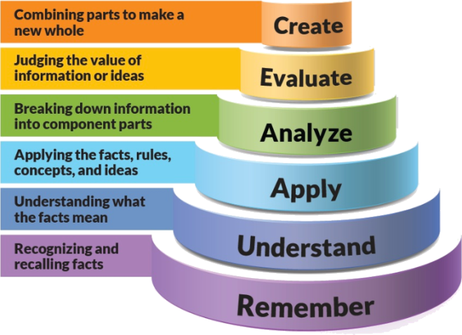
Figure 1: Blooms Taxonomy
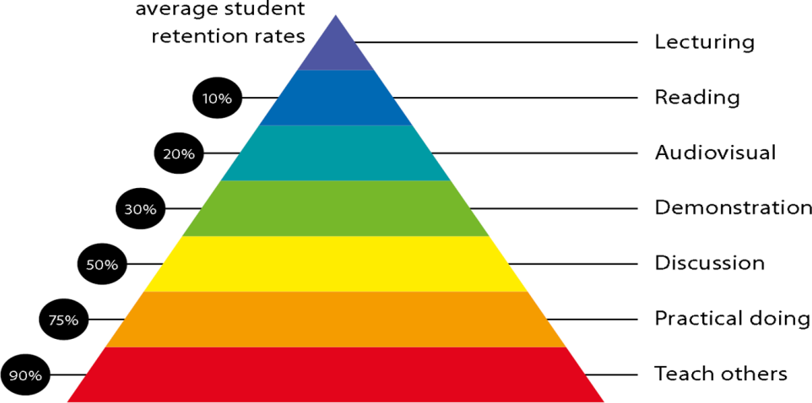
Figure 2: Knowledge retention

Graduate Qualities and Capabilities covered
(Qualities graduates harness crediting this Course)

General Graduate Qualities | Specific Department of ______Graduate Capabilities
Informed  Have a sound knowledge of an area of study or profession and understand its current issues, locally and internationally. Know how to apply this knowledge. Understand how an area of study has developed and how it relates to other areas. | 1 Professional knowledge, grounding & awareness
Independent learners  Engage with new ideas and ways of thinking and critically analyze issues. Seek to extend knowledge through ongoing research, enquiry and reflection. Find and evaluate information, using a variety of sources and technologies. Acknowledge the work and ideas of others. | 2 Information literacy, gathering & processing
Problem solvers  Take on challenges and opportunities. Apply creative, logical and critical thinking skills to respond effectively. Make and implement decisions. Be flexible, thorough, innovative and aim for high standards. | 4 Problem solving skills
Effective communicators  Articulate ideas and convey them effectively using a range of media. Work collaboratively and engage with people in different settings. Recognize how culture can shape communication. | 5 Written communication
 | 6 Oral communication
 | 7 Teamwork
Responsible  Understand how decisions can affect others and make ethically informed choices. Appreciate and respect diversity. Act with integrity as part of local, national, global and professional communities. | 10 Sustainability, societal & environmental impact

Practical work:
(Mention what practical work this Course involves)
As a part of practical, student have to perform various Python in machine learning project relevant activities.

Lecture/tutorial times
(Give lecture times in the format below)
For 3 Sem IT A and B

Monday: 11 AM to 12 PM: Lecture
Monday: 2 PM to 4: 10 PM: Laboratory
Tuesday: 11:10 AM to 12:10 PM: Lecture
Wednesday: 11:10 AM to 12:10 PM: Lecture
Friday: 2 PM to 4:10 PM: Laboratory

Attendance Requirements

The University norms states that it is the responsibility of students to attend all lectures, tutorials, seminars and practical work as stipulated in the Course outline. Minimum attendance requirement as per university norms is compulsory for being eligible for mid and end semester examinations.

Details of referencing system to be used in written work

Text books
Text Book :

- Compare and parameterize different learning algorithms
- Compare and parameterize different learning algorithms

Additional Materials

Reference Book:
- An introduction to Database Systems, C J Date, Addition-Wesley.
- Understanding SQL by Martin Gruber, BPB

ASSESSMENT GUIDELINES
Your final course mark will be calculated from the following:
Example:

Theory:
Internal evaluation 20% Objective (1-3-4)

05 marks as attendance bonus for all students having attendance > 80%
05 marks for presentation
10 marks for assignment or case studies, limited to minimum 02 assignments per course
Mid semester 40% (due week 10) Objectives (2-5)
Final exam (closed book) 40% Objectives (1-5)

Practical:
20% for performance/quiz
20% practical test +viva
20% for lab file, regularly and discipline
40% end semester practical exam +Viva

SUPPLEMENTARY ASSESSMENT

Students who receive an overall mark less than 40% in mid semester or end semester will be considered for supplementary assessment in the respective components (i.e mid semester or end semester) of semester concerned. Students must make themselves available during the supplementary examination period to take up the respective components (mid semester or end semester) and need to obtain the required minimum 40% marks to clear the concerned components.

Practical Work Report/Laboratory Report:
A report on the practical work is due the subsequent week after completion of the class by each group.

Late Work
Late assignments will not be accepted without supporting documentation. Late submission of the reports will result in a deduction of -% of the maximum mark per calendar day

Format
All assignments must be presented in a neat, legible format with all information sources correctly referenced. Assignment material handed in throughout the session that is not neat and legible will not be marked and will be returned to the student.

Retention of Written Work
Written assessment work will be retained by the Course coordinator/lecturer for two weeks after marking to be collected by the students.

University and Faculty Policies
Students should make themselves aware of the University and/or Faculty Policies regarding plagiarism, special consideration, supplementary examinations and other educational issues and student matters.

Plagiarism - Plagiarism is not acceptable and may result in the imposition of severe penalties. Plagiarism is the use of another person’s work, or idea, as if it is his or her own - if you have any doubts at all on what constitutes plagiarism, please consult your Course coordinator or lecturer. Plagiarism will be penalized severely.

Do not copy the work of other students.
Do not share your work with other students (except where required for a group activity or assessment)
.

Course schedule (subject to change)
(Mention quiz, assignment submission, breaks etc as well in the table under the Teaching Learning Activity Column)

 | Week # | Topic & contents |  |  | CO Addressed |  | Teaching Learning Activity (TLA)
 | Weeks 1 | Introduction: data, database, database management, database management system, application of database, why database, Data independence. |  |  | CO1
 | Weeks 2 | Architecture: The three levels of architecture-Levels, Mapping, Database users and DBA Brief overview of different types of model.
 | Week 3 | Entity-Relationship Model: Introduction, An overview of the E/R model, E/R diagrams, Database design with the E/R model, extended E-R features – generalization, specialization, aggregation, reduction to E-R database schema |  |  | CO4
 | Week 4 | Relational Model:Structure of relational databases, relational model, relations, relational integrity, Domains, Relational Algebra(fundamental and extended) and query. |  |  | CO3
 | Week 5 | Relation database design: Functional Dependency – definition, trivial and non-trivial FD, closure of FDset, closure of attributes, irreducible set of FD, Normalization – 1Nf, 2NF. |  |  | CO4
 | Week 6 | 3NF, composition using FD- dependency preservation, BCNF, Multivalued dependency, 4NF, Join dependency and 5NF. |  | CO4
 | Week 7 | Transaction Management and Security: Transaction concepts, properties of transactions. Serializability of transactions, testing for serializability , System recovery. |  | CO5
 | Week 8 | Two- Phase Commit protocol, Recovery and Atomicity, Log-based recovery, concurrent executions of transactions and related problems. |  | CO5
 | Week 9 | Locking mechanism, solution to concurrency related problems, deadlock, , two-phase locking protocol, Isolation, Intent locking. |  | CO5
 | Week 10 | Security: Introduction, Discretionary access control, Mandatory Access Control, Data Encryption. |  | CO5
 | Week 11 | SQL: Basics of SQL, DDL,DML,DCL, structure – creation, alteration, defining constraints – Primary key, foreign key, unique, not null, check, IN operator, aggregate functions, Built-in functions –numeric, date, string functions, set operations, sub-queries, correlated sub-queries. |  | CO2
 | Week 12 | Join, Exist, Any, All , view and its types., transaction control commands.  PL/SQL: Cursors, Stored Procedures, Stored Function, Database Triggers. |  | CO2

PROGRAM MAP for Bachelor of Engineering

(CE / CSE / IT)

