Name of Institute: Indus Institute of Management Studies (IIMS)

Name of Faculty: Dr. Renu Choudhary

Course code: BC0302
Course name: Income Tax Law and Practice
Pre-requisites: H.S.C
Credit points: 6 Credits
Offered Semester: III

Course Lecturer (weeks 01 – 15)
Full name: Dr. Renu Choudhary
Department with siting location: Management
Telephone: 8511557949
Email: renuchoudhary.mba@indusuni.ac.in
Consultation times: 3.00 PM to 4.00 PM

Students will be contacted throughout the Session via Mail with important information relating to this Course.

Course Objectives
- To provide basic knowledge and equip students with application of principles and provisions of Income-tax Act, 1961 and the relevant Rules
- To understand taxation laws requirements and its need for managerial decision-making.

Course Outcomes (CO)
On successful completion of this course students will be able to:
CO1: Understand the basic concepts in the field of taxation laws and determine the residential status of an individual
CO2: Compute taxable income from Salary and House property
CO3: Compute taxable income from Capital Gains and other sources
CO4: Compute taxable income from Profit and Gains of Business or Profession.
CO5: Compute taxable income and tax liability of an individual.
CO6: To know the impact of tax laws on companies and individuals

Course Outline
Unit-I
Introduction: Basic concepts: Income, person, assessee, assessment year, previous year, gross total income, total income, maximum marginal rate of tax; Permanent Account Number.
Residential status; Scope of total income on the basis of residential status
Agricultural income, Exempted income

Unit-II
Computation of Income under different heads-I: Income from Salaries; Income from house property

Unit-III
Computation of Income under different heads-II: Profits and gains of business or profession; Capital gains; Income from other sources

Unit-IV
Computation of Total Income and Tax Liability: Income of other persons included in assesse’s total income; Aggregation of income and set-off and carry forward of losses; Deductions from gross total income; Rebates and reliefs Computation of total income and tax liability of individuals

Method of delivery
Lectures, PPT, case studies, experiential exercises, Active Learning Techniques.

Study time
Six hours per week

CO-PO Mapping (PO: Program Outcomes)
PO1: Enhance Conceptual clarity &amp; domain knowledge
PO2: Create Awareness of Business Environment
PO3: Develop Effective communication skills
PO4: Build Analytical skills in Business
PO5: Comprehend Ethical and Social Responsibility
PO6: Build professional competence as per industry requirements
 | PO1 | PO2 | PO3 | PO4 | PO5 | PO6
CO 1 | 3 | 3 | 1 | 3 | 2 | 3
CO 2 | 3 | 2 | 1 | 2 | 2 | 2
CO 3 | 3 | 3 | 1 | 2 | 2 | 3
CO 4 | 3 | 3 | 1 | 2 | 2 | 3
CO 5 | 3 | 3 | 1 | 2 | 2 | 3
CO 6 | 3 | 3 | 1 | 2 | 2 | 3

Blooms Taxonomy and Knowledge retention (For reference)
(Blooms taxonomy has been given for reference)

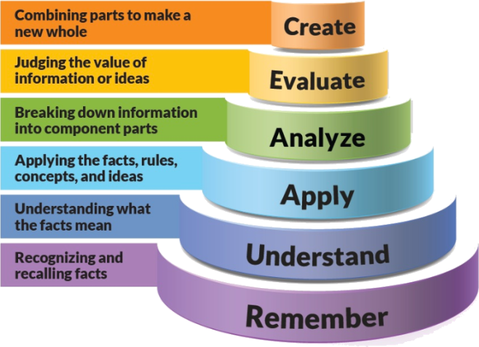
Figure 1: Blooms Taxonomy
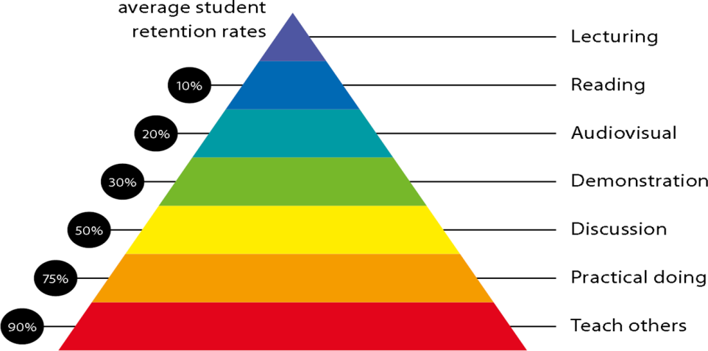
Figure 2: Knowledge retention

Graduate Qualities and Capabilities covered
(Qualities graduates harness crediting this Course)

General Graduate Qualities | Specific Department of ______Graduate Capabilities
Informed  Have a sound knowledge of an area of study or profession and understand its current issues, locally and internationally. Know how to apply this knowledge. Understand how an area of study has developed and how it relates to other areas. | 1 Professional knowledge, grounding & awareness
Independent learners  Engage with new ideas and ways of thinking and critically analyze issues. Seek to extend knowledge through ongoing research, enquiry and reflection. Find and evaluate information, using a variety of sources and technologies. Acknowledge the work and ideas of others. | 2 Information literacy, gathering & processing
Problem solvers  Take on challenges and opportunities. Apply creative, logical and critical thinking skills to respond effectively. Make and implement decisions. Be flexible, thorough, innovative and aim for high standards. | 3 Problem solving skills
Effective communicators  Articulate ideas and convey them effectively using a range of media. Work collaboratively and engage with people in different settings. Recognize how culture can shape communication. | 4 Written communication
 | 5 Oral communication
 | 6 Teamwork
Responsible  Understand how decisions can affect others and make ethically informed choices. Appreciate and respect diversity. Act with integrity as part of local, national, global and professional communities. | 7 Sustainability, societal & environmental impact

Practical work:
- ASSIGNMENT -1 Unit 1&2
- ASSIGNMENT -2 Unit 3&4

Lecture times
Monday – 3:10PM – 4:10PM
Tuesday - 2:05PM – 3:05PM
Wednesday - 3:10PM – 4:10PM
Thrusday - 3:10PM – 4:10PM
Friday - 1:00PM – 2:00PM

Attendance Requirements
The University norms states that it is the responsibility of students to attend all lectures, tutorials, seminars and practical work as stipulated in the Course outline. Minimum attendance requirement as per university norms is compulsory for being eligible for mid and end semester examinations.

Details of referencing system to be used in written work

Text books
- Dr. Girish Ahuja & Dr. Ravi Gupta, Systematic Approach to Income Tax. Allahabad, Bharat Law House. Latest Edition
- Dr. Vinod K. Singhania& Dr. Monica Singhania, Tax Planning & Business Tax Procedures, Taxmann’s Publication

Reference Books:
- Dr. Vinod K. Singhania& Dr. Monica Singhania, Student’s Guide to Income Tax,Taxmann’s Publication (Latest)
- Dr. Vinod K. Singhania& Dr. KapilSinghania,Direct Taxes: Law and Practices. Delhi, Taxman.
- Bhagwati Prasad, Direct Taxes Law & Practice, WishwaPrakashan.
- GirishAhuja& Ravi Gupta,Corporate Tax Planning & Management, Bharat Law House. Latest Edition

ASSESSMENT GUIDELINES
Your final course mark will be calculated from the following:

Assignment 10 Marks
Class Test 5 Marks
Attendance 5 Marks
Mid semester 40 Marks
Final exam (closed book) 40 Marks

SUPPLEMENTARY ASSESSMENT

Students who receive an overall mark less than 40% in mid semester or end semester will be considered for supplementary assessment in the respective components (i.e mid semester or end semester) of semester concerned. Students must make themselves available during the supplementary examination period to take up the respective components (mid semester or end semester) and need to obtain the required minimum 40% marks to clear the concerned components.

Late Work
Late assignments will not be accepted without supporting documentation. Late submission of the reports will result in a deduction of -5% of the maximum mark per calendar day

Format
All assignments must be presented in a neat, legible format with all information sources correctly referenced. Assignment material handed in throughout the session that is not neat and legible will not be marked and will be returned to the student.

Retention of Written Work
Written assessment work will be retained by the Course coordinator/lecturer for two weeks after marking to be collected by the students.

University and Faculty Policies
Students should make themselves aware of the University and/or Faculty Policies regarding plagiarism, special consideration, supplementary examinations and other educational issues and student matters.

Plagiarism - Plagiarism is not acceptable and may result in the imposition of severe penalties. Plagiarism is the use of another person’s work, or idea, as if it is his or her own - if you have any doubts at all on what constitutes plagiarism, please consult your Course coordinator or lecturer. Plagiarism will be penalized severely.

Do not copy the work of other students.
Do not share your work with other students (except where required for a group activity or assessment)

Course schedule(subject to change)
(Mention quiz, assignment submission, breaks etc as well in the table under the Teaching Learning Activity Column)

 | Week # | Topic & contents |  | CO Addressed |  | Teaching Learning Activity (TLA)
 | Weeks 1 | Basic concepts: Income, person, assessee, assessment year, previous year, gross total income, total income, maximum marginal rate of tax; Permanent Account Number. |  | CO1 |  | Lecture
 | Weeks 2 | Residential status; Scope of total income on the basis of residential status  Agricultural income, Exempted income |  | CO1 |  | Lecture
 | Week 3 | Computation of Income from Salaries |  | CO2 |  | Lecture
 | Week 4 | Computation of Income from Salaries |  | CO2 |  | Lecture
 | Week 5 | Computation of Income from house property |  | CO2 |  | Lecture
 | Week 6 | Computation of Income from Capital gains | CO3 |  | Lecture
 | Week 7 | Computation of Income from other sources | CO3 |  | Lecture
 | Week 8 | Computation of Profits and gains of business or profession | CO4 |  | Lecture
 | Week 9 | Income of other persons included in assesse’s total income; Aggregation of income and set-off and carry forward of losses | CO5 & CO6 |  | Lecture
 | Week 10 | Revision |  |  | Lecture
 | Week 11 | Mid Term
 | Week 12 | Deductions from gross total income; Rebates and reliefs | CO5 & CO6 |  | Lecture
 | Week 13 | Computation of total income and tax liability of individuals | CO5 & CO6 |  | Lecture
 | Week 14 | Computation of total income and tax liability of individuals | CO5 & CO6 |  | Lecture
 | Week 15 | Doubt solving & revision |  |  | Lecture

