Name of Institute: Indus Institute of Management Studies (IIMS)

Name of Faculty: Dr. Tejal Shah
Course code: BC0304
Course name: Business Statistics
Pre-requisites: H.S.C
Credit points: 6 Credits
Offered Semester: III

Course Lecturer (weeks 01 – 12)
Full name: Dr. Tejal Shah
Department with siting location: Management
Telephone: 9825042855
Email: tejalshah.mba@indusuni.ac.in
Consultation times: 2.00 PM to 4.00 PM

Students will be contacted throughout the Session via Mail with important information relating to this Course.

Course Objectives
- To enable the use of statistical, graphical and algebraic techniques wherever relevant.
- Students will be able to understand the importance of applying statistical analysis to solve business problems.
- To have a proper understanding of Statistical applications in Economics and Management.

Course Outcomes (CO)

- Describe and discuss the key terminology, concepts tools and techniques used in business statistical analysis.
- Demonstrate the ability of structuring and analyzing business problems statistically.
- Understand and critically discuss the issues surrounding sampling and significance.
- Identify the applications of quantitative management techniques.
- Apply quantitative methods for effective management decision making process.
- Develop the ability to perform statistical calculations using computer based statistical software.

Course Outline
Unit-I (15 Hours)
Introduction to Statistics: Definition, Function & Scope of Statistics, Collection of Data, Classification, Frequency Distribution, Diagrammatic and Graphic Presentation of Data.
Measures of Central Tendency: Arithmetic Mean, Median, Mode, Geometric Mean and their merits and demerits, Weighted Arithmetic Mean
Unit-II (15 Hours)
Measures of Variation: Methods of studying variation- Range, Average deviation, Standard deviation, Coefficient of Variation.
Correlation Analysis: Methods of Studying Correlation – Karl Pearson’s coefficient of correlation, Spearman’s Rank Correlation for ungrouped frequency distribution, Special cases of Rank correlation, Coefficient of determination.

Unit-III (15 Hours)
Regression Analysis: Introduction to simple linear regression, Equation of Regression Lines for Ungrouped frequency distribution, Coefficient of Determination, Standard Error of Estimate,

Forecasting & Time Series Analysis: Introduction, Types of Forecasting, Qualitative and Quantitative Methods of Forecasting, Meaning of Time Series, Analysis of Time Series, Components of Time Series: Secular Trends, Seasonal Fluctuations, Cyclical Variations, Irregular Variations.

Unit-IV (15 Hours)
Basic Concepts in Probability: Counting Rules, Permutations and Combinations. Venn diagram, Events, Set Operations on Events, Dependent and Independent Events, Introduction to Probability, Types of Probability, Marginal probability, Joint probability, Conditional probability, Addition and Multiplication Rules of probability, Bayes’ Theorem.

Method of delivery
Lectures, PPT, case studies, experiential exercises, Active Learning Techniques.

Study time
Six hours per week

CO-PO Mapping (PO: Program Outcomes)

 | PO1 | PO2 | PO3 | PO4 | PO5 | PO6
CO 1 | 3 | 2 | 1 | 2 | 1 | 3
CO 2 | 3 | 2 | 1 | 2 | 1 | 3
CO 3 | 3 | 2 | - | 3 | 1 | 3
CO 4 | 3 | 1 | - | 3 | - | 3
CO 5 | 3 | 1 | 1 | 3 | - | 3
CO 6 | 3 | 1 | 1 | 3 | - | 3

Blooms Taxonomyand Knowledge retention(For reference)
(Blooms taxonomy has been given for reference)

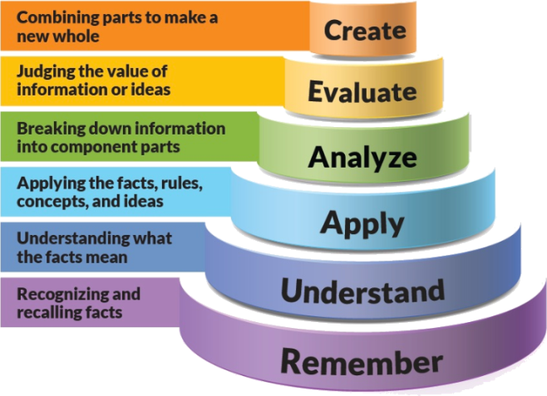
Figure 1: Blooms Taxonomy
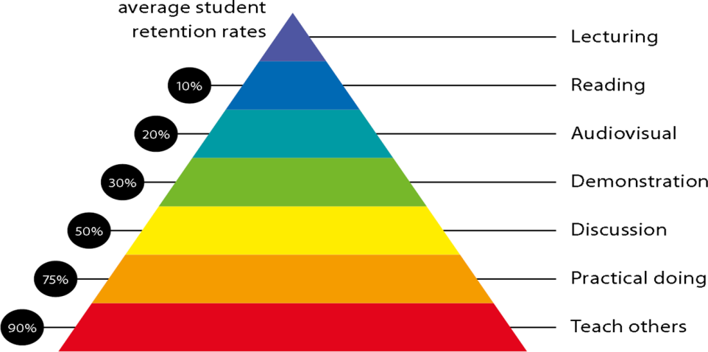
Figure 2: Knowledge retention

Graduate Qualities and Capabilities covered
(Qualities graduates harness crediting this Course)

General Graduate Qualities | Specific Department of ______Graduate Capabilities
Informed  Have a sound knowledge of an area of study or profession and understand its current issues, locally and internationally. Know how to apply this knowledge. Understand how an area of study has developed and how it relates to other areas. | 1 Professional knowledge, grounding & awareness
Independent learners  Engage with new ideas and ways of thinking and critically analyze issues. Seek to extend knowledge through ongoing research, enquiry and reflection. Find and evaluate information, using a variety of sources and technologies. Acknowledge the work and ideas of others. | 2 Information literacy, gathering & processing
Problem solvers  Take on challenges and opportunities. Apply creative, logical and critical thinking skills to respond effectively. Make and implement decisions. Be flexible, thorough, innovative and aim for high standards. | 3 Problem solving skills
Effective communicators  Articulate ideas and convey them effectively using a range of media. Work collaboratively and engage with people in different settings. Recognize how culture can shape communication. | 4 Written communication
 | 5 Oral communication
 | 6 Teamwork
Responsible  Understand how decisions can affect others and make ethically informed choices. Appreciate and respect diversity. Act with integrity as part of local, national, global and professional communities. | 7 Sustainability, societal & environmental impact

Practical work:
- ASSIGNMENT -1 Theory questions
- ASSIGNMENT -2 Practical problems

Lecture/tutorial times (As per time table)

Attendance Requirements
The University norms states that it is the responsibility of students to attend all lectures, tutorials, seminars and practical work as stipulated in the Course outline. Minimum attendance requirement as per university norms is compulsory for being eligible for mid and end semester examinations.

Details of referencing system to be used in written work
Text books
- Statistics for Management by Richard I. Levin and David S. Rubin, Pearson ( Latest Edition)
- Business Statistics by Naval Bajpai, Peason (Latest Edition)

Reference Books:
- Business Statistics by J K Sharma, Vikas Publication (Latest Edition)
- Business Statistics by Gupta and Gupta, Sultan Chand & Sons: New Delhi.
- Fundamental of Statistics by S.C. Gupta , Himalaya Publication
- Business Statistics for contemporary Decision Making by Ken Black, Wiley:India
- Statistics for Business by Levin, Rubin, Rastogi, Siddiqui, Pearson Publication

ASSESSMENT GUIDELINES
Your final course mark will be calculated from the following:
Assignment & Attendance 10 Marks
Class Test 10 Marks
Mid semester 40 Marks
Final exam (closed book) 40 Marks

SUPPLEMENTARY ASSESSMENT
Students who receive an overall mark less than 40% in mid semester or end semester will be considered for supplementary assessment in the respective components (i.e mid semester or end semester) of semester concerned. Students must make themselves available during the supplementary examination period to take up the respective components (mid semester or end semester) and need to obtain the required minimum 40% marks to clear the concerned components.

Practical Work Report/Laboratory Report:
A report on the practical work is due the subsequent week after completion of the class by each group.

Late Work
Late assignments will not be accepted without supporting documentation. Late submission of the reports will result in a deduction of -% of the maximum mark per calendar day

Format
All assignments must be presented in a neat, legible format with all information sources correctly referenced. Assignment material handed in throughout the session that is not neat and legible will not be marked and will be returned to the student.

Retention of Written Work
Written assessment work will be retained by the Course coordinator/lecturer for two weeks after marking to be collected by the students.

University and Faculty Policies
Students should make themselves aware of the University and/or Faculty Policies regarding plagiarism, special consideration, supplementary examinations and other educational issues and student matters.

Plagiarism - Plagiarism is not acceptable and may result in the imposition of severe penalties. Plagiarism is the use of another person’s work, or idea, as if it is his or her own - if you have any doubts at all on what constitutes plagiarism, please consult your Course coordinator or lecturer. Plagiarism will be penalized severely.

Do not copy the work of other students.
Do not share your work with other students (except where required for a group activity or assessment)

Course schedule (subject to change)
(Mention quiz, assignment submission, breaks etc as well in the table under the Teaching Learning Activity Column)

 | Week # | Topic & contents | CO  Addressed | Teaching Learning Activity (TLA)
 | Week 1 | Introduction: definition, scope , functions, collection of data , classification of data, frequency distribution | CO1 &CO2 | Lecture
 | Week 2 | Diagrammatic and graphical presentation of data | CO1 & CO2 | Lecture
 | Week 3 | Measures of central tendency: Arithmetic Mean, Median, Mode, Geometric Mean and their merits and demerits, Weighted Arithmetic Mean | CO1, CO2 &CO6 | Lecture
 | Week 4 | Measures of variation: range  ,average deviation, Standard deviation ,coefficient of variation | CO1,CO2,CO3 &CO6 | Lecture
 | Week 5 | Correlation analysis: karl pearson, spearsman’s rank (methods), Coefficient of determination, | CO4 & CO5 | Lecture
 | Week 6 | Regression analysis, Equation for regression lines, Methods of measuring secular trends | CO4, CO5 & CO6 | Lecture
 | Week 7 | Introduction, Types of Forecasting, Qualitative and Quantitative Methods of Forecasting,Time series analysis: meaning and analysis, | CO4, CO5 & CO6 | Lecture
 | Week 8 | Components and model of time series, Methods of determination of seasonal fluctuations, Measurement of cyclical variations, Measurement of irregular variations | CO5 & CO6 | Lecture
 | Week 9 | Counting Rules, Permutations and Combinations. Venn diagram, Events, Set Operations on Events, Dependent and Independent Events, | CO1, CO2 & CO3 | Lecture
 | Week 10 | Introduction to probability, Probability rules, | CO1, CO2 & CO3 | Lecture
 | Week 11 | Mid Term Exam | N.A | N.A
 | Week 12 | additional and multiplications rules of probability | CO1 &CO2 | Lecture
 | Week 13 | Types of Probability, Marginal probability, Joint probability, | CO1, CO2 & CO3 | Lecture
 | Week 14 | Conditional probability,B ayes’ Theorem. | CO1 &CO2 | Lecture
 | Week 15 | Practical Problems_Probability | CO1 &CO2 | Lecture

