Name of Institute: Indus Institute of Management Studies (IIMS)

Name of Faculty: Dr. Arnaz Wadia

Course code:BB0502
Course name: Introduction to Strategic Management
Prerequisites: HSC
Credit points: 3 Credits
Offered Semester: BBA SEM 5

Course Lecturer (weeks 01 - 12)
Full name: Dr.Arnaz Wadia
Department with siting location: Management
Telephone: 8849141910
Email: arnazwadia.mba@indusuni.ac.in
Consultation times: 2:00 PM to 4:00 PM

Students will be contacted throughout the Session via Mail with important information relating to this Course.

Course Objectives
By participating in and understanding all facets of this Course a student will:

The course aims to acquaint the students with the nature, scope and dimensions of Business Policy and Strategy Management Process. It create a better understanding of strategies & tactics in solving business related problems. To develop insights of strategic management application in businesses for maximizing returns.

Course Outcomes (CO)
- Develop business & corporate level strategies, concepts learnt in new context/ situations.
- Formulate strategy with organizational structure, culture and leadership
- Ability to formulate marketing strategies that incorporate psychological and sociological factors
- Apply knowledge of functional areas to enable holistic decisions.
- Ability to analyze marketing problems and provide solutions based on a critical examination of marketing information.
- Formulate strategy with organizational structure, culture and leadership

Course Outline
(Key in topics to be dealt)

Course Content:
Unit-I (9 Hours) Strategic Management: An Introduction
Introduction to strategy, Vision and Mission; Concept of Strategic management, components of Strategic Management, Significance of Strategic Management, Pitfalls of Strategic management system, strategic management process.
Unit-2 (9Hours) Scanning Business Environment
External and Industry Environmental Analysis using PEST and Porter’s Five-Force Model, Understanding concepts such as Key Success Factors; Driving Forces,Strategic Groups. Internal Analysis: Concept of Value Chain, SWOT Analysis; Resources, Capabilities and Competencies; Core Competence of Organizations; Competitive Advantage and Sustainable Competitive Advantage
Unit-3 (9Hours) Strategy Formulation
Strategy formulation at Business and Corporate levels, Diversification Strategic Alliance and Joint Ventures, Cooperative Strategies Acquisitions and Restructuring,Global Strategy, International Corporate-level and Business-level Strategies. Porter’s Generic Strategies
Unit-4 (9Hours) Strategy Execution and Implementation
Strategy execution, process of strategy implementation, Culture as adjunct to strategy execution, Strategic Leadership, Role of leadership in execution of strategy

Method of delivery
Face to face lectures, Self Study Material, Active Learning Techniques, Case Studies, Audio-Visuals.

Study time
3 hours per week

CO-PO Mapping (PO: Program Outcomes)
 | PO1 | PO2 | PO3 | PO4 | PO5 | PO6
CO1 | 2 | 2 | 3 | 1 | 2 | -
CO2 | 1 | 2 | 2 | 2 | 3 | 3
CO3 | 2 | 1 | 2 | 2 | 2 | 3
CO4 | 2 | 3 | 1 | 3 | 3 | -
CO5 | 2 | 3 | 2 | 1 | 2 | 2
CO6 | 1 | 3 | - | 1 | 2 | 2

Blooms Taxonomy and Knowledge retention (For reference)
(Blooms taxonomy has been given for reference)

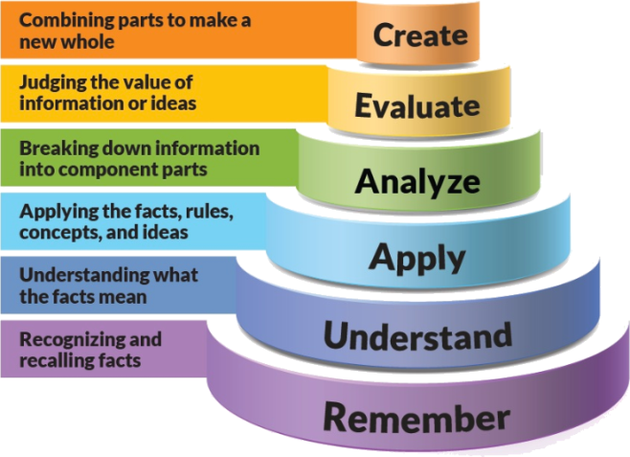
Figure 1: Blooms Taxonomy
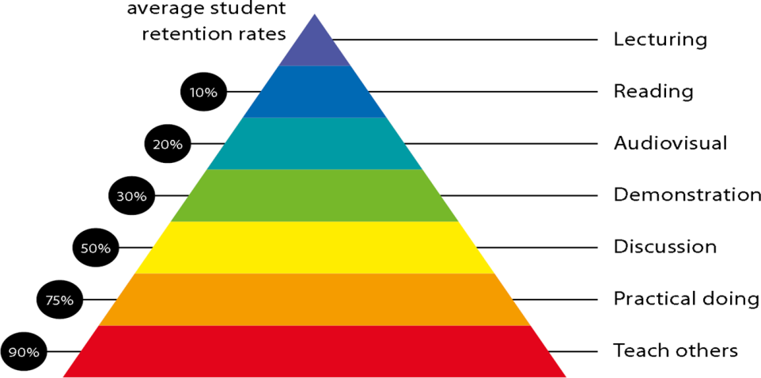
Figure 2: Knowledge retention

Graduate Qualities and Capabilities covered
(Qualities graduates harness crediting this Course)

General Graduate Qualities | Specific Department of ______Graduate Capabilities
Informed  Have a sound knowledge of an area of study or profession and understand its current issues, locally and internationally. Know how to apply this knowledge. Understand how an area of study has developed and how it relates to other areas. | 1 Professional knowledge, grounding & awareness
Independent learners  Engage with new ideas and ways of thinking and critically analyze issues. Seek to extend knowledge through ongoing research, enquiry and reflection. Find and evaluate information, using a variety of sources and technologies. Acknowledge the work and ideas of others. | 2 Information literacy, gathering & processing
Problem solvers  Take on challenges and opportunities. Apply creative, logical and critical thinking skills to respond effectively. Make and implement decisions. Be flexible, thorough, innovative and aim for high standards. | 4 Problem solving skills
Effective communicators  Articulate ideas and convey them effectively using a range of media. Work collaboratively and engage with people in different settings. Recognize how culture can shape communication. | 5 Written communication
 | 6 Oral communication
 | 7 Teamwork
Responsible  Understand how decisions can affect others and make ethically informed choices. Appreciate and respect diversity. Act with integrity as part of local, national, global and professional communities. | 10 Sustainability, societal & environmental impact

Practical work:
- Assignment-1: Case Study
- Assignment-2:Case Study
- Assignment-3:Presentation
- Assignment-4:Quiz

Attendance Requirements

The University norms states that it is the responsibility of students to attend all lectures, tutorials, seminars and practical work as stipulated in the Course outline. Minimum attendance requirement as per university norms is compulsory for being eligible for mid and end semester examinations.

Details of referencing system to be used in written work

Text books

Strategic Management Text and Cases by Dr. C.B Gupta S Chand Publication

Additional Material
- Strategic Management: Concepts, Skills And Practic by Srivastava R M Publisher : Phi Learning Pvt. Ltd-New Delhi
- AzharKazmi, Strategic Management and Business Policy, Tata Mcgraw Hill, New Delhi.
- Thomas Wheelen, Thomas Hunger, J. David Hunger, Concepts in Strategic Management and Business Policy, Pearson Education, New Delhi

ASSESSMENT GUIDELINES
Your final course mark will be calculated from the following:
Example:
Quiz 1 5% (week 4) Objective (1-3)
Quiz II 5% (week 8) Objective (1-4)
Mid semester 30% (due week 10) Objectives (2-5)
Final exam (closed book) 60% Objectives (1-5)

SUPPLEMENTARY ASSESSMENT

Students who receive an overall mark less than 40% in mid semester or end semester will be considered for supplementary assessment in the respective components (i.e mid semester or end semester) of semester concerned. Students must make themselves available during the supplementary examination period to take up the respective components (mid semester or end semester) and need to obtain the required minimum 40% marks to clear the concerned components.

Practical Work Report/Laboratory Report:
A report on the practical work is due the subsequent week after completion of the class by each group.

Late Work
Late assignments will not be accepted without supporting documentation. Late submission of the reports will result in a deduction of -% of the maximum mark per calendar day

Format
All assignments must be presented in a neat, legible format with all information sources correctly referenced. Assignment material handed in throughout the session that is not neat and legible will not be marked and will be returned to the student.

Retention of Written Work
Written assessment work will be retained by the Course coordinator/lecturer for two weeks after marking to be collected by the students.

University and Faculty Policies
Students should make themselves aware of the University and/or Faculty Policies regarding plagiarism, special consideration, supplementary examinations and other educational issues and student matters.

Plagiarism - Plagiarism is not acceptable and may result in the imposition of severe penalties. Plagiarism is the use of another person’s work, or idea, as if it is his or her own - if you have any doubts at all on what constitutes plagiarism, please consult your Course coordinator or lecturer. Plagiarism will be penalized severely.

Do not copy the work of other students.
Do not share your work with other students (except where required for a group activity or assessment
Course schedule (subject to change)
(Mention quiz, assignment submission, breaks etc as well in the table under the Teaching Learning Activity Column)

 | Week # | Topic & Contents |  |  | CO Addressed |  | Teaching Learning Activity (TLA)
 | Weeks 1 | Introduction to strategy, Vision and Mission; Concept of Strategic management, components of Strategic Management |  |  | CO1 |  | Lecture
 | Weeks 2 | Significance of Strategic Management, Pitfalls of Strategic management system |  |  | CO1 |  | Audio-Visual
 | Week 3 | Strategic management process |  |  | CO1 & CO2 |  | Audio-Visual
 | Week 4 | External and Industry Environmental Analysis using PEST and Porter’s Five-Force Model, Understanding concepts such as Key Success Factors |  |  | CO3 |  | Lecture
 | Week 5 | Driving Forces,Strategic Groups. Internal Analysis: Concept of Value Chain, SWOT Analysis; Resources |  |  | CO3 |  | Lecture
 | Week 6 | Capabilities and Competencies; Core Competence of Organizations; Competitive Advantage and Sustainable Competitive Advantage |  | CO3 |  | Case Study
 | Week 7 | Strategy formulation at Business and Corporate levels, Diversification Strategic Alliance and Joint Ventures |  | CO4 |  | Case Study
 | Week 8 | Cooperative Strategies Acquisitions and Restructuring,Global Strategy |  | CO5 |  | Audio-Visual
 | Week 9 | International Corporate-level and Business-level Strategies. Porter’s Generic Strategies |  | CO3 & CO4 |  | Audio-Visual
 | Week 10 | Strategy execution, process of strategy implementation |  | CO5 |  | Lecture
 | Week 11 | Culture as adjunct to strategy execution |  | CO6 |  | Lecture
 | Week 12 | Strategic Leadership |  | CO6 |  | Case Study
 | Week 13 | Role of leadership in execution of strategy |  | CO6 |  | Lecture
 | Week 14 | Strategy Implementation |  | CO6 |  | Lecture
 | Week 15 | Revision |  |  |  | Lecture

