Name of Institute: Indus Institute of Management Studies

Name of Faculty: Dr. Neelam Kshatriya

Course code: BC0301

Course name: Human Resource Management
Pre-requisites: Management Concepts
Credit points: 6/4
Offered Semester: III

Course Lecturer (weeks 1 - 18)
Full Name: Dr. Neelam Kshatriya
Department with siting location: Management, Staff Office, 4th floor, Bhanvar Building
Telephone: 9825070369
Email: neelamkshatriya.mba@indusuni.ac.in
Consultation times: 3:00 PM to 5:00 PM

Students will be contacted throughout the Session via Mail with important information relating to this Course. The google classroom will also have the updates.

Course Objectives

To acquaint the student to develop an understanding of the legal framework prevailing in industry.

Course Outcomes (CO)

CO 1: Gain a solid understanding of key Human Resource Management concepts and skills.

CO 2: Identify and demonstrate the dynamic nature of the Human Resource Management..

CO 3: Develop the students’ skills in applying the analytic perspectives; decision tools the field of Human Resource Management

CO 4: Develop an understanding of the underlying concepts, strategies and the issues
involved in Human Resource Management.

CO 5: Develop strong Human Resource Management plans and persuasively communicate your
recommendations and rational.

CO- PO Mapping :

 | PO1 | PO2 | PO3 | PO4 | PO5 | PO6 | PO7
CO 1 | 3 | 2 | 3 | 3 | 2 | 3 | 2
CO 2 | 2 | 3 | 2 | 2 | 2 | 2 | 2
CO 3 | 2 | 2 | 2 | 2 | 3 | 3 | 2
CO 4 | 2 | 3 | 2 | 2 | 3 | 2 | 3
CO 5 | 3 | 3 | 3 | 2 | 2 | 2 | 2

Course Outline

Course Content:
Module-I  (25% Weightage) | Human Resource Management: Concept and Functions, Role, Status and competencies of HR Manager, HR Policies, Evolution of HRM, HRM vs HRD. Emerging Challenges of Human Resource Management;
Module-II  (25% Weightage) | HR Planning and Talent Acquisition:  HR Planning; Job Analysis – Job Description and Job Specification;  Recruitment – Sources and Process.  Selection - Process, Tests and Interviews.
Module-III  (25% Weightage) | Managing and Rewarding Employee Performance :  Training and Development – Learning, training and development  Performance Management System – Performance planning, appraisal and review.  Compensation Management – Job evaluation, establishing pay structures, managing benefits and services, pay for performance, recognition and legal framework for compensation
Module-IV  (25% Weightage) | Managing Employee Relations  Employee Relations and Industrial Relations – Overview of Labour Legislations Industrial Disputes and Conflicts – Managing industrial unrest

Method of delivery
(Online lectures, self-study material, case discussions ,Active class participation,skill tests)

Study time
( Six Hours/Four hours Per Week )

CO-PO Mapping (PO: Program Outcomes)

 | PO1 | PO2 | PO3 | PO4 | PO5 | PO6 | PO7
CO 1 | 3 | 2 | 3 | 3 | 2 | 3 | 2
CO 2 | 2 | 3 | 2 | 2 | 2 | 2 | 2
CO 3 | 2 | 2 | 2 | 2 | 3 | 3 | 2
CO 4 | 2 | 3 | 2 | 2 | 3 | 2 | 3
CO 5 | 3 | 3 | 3 | 2 | 2 | 2 | 2

Blooms Taxonomy and Knowledge retention (For reference)
(Blooms taxonomy has been given for reference)

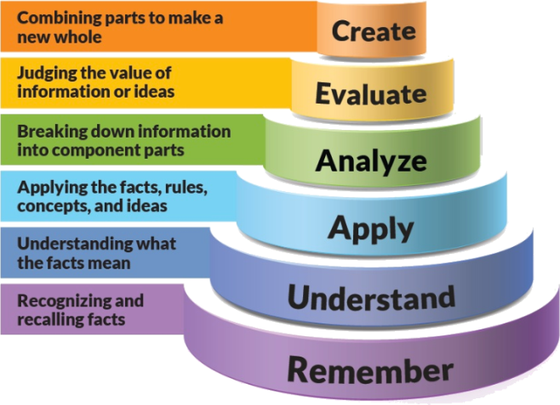
Figure 1: Blooms Taxonomy
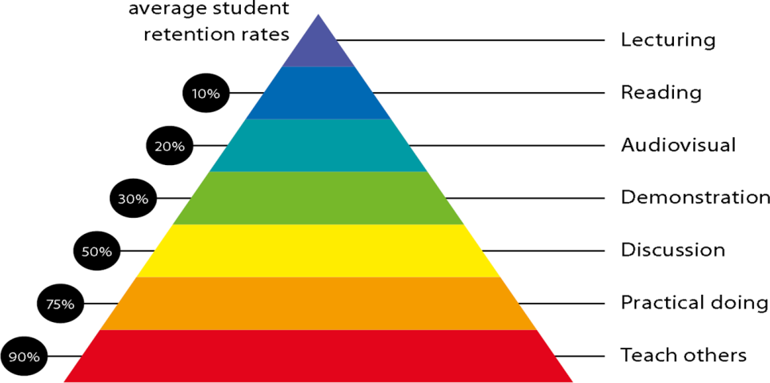
Figure 2: Knowledge retention

Graduate Qualities and Capabilities covered
(Qualities graduates harness crediting this Course)

General Graduate Qualities | Specific Department of Management Graduate Capabilities
Informed  Disciplinary Knowledge  - How Human Resource Manager works  - HR Processes | 1 Professional knowledge, grounding & awareness,industry updates
Independent learners  - Metacognition  - Planning  - Evaluating | 2 Information literacy, gathering & processing
Thinking • critical • creative • practical | 4 Problem solving skills
Effective Production Managers  - Effective Human Resource Management  - Activities to maintain and enhance effective Human Resource Management | 5 Communication
 | 6 Participation
 | 7 Leadership
Responsible  - Learning • capacity for life-long learning • flexibility • adaptability | 10 Efficiency, Accuracy, Flexibility, Consistency

Practical work:
Students shall be given assignments

Lecture/tutorial times

Lecture Monday 10:00 am – 11:00 am
Tuesday 9.00 am – 10:00 am
Wednesday 9.00 am – 10:00 am ;10:05-11:05 am
Thursday 9:00am – 10:00 am
Friday 9:00am – 10:00 am

Attendance Requirements

The University norms states that it is the responsibility of students to attend all lectures, tutorials, seminars and practical work as stipulated in the Course outline. Minimum attendance requirement as per university norms is compulsory for being eligible for mid and end semester examinations.

Details of referencing system to be used in written work

Text books

- Gary Dessler. A Framework for Human Resource Management. Pearson Education.
- Ivancevich, John M. Human Resource Management. McGraw Hill.
- TN Chhabra, Human Resource Management, Dhanpat Rai & Co., Delhi
- Biswajeet Patttanayak, Human Resource Management, PHI LearningAdditional Materials

Reference Book

- DeCenzo, D.A. and S.P. Robbins, Personnel/Human Resource Management, PearsonEducation.
- Bohlendar and Snell, Principles of Human Resource Management, Cengage Learning
- Robert L. Mathis and John H. Jackson. Human Resource Management. Cengage Learning.
- Wreather and Davis. Human Resource Management. Pearson Education.

Websites, newspapers, magazines to be referred for better understanding of the course.

- https://labour.gov.in- Website of Ministry of Labour and Employment ,Government of India
- https://col.gujarat.gov.in - Website of Director of Labour , Labour and Employment Department ,Government of Gujarat
- ‘Research in Personnel and Human Resources Management’- Journal by JAI Press
- The Times of India- Newspaper

Late Work

Late assignments will not be accepted without supporting documentation. Late submission of the reports will result in a deduction of 5% of the maximum mark per calendar day

Format
All assignments must be presented in a neat, legible format with all information sources correctly referenced. Assignment material handed in throughout the session that is not neat and legible will not be marked and will be returned to the student.

Retention of Written Work
Written assessment work will be retained by the Course coordinator/lecturer for two weeks after marking to be collected by the students.

University and Faculty Policies
Students should make themselves aware of the University and/or Faculty Policies regarding plagiarism, special consideration, supplementary examinations and other educational issues and student matters.

Plagiarism - Plagiarism is not acceptable and may result in the imposition of severe penalties. Plagiarism is the use of another person’s work, or idea, as if it is his or her own - if you have any doubts at all on what constitutes plagiarism, please consult your Course coordinator or lecturer. Plagiarism will be penalized severely.

Do not copy the work of other students.
Do not share your work with other students (except where required for a group activity or assessment)
.

Course schedule (subject to change)
(Mention quiz, assignment submission, breaks etc as well in the table under the Teaching Learning Activity Column)

 | Week # | Topic & contents |  |  | CO Addressed |  | Teaching Learning Activity (TLA)
 | Week 1 | Human Resource Management: Concept and Functions |  |  | CO1 |  | Discussion/Case Study
 | Week 2 | Role, Status and competencies of HR Manager, HR Policies |  |  | CO2 |  | Skill Test,Lecture
 | Week 3 | Evolution of HRM, HRM vs HRD. Emerging Challenges of Human Resource Management |  |  | CO2 |  | Discussion,presentation
 | Week 4 | HR Planning and Talent Acquisition:  Job Description |  |  | CO2 |  | Lecture,presentation
 | Week 5 | Job Specification |  |  | CO3 |  | Lecture,Case study
 | Week 6 | Recruitment – Sources and Process. |  | CO4 |  | Lecture , Case study
 | Week 7 | Selection - Process, Tests and Interviews. |  | CO4 |  | Lecture , Case study
 | Week 8 | Managing and Rewarding Employee Performance :  Training and Development – Learning, training and development |  | CO3 |  | Discussion ,Lecture
 | Week 9 | Performance Management System – Performance planning, appraisal and review. |  | C03 |  | Lecture
 | Week 10 | Compensation Management – Job evaluation,Establishing pay structures, managing benefits and services |  | C03 |  | Lecture
 | Week 11 | Case lets dicussion by groups |  | C04 |  | Lecture, Group Discussion
 | Week 12 | Pay for performance |  | C05 |  | Discussion with examples of firms
 | Week 13 | Recognition and legal framework for compensation |  | C05 |  | Lecture;  Discussion
 | Week 14 | Managing Employee Relations  Employee Relations and Industrial Relations – Overview of Labour Legislations |  | C04 |  | Lecture;  Discussion
 | Week 15 | Employee Relations and Industrial Relations – Overview of Labour Legislations |  | C03 |  | Lecture;  Discussion

