Name of Institute: Indus Institute of Management Studies (IIMS)

Name of Faculty: Dr. Rajesh Ojha

Course code: MB0321
Course name: MANAGING BANKS & FINANCIAL INSTITUTIONS
Pre-requisites: Graduation
Credit points: 3 Credits
Offered Semester: III

Course Lecturer (Weeks 01 – 15)
Full name: Dr. Rajesh Ojha
Department with sitting location: IIMS , Management
Telephone: (M) 8200991625
Email: rajeshojha.mba@indusuni.ac.in
Consultation times:4.00pm to 5.00pm

Students will be contacted throughout the Session via Mail with important information relating to this Course.

Course Objectives
By participating in and understanding all facets of this Course a student will:

This subject aims to provide general exposure of the financial system pertaining to banks and Financial Institutions

Course Outcomes (CO)
Upon completion of this course, students will be able to complete the following key tasks:
CO1: To understand the reasons why different financial institutions have different functions in the economy
CO2: Understanding how financial institutions asses and manage risk using some of the trading strategies and instruments available in financial markets
CO3: Understanding how institutions and markets are regulated in domestic and international environments
CO4: evaluation of proposals for regulatory reform.
CO5: Understanding how monetary policy is implemented in an open economy
CO6: Application of general exposure of the financial system pertaining to banking

Course Outline
UNIT-I

Introduction to banking - history of banks - meaning of banking - functions of bank - banker customer relationship - banking systems - unit banking - branch banking - banking sectors - corporate banking - retail banking - international banking - rural banking - role of banks in primary, secondary and tertiary sector

UNIT-II

Structure of Indian banking system - Reserve bank of India - commercial banks - public sector banks - private sector banks - foreign banks - cooperative banks - state cooperative banks - district cooperative banks - primary credit societies - regional rural banks - development banks
UNIT-III

Structure of Financial System – role of Financial System in Economic Development – Financial Markets and Financial Instruments – Capital Markets – Money Markets – Primary Market Operations – Role of SEBI – Secondary Market Operations – Regulation – Functions of Stock Exchanges – Listing – Formalities – Financial Services Sector Problems and Reforms.

UNIT-IV

Financial Services: Concept, Nature and Scope of Financial Services – Regulatory Frame Work of Financial Services – Growth of Financial Services in India – Merchant Banking – Meaning-Types – Responsibilities of Merchant Bankers – Role of Merchant Bankers in Issue Management – Regulation of Merchant Banking in India.

UNIT-V

Mutual Funds – Concept and Objectives, Functions and Portfolio Classification, Organization and Management, Guidelines for Mutual Funds, Working of Public and Private Mutual Funds in India. Debt Securitization – Concept and Application – De-mat Services-need and Operations-role of NSDL and CSDL.

Method of delivery
Lectures, PPT, Case Studies, Group Presentations

Study time
Three hours per week

CO-PO Mapping (PO: Program Outcomes)

 | PO1 | PO2 | PO3 | PO4 | PO5 | PO6
CO 1 | 3 | - | 2 | 2 | 1 | -
CO 2 | 3 | - | 3 | 2 | 1 | -
CO 3 | 3 | - | 2 | 3 | 2 | -
CO 4 | 3 | 3 | 2 | 2 | 1 | 3
CO 5 | 3 | - | 2 | 2 | 2 | -
CO 6 | 2 | - | 3 | 2 | - | -

Blooms Taxonomy and Knowledge retention(For reference)
(Blooms taxonomy has been given for reference)

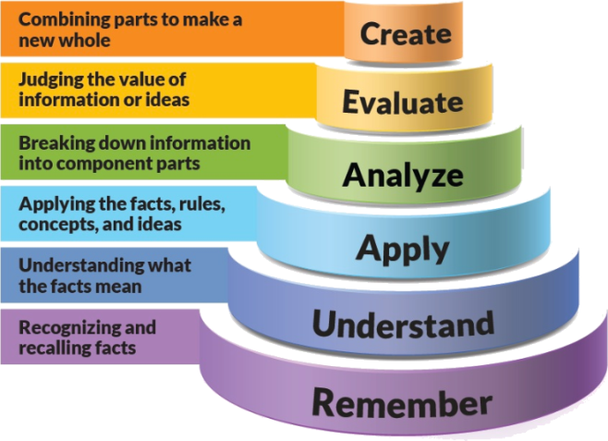
Figure 1: Blooms Taxonomy
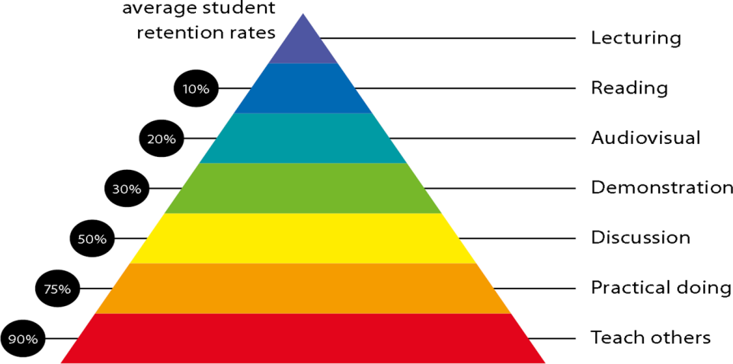
Figure 2: Knowledge retention

Graduate Qualities and Capabilities covered
(Qualities graduates harness crediting this Course)

General Graduate Qualities | Specific Department of ______Graduate Capabilities
Informed  Have a sound knowledge of an area of study or profession and understand its current issues, locally and internationally. Know how to apply this knowledge. Understand how an area of study has developed and how it relates to other areas. | 1 Professional knowledge, grounding & awareness
Independent learners  Engage with new ideas and ways of thinking and critically analyze issues. Seek to extend knowledge through ongoing research, enquiry and reflection. Find and evaluate information, using a variety of sources and technologies. Acknowledge the work and ideas of others. | 2 Information literacy, gathering & processing
Problem solvers  Take on challenges and opportunities. Apply creative, logical and critical thinking skills to respond effectively. Make and implement decisions. Be flexible, thorough, innovative and aim for high standards. | 4 Problem solving skills
Effective communicators  Articulate ideas and convey them effectively using a range of media. Work collaboratively and engage with people in different settings. Recognize how culture can shape communication. | 5 Written communication
 | 6 Oral communication
 | 7 Teamwork
Responsible  Understand how decisions can affect others and make ethically informed choices. Appreciate and respect diversity. Act with integrity as part of local, national, global and professional communities. | 10 Sustainability, societal & environmental impact

Practical work:
- ASSIGNMENT -1 Theory Question from Unit No: 1
- ASSIGNMENT -2 MCQ Class Test from Unit 1 & 2
- ASSIGNMENT -3 Group/Individual Presentations .

Lecture/tutorial times

Attendance Requirements

The University norms states that it is the responsibility of students to attend all lectures, tutorials, seminars and practical work as stipulated in the Course outline. Minimum attendance requirement as per university norms is compulsory for being eligible for mid and end semester examinations.

Details of referencing system to be used in written work

Text books
- Elements of Banking and Insurance - By Jyotsna Sethi, Nishwan Bhatia
- Gupta P.K, “ Insurance and Risk Management”, Himalya Publishing House;
- Mishra M.N., “ Principles and Practices of Insurance”,S. Chand and Co;
- Bhole&Mahakud, Financial Institutions and Market, TMH, New Delhi
- Anthony Saunders and MM Cornett, Fin Markets & Institutions,TMH, New Delhi

Additional Materials (Reference Books)

- K. P. M., Banking Theory Law and Practice by Sundhram, Sultan Chand
- Banking and financial system - B. Santhanam, Sundharam &Varshney
- Banking and Insurance - By R.K. Sharma, Shashi K. Gupta, Jagwant Singh
- Principles of Insurance - By S.K. Jain
- Arthur C. and C. William Jr., “Risk Management and Insurance,” Tata Mcgraw Hill;
- Vasanth Desai, Financial Markets & Financial Services, Himalaya, Mumbai

ASSESSMENT GUIDELINES
Your final course mark will be calculated from the following:
1. Assignment No: 1 - 5 Marks
2. MCQ Class Test - 5 Marks
3. Group Presentations - 5 Marks
4. Attendance - 5 Marks
5. Mid Semester Exams - 40 Marks
6. End Semester Exam - 40 Marks

SUPPLEMENTARY ASSESSMENT

Students who receive an overall mark less than 40% in mid semester or end semester will be considered for supplementary assessment in the respective components (i.e mid semester or end semester) of semester concerned. Students must make themselves available during the supplementary examination period to take up the respective components (mid semester or end semester) and need to obtain the required minimum 40% marks to clear the concerned components.

Practical Work Report/Laboratory Report:
A report on the practical work is due the subsequent week after completion of the class by each group.

Late Work
Late assignments will not be accepted without supporting documentation. Late submission of the reports will result in a deduction of -% of the maximum mark per calendar day

Format
All assignments must be presented in a neat, legible format with all information sources correctly referenced. Assignment material handed in throughout the session that is not neat and legible will not be marked and will be returned to the student.

Retention of Written Work
Written assessment work will be retained by the Course coordinator/lecturer for two weeks after marking to be collected by the students.

University and Faculty Policies
Students should make themselves aware of the University and/or Faculty Policies regarding plagiarism, special consideration, supplementary examinations and other educational issues and student matters.

Plagiarism - Plagiarism is not acceptable and may result in the imposition of severe penalties. Plagiarism is the use of another person’s work, or idea, as if it is his or her own - if you have any doubts at all on what constitutes plagiarism, please consult your Course coordinator or lecturer. Plagiarism will be penalized severely.

Do not copy the work of other students.
Do not share your work with other students (except where required for a group activity or assessment)
.

Course schedule(subject to change)
(Mention quiz, assignment submission, breaksetcas well in the table under the Teaching Learning Activity Column)

 | Week # | Topic & contents | CO  Addressed | Teaching Learning Activity (TLA)
 | Weeks 1 | UNIT-I Introduction to banking - history of banks - meaning of banking functions of bank - banker customer relationship - | CO1 & CO2 |  | Lecture
 | Weeks 2 | UNIT-I banking systems - unit banking - branch banking - | CO1 & CO2 |  | Lecture
 | Week 3 | UNIT -1 Banking sectors - corporate banking - retail banking - international banking | CO1 & CO2 |  | Lecture  Assignment No:1
 | Week 4 | Unit -1 rural banking - role of banks in primary, secondary and tertiary sector | CO1 & CO2 |  | Lecture
 | Week 5 | UNIT -II  Structure of Indian banking system - Reserve bank of India | CO1,CO2 |  | Lecture
 | Week 6 | Unit - II commercial banks - public sector banks - private sector banks - foreign banks | CO1,CO2 |  | Lecture  MCQ Class Test
 | Week 7 | UNIT -II Cooperative banks - state cooperative banks - district cooperative banks - primary credit societies - regional rural banks - development banks | CO1, CO2 |  | Lecture
 | Week 8 | UNIT-III Structure of Financial System – role of Financial System in Economic Development | CO1. CO2 |  | Lecture
 | Week 9 | Unit -III Financial Markets and Financial Instruments – Capital Markets – Money Markets – Primary Market Operations | CO1.CO2 |  | Lecture  Group Presentations
 | Week 10 | . UNIT -III Role of SEBI – Secondary Market Operations – Regulation – Functions of Stock Exchanges – Listing – Formalities – Financial Services Sector Problems and Reforms. | CO3 |  | Lecture
 | Week 11 | Mid Semester Examination | NA |  | NA
 | Week 12 | UNIT-IV Financial Services: Concept, Nature and Scope of Financial Services – Regulatory Frame Work of Financial Services – Growth of Financial Services in India – | CO1.C02,C03 |  | Lecture
 | Week 13 | UNIT -IV Merchant Banking – Meaning-Types – Responsibilities of Merchant Bankers – Role of Merchant Bankers in Issue Management – Regulation of Merchant Banking in India | CO3,CO4,CO5,C06 |  | Lecture
 | Week 14 | UNIT-V Mutual Funds – Concept and Objectives, Functions and Portfolio Classification, Organization and Management, | CO3,CO4,CO5,C06 |  | Lecture
 | Week 15 | UNIT -V Guidelines for Mutual Funds, Working of Public and Private Mutual Funds in India. Debt Securitization – Concept and Application – De-mat Services-need and Operations-role of NSDL and CSDL. | CO3,C04,C05,C06 |  | Lecture

