Name of Institute: Indus Institute of Management Studies (IIMS)

Name of Faculty: Dr. Rajesh Ojha

Course code: IMB0302
Course name: FINANCIAL MANAGEMENT
Pre-requisites: Graduation
Credit points: 4 Credits
Offered Semester: III

Course Lecturer (Weeks 01 – 12)
Full name: Dr. Rajesh Ojha
Department with sitting location: IIMS , Management
Telephone(M) 8200991625
Email: rajeshojha.mba@indusuni.ac.in
Consultation times: 4.00 pm to 5.00pm

Students will be contacted throughout the Session via Mail with important information relating to this Course.

Course Objectives
By participating in and understanding all facets of this Course a student will:

The objective of this course is to help the students understand the fundamental concepts of Finance & Financial Management

Course Outcomes (CO)
Upon completion of this course, students will be able to complete the following key tasks:

CO 1 : Describe the basic concepts related to Financial Management , Techniques of Financial Statement Analysis , Working Capital , Capital Structure, Leverage and Capital Budgeting.

CO 2 : Explain all theoretical concepts through out the syllabus.

CO3 :.Perform all required calculations thorough relevant problems

CO 4 : Analyse the Situation and comment , estimate , decide, evaluate.

CO5 : Assess the impact of business decisions .

CO6 : Ability to assess and analyse the financial environment in the local and international markets

Course Outline
Unit-I
Understanding the Meaning of Financial Management, Financial System, and Basics of Valuation ,Introduction to Financial Management; Introduction to the Financial System; The concept of Time value of money;Valuation of Bonds and Shares

Unit-II
INVESTMENT DECISIONS: Meaning, Significance, Objectives and Importance of Capital Budgeting - Capital budgeting Process - Basic Principles of Capital Expenditure Proposals - Various appraisal Methods: Pay Back Period, Discounted Cash Flow Method, Average Rate of Return

Unit-III
CAPITAL STRUCTURE: Meaning and Significance of Capital Structures - Capital structure and financial structure - Patterns of Capital Structure - Ideal Capital Structure, Features of Ideal Capital Structure - Merits and Demerits of different types of Capital Structure

Unit-IV
FINANCING DECISIONS:Sources of Finance - Equity Shares - Preference Shares –Debentures –Term Loans- Retained earning, - Bridge finance - Government policy on security financing and Term Loan - Operating and Financial Leverage, Working Capital Management and Working Capital Financing (Funds Based and Non Funds Based )

Method of delivery
Lectures, PPT, Group Presentations and Problem Solving.

Study time
Four hours per week

CO-PO Mapping (PO: Program Outcomes)

 | PO1 | PO2 | PO3 | PO4 | PO5 | PO6
CO 1 | 3 | - | 3 | 2 | - | -
CO 2 | 3 | - | 2 | - | 2 | -
CO 3 | 3 | - | 3 | 2 | 1 | -
CO 4 | 2 | - | 3 | 2 | - | -
CO 5 | - | 3 | 3 | - | 2 | 3
CO 6 | 3 | - | 3 | 2 | 1 | -

Blooms Taxonomy and Knowledge retention(For reference)
(Blooms taxonomy has been given for reference)

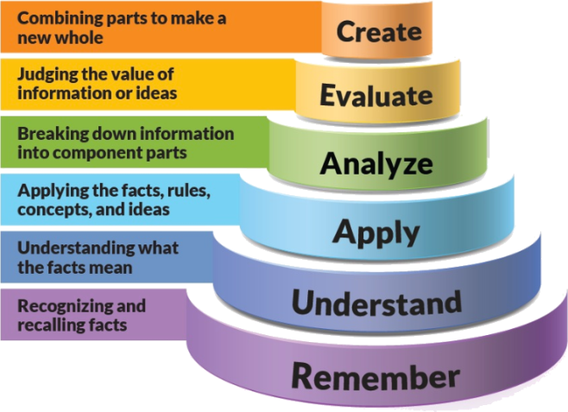
Figure 1: Blooms Taxonomy
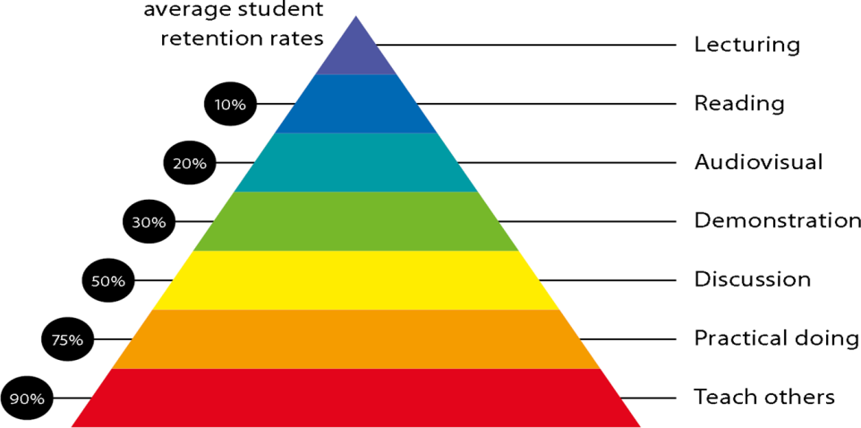
Figure 2: Knowledge retention

Graduate Qualities and Capabilities covered
(Qualities graduates harness crediting this Course)

General Graduate Qualities | Specific Department of ______Graduate Capabilities
Informed  Have a sound knowledge of an area of study or profession and understand its current issues, locally and internationally. Know how to apply this knowledge. Understand how an area of study has developed and how it relates to other areas. | 1 Professional knowledge, grounding & awareness
Independent learners  Engage with new ideas and ways of thinking and critically analyze issues. Seek to extend knowledge through ongoing research, enquiry and reflection. Find and evaluate information, using a variety of sources and technologies. Acknowledge the work and ideas of others. | 2 Information literacy, gathering & processing
Problem solvers  Take on challenges and opportunities. Apply creative, logical and critical thinking skills to respond effectively. Make and implement decisions. Be flexible, thorough, innovative and aim for high standards. | 4 Problem solving skills
Effective communicators  Articulate ideas and convey them effectively using a range of media. Work collaboratively and engage with people in different settings. Recognize how culture can shape communication. | 5 Written communication
 | 6 Oral communication
 | 7 Teamwork
Responsible  Understand how decisions can affect others and make ethically informed choices. Appreciate and respect diversity. Act with integrity as part of local, national, global and professional communities. | 10 Sustainability, societal & environmental impact

Practical work:
- ASSIGNMENT -1 Theory Questions from Unit 1
- ASSIGNMENT -2 MCQ Class Test from Unit 1 & 2
- ASSIGNMENT -3 Group Presentation

Lecture/tutorial times

Attendance Requirements

The University norms states that it is the responsibility of students to attend all lectures, tutorials, seminars and practical work as stipulated in the Course outline. Minimum attendance requirement as per university norms is compulsory for being eligible for mid and end semester examinations.

Details of referencing system to be used in written work

Text books

1.Fundamentals of Financial Management: Prasanna Chandra, Tata McGraw Hills

Additional Materials (Reference Books)

1.Financial Management: S N Maheshwari, Sultan Chand & Sons, New Delhi
2.Financial Management: Khan & Jain, Tata McGraw Hill Publishing Co.
3.Financial Management: I M Pandey, Vikas Publishing House, New Delhi.

ASSESSMENT GUIDELINES
Your final course mark will be calculated from the following:

- Assignment No : 1 - 5 Marks
- MCQ Class Test - 5 Marks
- Group Presentations - 5 Marks
- Attendance - 5 Marks
- Mid Semester Exams 40 Marks
- End Semester Exams 40 Marks

SUPPLEMENTARY ASSESSMENT

Students who receive an overall mark less than 40% in mid semester or end semester will be considered for supplementary assessment in the respective components (i.e mid semester or end semester) of semester concerned. Students must make themselves available during the supplementary examination period to take up the respective components (mid semester or end semester) and need to obtain the required minimum 40% marks to clear the concerned components.

Practical Work Report/Laboratory Report:
A report on the practical work is due the subsequent week after completion of the class by each group.

Late Work
Late assignments will not be accepted without supporting documentation. Late submission of the reports will result in a deduction of -% of the maximum mark per calendar day

Format
All assignments must be presented in a neat, legible format with all information sources correctly referenced. Assignment material handed in throughout the session that is not neat and legible will not be marked and will be returned to the student.

Retention of Written Work
Written assessment work will be retained by the Course coordinator/lecturer for two weeks after marking to be collected by the students.

University and Faculty Policies
Students should make themselves aware of the University and/or Faculty Policies regarding plagiarism, special consideration, supplementary examinations and other educational issues and student matters.

Plagiarism - Plagiarism is not acceptable and may result in the imposition of severe penalties. Plagiarism is the use of another person’s work, or idea, as if it is his or her own - if you have any doubts at all on what constitutes plagiarism, please consult your Course coordinator or lecturer. Plagiarism will be penalized severely.

Do not copy the work of other students.
Do not share your work with other students (except where required for a group activity or assessment)
.

Course schedule(subject to change)
(Mention quiz, assignment submission, breaksetcas well in the table under the Teaching Learning Activity Column)

 | Week # | Topic & contents | CO  Addressed | Teaching Learning Activity (TLA)
 | Weeks 1 | Unit-I Understanding the Meaning of Financial Management, Financial System, and ,Introduction to Financial Management; Introduction to the Financial System; | CO1,CO2,CO3 | Lecture
 | Weeks 2 | Unit - 1 :The concept of Time value of money; | CO1,CO2,CO3, | Lecture
 | Week 3 | Unit - 1 : Basics of Valuation Valuation of Bonds and Shares | CO1,CO2,CO3, | Lecture  Assignment No:1
 | Week 4 | Unit - 1 : Basics of Valuation Valuation of Bonds and Shares (Continued) | CO1,CO2,CO3, | Lecture
 | Week 5 | Unit-II Investment Decisions: Meaning, Significance, Objectives and Importance of Capital Budgeting | CO1,CO2 | Lecture
 | Week 6 | Unit-II Capital budgeting Process | ,CO2,CO3 | Lecture  MCQ Class Test
 | Week 7 | Unit - II Basic Principles of Capital Expenditure Proposals - Various appraisal Methods: | CO1,CO2,CO3,CO4 | Lecture
 | Week 8 | Unit - II Pay Back Period, Discounted Cash Flow Method, Average Rate of Return. | CO1,CO2,CO3,CO4 | Lecture
 | Week 9 | Unit-III Meaning and Significance of Capital Structures - Capital structure and financial structure - | CO1,CO2,C03 | Lecture  Group Presentations
 | Week 10 | Unit -III Patterns of Capital Structure - | CO4 | Lecture
 | Week 11 | Mid Semester Exams | NA | NA
 | Week 12 | Unit -III Ideal Capital Structure, Features of Ideal Capital Structure - Merits and Demerits of different types of Capital Structure | CO5 | Lecture
 | Week 13 | Unit-IV Financing Decisions :Sources of Finance - Equity Shares - Preference Shares –Debentures – Retained earning, - Bridge finance - | CO1,CO2,,CO4,CO5 | Lecture
 | Week 14 | Unit IV Government policy on security financing and Term Loan - Operating and Financial Leverage, | CO6 | Lecture
 | Week 15 | Unit IV :Working Capital Management and Working Capital Financing (Funds Based and Non Funds Based ) | CO1,CO2,C03 | Lecture

