Name of Institute: Indus Institute of Management Studies (IIMS)

Name of Faculty: Dr. Arnaz Wadia

Course code:MB0106
Course name: Business Environment
Prerequisites: Graduation
Credit points: 3 Credits
Offered Semester: MBA SEM 1

Course Lecturer (weeks 01 - 12)
Full name: Dr.Arnaz wadia
Department with siting location: Management
Telephone: 8849141910
Email: arnazwadia.mba@indusuni.ac.in
Consultation times: 2:00 PM to 4:00 PM

Students will be contacted throughout the Session via Mail with important information relating to this Course.

Course Objectives
By participating in and understanding all facets of this Course a student will:

To analyze the overall business environment and evaluate its various components in decision making. To provides an analysis and examination of significant contemporary ethical issues and challenges existing throughout the professional business arena.

Course Outcomes (CO)
- To sensitize the class that there are continuous changes taking place in the environment
- To help understand importance of scanning environment on continuous basis •
- To sensitize with external factors (micro and macro) that can have potential impact organization.
- To sensitize the class, that there are continuous changes taking place in the environment. These changes are beyond the control of organization but they have significant impact on organizational functioning. •
- To help understand importance of scanning environment on continuous basis. •
- To sensitize with external factors (micro and macro) that can have potential impact on organization.

Course Outline
(Key in topics to be dealt)

Unit-I (9 Hours)
Glimpse of Business Environment
Types of environment; internal environment; external environment; micro environment; macro environment; competitive structure of industries; competitor analysis; environmental analysis; Business System/Process; Classification of business; classification of industries; characteristics of business; goals of business
Unit-2 (9 Hours)
Environmental Analysis & Forecasting
Techniques for environmental analysis; steps in/approaches to environmental analysis; types of environmental forecasting; techniques for environmental forecasting; benefits/importance of environmental analysis; limitations of environmental forecasting
Unit-3 (9 Hours)
Economy, business & Society
Nature of the economy; structure of the economy, Economic policies - Privatization, Monetary Policy, Fiscal Policy Business & Society; Objectives & Importance of business; business ethics, technological development & social change;
Unit-4 (9 Hours)
Globalization of World Economy
Drivers and Hurdles of globalization; globalization stages; essential conditions for globalization; foreign market entry strategies; pros & cons of globalization

Method of delivery
Face to face lectures, Self Study Material, Active Learning Techniques, Case Studies, Audio-Visuals.

Study time
3 hours per week

CO-PO Mapping (PO: Program Outcomes)
 | PO1 | PO2 | PO3 | PO4 | PO5 | PO6
CO1 | 2 | 2 | 1 | 2 | 2 | -
CO2 | 3 | 2 | 2 | 2 | 3 | 3
CO3 | 2 | 1 | - | 3 | 2 | 3
CO4 | 2 | 3 | 2 | 1 | 3 | 2
CO5 | 2 | - | 2 | 2 | 2 | 2
CO6 | 2 | 3 | 3 | 2 | 1 | 2

Blooms Taxonomy and Knowledge retention (For reference)
(Blooms taxonomy has been given for reference)

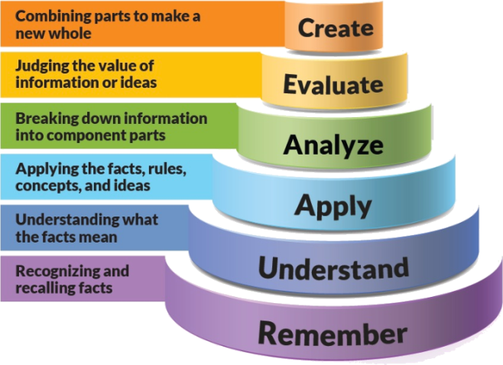
Figure 1: Blooms Taxonomy
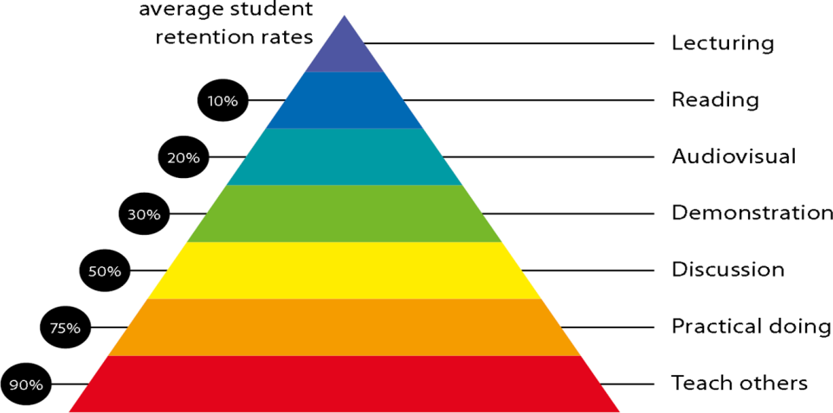
Figure 2: Knowledge retention

Graduate Qualities and Capabilities covered
(Qualities graduates harness crediting this Course)

General Graduate Qualities | Specific Department of ______Graduate Capabilities
Informed  Have a sound knowledge of an area of study or profession and understand its current issues, locally and internationally. Know how to apply this knowledge. Understand how an area of study has developed and how it relates to other areas. | 1 Professional knowledge, grounding & awareness
Independent learners  Engage with new ideas and ways of thinking and critically analyze issues. Seek to extend knowledge through ongoing research, enquiry and reflection. Find and evaluate information, using a variety of sources and technologies. Acknowledge the work and ideas of others. | 2 Information literacy, gathering & processing
Problem solvers  Take on challenges and opportunities. Apply creative, logical and critical thinking skills to respond effectively. Make and implement decisions. Be flexible, thorough, innovative and aim for high standards. | 4 Problem solving skills
Effective communicators  Articulate ideas and convey them effectively using a range of media. Work collaboratively and engage with people in different settings. Recognize how culture can shape communication. | 5 Written communication
 | 6 Oral communication
 | 7 Teamwork
Responsible  Understand how decisions can affect others and make ethically informed choices. Appreciate and respect diversity. Act with integrity as part of local, national, global and professional communities. | 10 Sustainability, societal & environmental impact

Practical work:
- Assignment-1: Case Study
- Assignment-2:Case Study
- Assignment-3:Presentation
- Assignment-4:Quiz

Attendance Requirements

The University norms states that it is the responsibility of students to attend all lectures, tutorials, seminars and practical work as stipulated in the Course outline. Minimum attendance requirement as per university norms is compulsory for being eligible for mid and end semester examinations.

Details of referencing system to be used in written work

Text books

- Business Environment: Text and Cases Francis Cherunilam Himalaya Publishing House.
- Essentials of Business Environment - K Ashwathapa Himalaya Publishing House.

Additional Material
- Business Environment - Shaikh Saleem, Pearson Education.
4. Business Environment - Vivek Mittal, Excel Book

ASSESSMENT GUIDELINES
Your final course mark will be calculated from the following:
Example:
Quiz 1 5% (week 4) Objective (1-3)
Quiz II 5% (week 8) Objective (1-4)
Mid semester 30% (due week 10) Objectives (2-5)
Final exam (closed book) 60% Objectives (1-5)

SUPPLEMENTARY ASSESSMENT

Students who receive an overall mark less than 40% in mid semester or end semester will be considered for supplementary assessment in the respective components (i.e mid semester or end semester) of semester concerned. Students must make themselves available during the supplementary examination period to take up the respective components (mid semester or end semester) and need to obtain the required minimum 40% marks to clear the concerned components.

Practical Work Report/Laboratory Report:
A report on the practical work is due the subsequent week after completion of the class by each group.

Late Work
Late assignments will not be accepted without supporting documentation. Late submission of the reports will result in a deduction of -% of the maximum mark per calendar day

Format
All assignments must be presented in a neat, legible format with all information sources correctly referenced. Assignment material handed in throughout the session that is not neat and legible will not be marked and will be returned to the student.

Retention of Written Work
Written assessment work will be retained by the Course coordinator/lecturer for two weeks after marking to be collected by the students.

University and Faculty Policies
Students should make themselves aware of the University and/or Faculty Policies regarding plagiarism, special consideration, supplementary examinations and other educational issues and student matters.

Plagiarism - Plagiarism is not acceptable and may result in the imposition of severe penalties. Plagiarism is the use of another person’s work, or idea, as if it is his or her own - if you have any doubts at all on what constitutes plagiarism, please consult your Course coordinator or lecturer. Plagiarism will be penalized severely.

Do not copy the work of other students.
Do not share your work with other students (except where required for a group activity or assessment
Course schedule (subject to change)
(Mention quiz, assignment submission, breaks etc as well in the table under the Teaching Learning Activity Column)

 | Week # | Topic & contents |  |  | CO Addressed |  | Teaching Learning Activity (TLA)
 | Weeks 1 | Types of environment; internal environment; external environment |  |  | CO1 |  | Lecture
 | Weeks 2 | Micro environment; macro environment; competitive structure of industries; competitor analysis |  |  | CO1 |  | Audio-Visual
 | Week 3 | Environmental analysis; Business System/Process; Classification of business; classification of industries; characteristics of business; goals of business |  |  | CO1 & CO2 |  | Audio-Visual
 | Week 4 | Techniques for environmental analysis; steps in/approaches to environmental analysis; types of environmental forecasting |  |  | CO3 |  | Lecture
 | Week 5 | Techniques for environmental forecasting; benefits/importance of environmental analysis; limitations of environmental forecasting |  |  | CO3 |  | Lecture
 | Week 6 | Nature of the economy; structure of the economy |  | CO3 |  | Case Study
 | Week 7 | Economic policies - Privatization, Monetary Policy, Fiscal Policy Business & Society |  | CO4 |  | Case Study
 | Week 8 | Objectives & Importance of business |  | CO5 |  | Audio-Visual
 | Week 9 | Business ethics, technological development & social change |  | CO3 & CO4 |  | Audio-Visual
 | Week 10 | Drivers and Hurdles of globalization |  | CO5 |  | Lecture
 | Week 11 | Globalization stages; essential conditions for globalization |  | CO6 |  | Lecture
 | Week 12 | Foreign market entry strategies; pros & cons of globalization |  | CO6 |  | Case Study
 | Week 13 | pros & cons of globalization |  | CO6 |  | Lecture
 | Week 14 | Globalization Problems |  | CO6 |  | Lecture
 | Week 15 | Revision

