Name of Institute: Indus Institute of Management Studies - Ahmedabad

Name of Faculty: Dr. Akhilesh Shukla

Course code: BC0102
Course name: Financial Accounting
Pre-requisites: 10+2
Credit points: 03
Offered Semester: Semester – I

Course Coordinator (weeks 01 - 12)
Full Name: Dr. Akhilesh Shukla
Department with siting location: Indus Institute of Management Studies
Telephone:
Email: akhileshshukla.mba@indusuni.ac.in
Consultation times: 09:00 AM to 05:00 PM Working days (Monday to Friday)

Course Coordinator (weeks 01 - 12)
Full Name: Dr. Akhilesh Shukla
Department with siting location: Indus Institute of Management Studies
Telephone:
Email: akhileshshukla.mba@indusuni.ac.in
Consultation times: 09:00 AM to 05:00 PM Working days (Monday to Friday)

Students will be contacted throughout the Session via Mail with important information relating to this Course.

Course Objectives
By participating in and understanding all facets of this Course a student will:

- The objective of this subject is to help students to acquire conceptual knowledge of the financial accounting and to impart skills for recording various kinds of business transactions.
- Primary area of study includes the nature, scope, importance of accounting; preparation of final accounts; accounting for non-profit organization; bills of exchange and bank reconciliation statement, Joint venture and consignment Account.

Course Outcomes (CO)

After passing the course the student should be able to

- Understand the purpose and types of businesses and how they interact with key stakeholders and the external environment.
- Understand the importance of person effectiveness as the basis for effective team and organizational behaviour.
- Recognize that all aspects of business and finance should be conducted in a manner which complies with and is in the spirit of accepted professional ethics and professional values.
- To develop skill to manage and analysis financial information of a company.
- To understand the important financial accounting formation for running a business.
- To appreciate decision facilitating roles of accounting information.

Course Outline
(Key in topics to be dealt)

- UNIT-I
- Introduction to Financial Accounting: Fundamental overview of accounting process,
- Introduction to Accounting Standards – concepts, benefits, Procedure to issue accounting standards, salient features of accounting standards.
- International Financial Reporting Standards (IFRS): Need and procedures.
- Final Accounts: Books of Accounts leading to the preparation of Trial Balance. Preparation of financial statements (Final Accounts) of non-corporate business entities.

- UNIT-II

- Partnership Accounts Final accounts of partnership firms: Basic concepts of admission, retirement and death of a partner including Insolvency of partners, sale to a limited company and piecemeal distribution.

- UNIT-III

- Inventories: Meaning. Significance of inventory valuation. Inventory Record Systems: periodic and perpetual. Methods: FIFO, LIFO and Weighted Average.
- Accounting for Inland Branches: Concept of dependent branches; accounting aspects; debtors’ system, stock and debtor’s system, branch final accounts system and whole sale basis system. Independent branches: concept-accounting treatment: important adjustment entries and preparation of consolidated profit and loss account and balance sheet.

- UNIT-IV

- Accounting for Hire Purchase and Instalment Systems: Calculation of interest, partial and full repossession, Hire purchase trading (total cash price basis), stock and debtors’ system; Concepts of operating and financial lease (theory only)
- Consignment Accounts: Definition, difference between consignment and sale, journal entries and posting in the books of consigner and consignee. (With adjustments of normal, abnormal loss, normal commission, del-credere commission and over ridding commission.)

Method of delivery
(Face to face lectures, self-study material, Active Learning Techniques)
- In Class Discussion
- Business Projects/Research Paper discussion.
- Presentation – newspaper analysis – The Hindu Business Line, BS, ET...
- Assignments
- Quiz
- Group Business Activities

Study time
(How many hours per week including class attendance)
3 Hours a week

CO-PO Mapping (PO: Program Outcomes)
 | P1 | P2 | P3 | P4 | P5 | P6
C1 | 3 | 2 | 2 | 3 | 3 | 2
C2 | 2 | 2 | 1 | 3 | 2 | 1
C3 | 3 | 2 | 1 | 2 | 2 | 1
C4 | 2 | 2 | 1 | 2 | 1 | 1
C5 | 3 | 2 | 3 | 1 | 1 | 2
C6 | 2 | 1 | - | 2 | - | 2

Blooms Taxonomy and Knowledge retention (For reference)
(Blooms taxonomy has been given for reference)

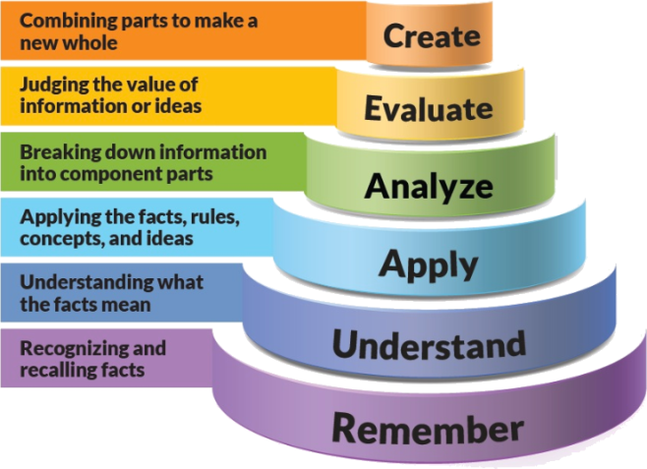
Figure 1: Blooms Taxonomy
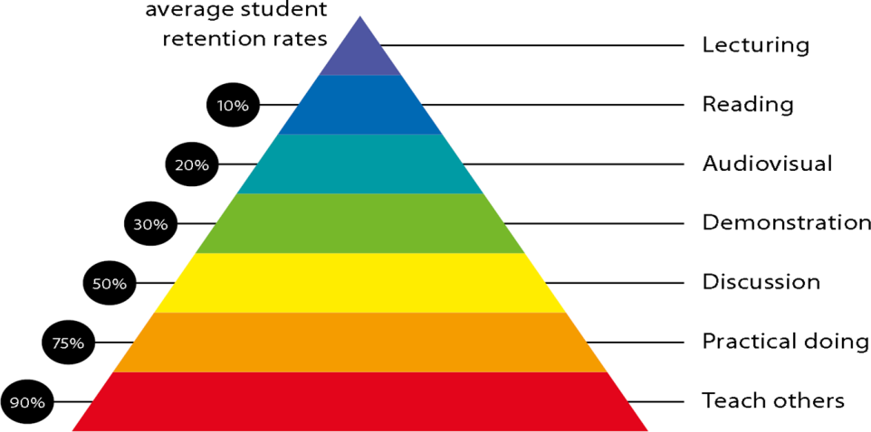
Figure 2: Knowledge retention

Graduate Qualities and Capabilities covered
(Qualities graduates harness crediting this Course)

General Graduate Qualities | Specific Department of ______Graduate Capabilities
Informed  Have a sound knowledge of an area of study or profession and understand its current issues, locally and internationally. Know how to apply this knowledge. Understand how an area of study has developed and how it relates to other areas. | 1 Professional knowledge, grounding & awareness
Independent learners  Engage with new ideas and ways of thinking and critically analyze issues. Seek to extend knowledge through ongoing research, enquiry and reflection. Find and evaluate information, using a variety of sources and technologies. Acknowledge the work and ideas of others. | 2 Information literacy, gathering & processing
Problem solvers  Take on challenges and opportunities. Apply creative, logical and critical thinking skills to respond effectively. Make and implement decisions. Be flexible, thorough, innovative and aim for high standards. | 4 Problem solving skills
Effective communicators  Articulate ideas and convey them effectively using a range of media. Work collaboratively and engage with people in different settings. Recognize how culture can shape communication. | 5 Written communication
 | 6 Oral communication
 | 7 Teamwork
Responsible  Understand how decisions can affect others and make ethically informed choices. Appreciate and respect diversity. Act with integrity as part of local, national, global and professional communities. | 10 Sustainability, societal & environmental impact

Practical work:
(Mention what practical work this Course involves)
- Group Business Activities
- Business Assignments/Group Assignments
- Presentation
- Business Simulation

Lecture/tutorial times
(Give lecture times in the format below)
Example:
Lecture Thursday 09.00 – 10.00 am Room LH /GoogleMeet
Lecture Tuesday 09.00 – 10.00 am Room LH /GoogleMeet
Lecture/Tutorial Monday 11.10 – 12.10 am Room LH /GoogleMeet
Lecture/Tutorial Wednesday 01.00 – 02.00 pm Room LH /GoogleMeet
Lecture/Tutorial Friday 01.00 – 02.00 pm Room LH /GoogleMeet
Practicals/Presen. Tuesday 02.10 – 03.10 pm Room LH / GoogleMeet

Attendance Requirements

The University norms states that it is the responsibility of students to attend all lectures, tutorials, seminars and practical work as stipulated in the Course outline. Minimum attendance requirement as per university norms is compulsory for being eligible for mid and end semester examinations.

Details of referencing system to be used in written work

Text books

- S N Maheshwari, S K Maheshwari Advanced Accountancy Volume - I, 10th Edition (Vikas Publication)
- M.C. Shukla, T.S. Grewal & S.C. Gupta& Advanced accounts Vol-1, 17 Edition (S. Chand)
- Hanif and Mukherjee (2003), Modern Accountancy Volume 1,2nd Edition. (Tata McGraw Hill Publishing Company limited, New Delhi)
- Rajshekaran, Lalitha, Financial Accounting, Latest Edition (Pearson)

Additional Materials

- Ashish K. Bhattacharya Essentials of Financial Accounting (Based on IFRS) 2nd Edition (PHI)
- Advanced accountancy – S.P. Jain, K.L. Narang (Kalyani publishers)
- Paresh Shah Basic Financial Accounting for Management latest edition (Oxford University Press)
- Ambrish Gupta, Financial Accounting for Management, an Analytical Perspective (Pearson Publication)
- Robert. N. Anthony, David. F. Hawkins, Kenneth A. Merchant. Accounting Text and Cases, (Tata McGraw Hill Publishing Company Limited, New Delhi)
- Frankwood& Alan Sangster. (2008). Business Accounting, Pearson education limited, 11th Edition

ASSESSMENT GUIDELINES
Your final course mark will be calculated from the following:
Example:
Quiz 1 5% (week 4) Objective (1-3)
Quiz II 5% (week 8) Objective (1-4)
Mid semester 30% (due week 10) Objectives (2-5)
Final exam (closed book) 60% Objectives (1-5)

SUPPLEMENTARY ASSESSMENT

Students who receive an overall mark less than 40% in mid semester or end semester will be considered for supplementary assessment in the respective components (i.e mid semester or end semester) of semester concerned. Students must make themselves available during the supplementary examination period to take up the respective components (mid semester or end semester) and need to obtain the required minimum 40% marks to clear the concerned components.

Practical Work Report/Laboratory Report:
A report on the practical work is due the subsequent week after completion of the class by each group.

Late Work
Late assignments will not be accepted without supporting documentation. Late submission of the reports will result in a deduction of -% of the maximum mark per calendar day

Format
All assignments must be presented in a neat, legible format with all information sources correctly referenced. Assignment material handed in throughout the session that is not neat and legible will not be marked and will be returned to the student.

Retention of Written Work
Written assessment work will be retained by the Course coordinator/lecturer for two weeks after marking to be collected by the students.

University and Faculty Policies
Students should make themselves aware of the University and/or Faculty Policies regarding plagiarism, special consideration, supplementary examinations and other educational issues and student matters.

Plagiarism - Plagiarism is not acceptable and may result in the imposition of severe penalties. Plagiarism is the use of another person’s work, or idea, as if it is his or her own - if you have any doubts at all on what constitutes plagiarism, please consult your Course coordinator or lecturer. Plagiarism will be penalized severely.

Do not copy the work of other students.
Do not share your work with other students (except where required for a group activity or assessment)
.

Course schedule (subject to change)
(Mention quiz, assignment submission, breaks etc as well in the table under the Teaching Learning Activity Column)

 | Week # | Topic & contents |  | CO Addressed | Teaching Learning Activity (TLA)
 | Weeks 1 | UNIT-I  - Introduction to Financial Accounting: Fundamental overview of accounting process,  - Introduction to Accounting Standards – concepts, benefits, Procedure to issue accounting standards, salient features of accounting standards.  - International Financial Reporting Standards (IFRS): Need and procedures.  - Final Accounts: Books of Accounts leading to the preparation of Trial Balance. Preparation of financial statements (Final Accounts) of non-corporate business entities. |  | 1,2,3,6
 | Weeks 2 | UNIT-I  - Introduction to Financial Accounting: Fundamental overview of accounting process,  - Introduction to Accounting Standards – concepts, benefits, Procedure to issue accounting standards, salient features of accounting standards.  - International Financial Reporting Standards (IFRS): Need and procedures.  - Final Accounts: Books of Accounts leading to the preparation of Trial Balance. Preparation of financial statements (Final Accounts) of non-corporate business entities. |  | 1,2,3,6
 | Week 3 | Presentation
 | Week 4 | UNIT-II  - Partnership Accounts Final accounts of partnership firms: Basic concepts of admission, retirement and death of a partner including Insolvency of partners, sale to a limited company and piecemeal distribution. |  | 1,2,4,5
 | Week 5 | UNIT-II  Partnership Accounts Final accounts of partnership firms: Basic concepts of admission, retirement and death of a partner including Insolvency of partners, sale to a limited company and piecemeal distribution. |  | 1,2,4,5
 | Week 6 | Quiz
 | Week 7 | UNIT-III  - Inventories: Meaning. Significance of inventory valuation. Inventory Record Systems: periodic and perpetual. Methods: FIFO, LIFO and Weighted Average.  - Accounting for Inland Branches: Concept of dependent branches; accounting aspects; debtors’ system, stock and debtor’s system, branch final accounts system and whole sale basis system. Independent branches: concept-accounting treatment: important adjustment entries and preparation of consolidated profit and loss account and balance sheet. |  | 2,3,4,5
 | Week 8 | UNIT-III  - Inventories: Meaning. Significance of inventory valuation. Inventory Record Systems: periodic and perpetual. Methods: FIFO, LIFO and Weighted Average.  - Accounting for Inland Branches: Concept of dependent branches; accounting aspects; debtors’ system, stock and debtor’s system, branch final accounts system and whole sale basis system. Independent branches: concept-accounting treatment: important adjustment entries and preparation of consolidated profit and loss account and balance sheet. |  | 2,3,4,5
 | Week 9 | UNIT-IV  - Accounting for Hire Purchase and Instalment Systems: Calculation of interest, partial and full repossession, Hire purchase trading (total cash price basis), stock and debtors’ system; Concepts of operating and financial lease (theory only)  - Consignment Accounts: Definition, difference between consignment and sale, journal entries and posting in the books of consigner and consignee. (With adjustments of normal, abnormal loss, normal commission, del-credere commission and over ridding commission.) |  | 1,2,4,5,6
 | Week 10 | UNIT-IV  - Accounting for Hire Purchase and Instalment Systems: Calculation of interest, partial and full repossession, Hire purchase trading (total cash price basis), stock and debtors’ system; Concepts of operating and financial lease (theory only).  - Consignment Accounts: Definition, difference between consignment and sale, journal entries and posting in the books of consigner and consignee. (With adjustments of normal, abnormal loss, normal commission, del-credere commission and over ridding commission.) |  | 1,2,4,5,6
 | Week 11 | UNIT-IV  - Accounting for Hire Purchase and Instalment Systems: Calculation of interest, partial and full repossession, Hire purchase trading (total cash price basis), stock and debtors’ system; Concepts of operating and financial lease (theory only).  - Consignment Accounts: Definition, difference between consignment and sale, journal entries and posting in the books of consigner and consignee. (With adjustments of normal, abnormal loss, normal commission, del-credere commission and over ridding commission.) |  | 1,2,4,5,6
 | Week 12 | Quiz and Presentation

