Name of Institute: INDUS INSTITUTE OF MANAGEMENT
Name of Faculty: Prof. PARSHVA SHAH

Course code: BB00302
Course name: Advance Accountancy-II
Pre-requisites:
Credit points: 4
Offered Semester: III

Course Coordinator (weeks 15)
Full Name: Prof. Parshva Jitendrakumar Shah
Department with siting location: MBA Department, Bhawar Buliding 4th Floor
Telephone: 9737530515
Email: parshvashah.mba@indusuni.ac.in
Consultation times: 2.00 PM to 4.00 PM

Course Lecturer (weeks 15)
Full Name: Prof. Parshva Jitendrakumar Shah
Department with siting location: MBA Department, Bhawar Buliding 4th Floor
Telephone: 9737530515
Email: parshvashah.mba@indusuni.ac.in
Consultation times: 2.00 PM to 4.00 PM

Students will be contacted throughout the Session via Mail with important information relating to this Course.

Course Objectives

This course aims to provide an important aspects of company accounts. It is intended
to provide information that is vital in making business decisions. The objective of this
course is to make students understand accounting of important issues of companies.

Course Outcomes (CO)

Upon successful completion of this course, the student will have reliably demonstrated
the ability to:

CO1: Determine appropriate accounting method required under various share ownership
scenarios.
CO2: Determine Goodwill and prepare a consolidated balance sheet at the date of
acquisition for business combinations.
CO3: Translate the financial statements of a foreign subsidiary using the appropriate
method.
CO4: Preparation of financial statements.
CO5: To understand and prepare statement of affairs to understand priority wise payment
CO6: To understand theory of computerized accounting system theory

Course Outline

Unit-I
Introduction- Shares and Debentures, Redemption of Preference shares and Debentures

Unit-II
• Final Accounts- Ascertaining profit for managerial remuneration, overall managerial remuneration, Profit Prior to Incorporation
• Valuation of Goodwill and Shares

Unit-III
• Amalgamation of Companies
• Internal Reconstruction

Unit-IV
• Liquidation of Companies;
• Computerized Accounting System

Method of delivery
Face to face lectures, self study material, Active Learning Techniques,Chalk & Board, Transparencies & OHP, Power Point Presentation(PPT), Hand Outs, Visits, Seminar, Group Discussion, Report writing, Using Mini, Minor, Major Projects, etc.

Study time
4 lecture per week, Average attendance 80%

CO-PO Mapping (PO: Program Outcomes)
 | Introduction to Taxation | PO1 | PO2 | PO3 | PO4 | PO5
CO1 | Determine appropriate accounting method required under various share ownership scenarios. | 2 | 3 | 2 | 3 | 3
CO2 | Determine Goodwill and prepare a consolidated balance sheet at the date of acquisition for business combinations. | 2 | 2 | 2 | 2 | 3
CO3 | Translate the financial statements of a foreign subsidiary using the appropriate method. | 2 | 3 | 3 | 2 | 2
CO4 | Preparation of financial statements. | 2 | 2 | 2 | 3 | 3
CO5 | To understand and prepare statement of affairs to understand priority wise payment | 2 | 2 | 3 | 2 | 3
CO6 | To understand theory of computerized accounting system theory | 3 | 3 | 2 | 2 | 2

Blooms Taxonomy and Knowledge retention (For reference)
(Blooms taxonomy has been given for reference)

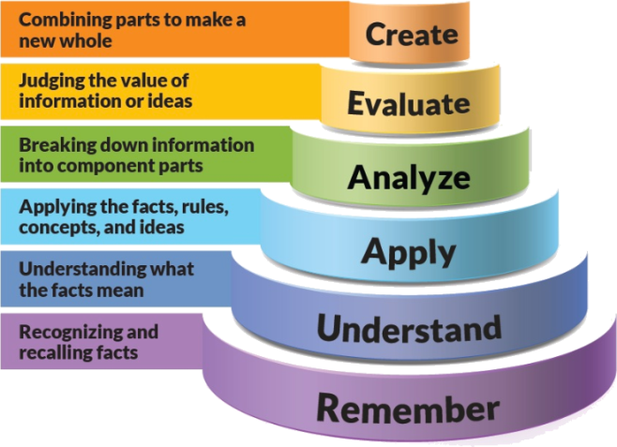
Figure 1: Blooms Taxonomy
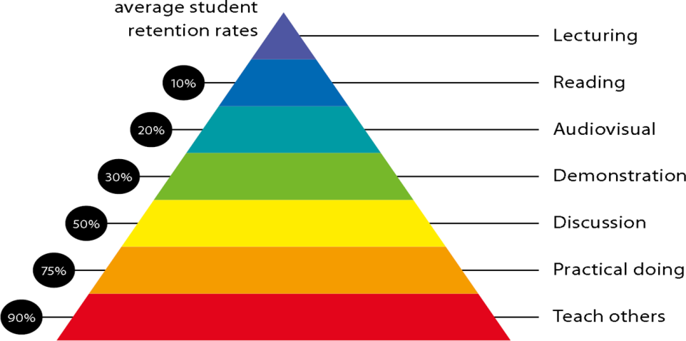
Figure 2: Knowledge retention

Graduate Qualities and Capabilities covered
(Qualities graduates harness crediting this Course)

General Graduate Qualities | Specific Department of ______Graduate Capabilities
Informed  Gain an understanding of the complexity of managing people and how interventions by the different parties to the employment relationship (employers, workers and the State) can provide challenges for the successful application of even the best developed HRM policies and practices. | 1 Professional knowledge, grounding & awareness
Independent learners  Locate, evaluate and synthesize complex information. Opportunities to acquire these abilities are developed through lectures, case discussion and various experiential exercises. | 2 Information literacy, gathering & processing
Problem solvers  Developing critical thinking skills that are pertinent for problem solving and innovation in today’s competitive labour market (which are not easily replaced by automation). | 4 Problem solving skills
Effective communicators  Develop the ability to reflect on issues on hand. Through active participation enhance the skills to communicate verbally and in writing and develop practices expected of today’s professionals. | 5 Written communication
 | 6 Oral communication
 | 7 Teamwork
Responsible  Gain a more nuanced appreciation of the challenges posed by globalisation, including the economic, social, legal and ethical implications of HRM interventions and how to respond to an ever-changing employment market, which will help to thrive in a diverse range of careers after graduation. | 10 Sustainability, societal & environmental impact

Practical work:
Case Study, Presentation , Practical problems of each .
- ASSIGNMENT -1 Theory aspect question
- ASSIGNMENT -2 Practical questions
- MCQ Test
- Practical Case Discussion
- Projects

Lecture/tutorial times
Lecture Tuesday 9:00 – 9:50 a.m. Room LH 37
Lecture Wednesday 11:00 – 11:55 a.m. Room LH 37
Lecture Thursday 9:00 – 9:55 a.m. Room LH 37
Lecture Friday 9:55_10:50 a.m. Room LH 37

Attendance Requirements

The University norms states that it is the responsibility of students to attend all lectures, tutorials, seminars and practical work as stipulated in the Course outline. Minimum attendance requirement as per university norms is compulsory for being eligible for mid and end semester examinations.

Details of referencing system to be used in written work

Text books

- Advance Accountancy Vol. – II by M. C. Shukla, T. S. Grewal, and S. C. Gupta (S. Chand)
- Corporate Accounting by S.N. Maheshwari and S.K. Maheshwari (Vikas)

Additional Materials (Reference Books)

- Corporate Accounting by A. Mukherjee and M. Hanif (TMH)
- Fundamentals of Advance Accounting Vol. – II 3rd edition by RSN Pillai, Bagavathi, S. Uma (S. Chand)
- Advanced Accounting Vol.– II by S.P. Jain and K. L. Narang (Kalyani Publisher)
- Company Accounts by R.L. Gupta and Radhaswamy (Sultan Chand)

ASSESSMENT GUIDELINES
Your final course mark will be calculated from the following:

- ASSIGNMENT -1 Theory aspect question 10 Marks
- ASSIGNMENT -2 Practical questions 10 Marks
- MCQ Test 10 Marks
- Class Test 20 Marks
- Class Performance / Attendance 10 Marks

SUPPLEMENTARY ASSESSMENT

Students who receive an overall mark less than 40% in mid semester or end semester will be considered for supplementary assessment in the respective components (i.e mid semester or end semester) of semester concerned. Students must make themselves available during the supplementary examination period to take up the respective components (mid semester or end semester) and need to obtain the required minimum 40% marks to clear the concerned components.

Practical Work Report/Laboratory Report:
A report on the practical work is due the subsequent week after completion of the class by each group.

Late Work
Late assignments will not be accepted without supporting documentation. Late submission of the reports will result in a deduction of -% of the maximum mark per calendar day

Format
All assignments must be presented in a neat, legible format with all information sources correctly referenced. Assignment material handed in throughout the session that is not neat and legible will not be marked and will be returned to the student.

Retention of Written Work
Written assessment work will be retained by the Course coordinator/lecturer for two weeks after marking to be collected by the students.

University and Faculty Policies
Students should make themselves aware of the University and/or Faculty Policies regarding plagiarism, special consideration, supplementary examinations and other educational issues and student matters.

Plagiarism - Plagiarism is not acceptable and may result in the imposition of severe penalties. Plagiarism is the use of another person’s work, or idea, as if it is his or her own - if you have any doubts at all on what constitutes plagiarism, please consult your Course coordinator or lecturer. Plagiarism will be penalized severely.

Do not copy the work of other students.
Do not share your work with other students (except where required for a group activity or assessment)
.

Course schedule (subject to change)
(Mention quiz, assignment submission, breaks etc as well in the table under the Teaching Learning Activity Column)

 | Week # | Topic & contents |  |  | CO Addressed | Teaching Learning Activity (TLA)
 | Weeks 1 | Introduction- Shares and Debentures |  |  | CO1,CO3,CO5, CO6 | Chalk & Board / / PPT / Handouts / Tutorials / Assignments,
 | Weeks 2 | Sums of Shares and Debentures, |  |  | CO1,CO3,CO5, CO6 | Chalk & Board / / PPT / Handouts / Tutorials / Assignments,
 | Week 3 | Redemption of Preference shares and Debentures |  |  | CO1,CO3,CO5, CO6 | Chalk & Board / / PPT / Handouts / Tutorials / Assignments,
 | Week 4 | Redemption of Preference shares and Debentures |  |  | CO1,CO3,CO5, CO6 | Chalk & Board / / PPT / Handouts / Tutorials / Assignments,
 | Week 5 | Final Accounts- Ascertaining profit for managerial remuneration, overall managerial remuneration |  |  | CO1,CO2,CO3,CO4,CO5 | Chalk & Board / / PPT / Handouts / Tutorials / Assignments,
 | Week 6 | Final Accounts- Ascertaining profit for managerial remuneration, overall managerial remuneration |  | CO1,CO2,CO3,CO4,CO5 |  | Chalk & Board / / PPT / Handouts / Tutorials / Assignments,
 | Week 7 | Final Accounts- Ascertaining profit for managerial remuneration, overall managerial remuneration |  | CO1,CO2,CO3,CO4,CO5 |  | Chalk & Board / / PPT / Handouts / Tutorials / Assignments,
 | Week 8 | Profit Prior to Incorporation |  | CO1,CO3,CO5 |  | Chalk & Board / / PPT / Handouts / Tutorials / Assignments,
 | Week 9 | Valuation of Goodwill and Shares |  | CO1,CO2,CO3,CO4,CO5 |  | Chalk & Board / / PPT / Handouts / Tutorials / Assignments,
 | Week 10 | Amalgamation of Companies |  | CO1,CO2,CO3,CO4,CO5,CO6 |  | Chalk & Board / / PPT / Handouts / Tutorials / Assignments,
 | Week 11 | Mid Term Exam |  | Mid Term Exam |  | Mid Term Exam
 | Week 12 | Amalgamation of Companies |  | CO1,CO2,CO3,CO4,CO5,CO6 |  | Chalk & Board / / PPT / Handouts / Tutorials / Assignments,
 | Week 13 | Internal Reconstruction |  | CO1,CO2,CO3,CO5,CO6 |  | Chalk & Board / / PPT / Handouts / Tutorials / Assignments,
 | Week 14 | Liquidation of Companies |  | CO1,CO2,CO3,CO4,CO5,CO6 |  | Chalk & Board / / PPT / Handouts / Tutorials / Assignments,
 | Week 15 | Computerized Accounting System |  | CO1,CO2,CO3,CO4,CO5,CO6 |  | Chalk & Board / / PPT / Handouts / Tutorials / Assignments,

