# Name of Institute: Indus Institute of Technology and Engineering

# Name of Faculty: Prof. Dharmendra Sapariya

**Course code: ME0729**

# Course name: Introduction to Research (Open Elective)

|  |  |  |  |  |  |  |  |  |
| --- | --- | --- | --- | --- | --- | --- | --- | --- |
| **Subject: Introduction to Research (OE-9)** | | | | | | | | |
| **Program: B. Tech. (Mechanical)** | | | | **Subject Code: ME0729** | | | **Semester: VII** | |
| **Teaching Scheme** | | | | **Examination Evaluation Scheme** | | | | |
| **Lecture** | **Tutorial** | **Practical** | **Credits** | **University Theory Examination** | **University Practical Examination** | **Continuous Internal Evaluation (CIE)**  **Theory** | **Continuous Internal Evaluation (CIE)**  **Practical** | **Total Marks** |
| **3** | **0** | **0** | **3** | **16/40** | **\*\*\*** | **24/60** | **\*\*\*** | **100** |

Pre-requisites: None

Credit Points: 3

Offered Semester: VII

# Course Coordinator

Full name: **Prof. Dharmendra Sapariya**

Department with siting location: Mechanical Engg. 3rd Floor, DH-4ME- Bhanwar Building, Indus University

Telephone: 3313,

Email: [dharmendrasapariya.me@indusuni.ac.in](mailto:umangpatdiwala.me@indusuni.ac.in)

Consultation times: Everyday (4.00 PM to 5:00 PM)

**Subject Teachers:**

- Full name: **Dr. Umang Patdiwala**

Department with siting location: Mechanical Engg. 3rd Floor, ME-HoD office, Bhanwar Building, Indus University

Telephone: 3327,

Email: [umangpatdiwala.me@indusuni.ac.in](mailto:umangpatdiwala.me@indusuni.ac.in) Consultation times: Everyday (4.00 PM to 5:00 PM)

Students will be contacted throughout the session via e-mail and Google Class room with important information relating to this course.

- Full name: **Dr. Dhiren Patel**

Department with siting location: Mechanical Engg. 3rd Floor, Common Staffroom, Bhanwar Building, Indus University

Telephone: 3333,

Email: [dhirenpatel.me@indusuni.ac.in](mailto:umangpatdiwala.me@indusuni.ac.in)

Consultation times: Everyday (4.00 PM to 5:00 PM)

# Course Objectives

1. To familiarize participants with basic of research and the research process.
2. To understand difference between discovery and research.
3. To select and define appropriate research problem and parameters.
4. To organize and conduct research (advanced project) in a more appropriate manner
5. To enable the participants in conducting research work and formulating research synopsis and report.

# Course Outcomes:

After learning the course, the students should be able to:

1. Develop understanding of the basic framework of research process.
2. Develop understanding of various research designs and techniques.
3. Identify various sources of information for literature review and data collection.
4. Develop an understanding of the ethical dimensions of conducting applied research.
5. Appreciate the components of scholarly writing and evaluate its quality.
6. Be aware of the ethical principles of research, ethical challenges and approval processes
7. Describe quantitative, qualitative and mixed methods approaches to research.
8. Critically analyze published research.

**Detail Syllabus:**

|  |  |
| --- | --- |
| **COURSE CONTENT** | |
| **UNIT-1** | **[10]** |
| **Research Methodology:**  An Introduction: Meaning, Objectives, Motivation, Types of Research, Research Approaches, Significance of Research, Research Process, Criteria of Good  Research | |
| **Strategy and Tools for Discovery**  Strategic Planning Development Strategy and Process Assessment, Applying Search Strategies to Find Information, Discovery Procedures, types of discovery, Method of discovery, Techniques of discovery, Different between discovery and  research | |
| **UNIT-2** | **[10]** |
| **Research Problem Formulation:**  Selecting the Problem, Necessity of Defining the Problem, Literature Survey, Guidelines for literature review | |
| **Research Design:**  Meaning of Research Design, Need for Research Design, Different Research Designs, and Basic Principles of Design. | |
| **UNIT-3** | **[12]** |
| **Probability, Sampling and its Distributions:**  Probability laws, Probability distributions, Normal Distribution, Exponential distribution, Binomial distribution, Poisson distribution, Sampling, Sampling Design Process, Sampling Methods, Sampling distributions | |
| **Design of Experiments and Regression Analysis:**  Planning of experiments, Taguchi Approach, Curve fitting, Types of regression analysis: Simple and Multiple regression analysis, Data analysis, Interpretation of results | |
| **UNIT-4** | **[14]** |
| **Structure of Thesis Report and thesis writing:**  Preliminary Pages, Main body of Thesis, Summary, Appendices, References Steps in writing the report, mechanics of writing, Presentation of figures and tables | |
| **Writing of papers and Synopsis:**  Audience Analysis, Preparing papers for Journals, Preparation of Synopsis | |

# Method of delivery

(Online Lecture), PPT & Video, Self-Assessment study Material, Problem Based Learning and Case Study)

# Study time:

|  |  |  |  |
| --- | --- | --- | --- |
|  | Lecture | Tutorial | Practical |
| No of hours | 3 | 0 | 0 |

# CO-PO Mapping (PO: Program Outcomes)

## Program Outcomes (PO’s)

Engineering Graduates will be able to:

**PO1 Engineering knowledge:** Apply the knowledge of mathematics, science, engineering fundamentals, and an engineering specialization to the solution of complex engineering problems.

**PO2 Problem analysis:** Identify, formulate, review research literature, and analyze complex engineering problems reaching substantiated conclusions using first principles of mathematics, natural sciences, and engineering sciences.

**PO3 Design/development of solutions:** Design solutions for complex engineering problems and design system components or processes that meet the specified needs with appropriate consideration for the public health and safety, and the cultural, societal, and environmental considerations.

**PO4 Conduct investigations of complex problems:** Use research-based knowledge and research methods including design of experiments, analysis and interpretation of data, and synthesis of the information to provide valid conclusions.

**PO5 Modern tool usage:** Create, select, and apply appropriate techniques, resources, and modern engineering and IT tools including prediction and modelling to complex engineering activities with an understanding of the limitations.

**PO6 The engineer and society:** Apply reasoning informed by the contextual knowledge to assess societal, health, safety, legal and cultural issues and the consequent responsibilities relevant to the professional engineering practice.

**PO7 Environment and sustainability:** Understand the impact of the professional engineering solutions in societal and environmental contexts, and demonstrate the knowledge of, and need for sustainable development.

**PO8 Ethics:** Apply ethical principles and commit to professional ethics and responsibilities and norms of the engineering practice.

**PO9 Individual and team work:** Function effectively as an individual, and as a member or leader in diverse teams, and in multidisciplinary settings.

**PO10 Communication:** Communicate effectively on complex engineering activities with the engineering community and with society at large, such as, being able to comprehend and write effective reports and design documentation, make effective presentations, and give and receive clear instructions.

**PO11 Project management and finance:** Demonstrate knowledge and understanding of the engineering and management principles and apply these to one’s own work, as a member and leader in a team, to manage projects and in multidisciplinary environments.

**P012 Life-long learning:** Recognize the need for, and have the preparation and ability to engage in independent and life-long learning in the broadest context of technological change.

**Program Specific Outcomes (PSOs) of Department**

At the end of the program, the student:

**PSO1**. Should be able to clearly understand the concepts and applications in the field of design of mechanical systems, thermal engineering and production technology and also possess the skills to communicate effectively as well as demonstrating the practice of professional ethics and the concerns for societal and environmental wellbeing.

**PSO2**. Should be able to associate the learning from the courses related to Thermodynamics, Fluid Science, Mechanical system design, Machining and Manufacturing processes, Production Technology and Automation of systems, to arrive at solutions to real world problems.

**PSO3**. Should have the capability to comprehend the technological advancements in the usage of modern design tools to analyze and design subsystems/processes for a variety of applications.

## Mapping CO’s with PO’s

|  |  |
| --- | --- |
| **PO/PSO**  **CO** | **PO** |
| **1** | **2** | **3** | **4** | **5** | **6** | **7** | **8** | **9** | **10** | **11** | **12** |
| **CO1** | 3 | - | - | - | - | 2 | 1 | - | - | - | - | - |
| **CO2** | 2 | 2 | 1 | - | - | 1 | - | 1 | - | - | 1 | 1 |
| **CO3** | 3 | 2 | 2 | 2 | 2 | 1 | - | - | - | - | - | 1 |
| **CO4** | 2 | 2 | 1 | - | - | - | - | - | 1 | - | - | 1 |
| **CO5** | 3 | - | 3 | 1 | 3 | - | - | - | - | - | - | 1 |
| **CO6** | 2 | 3 | - | 1 | - | - | - | 3 | - | - | - | 1 |
| **CO7** | 2 | 1 | 1 | 2 | - | - | - | - | - | 2 | - | 1 |
| **CO8** | 1 | 2 | 1 | - | - | - | - | 1 | - | 1 | - | 1 |
| **ME0729** | **2.3** | **2** | **1.5** | **1.5** | **2.5** | **1.3** | **1** | **1.3** | **1** | **1.5** | **1** | **1** |

## Mapping of CO’s with PSO’s

|  |  |  |  |
| --- | --- | --- | --- |
| **CO** | **PSO1** | **PSO2** | **PSO3** |
| **CO 1** | 2 | - | - |
| **CO2** | 2 | 1 | 1 |
| **CO 3** | 1 | - | - |
| **CO 4** | 1 | - | - |
| **CO 5** | 2 | - | - |
| **CO 6** | 1 | - | - |
| **CO7** | 1 | - | - |
| **CO8** | 1 | **-** | 1 |
| **ME0729** | **1.4** | **1** | **1** |

## Blooms Taxonomyand Knowledge retention(For reference)

(Blooms taxonomy has been given for reference)

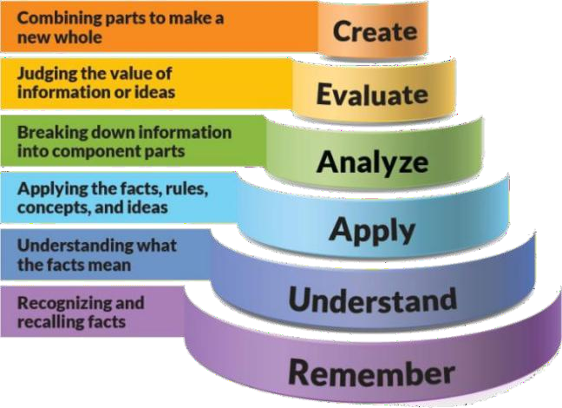

**Figure 1: Blooms Taxonomy**

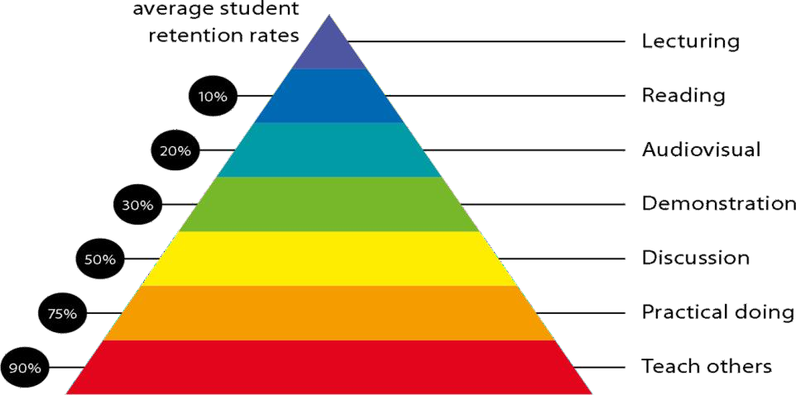

**Figure 2: Knowledge retention**

# Graduate Qualities and Capabilities covered

(Qualities graduates harness crediting this Course)

|  |  |
| --- | --- |
| **General Graduate Qualities** | **Specific Department of**  **Graduate Capabilities** |
| **Informed**  Have a sound knowledge of an area of study or profession and understand its current issues, locally and internationally. Know how to apply this knowledge.  Understand how an area of study has developed and how it relates to other areas. | **1 Professional knowledge, grounding & awareness** |

|  |  |
| --- | --- |
| **Independent learners**  Engage with new ideas and ways of thinking and critically analyze issues. Seek to extend knowledge through ongoing research, enquiry and reflection. Find and evaluate information,using a variety of sources and technologies.  Acknowledge the work and ideas of others. | **2 Information literacy, gathering & processing** |
| **Problem solvers**  Take on challenges and opportunities. Apply creative, logical and critical thinking skills to respond effectively. Make and implement decisions. Be flexible, thorough, innovative and aim for high standards. | **4 Problem solving skills** |
| **Effective communicators** Articulate ideas and convey them effectively using a range of media. Work collaborative engage with people in different settings.  Recognize how culture can shape communication. | **5 Written communication** |
| **6 Oral communication** |
| **7 Teamwork** |
| **Responsible**  Understand how decisions can affect others and make ethically informed choices.  Appreciate and respect diversity. Act with integrity as part of local, national, global and professional  communities. | **10 Sustainability, societal & environmental impact** |

## Lecture/tutorial times

(Give lecture times in the format below)

Tuesday 12:20 to 13:20

Thursday: 9:00 to 10:00

Friday: 14:00 to 15:00

## Attendance Requirements

The University norms states that it is the responsibility of students to attend all lectures, tutorials, seminars and practical work as stipulated in the course outline. Minimum attendance requirement as per university norms is compulsory for being eligible for semester examinations.

## Details of referencing system to be used

**Text books**

1. Research Methodology for Engineers – R. Ganesan, MJP Publishers
2. Research Methodology: Methods and Techniques – C. R. Kothari, Publisher New – Age International
3. Research Methodology by Deepak Chawla &NeenaSodhi S. Chand Publication

## Reference Books

1. Business Research Methods- Naval Bajpai Pearson Publication
2. Uma Sekaran, Research Methods for Business, John Wiley and Sons Inc., New York, 2000.
3. Gupta,S.P.Statistical Methods, 30" Sultan Chand, New Delhi

**Additional Materials**

1. <http://nptel.ac.in/courses/112103019/>

### MOOC:

1. <https://nptel.ac.in/courses/121106007/>
2. <https://nptel.ac.in/courses/107108011/>

## ASSESSMENT GUIDELINES

Your final course mark will be calculated from the following:

For Theory Component CIE-TH (60 Marks)

* Mid Semester Exam 40 Marks
* Assignment 10 Marks
* Attendance/Class Participation 5 Marks
* Presentation 5 Marks

Theory End Semester Exam (40 Marks)

## SUPPLEMENTARY ASSESSMENT

Students who receive an overall mark less than 40% in internal component or less than 40% in the end semester will be considered for supplementary assessment in the respective components (i.e internal component or end semester) of semester concerned. Students must make themselves available during the supplementary examination period to take up the respective components (internal component or end semester) and need to obtain the required minimum 40% marks to clear the concerned components.

## Practical Work Report/Laboratory Report:

A report on the practical work is due the subsequent week after completion of the class by each group.

## Late Work

Late assignments will not be accepted without supporting documentation. Late submission of the reports will result in a deduction of -% of the maximum mark per calendar day

## Format

All assignments must be presented in a neat, legible format with all information sources correctly referenced. **Assignment material handed in throughout the session that is not neat and legible will not be marked and will be returned to the student.**

## Retention of Written Work

Written assessment work will be retained by the Course coordinator/lecturer for two weeks after marking to be collected by the students.

## University and Faculty Policies

Students should make themselves aware of the University and/or Faculty Policies regarding plagiarism, special consideration, supplementary examinations and other educational issues and student matters.

**Plagi**a**rism** - Plagiarism is not acceptable and may result in the imposition of severe penalties. Plagiarism is the use of another person’s work, or idea, as if it is his or her own - if you have any doubts at all on what constitutes plagiarism, please consult your Course coordinator or lecturer. Plagiarism will be penalized severely.

***Do not copy the work of other students.***

***Do not share your work with other students (except where required for a group activity or assessment).***

**Course schedule (subject to change)**

|  |  |  |  |  |  |  |  |
| --- | --- | --- | --- | --- | --- | --- | --- |
|  | **Week #** | **Topic & contents** | | | | **CO**  **Addressed** | **Teaching Learning Activity**  **(TLA)** |
|  | Weeks 1 | An Introduction: Meaning, Objectives, Motivation, Type of Research, Research Approaches, Significance of Research,  Research Process, Criteria of Good Research | | | | 1,2 | Discussion |
| Weeks 2 | Strategy and Tools for Discovery Strategic Planning Development Strategy and Process Assessment, Applying Search Strategies to Find Information, Discovery Procedures, types of discovery, Method of discovery,  Techniques of discovery, Different between discovery and research | | | | 1,2 | Worksheet Submission |
| Week 3 | Research Problem Formulation: Selecting the Problem, Necessity of Defining the Problem, Literature Survey,  Guidelines for literature review | | | | 2,3 | Worksheet submission, Quiz |
| Week 4 | Research Design:  Meaning of Research Design, Need for Research Design, Different Research Designs, and Basic Principles of Design.. | | | | 3,4 | Assignment and Worksheet Submission |
| Week 5 | Probability, Sampling and its Distributions:  Probability laws, Probability distributions, Normal Distribution, Exponential distribution, Binomial distribution, Poisson distribution, Sampling, Sampling Design Process, Sampling Methods, Sampling  distributions | | | | 3,4 | Assignment and Worksheet Submission |
|  | |  | | | | | |
|  | Week 6 | Design of Experiments and Regression Analysis: Planning of experiments, Taguchi Approach, Curve fitting | | 4 | | | Assignment and Worksheet Submission |
|  | Week 7 | | ,Types of regression analysis: Simple and Multiple regression analysis, Data  analysis, Interpretation of results | | 4,6 | | Assignment and Worksheet Submission |
| Week 8 | | Probability, Sampling and its Distributions:  Probability laws, Probability distributions, Normal Distribution, Exponential distribution, Binomial  distribution, | | 7 | | Assignment and Worksheet Submission, Quiz |
|  | Week 9 | | Poisson distribution, Sampling,  Sampling Design Process, Sampling Methods, Sampling distributions | | 7 | | Mid Semester Exam |
|  | Week 10 | | Design of Experiments and Regression Analysis: Planning of experiments, Taguchi Approach, Curve fitting, | | 6 | | Assignment and Worksheet Submission,  Quiz |
| Week 11 | | Types of regression analysis: Simple and Multiple regression analysis, Data analysis, Interpretation of results | | 6 | | Assignment and Worksheet |
|  | Week 12 | | Structure of Thesis Report and thesis writing:  Preliminary Pages, Main body of Thesis, Summary, Appendices, | | 5 | | Assignment  an d Worksheet |
|  | Week 13 | | References Steps in writing the report, mechanics of writing, | | 5, 8 | | Assignment  an d Worksheet |
|  | Week 14 | | Presentation of figures and tables | | 5 | | Assignment  an d Worksheet |
|  | Week 15 | | Writing of papers and Synopsis: Audience Analysis, Preparing papers for Journals, Preparation of Synopsis | | 5 | | Submission of work |
| End of Semester | | | | | | | |