Name of Institute: INDUS UNIVERSITY- IISHLS (Institute of science Humanities and liberal studies)

Name of Faculty: Dr. Mayur Savaliya

Central Lab & Medical Therapeutic Area
Course code: PCR0301
Course name: M.SC CLINICAL RESEARCH
Pre-requisites: Basic understanding and knowledge of clinical research
Credit points: 4 credits
Offered Semester:

Course Coordinator
Full Name:Dr. Mayur Savaliya
Department with siting location: 4thfloor Bhawar building, Staff Room
Telephone: 8156071033

Email:mayursavaliya.cr@indusuni.ac.in
Consultation times:Monday to Friday 3 to 4 pm

Course Lecturer
Full name:Dr. Mayur Savaliya
Department with siting location: 4thfloor Bhawar building, Staff Room
Telephone: 8156071033
Email:mayursavaliya.cr@indusuni.ac.in
Consultation times: Monday to Friday 3 to 4 pm

Students will be contacted throughout the Session via Mail with important information relating to this Course.

Course Objectives
- By participating in and understanding all facets of this Course a student will understand Central lab and its application in Clinical Trials.

Course Outcomes (CO):

This course Unit will provide an overview on the
- Basic concepts of physiology, pathophysiology and treatment for various medical conditions.
- Highlights some concepts of laboratory management and planning

Course Outline
(Key in topics to be dealt)

UNIT 1: LABORATORY MANAGEMENT AND PLANNING:
Introduction to Laboratory management and planning, Quality Control- Role of quality control and its importance, Accuracy, Reliability; Precision; Internal and external quality control measure, Preparation of reagents, Standardization of methods, Safety measures and precautions;

UNIT 2: ANALYTICAL INSTRUMENTS AND TECHNIQUES
Analytical Instruments and Techniques- Principles, types, use, care and maintenance of photoelectric colorimeters, spectrophotometers, flame photometers, electrophoresis, Chromatography, ELISA and RIA, Isotopes. Bio chemistry Analyzer

UNIT3: MEDICAL THERAPEUTICS AREA I
Introduction to Dermatology- Physiology, Pathophysiology and Treatment for most common dermatological disorders. Gastroenterology- Physiology, Pathophysiology and Treatment for most common Gastroenterological disorders. Hematology: Physiology, Pathophysiology and Treatment for most common Blood related disorders. Immunology/Infectious Diseases: Physiology, Pathophysiology and Treatment for most common Immune system compromised disorders and common infections.

UNIT 4: MEDICAL THERAPEUTICS AREA II
Musculoskeletal: Physiology, Pathophysiology and Treatment for most common Musculo-skeletal disorders. Obstetrics/Gynecology: Physiology, Pathophysiology and Treatment for most common Gynecological disorders. Oncology: Physiology, Pathophysiology and Treatment for most common oncological conditions. Ophthalmology: Physiology, Pathophysiology and Treatment for most common Ophthalmological disorders

UNIT 5: MEDICAL THERAPEUTICS AREA III
Pediatrics/Neonatology: Physiology, Pathophysiology and Treatment for most common Paediatric diseases and disorders. Cardiology: Physiology, Pathophysiology and Treatment for most common Cardiovascular disorders. Endocrinology: Physiology, Pathophysiology and Treatment for most common Endocrine disorders. Nephrology: Physiology, Pathophysiology and Treatment for most common Nephrological disorders. Neurology: Physiology, Pathophysiology and Treatment for most common Neurological disorders.

Method of delivery
- Face to face lectures
- PPT/Video presentation/
- Class activities
- Article presentation
- Seminar presentation

Study time
4 hours/week

Blooms Taxonomyand Knowledge retention(For reference)
(Blooms taxonomy has been given for reference)

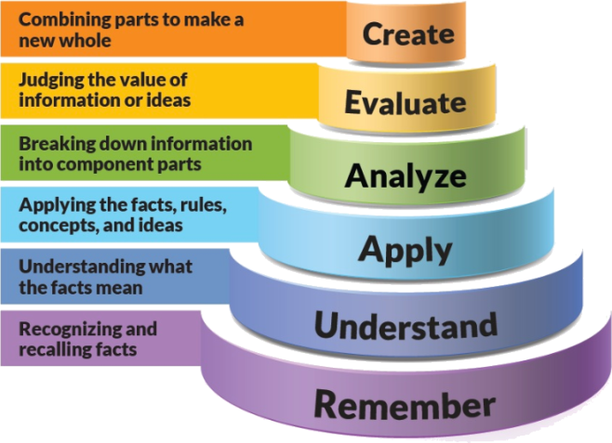
Figure 1: Blooms Taxonomy
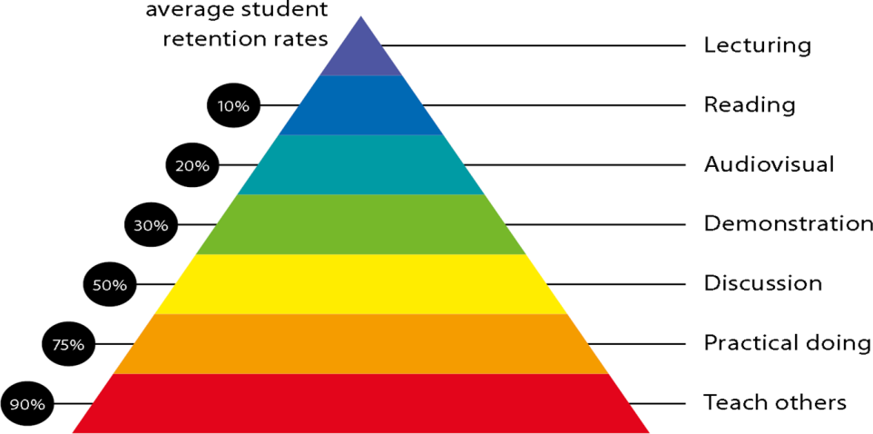
Figure 2: Knowledge retention

Graduate Qualities and Capabilities covered
(Qualities graduates harness crediting this Course)

General Graduate Qualities | Specific Department of ______Graduate Capabilities
Informed  Have a sound knowledge of an area of study or profession and understand its current issues, locally and internationally. Know how to apply this knowledge. Understand how an area of study has developed and how it relates to other areas. | 1 Professional knowledge, grounding & awareness:  Student will be able to learn Basic concepts of physiology, pathophysiology and treatment for various medical conditions.
Independent learners  Engage with new ideas and ways of thinking and critically analyze issues. Seek to extend knowledge through ongoing research, enquiry and reflection. Find and evaluate information, using a variety of sources and technologies. Acknowledge the work and ideas of others. | 2 Information literacy, gathering & processing  Student will be able to learn different types of diseases, Patho physiology and Medicines to cure the diseases.
Problem solvers  Take on challenges and opportunities. Apply creative, logical and critical thinking skills to respond effectively. Make and implement decisions. Be flexible, thorough, innovative and aim for high standards. | 4 Problem solving skills  Student will be able to learn problem solving skill by solving queries in project and can use easy software Handling.
Effective communicators  Articulate ideas and convey them effectively using a range of media. Work collaboratively and engage with people in different settings. Recognize how culture can shape communication. | 5 Written communication
 | 6 Oral communication
7 Teamwork
Students can learn in industry with practical approach and in team work with user department and in collaboration with different stakeholders.
Responsible  Understand how decisions can affect others and make ethically informed choices. Appreciate and respect diversity. Act with integrity as part of local, national, global and professional communities. | 10 Sustainability, societal & environmental impact  Students can understand the mechanism of action of drugs used in different types diseases.

Practical work:
Document preparation
Case studies in clinical trials

Lecture/tutorial times
(Give lecture times in the format below)
4 Lectures/week

Attendance Requirements

The University norms states that it is the responsibility of students to attend all lectures, tutorials, seminars and practical work as stipulated in the Course outline. Minimum attendance requirement as per university norms is compulsory for being eligible for mid and end semester examinations.

Details of referencing system to be used in written work
- Anatomy and Physiology for paramedics-Jaypee brothers, Publication, 2008
- Fundamentals of Anatomy and Physiology-Frederic H. Martini, 11th edition
- Human Anatomy and Physiology- Elaine N. Marieb, Katja Hoehn.
- Robbins & Cotran Pathologic Basis of Disease-9th Edition
- Principles of Anatomy and Physiology, 13th Edition, Gerard J. Tortora, Bryan H. Derrickson

- Textbook:
- Anatomy and Physiology for paramedics-Jaypee brothers, Publication, 2008

Additional Materials

Notes and PPT assessment guidelines

Your final course mark will be calculated from the following:

Assessment guidelines

Subject : Central Lab & Medical Therapeutic Area
Program : M.Sc. Clinical Research |  |  | Subject Code :PCR0301 |  |  | Semester : III
Teaching Scheme |  |  | Examination Evaluation Scheme
Lecture | Tutorial | Practical | Credits | University Theory Examination | University Practical Examination | Continuous Internal Evaluation (CIE)- Theory | Continuous Internal Evaluation (CIE) - Practical | Total
4 | 0 | 0 | 4 | 40 |  | 60 |  | 100

Mid sem exam 40 marks Attendance 05 marks Presentation 05 marks Assignment 1 05 marks Assigment 2 05 marks Final exam 40 marks

SUPPLEMENTARY ASSESSMENT

Students who receive an overall mark less than 40% in mid semester or end semester will be considered for supplementary assessment in the respective components (i.e mid semester or end semester) of semester concerned. Students must make themselves available during the supplementary examination period to take up the respective components (mid semester or end semester) and need to obtain the required minimum 50% marks to clear the concerned components.

Practical Work Report/Laboratory Report:
A report on the practical work is due the subsequent week after completion of the class by each group.

Late Work
Late assignments will not be accepted without supporting documentation. Late submission of the reports will result in a deduction of -% of the maximum mark per calendar day

Format
All assignments must be presented in a neat, legible format with all information sources correctly referenced. Assignment material handed in throughout the session that is not neat and legible will not be marked and will be returned to the student.

Retention of Written Work
Written assessment work will be retained by the Course coordinator/lecturer for two weeks after marking to be collected by the students.

University and Faculty Policies
Students should make themselves aware of the University and/or Faculty Policies regarding plagiarism, special consideration, supplementary examinations and other educational issues and student matters.

Plagiarism - Plagiarism is not acceptable and may result in the imposition of severe penalties. Plagiarism is the use of another person’s work, or idea, as if it is his or her own - if you have any doubts at all on what constitutes plagiarism, please consult your Course coordinator or lecturer. Plagiarism will be penalized severely.

Do not copy the work of other students.
Do not share your work with other students (except where required for a group activity or assessment)
.

Course schedule(subject to change)
(Mention quiz, assignment submission, breaks etc.as well in the table under the Teaching Learning Activity Column)

 | Week # | Topic & contents |  |  | CO Addressed |  | Teaching Learning Activity (TLA)
 | Weeks 1 | LABORATORY MANAGEMENT AND PLANNING: |  |  | Presentation material |  | PPT/Notes
 | Weeks 2 | Introduction to Laboratory management and planning, Quality Control- Role of quality control and its importance |  |  | Presentation material |  | PPT/Notes
 | Week 3 | ANALYTICAL INSTRUMENTS AND TECHNIQUES |  |  | Presentation material |  | PPT/Notes
 | Week 4 | AUTONOMIC DRUGS |  |  | Presentation material |  | PPT/Notes
 | Week 5 | Analytical Instruments and Techniques- Principles, types, use, care and maintenance of photoelectric colorimeters, spectrophotometers, flame photometers, electrophoresis, Chromatography, ELISA and RIA, Isotopes. Bio chemistry Analyzer |  |  | Presentation material |  | PPT/Notes
 | Week 6 | MEDICAL THERAPEUTICS AREA I |  | Presentation material |  | PPT/Notes
 | Week 7 | Introduction to Dermatology- Physiology, Pathophysiology and Treatment for most common dermatological disorders. Gastroenterology- Physiology, Pathophysiology and Treatment for most common Gastroenterological disorders. |  | Presentation material |  | PPT/Notes
 | Week 8 | Hematology: Physiology, Pathophysiology and Treatment for most common Blood related disorders. Immunology/Infectious Diseases: Physiology, Pathophysiology and Treatment for most common Immune system compromised disorders and common infections. |  | Presentation material |  | PPT/Notes
 | Week 9 | MEDICAL THERAPEUTICS AREA II |  | Presentation material |  | PPT/Notes
 | Week 10 | Musculoskeletal: Physiology, Pathophysiology and Treatment for most common Musculo-skeletal disorders. Obstetrics/Gynecology: Physiology, Pathophysiology and Treatment for most common Gynecological disorders. Oncology: Physiology, Pathophysiology and Treatment for most common oncological conditions. Ophthalmology: Physiology, Pathophysiology and Treatment for most common Ophthalmological disorders |  | Presentation material |  | PPT/Notes
 | Week 11 | MEDICAL THERAPEUTICS AREA III |  | Presentation material |  | PPT/Notes
 | Week 12 | Pediatrics/Neonatology: Physiology, Pathophysiology and Treatment for most common Paediatric diseases and disorders. Cardiology: Physiology, Pathophysiology and Treatment for most common Cardiovascular disorders. Endocrinology: Physiology, Pathophysiology and Treatment for most common Endocrine disorders. Nephrology: Physiology, Pathophysiology and Treatment for most common Nephrological disorders. Neurology: Physiology, Pathophysiology and Treatment for most common Neurological disorders. |  | Presentation material |  | PPT/Notes

