Name of Institute: INDUS UNIVERSITY- IISHLS (Institute of science Humanities and liberal studies)

Name of Faculty: Dr. Mayur Savaliya

Pre-Clinical Studies
Course code: UCR0304
Course name: B.SC CLINICAL RESEARCH AND HEALTHCARE MANAGEMENT
Pre-requisites: Basic understanding and knowledge of clinical research
Credit points: 3 credits
Offered Semester:

Course Coordinator
Full Name:Dr. Mayur Savaliya
Department with siting location: 4thfloor Bhawar building, Staff Room
Telephone: 8156071033

Email:mayursavaliya.cr@indusuni.ac.in
Consultation times:Monday to Friday 3 to 4 pm

Course Lecturer
Full name:Dr. Mayur Savaliya
Department with siting location: 4thfloor Bhawar building, Staff Room
Telephone: 8156071033
Email:mayursavaliya.cr@indusuni.ac.in
Consultation times: Monday to Friday 3 to 4 pm

Students will be contacted throughout the Session via Mail with important information relating to this Course.

Course Objectives
By participating in and understanding all facets of this Course a student will:

To learn preclinical studies in order to achieve completion within timelines.

Course Outcomes (CO)
After successful completion of course, student will able to understand the importance of preclinical studies

Course Outline
(Key in topics to be dealt)

UNIT – 1 INTRODUCTION TO PRE-CLINICAL STUDIES:
Objectives, Importance of Pre-Clinical trials, Steps involved in Pre-clinical studies, Drug Development process, Types of Pre-Clinical Studies, Role of F&D department in Pre-Clinical trial, GLP, Toxicity Studies.

UNIT – 2 HIGH THROUGH PUT SCREENING (HTS)
Introduction, Advantages and Disadvantages, Uses, Methodology, Cell based Assays.

UNIT – 3 IN VITRO PRE-CLINICAL STUDIES
Selection of animal models, Overview of study types, Pre-clinical studies to be performed before phase I, II and III. Differences between in vitro study and in vivo study.

UNIT– 4 IN-VIVO STUDIES
Introduction, Factors to be considered for animal studies, Animal models of diseases, Teratogenicity, Mutagenicity, Carcinogenicity, Significance of Adverse event, Serious Adverse event and End point.

Method of delivery
- Face to face lectures
- PPT/Video presentation/
- Class activities
- Article presentation
- Seminar presentation

Study time
3 hours/week

Blooms Taxonomyand Knowledge retention(For reference)
(Blooms taxonomy has been given for reference)

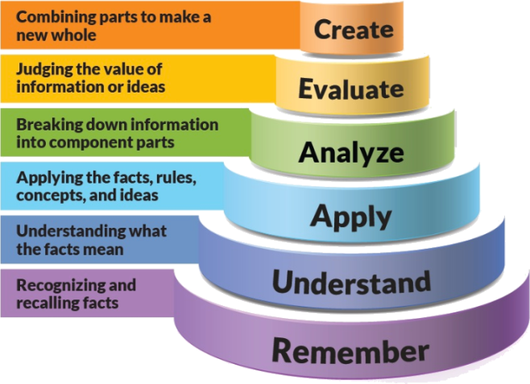
Figure 1: Blooms Taxonomy
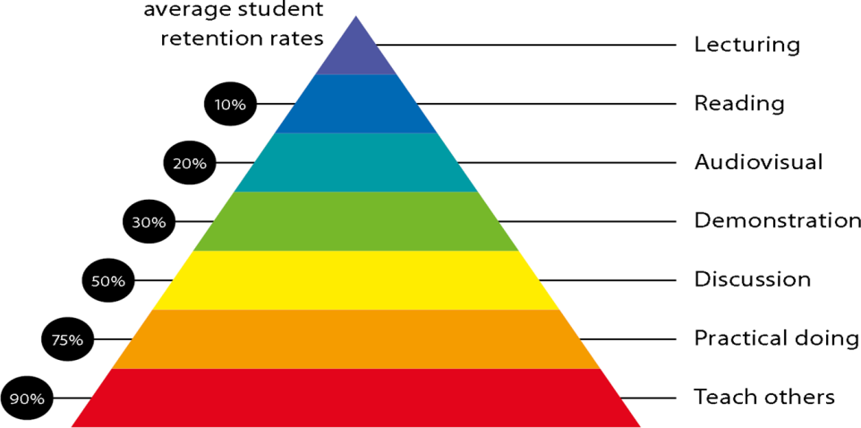
Figure 2: Knowledge retention

Graduate Qualities and Capabilities covered
(Qualities graduates harness crediting this Course)

General Graduate Qualities | Specific Department of ______Graduate Capabilities
Informed  Have a sound knowledge of an area of study or profession and understand its current issues, locally and internationally. Know how to apply this knowledge. Understand how an area of study has developed and how it relates to other areas. | 1 Professional knowledge, grounding & awareness:  Student will be able to learn regarding preclinical studies.
Independent learners  Engage with new ideas and ways of thinking and critically analyze issues. Seek to extend knowledge through ongoing research, enquiry and reflection. Find and evaluate information, using a variety of sources and technologies. Acknowledge the work and ideas of others. | 2 Information literacy, gathering & processing  Student will be able to learn and create  Different studies and application could be done in pre phases of trial.
Problem solvers  Take on challenges and opportunities. Apply creative, logical and critical thinking skills to respond effectively. Make and implement decisions. Be flexible, thorough, innovative and aim for high standards. | 4 Problem solving skills  Student will be able to learn problem solving skill by solving queries in project and can use easy software Handling.
Effective communicators  Articulate ideas and convey them effectively using a range of media. Work collaboratively and engage with people in different settings. Recognize how culture can shape communication. | 5 Written communication
 | 6 Oral communication
7 Teamwork
Students can learn in industry with practical approach and in team work with user department and in collaboration with different stakeholders.
Responsible  Understand how decisions can affect others and make ethically informed choices. Appreciate and respect diversity. Act with integrity as part of local, national, global and professional communities. | 10 Sustainability, societal & environmental impact  Students can understand importance of preclinical studies and application finally in drug research  In the Pharmaceutical industry.

Practical work:
Document preparation
Case studies in clinical trials

Lecture/tutorial times
(Give lecture times in the format below)
3 Lectures/week

Attendance Requirements

The University norms states that it is the responsibility of students to attend all lectures, tutorials, seminars and practical work as stipulated in the Course outline. Minimum attendance requirement as per university norms is compulsory for being eligible for mid and end semester examinations.

Details of referencing system to be used in written work

- Preclinical Drug Development, Edited by Mark Rogge, David R. Taft, Second Edition, 25th Sep 2009.
- Drug Design to Clinical Research – ICRI.

A Comprehensive Guide to Toxicology in Preclinical Drug Development, Ali S. Faqi, Second Edition, 2013.
- Pre-Clinical evaluation of new drugs, S K Gupta.

Textbook:
Pre-Clinical evaluation of new drugs, S K Gupta.

Additional Materials

Notes and PPT assessment guidelines

Your final course mark will be calculated from the following:

Assessment guidelines

Subject : Pre-Clinical Studies
Program : B.Sc-Clinical Research and Healthcare Management |  |  | Subject Code : UCR0304 |  |  | Semester : III
Teaching Scheme |  |  | Examination Evaluation Scheme
Lecture | Tutorial | Practical | Credits | University Theory Examination | University Practical Examination | Continuous Internal Evaluation (CIE)- Theory | Continuous Internal Evaluation (CIE) - Practical | Total
3 | 0 | 0 | 3 | 40 |  | 60 |  | 100

Mid sem exam 40 marks Attendance 05 marks Presentation 05 marks Assignment 1 05 marks Assigment 2 05 marks Final exam 40 marks

SUPPLEMENTARY ASSESSMENT

Students who receive an overall mark less than 40% in mid semester or end semester will be considered for supplementary assessment in the respective components (i.e mid semester or end semester) of semester concerned. Students must make themselves available during the supplementary examination period to take up the respective components (mid semester or end semester) and need to obtain the required minimum 50% marks to clear the concerned components.

Practical Work Report/Laboratory Report:
A report on the practical work is due the subsequent week after completion of the class by each group.

Late Work
Late assignments will not be accepted without supporting documentation. Late submission of the reports will result in a deduction of -% of the maximum mark per calendar day

Format
All assignments must be presented in a neat, legible format with all information sources correctly referenced. Assignment material handed in throughout the session that is not neat and legible will not be marked and will be returned to the student.

Retention of Written Work
Written assessment work will be retained by the Course coordinator/lecturer for two weeks after marking to be collected by the students.

University and Faculty Policies
Students should make themselves aware of the University and/or Faculty Policies regarding plagiarism, special consideration, supplementary examinations and other educational issues and student matters.

Plagiarism - Plagiarism is not acceptable and may result in the imposition of severe penalties. Plagiarism is the use of another person’s work, or idea, as if it is his or her own - if you have any doubts at all on what constitutes plagiarism, please consult your Course coordinator or lecturer. Plagiarism will be penalized severely.

Do not copy the work of other students.
Do not share your work with other students (except where required for a group activity or assessment)
.

Course schedule(subject to change)
(Mention quiz, assignment submission, breaks etc.as well in the table under the Teaching Learning Activity Column)

 | Week # | Topic & contents |  |  | CO Addressed |  | Teaching Learning Activity (TLA)
 | Weeks 1 | Objectives, Importance of Pre-Clinical trials, Steps involved in Pre-clinical studies, |  |  | Presentation material |  | PPT/Notes
 | Weeks 2 | Drug Development process, Types of Pre-Clinical Studies |  |  | Presentation material |  | PPT/Notes
 | Week 3 | Role of F&D department in Pre-Clinical trial, GLP, Toxicity Studies. |  |  | Presentation material |  | PPT/Notes
 | Week 4 | Gel Electrophoresis - PAGE, SDS - PAGE, 2D-PAGE, |  |  | Presentation material |  | PPT/Notes
 | Week 5 | Introduction, Advantages and Disadvantages, |  |  | Presentation material |  | PPT/Notes
 | Week 6 | Uses, Methodology, Cell based Assays. |  | Presentation material |  | PPT/Notes
 | Week 7 | Selection of animal models, Overview of study types, |  | Presentation material |  | PPT/Notes
 | Week 8 | Pre-clinical studies to be performed before phase I, II and III. |  | Presentation material |  | PPT/Notes
 | Week 9 | Differences between in vitro study and in vivo study. |  | Presentation material |  | PPT/Notes
 | Week 10 | Introduction, Factors to be considered for animal studies, |  | Presentation material |  | PPT/Notes
 | Week 11 | Teratogenicity, Mutagenicity, Carcinogenicity |  | Presentation material |  | PPT/Notes
 | Week 12 | Significance of Adverse event, Serious Adverse event and End point. |  | Presentation material |  | PPT/Notes

