Name of Institute: INDUS UNIVERSITY- IISHLS (Institute of science Humanities and liberal studies)

Name of Faculty: Dr. Anokhi shah

Advance Clinical Research
Course code: PCR0305
Course name: Msc clinical Research
Pre-requisites: Basic understanding and knowledge of clinical research
Credit points: 4 credits
Offered Semester:

Course Coordinator
Full Name:Dr. Anokhi shah
Department with siting location: 4thfloor Bhawar building, class 11
Telephone: 9974702063

Email:anokhishah.cr@indusuni.ac.in
Consultation times:Monday to Friday 3 to 4 pm

Course Lecturer
Full name:Dr.Anokhi shah
Department with siting location: 4thfloor Bhawar building, class 11
Telephone: 9974702063
Email:Anokhishah.cr@indusuni.ac.in
Consultation times: Monday to Friday 3 to 4 pm

Students will be contacted throughout the Session via Mail with important information relating to this Course.

Course Objectives
By participating in and understanding all facets of this Course a student will:

1 To learn about Advance in Clinical Research of quality management and medical writings.

Course Outcomes (CO)
After successful completion of course, student will able to understand,
- Introduction to advance medical writing and document preparation.
- Methodology of clinical trial operations and managing research data
- Planning of clinical trial finance and budgeting

Course Outline
(Key in topics to be dealt)

Course Content:

Unit 1: Advance medical writing: Basics of good medical writing, Medical case reports preparation, final study report preparation, Monitoring report writing, Audit report writing, Publication, oral presentation.
Unit 2: Quality management in clinical trial: Quality management and clinical trial documents, Misconduct and frauds in clinical trial, FDA inspections, DCGI audits and inspections, NABH audits of ethics committee

Unit 3: Clinical trial operations: Managing research data, managing multicenter research projects. Introduction to Sugam portal, its application

Unit 4: Project and vendor management: strategies of patient recruitment and retention, concept of SMO, Advertising and media marketing

Unit 5: Clinical trial finance and budgeting: Routine cost Vs Research only cost, Financial management of a clinical trial, Account reconciliation of clinical trials, clinical trial finance life cycle.

. Method of delivery
- Face to face lectures
- PPT/Video presentation/
- Class activities
- Article presentation
- Seminar presentation

Study time
4 hours/week

Blooms Taxonomyand Knowledge retention(For reference)
(Blooms taxonomy has been given for reference)

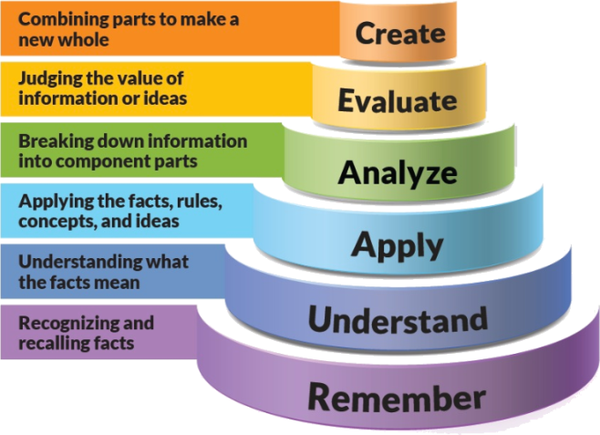
Figure 1: Blooms Taxonomy
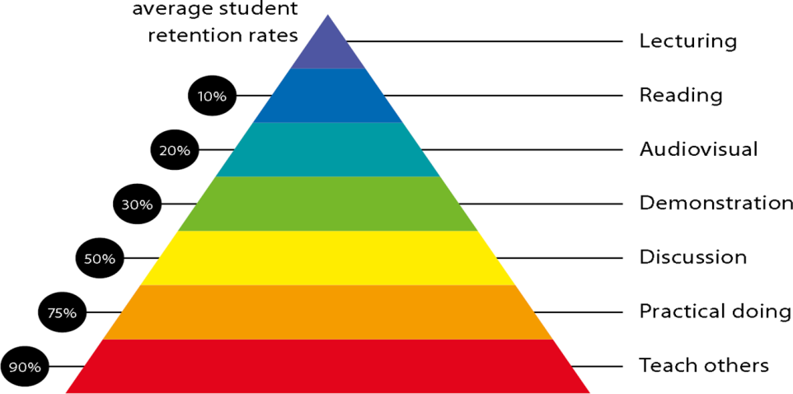
Figure 2: Knowledge retention

Graduate Qualities and Capabilities covered
(Qualities graduates harness crediting this Course)

General Graduate Qualities | Specific Department of ______Graduate Capabilities
Informed  Have a sound knowledge of an area of study or profession and understand its current issues, locally and internationally. Know how to apply this knowledge. Understand how an area of study has developed and how it relates to other areas. | 1 Professional knowledge, grounding & awareness:  Student will be able to learn regarding different application of clinical Data management, startup phase and process of data Management.
Independent learners  Engage with new ideas and ways of thinking and critically analyze issues. Seek to extend knowledge through ongoing research, enquiry and reflection. Find and evaluate information, using a variety of sources and technologies. Acknowledge the work and ideas of others. | 2 Information literacy, gathering & processing  Student will be able to learn and create  Different CRF designing and application could be done in different phases of trial.
Problem solvers  Take on challenges and opportunities. Apply creative, logical and critical thinking skills to respond effectively. Make and implement decisions. Be flexible, thorough, innovative and aim for high standards. | 4 Problem solving skills  Student will be able to learn problem solving skill by solving queries in project and can use easy software Handling.
Effective communicators  Articulate ideas and convey them effectively using a range of media. Work collaboratively and engage with people in different settings. Recognize how culture can shape communication. | 5 Written communication
 | 6 Oral communication
7 Teamwork
Students can learn in industry with practical approach and in team work with user department and in collaboration with different stakeholders.
Responsible  Understand how decisions can affect others and make ethically informed choices. Appreciate and respect diversity. Act with integrity as part of local, national, global and professional communities. | 10 Sustainability, societal & environmental impact  Students can understand importance of data and application finally in drug research  In the Pharmaceutical industry.

Practical work:
Document preparation
Case studies in clinical trials

Lecture/tutorial times
(Give lecture times in the format below)
4 lectures/week

Attendance Requirements

The University norms states that it is the responsibility of students to attend all lectures, tutorials, seminars and practical work as stipulated in the Course outline. Minimum attendance requirement as per university norms is compulsory for being eligible for mid and end semester examinations.

Details of referencing system to be used in written work
- Mastering Scientific and medical writing- Silvia M. Rogers , 2nd Edition.
- Medical Writing: A Brief guide for beginners- Carol Scott-Conner
- Research Methodology, C R Kothari

Text books

Additional Materials

Notes and PPT assessment guidelines

Your final course mark will be calculated from the following:

Assessment guidelines

Subject : Advance clinical research
Program : M.Sc. Clinical Research |  |  | Subject Code :PCR0305 |  |  | Semester : III
Teaching Scheme |  |  | Examination Evaluation Scheme
Lecture | Tutorial | Practical | Credits | University Theory Examination | University Practical Examination | Continuous Internal Evaluation (CIE)- Theory | Continuous Internal Evaluation (CIE) - Practical | Total
4 | 0 | 0 | 4 | 40 |  | 60 |  | 100

Mid sem exam 40 marks Attendance 05 marks Presentation 05 marks Assignment 1 05 marks Assigment 2 05 marks Final exam 40 marks

SUPPLEMENTARY ASSESSMENT

Students who receive an overall mark less than 40% in mid semester or end semester will be considered for supplementary assessment in the respective components (i.e mid semester or end semester) of semester concerned. Students must make themselves available during the supplementary examination period to take up the respective components (mid semester or end semester) and need to obtain the required minimum 50% marks to clear the concerned components.

Practical Work Report/Laboratory Report:
A report on the practical work is due the subsequent week after completion of the class by each group.

Late Work
Late assignments will not be accepted without supporting documentation. Late submission of the reports will result in a deduction of -% of the maximum mark per calendar day

Format
All assignments must be presented in a neat, legible format with all information sources correctly referenced. Assignment material handed in throughout the session that is not neat and legible will not be marked and will be returned to the student.

Retention of Written Work
Written assessment work will be retained by the Course coordinator/lecturer for two weeks after marking to be collected by the students.

University and Faculty Policies
Students should make themselves aware of the University and/or Faculty Policies regarding plagiarism, special consideration, supplementary examinations and other educational issues and student matters.

Plagiarism - Plagiarism is not acceptable and may result in the imposition of severe penalties. Plagiarism is the use of another person’s work, or idea, as if it is his or her own - if you have any doubts at all on what constitutes plagiarism, please consult your Course coordinator or lecturer. Plagiarism will be penalized severely.

Do not copy the work of other students.
Do not share your work with other students (except where required for a group activity or assessment)
.

Course schedule(subject to change)
(Mention quiz, assignment submission, breaks etc.as well in the table under the Teaching Learning Activity Column)

 | Week # | Topic & contents |  |  | CO Addressed |  | Teaching Learning Activity (TLA)
 | Weeks 1 | Basics of good medical writing |  |  | Presentation material |  | PPT/Notes
 | Weeks 2 | Medical case reports preparation, final study report preparation |  |  | Presentation material |  | PPT/Notes
 | Week 3 | Monitoring report writing, Audit report writing, Publication, oral presentation. |  |  | Presentation material |  | PPT/Notes
 | Week 4 | Quality management and clinical trial documents |  |  | Presentation material |  | PPT/Notes
 | Week 5 | Misconduct and frauds in clinical trial |  |  | Presentation material |  | PPT/Notes
 | Week 6 | FDA inspections, DCGI audits and inspections, NABH audits of ethics committee |  | Presentation material |  | PPT/Notes
 | Week 7 | Managing research data, managing multicenter research projects. Introduction to Sugam portal |  | Presentation material |  | PPT/Notes
 | Week 8 | strategies of patient recruitment and retention, concept of SMO |  | Presentation material |  | PPT/Notes
 | Week 9 | Routine cost Vs Research only cost, |  | Presentation material |  | PPT/Notes
 | Week 10 | Financial management of a clinical trial |  | Presentation material |  | PPT/Notes
 | Week 11 | Account reconciliation of clinical trials |  | Presentation material |  | PPT/Notes
 | Week 12 | clinical trial finance life cycle. |  | Presentation material |  | PPT/Notes

