Name of Institute: IITE

Name of Faculty: Mr. Monil Salot

Course code: MT0702
Course name: Non Destructive Testing
Pre-requisites: Materials Science
Credit points: 4
Offered Semester: 7

Course Coordinator
Full Name: Mr. Monil Salot
Department with siting location: Ground Floor Met Lab 4
Telephone: +91-9428600336
Email: monilsalot.mt@indusuni.ac.in
Consultation times: 4:15 – 5:00

Course Lecturer
Full name: Mr. Monil Salot
Department with siting location: Ground Floor Met Lab 4
Telephone: +91-9428600336
Email: monilsalot.mt@indusuni.ac.in
Consultation times: 4:15 – 5:00

Students will be contacted throughout the Session via Mail with important information relating to this Course.

Course Objectives
By participating in and understanding all facets of this Course a student will:
- To understand the principle and application of visual testing methods
- To understand principle of liquid penetration testing and magnetic particle testing technique.
- To understand principle of ultrasonic and radiographic testing technique and its applications.

Course Outcomes (CO)
- To understand the significance of testing of metallic and non metallic materials and components without destroying them.
- To study the application of these methods in assessing reliability of components & plants.
- To study the life time assessment of components.

Course Outline
The proposed course deals with visual, liquid penetrant, magnetic particle, ultrasonic, radiographic, eddy current, acoustic emission testing.

Method of delivery
(Face to face lectures, self study material, Active Learning Techniques)

Study time
4 lectures per week

CO-PO Mapping (PO: Program Outcomes)

 | PO1 | PO2 | PO3 | PO4 | PO5 | PO6 | PO7 | PO8 | PO9 | PO10 | PO11 | PO12
CO1 | 1 | - | 2 | - | 1 | 1 | 3 | 1 | - | - | 2 | -
CO2 | 3 | 3 | 2 | 1 | 2 | 2 | 2 | - | - | - | 3 | 1
CO3 | 3 | 3 | 1 | 2 | 3 | 3 | 2 | 1 | - | - | 2 | -

1-Lightly Mapped 2- Moderately Mapped 3- Highly Mapped

Blooms Taxonomyand Knowledge retention(For reference)
(Blooms taxonomy has been given for reference)

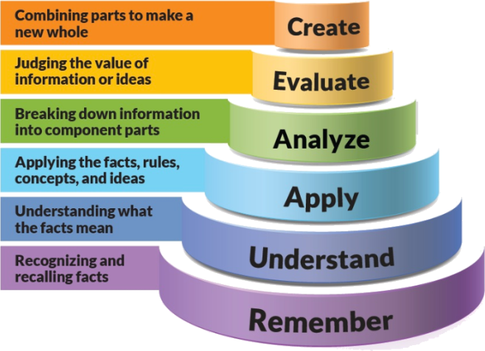
Figure 1: Blooms Taxonomy
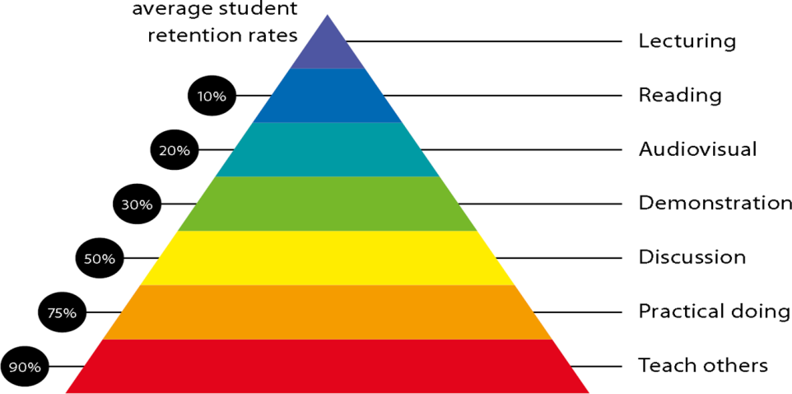
Figure 2: Knowledge retention

Graduate Qualities and Capabilities covered
(Qualities graduates harness crediting this Course)

General Graduate Qualities | Specific Department of ______Graduate Capabilities
Informed  Have a sound knowledge of an area of study or profession and understand its current issues, locally and internationally. Know how to apply this knowledge. Understand how an area of study has developed and how it relates to other areas. | 1 Professional knowledge, grounding & awareness
Independent learners  Engage with new ideas and ways of thinking and critically analyze issues. Seek to extend knowledge through ongoing research, enquiry and reflection. Find and evaluate information, using a variety of sources and technologies. Acknowledge the work and ideas of others. | 2 Information literacy, gathering & processing
Problem solvers  Take on challenges and opportunities. Apply creative, logical and critical thinking skills to respond effectively. Make and implement decisions. Be flexible, thorough, innovative and aim for high standards. | 4 Problem solving skills
Effective communicators  Articulate ideas and convey them effectively using a range of media. Work collaboratively and engage with people in different settings. Recognize how culture can shape communication. | 5 Written communication
 | 6 Oral communication
 | 7 Teamwork
Responsible  Understand how decisions can affect others and make ethically informed choices. Appreciate and respect diversity. Act with integrity as part of local, national, global and professional communities. | 10 Sustainability, societal & environmental impact

Practical work:
NA

Lecture/tutorial times

Lecture Monday 3:10 – 4:10 pm Google Classroom
Lecture Tuesday 10:00 – 11:00 am Google Classroom
Lecture Wednesday 12:20 – 1:20 pm Google Classroom
Lecture Thursday 11:10 – 12:10 pm Google Classroom

Attendance Requirements

The University norms states that it is the responsibility of students to attend all lectures, tutorials, seminars and practical work as stipulated in the Course outline. Minimum attendance requirement as per university norms is compulsory for being eligible for mid and end semester examinations.

Details of referencing system to be used in written work

Text Book(s)
- Practical Non-destructive Testing–BaldevRaj, T.Jayakumar & M.Thavasimuthu, Norosa Publishing House, New Delhi.
- Non-destructive testing, Warren J. McGonnagle, Gordon Breach, Science

Reference Books

- Ultrasonic Testing of Materials,J.Krautkramer
- Treaties on Non-destructive testing,by Dr.E.G.Krishnadas Nair, Non-destructive testing, R. Hatmshaw.
- Ultrasonic Methods of Testing Materials, Leszek Filipezynski, Zdzislaw Pawlowski

Digital Learning Resources

www.nptel.ac.in

ASSESSMENT GUIDELINES
Your final course mark will be calculated from the following:
CIE 60 marks :(40 marks mid semester examination + 20 marks internal evaluation)

Breakup of 20 Marks: (05 marks as attendance bonus for all students having attendance > 80%) + (05 marks for presentation)+(10 marks for two assignment or case studies)

ESE: 40 Marks of End Semester Examination

SUPPLEMENTARY ASSESSMENT

Students who receive an overall mark less than 40% in mid semester or end semester will be considered for supplementary assessment in the respective components (i.e mid semester or end semester) of semester concerned. Students must make themselves available during the supplementary examination period to take up the respective components (mid semester or end semester) and need to obtain the required minimum 40% marks to clear the concerned components. , For remedial and repeater remedial - CIE 60 marks (40 marks remedial mid semester examination + 20 marks for assignments or case studies, limited to minimum 04 assignments per course), and end semester repeater and remedial examination would be carried out centrally according to University Policy

Practical Work Report/Laboratory Report:
NA

Late Work
Late assignments will not be accepted without supporting documentation. Late submission of the reports will result in a deduction of -1% of the maximum mark per calendar day

Format
All assignments must be presented in a neat, legible format with all information sources correctly referenced. Assignment material handed in throughout the session that is not neat and legible will not be marked and will be returned to the student.

Retention of Written Work
Written assessment work will be retained by the Course coordinator/lecturer for two weeks after marking to be collected by the students.

University and Faculty Policies
Students should make themselves aware of the University and/or Faculty Policies regarding plagiarism, special consideration, supplementary examinations and other educational issues and student matters.

Plagiarism - Plagiarism is not acceptable and may result in the imposition of severe penalties. Plagiarism is the use of another person’s work, or idea, as if it is his or her own - if you have any doubts at all on what constitutes plagiarism, please consult your Course coordinator or lecturer. Plagiarism will be penalized severely.

Do not copy the work of other students.
Do not share your work with other students (except where required for a group activity or assessment)
.

Course schedule (subject to change)

 | Week # | Topic & contents |  | CO Addressed |  | Teaching Learning Activity (TLA)
 | Weeks 1 | Fundamentals and introduction to non-destructive testing. Scope and limitationsof NDT |  | 1,2,3 |  | PPT-Online Platform
 | Weeks 2 | Visual examination methods. Different visual examination aids. |  | 1,2,3 |  | PPT-Online Platform
 | Week 3 | Leak and pressure testing of industrial components. Various methods of pressure and leak testing underlying principles of these testing systems. |  | 1,2,3 |  | PPT-Online Platform
 | Week 4 | Dye penetrant Methods, Basic Principles, Capillary Action, Wetting and Non-Wetting |  | 1,2,3 |  | PPT-Online Platform
 | Week 5 | Characteristics, Different Types of Penetrants, Detailed Procedure and Recent Developments in DPT. |  | 1,2,3 |  | PPT-Online Platform
 | Week 6 | Magnetic Particle Testing methods, Basic Principles of MPT, magnetizationmethods demagnetization methods. | 1,2,3 |  | PPT-Online Platform
 | Week 7 | MPT equipment & instruments, sensitivity calibration of MPT equipment. | 1,2,3 |  | PPT-Online Platform
 | Week 8 | Ultrasonic methods of NDT-Basic principles of wave propagation, types of waves | 1,2,3 |  | PPT-Online Platform
 | Week 9 | Transducers and transducer materials, advantages and limitations of UT. Pulse Echo and Through Transmission techniques of UT | 1,2,3 |  | PPT-Online Platform
 | Week 10 | Calibration methods, use of standard blocks, Thickness determination by ultrasonic method. Study of A, B and C scan presentations. | 1,2,3 |  | PPT-Online Platform
 | Week 11 | Radiographic testing of metallic components. X-ray and Gamma-Ray radiography. Their principles, methods of generation. | 1,2,3 |  | PPT-Online Platform
 | Week 12 | Industrial radiography techniques. Types of films, screens and penetrameters. Interpretation of radiographs. Film Processing. Radiography Contrast. | 1,2,3 |  | PPT-Online Platform
 | Week 13 | Eddy current testing: Basic principles and applications such as detection of defects and characterization, sorting of materials, determination of film/coating thickness, measurement of electrical conductivity and magnetic permeability of materials. | 1,2,3 |  | PPT-Online Platform
 | Week 14 | Eddy current testing equipments and its block diagram, different types of test coils and their applications. | 1,2,3 |  | PPT-Online Platform
 | Week 15 | Acoustic Emission Technique. Conductivity & resistivity methods and their applications. Thermal methods of NDT. | 1,2,3 |  | PPT-Online Platform
 | Week 16 | Selection Criteria for various NDT techniques.  Revision | 1,2,3 |  | PPT-Online Platform

