Name of Institute: INDUS UNIVERSITY- ISHLS (Institute of science Humanities and liberal studies)

Name of Faculty: Dr. Anokhi shah

Course code: PCR0201, Clinical Trial Management
Course name: Msc Clinical Research
Pre-requisites: Basic understanding and knowledge of clinical research
Credit points: 4 credits
Offered Semester: II

Course Coordinator
Full Name: Dr. Anokhi shah
Department with siting location: 4th floor Bhawar building, class 11
Telephone: 9974702063

Email: anokhishah.cr@indusuni.ac.in
Consultation times: Monday to Friday 3 to 4 pm

Course Lecturer
Full name: Dr. Anokhi shah
Department with siting location: 4th floor Bhawar building, class 11
Telephone: 9974702063
Email: Anokhishah.cr@indusuni.ac.in
Consultation times: Monday to Friday 3 to 4 pm

Students will be contacted throughout the Session via Mail with important information relating to this Course.

Course Objectives
By participating in and understanding all facets of this Course a student will:

- To learn about clinical trial management from different Perspective in Clinical Trial.
.

Course Outcomes (CO)
After successful completion of course, student will able to understand,
1. This course helps to know about the clinical trial related activities and individuals responsibilities
2. Preparation of Essential Documents like ICF, CRF’s, IB and Advertisement tools.
3. Preparation of documents for Investigators Meeting.
4. Preparation of Service plans like Data Management plan, eCRF Completion guidelines.
5. Audit Preparation.

Course Outline
(Key in topics to be dealt)

Course Content:
UNIT 1: AN OVERVIEW
Defining Clinical Trial Process, Basics of Project Management-Definition of project, Stages of Project Development, Definition of Stake Holders of a project, defining project management in general, different models of project management, Concept of stake holders in a clinical trial project, definition of a clinical trial project management, concept of clinical Trial Management flow; Essential Document preparation (IB, ICF, PIS, TMF, ISF, Advertisements, CDA, CTA etc.

UNIT 2: CLINICAL TRIAL MANAGEMENT; A SPONSOR’S PERSPECTIVE
Definition, types and responsibilities of sponsors: Study Preparation Initial documents and Capability Assessment- Sponsor’s team and concept of delegation and outsourcing, Study feasibility - Definition, feasibility categories, Basic concept for Investigator’s selection, Concept of Feasibility flow and confidentiality in clinical trial process, Basic concept for vendors’ / service providers’ selection , Budgeting in Clinical Trial – Basics of cost, bidding process, negotiation and budgeting for a clinical study, Clinical Trial Agreement (CTA) Process- Concept and types of CTAs , Regulatory Submissions and approval, Investigators’ Meeting Sponsor’s obligations outlined in Good Clinical Practices and regulations.

UNIT 3: CLINICAL TRIAL MANAGEMENT; AN INVESTIGATOR’S PERSPECTIVE Definition, Investigator’s obligations outlined in Good Clinical Practices and regulations, Recruitment, retention and Compliance of study subjects, Ethics Committee Submission \Adverse event & safety reporting-Types and Investigator’s obligations in brief

UNIT 4: CLINICAL TRIAL MANAGEMENT; SERVICE PROVIDERS / VENDORS
PERSPECTIVE
Concept of different services plans, e.g., CMP, CDMP, Recruitment Plan, Logistics Management Plan, etc. Contract Research Organizations (CRO) - Definition, Monitoring services, Roles and Responsibilities of a Project Manager and Clinical Research Associate (CRA), CRO business scenario; Difference between a CRO and SMO Site Management Organization (SMO) – Definition, Site Management Services, Roles and Responsibilities of a Clinical Research Coordinator (CRC), SMO Business scenario, Central Lab- Definition, services,

Unit 5: Clinical Data Management: SERVICE PROVIDERS/Concept of Safety Reporting services
Clinical Data Management Organizations (CDMO) – Definition and Services, Medical Writing Organizations- Definition and services, Logistics Management Organization- Definition and concept of logistics in Clinical research, Services Pharmacovigilance Organization- concept of safety reporting services

Method of delivery
- Face to face lectures
- PPT/Video presentation/
- Class activities
- Article presentation
- Seminar presentation

Study time
4 hours/week

CO-PO Mapping (PO: Program Outcomes):-

Blooms Taxonomy and Knowledge retention (For reference)
(Blooms taxonomy has been given for reference)

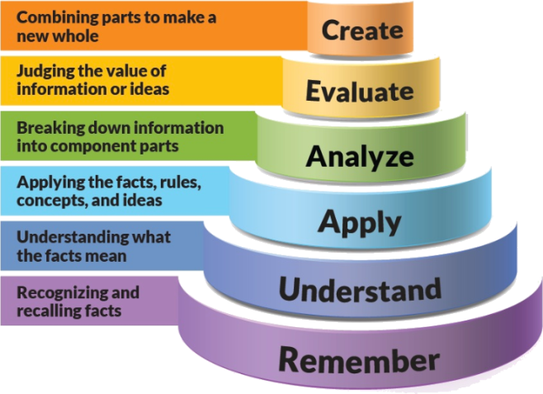
Figure 1: Blooms Taxonomy
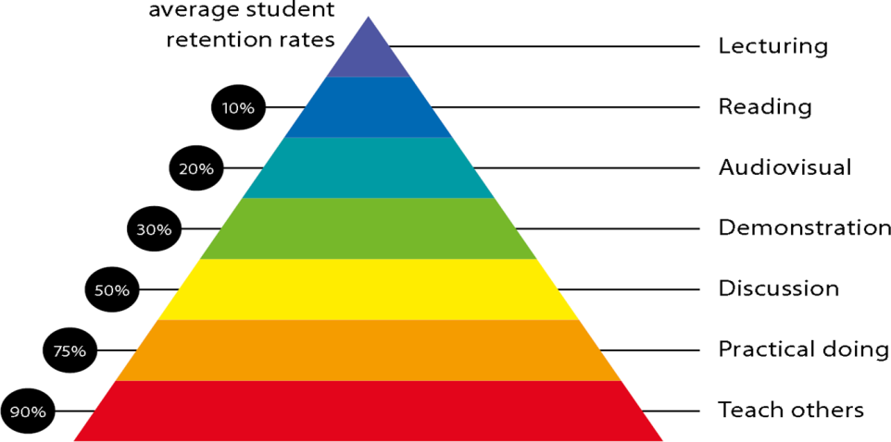
Figure 2: Knowledge retention

Graduate Qualities and Capabilities covered
(Qualities graduates harness crediting this Course)

General Graduate Qualities | Specific Department of ______Graduate Capabilities
Informed  Have a sound knowledge of an area of study or profession and understand its current issues, locally and internationally. Know how to apply this knowledge. Understand how an area of study has developed and how it relates to other areas. | 1 Professional knowledge, grounding & awareness  Students should able to know clinical trial management from the perspective of Investigator and sponsor.
Independent learners  Engage with new ideas and ways of thinking and critically analyze issues. Seek to extend knowledge through ongoing research, enquiry and reflection. Find and evaluate information, using a variety of sources and technologies. Acknowledge the work and ideas of others. | 2 Information literacy, gathering & processing  Students should able to know about Budgeting in Clinical Trial, different CTA modes, and how to deal practically in clinical trial agreement.
Problem solvers  Take on challenges and opportunities. Apply creative, logical and critical thinking skills to respond effectively. Make and implement decisions. Be flexible, thorough, innovative and aim for high standards. | 4 Problem solving skills  Students should able to know about application of creative, logical and critical thinking skills to respond effectively on management of whole clinical trial project from feasibility to close out procedure.
Effective communicators  Articulate ideas and convey them effectively using a range of media. Work collaboratively and engage with people in different settings. Recognize how culture can shape communication. | 5 Written communication
 | 6 Oral communication
7 Teamwork
Students should able to know about Work collaboratively and engage every staff member according to job responsibility of respective field.
Responsible  Understand how decisions can affect others and make ethically informed choices. Appreciate and respect diversity. Act with integrity as part of local, national, global and professional communities. | 10 Sustainability, societal & environmental impact  Students can understand effective and qualitative project handling will useful in ethical result of drug research which is very  Useful to society.

Practical work:
Document preparation
Medical writing Documents-Practice

Lecture/tutorial times
(Give lecture times in the format below)

Attendance Requirements

The University norms states that it is the responsibility of students to attend all lectures, tutorials, seminars and practical work as stipulated in the Course outline. Minimum attendance requirement as per university norms is compulsory for being eligible for mid and end semester examinations.

Details of referencing system to be used in written work
- Guide to Clinical Trials,Bert Spilker, 1991 (Now 3rd edition)
- Practical Guide Clinical Management - Nancy J Stark February 2004

Text books

- Practical Guide Clinical Management - Nancy J Stark February 2004
- A Practical Guide to Managing Clinical Trials book by Cris Wells and JoAnn Pfeiffer
Additional Materials

Notes and PPT assessment guidelines

Your final course mark will be calculated from the following:

Assessment guidelines

Subject : Clinical Trial Management
Program : M.Sc. Clinical Research |  |  | Subject Code :PCR0201 |  |  | Semester : II
Teaching Scheme |  |  | Examination Evaluation Scheme
Lecture | Tutorial | Practical | Credits | University Theory Examination | University Practical Examination | Continuous Internal Evaluation (CIE)- Theory | Continuous Internal Evaluation (CIE) - Practical | Total
4 | 0 | 0 | 4 | 40 |  | 60 |  | 100

Class test: 20 marks
Presentation: 20 marks
Quiz/class activities/viva: 20 marks

SUPPLEMENTARY ASSESSMENT

Students who receive an overall mark less than 40% in mid semester or end semester will be considered for supplementary assessment in the respective components (i.e mid semester or end semester) of semester concerned. Students must make themselves available during the supplementary examination period to take up the respective components (mid semester or end semester) and need to obtain the required minimum 50% marks to clear the concerned components.

Practical Work Report/Laboratory Report:
A report on the practical work is due the subsequent week after completion of the class by each group.

Late Work
Late assignments will not be accepted without supporting documentation. Late submission of the reports will result in a deduction of -% of the maximum mark per calendar day

Format
All assignments must be presented in a neat, legible format with all information sources correctly referenced. Assignment material handed in throughout the session that is not neat and legible will not be marked and will be returned to the student.

Retention of Written Work
Written assessment work will be retained by the Course coordinator/lecturer for two weeks after marking to be collected by the students.

University and Faculty Policies
Students should make themselves aware of the University and/or Faculty Policies regarding plagiarism, special consideration, supplementary examinations and other educational issues and student matters.

Plagiarism - Plagiarism is not acceptable and may result in the imposition of severe penalties. Plagiarism is the use of another person’s work, or idea, as if it is his or her own - if you have any doubts at all on what constitutes plagiarism, please consult your Course coordinator or lecturer. Plagiarism will be penalized severely.

Do not copy the work of other students.
Do not share your work with other students (except where required for a group activity or assessment)
.

Course schedule (subject to change)
(Mention quiz, assignment submission, breaks etc. as well in the table under the Teaching Learning Activity Column)

 | Week # | Topic & contents |  |  | CO Addressed |  | Teaching Learning Activity (TLA)
 | Weeks 1 | Defining Clinical Trial Process, Basics of Project Management-Definition of project, Stages of Project Development |  |  | Presentation material |  | PPT/Notes
 | Weeks 2 | , Definition of Stake Holders of a project, defining project management in general, different models of project management, Concept of stake holders in a clinical trial project |  |  | Presentation material |  | PPT/Notes
 | Week 3 | Definition, types and responsibilities of sponsors: Study Preparation Initial documents and Capability Assessment- Sponsor’s team and concept of delegation and outsourcing, Study feasibility - Definition, feasibility categories, |  |  | Presentation material |  | PPT/Notes
 | Week 4 | Basic concept for Investigator’s selection, Concept of Feasibility flow and confidentiality in clinical trial process, Basic concept for vendors’ / service providers’ selection , Budgeting in Clinical Trial – Basics of cost, bidding process, negotiation and budgeting for a clinical study, |  |  | Presentation material |  | PPT/Notes
 | Week 5 | Clinical Trial Agreement (CTA) Process- Concept and types of CTAs , Regulatory Submissions and approval, Investigators’ Meeting Sponsor’s obligations outlined in Good Clinical Practices and regulations. |  |  | Presentation material |  | PPT/Notes
 | Week 6 | Practices and regulations, Recruitment, retention and Compliance of study subjects |  | Presentation material |  | PPT/Notes
 | Week 7 | Ethics Committee Submission \Adverse event & safety reporting-Types and Investigator’s obligations in brief |  | Presentation material |  | PPT/Notes
 | Week 8 | Concept of different services plans, e.g., CMP, CDMP, Recruitment Plan, Logistics Management Plan, etc. Contract Research Organizations (CRO) - Definition, Monitoring services, Roles and Responsibilities of a Project Manager and Clinical Research Associate (CRA |  | Presentation material |  | PPT/Notes
 | Week 9 | CRO business scenario; Difference between a CRO and SMO Site Management Organization (SMO) – |  | Presentation material |  | PPT/Notes
 | Week 10 | , Roles and Responsibilities of a Clinical Research Coordinator (CRC), SMO Business scenario, Central Lab- Definition, services, |  | Presentation material |  | PPT/Notes
 | Week 11 | Clinical Data Management Organizations (CDMO) – Definition and Services, Medical Writing Organizations |  | Presentation material |  | PPT/Notes
 | Week 12 | Definition and services, Logistics Management Organization- Definition and concept of logistics in Clinical research, Services Pharmacovigilance Organization- concept of safety reporting services |  | Presentation material |  | PPT/Notes

