Pointers in C

- Pointers are variable that stores the address of another variable.
- Unlike other variables that hold values of a certain type, pointer holds the address of a variable.
- For example, an integer variable holds (or you can say stores) an integer value, however an integer pointer holds the address of a integer variable.

- A simple example to understand how to access the address of a variable without pointers?

- 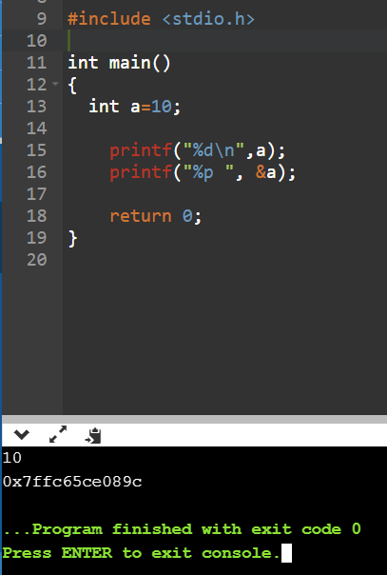
Address of variable a
Value of variable a
Variable Name
0x7ffc65ce089c
a
10

- C Pointers – Operators that are used with Pointers
  - “Address of”(&) Operator
    - I have used &a to access the address of variable a. The & operator is also known as “Address of” Operator.
    - printf("Address of var is: %p", &a);
    - Point to note: %p is a format specifier which is used for displaying the address in hex format.
  - “Value at Address”(*) Operator
    - The * Operator is also known as Value at address operator.
  - How to declare a pointer?
- int *p1 /*Pointer to an integer variable*/
- double *p2 /*Pointer to a variable of data type double*/
- char *p3 /*Pointer to a character variable*/
- float *p4 /*pointer to a float variable*/
    - By using * operator we can access the value of a variable through a pointer.
    - For example:

double a = 10;
double *p;
p = &a;
    - *p would give us the value of the variable a. The following statement would display 10 as output.

printf("%d", *p);

    - Similarly if we assign a value to *pointer like this:
*p = 200;
    - It would change the value of variable a. The statement above will change the value of a from 10 to 200.
- Example of Pointer demonstrating the use of & and *
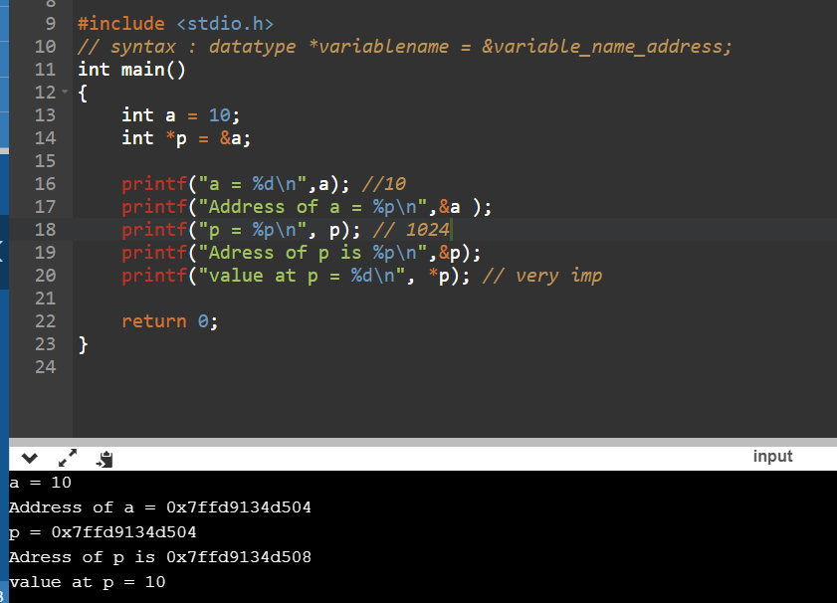How to
- declare a Pointer to Pointer (Double Pointer) in C?
- int **pr;
- Here pr is a double pointer. There must be two *’s in the declaration of double pointer.

