Functions in C

- There are 2 types of functions.
- 1) Standard Library Functions – ex. printf(), scanf(), sqrt().
- 2) User defined Functions – defined by programmer for implementing specific functionality.
      - - To make program modular and structured. As C is Procedural language
- To define any user define function we need to define 3 things :
  - Function declaration – Syntax : return_type function_name(list of parameters);
  - Function definition – Syntax :
return_type function_name(list of parameters)
{
// Statements;
}
  - Function calling – Syntax : function_name(list of parameters);

- 4 Types of user defined functions –
- 1) No Return , No Argument
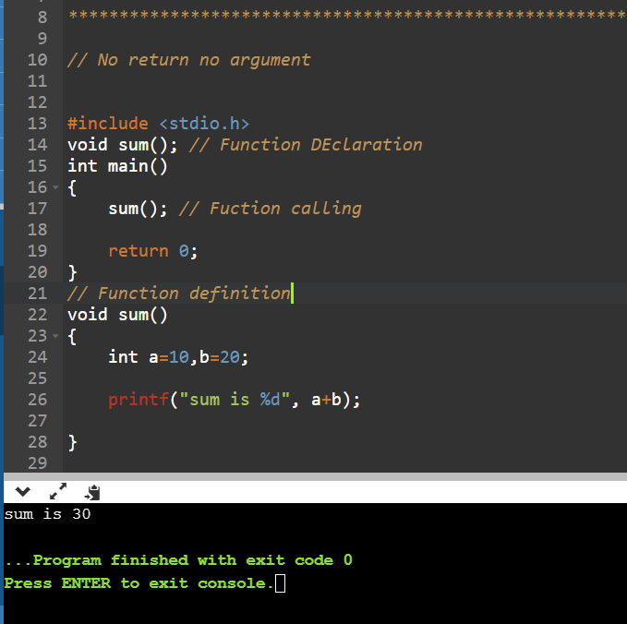
- 2) No return, With Argument
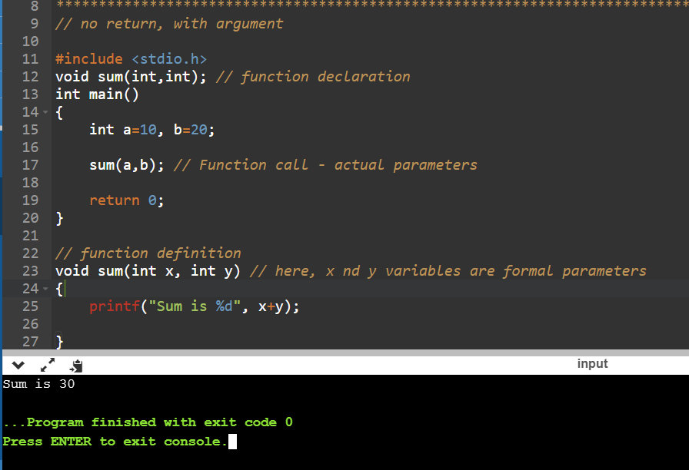
- 3) With return, No argument
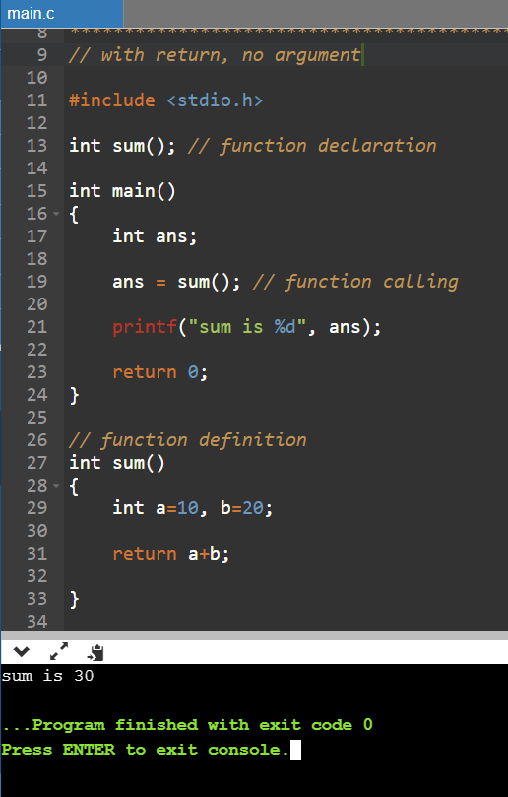
- 4) With return, with argument
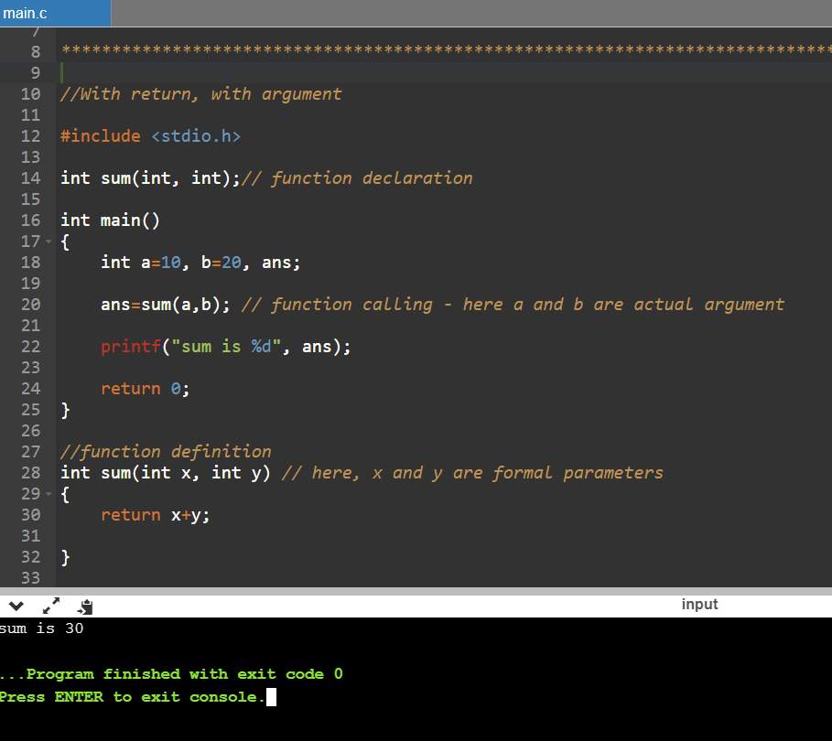

- Recursion : when function calls itself
  - For example ,
