Name of Institute: IITE

Name of Faculty: Prof. Sujoy Krishna Chaudhury

Course code: MT0706
Course name: Advanced Ferrous Metallurgy
Pre-requisites: Mineral Processing, Introduction to Process Metallurgy, Iron Making, Steel Making
Credit points: 04
Offered Semester: 07

Course Coordinator
Full Name: Dr. Sujoy Krishna Chaudhury
Department with siting location: Metallurgical Engineering, Bhanwar Building, Lab-004 (GF)
Telephone: 8469943117
Email:sujoychaudhury.mt@indusuni.ac.in
Consultation times: 3:45-4:20 PM

Course Lecturer
Full Name: Dr. Sujoy Krishna Chaudhury
Department with siting location: Metallurgical Engineering, Bhanwar Building, Lab-004 (GF)
Telephone:8469943117
Email: sujoychaudhury.mt@indusuni.ac.in
Consultation times: 3:45-4:20 PM

Students will be contacted throughout the Session via Mail with important information relating to this Course.

Course Objectives
By participating in and understanding all facets of this Course a student will:

1. Impart the overall idea of how iron and steel is produced and the history of iron and steel making.
2. Know about various techniques of raw material preparation for charging in iron making furnace, construction, operation of iron making furnace, reactions occurring in the furnace, reaction mechanism inside the blast furnace, and post treatment to make steel.

Course Outcomes (CO)
1. To apply the knowledge of various processes of iron and steel making to practical scenarios.
2. To understand existing knowledge of making Iron and steel and update with advanced techniques for developing the technology to make this process energy intensive and cost effective.

Course Outline
Proposed course mainly deals with nuances of iron and steel making using advanced technologies and exploring alternative routes for the production of the same. In addition, the subject deals with reaction mechanisms for production of high quality ferrous materials.

Method of delivery
Face to face lectures, Model Making

Study time
4 Lectures per week

CO-PO Mapping (PO: Program Outcomes)

 | PO1 | PO2 | PO3 | PO4 | PO5 | PO6 | PO7 | PO8 | PO9 | PO10 | PO11 | PO12
CO1 | 1 | - | 2 | - | 1 | 1 | 3 | 1 | - | - | 2 | -
CO2 | 3 | 3 | 2 | 1 | 2 | 2 | 2 | - | - | - | 3 | 1

1-Lightly Mapped 2- Moderately Mapped 3- Highly Mapped

Blooms Taxonomy and Knowledge retention (For reference)
(Blooms taxonomy has been given for reference)

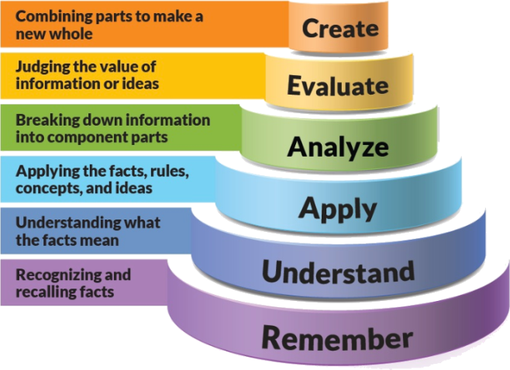
Figure 1: Blooms Taxonomy
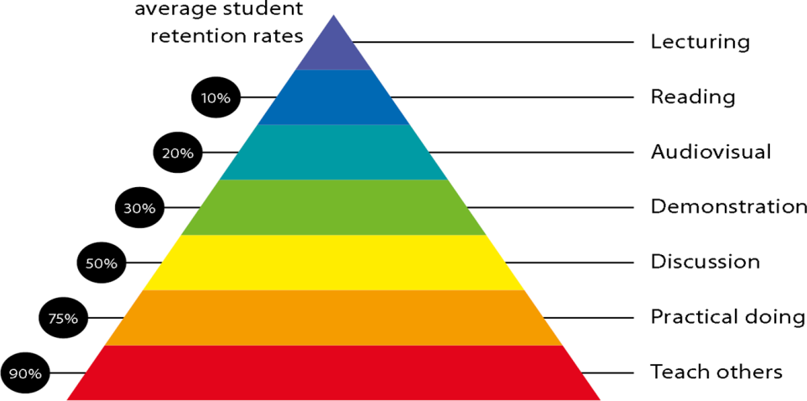
Figure 2: Knowledge retention

Graduate Qualities and Capabilities covered
(Qualities graduates harness crediting this Course)

General Graduate Qualities | Specific Department of ______Graduate Capabilities
Informed  Have a sound knowledge of an area of study or profession and understand its current issues, locally and internationally. Know how to apply this knowledge. Understand how an area of study has developed and how it relates to other areas. | 1 Professional knowledge, grounding & awareness
Independent learners  Engage with new ideas and ways of thinking and critically analyze issues. Seek to extend knowledge through ongoing research, enquiry and reflection. Find and evaluate information, using a variety of sources and technologies. Acknowledge the work and ideas of others. | 2 Information literacy, gathering & processing
Problem solvers  Take on challenges and opportunities. Apply creative, logical and critical thinking skills to respond effectively. Make and implement decisions. Be flexible, thorough, innovative, and aim for high standards. | 4 Problem solving skills
Effective communicators  Articulate ideas and convey them effectively using a range of media. Work collaboratively and engage with people in different settings. Recognize how culture can shape communication. | 5 Written communication
 | 6 Oral communication
 | 7 Teamwork
Responsible  Understand how decisions can affect others and make ethically informed choices. Appreciate and respect diversity. Act with integrity as part of local, national, global and professional communities. | 10 Sustainability, societal & environmental impact

Practical work:

(NA)

Lecture/tutorial times
Lecture Tuesday 2:00-3:00 PM Google Classroom

Lecture Wednesday 11:10-12:10 PM and 3.10-4.10 PM Google Classroom

Lecture Wednesday 3:10-4:10 PM Google Classroom

Lecture Thursday 3:10-4:10 PM Google Classroom

Attendance Requirements

The University norms states that it is the responsibility of students to attend all lectures, tutorials, seminars and practical work as stipulated in the Course outline. Minimum attendance requirement as per university norms is compulsory for being eligible for mid and end semester examinations.

Details of referencing system to be used in written work

Reference Books
1. A. W. Cramb, “Making, Shaping and Treating of Steels”, Association of Iron and Steel Engineers, 11thEdition, 1985, ISBN: 9780930767020.
2. J. G. Peacey and W. G. Davenport, “Blast Furnace: Theory and Practice”, Pergamon Press, Oxford, 1stEdition, 1979, ISBN: 9780080232584.

Text books
1. A. Ghosh, “Principles of Secondary Processing and Casting of Liquid Steel”, South Asia Books, 1st Edition, 1990, ISBN: 9788120405585.
2. F.P.Edneral, “Electrometallurgy of Steel and Ferro-alloys, Vol. I & II”, Mir Publishers, 1st Edition, 1979, ISBN: 9780828515184.

Additional Materials
1. NPTEL MOOC Course on “Steel Quality: Role of Secondary Refining & Continuous Casting”
(https://nptel.ac.in/courses/112/106/112106226/)
2. NPTEL Course on “Materials and Heat Balance in Metallurgical Processes”
(http://nptel.ac.in/courses/113104060/26)

ASSESSMENT GUIDELINES
Your final course mark will be calculated from the following:
CIE 60 marks :(40 marks mid semester examination + 20 marks internal evaluation)

Breakup of 20 Marks: (05 marks as attendance bonus for all students having attendance > 80%) + (05 marks for presentation)+(10 marks for two assignment or case studies)

ESE: 40 Marks of End Semester Examination

SUPPLEMENTARY ASSESSMENT

Students who receive an overall mark less than 40% in mid semester or end semester will be considered for supplementary assessment in the respective components (i.e. mid semester or end semester) of semester concerned. Students must make themselves available during the supplementary examination period to take up the respective components (mid semester or end semester) and need to obtain the required minimum 40% marks to clear the concerned components, For remedial and repeater remedial - CIE 60 marks (40 marks remedial mid semester examination + 20 marks for assignments or case studies, limited to minimum 04 assignments per course), and end semester repeater and remedial examination would be carried out centrally according to University Policy.

Practical Work Report/Laboratory Report:
Not applicable.

Late Work
Late assignments will not be accepted without supporting documentation. Late submission of the reports will result in a deduction of -% of the maximum mark per calendar day

Format
All assignments must be presented in a neat, legible format with all information sources correctly referenced. Assignment material handed in throughout the session that is not neat and legible will not be marked and will be returned to the student.

Retention of Written Work
Written assessment work will be retained by the Course coordinator/lecturer for two weeks after marking to be collected by the students.

University and Faculty Policies
Students should make themselves aware of the University and/or Faculty Policies regarding plagiarism, special consideration, supplementary examinations and other educational issues and student matters.

Plagiarism - Plagiarism is not acceptable and may result in the imposition of severe penalties. Plagiarism is the use of another person’s work, or idea, as if it is his or her own - if you have any doubts at all on what constitutes plagiarism, please consult your Course coordinator or lecturer. Plagiarism will be penalized severely.

Do not copy the work of other students.
Do not share your work with other students (except where required for a group activity or assessment).

Course schedule (subject to change)

 | Week # | Topic & contents |  | CO Addressed |  | Teaching Learning Activity (TLA)
 | Weeks 1 | Thermodynamics of oxides and their reduction: |  | 1,2 |  | PPT-Online Platform
 | Weeks 2 | Thermodynamics and kinetics of iron oxide reduction |  | 1,2 |  | PPT-Online Platform
 | Week 3 | . Kinetics of solid- solid and solid-gas reactions. |  | 1,2 |  | PPT-Online Platform
 | Week 4 | General Problems related to Indian Steel plants |  | 1,2 |  | PPT-Online Platform
 | Week 5 | Problems of Indian Steel Plants. High temperature properties of iron bearing materials |  | 1,2 |  | PPT-Online Platform
 | Week 6 | Advances in Charging Mechanisms and Blast Modifications. | 1,2 |  | PPT-Online Platform
 | Week 7 | Pre-treatment Techniques:  Pre-treatment of hot metal. Physico-chemical aspects of pre-treatment processes. Status of hot metal treatment in India. | 1,2 |  | PPT-Online Platform
 | Week 8 | Electric Arc Furnace (EAF) steel making:  Design of EAF-AC, DC electric arc. Latest trends in EAF design and operation. | 1,2 |  | PPT-Online Platform
 | Week 9 | Secondary steel making processes:  Alloy steel making in EAF using secondary refining. Continuous casting | 1,2 |  | PPT-Online Platform
 | Week 10 | Secondary steel making processes:  Continuous casting | 1,2 |  | PPT-Online Platform
 | Week 11 | Secondary steel making processes:  ESR | 1,2 |  | PPT-Online Platform
 | Week 12 | Quality Assessment of sound steel making | 1,2 |  | PPT-Online Platform
 | Week 13 | Con-Cast Technique | 1,2 |  | PPT-Online Platform
 | Week 14 | Role of synthetic slags. Electro-slag refining. | 1,2 |  | PPT-Online Platform
 | Week 15 | Slag-metal reaction in iron and steel making. | 1,2 |  | PPT-Online Platform
 | Week 16 | Ferro-alloy production. Application of plasma technology. | 1,2 |  | PPT-Online Platform

Program Mapping for Metallurgy Department:
