Assignment No 2 of Advance corporate accounting IMBA – semester 3(Marks30)
Submission Date: 6/11/2019

Ques 1. On 31st December 2004, the Balance Sheet of a Limited Company disclosed the following position: ( 8 Marks)
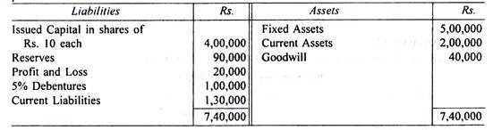
On 31st December 2004, the fixed assets were independently valued at Rs. 3, 50,000 and the goodwill at Rs. 50,000.
The net profits for the three years were:
2002 Rs. 51,600; 2003 Rs. 52,000 and 2004 Rs. 51.650 of which 20% was placed to Reserve Account and this proportion being considered reasonable in the industry in which the Company is engaged and where a fair investment return may be taken at 10%. Compute the value of the Company’s share by (a) the Assets Method and (b) the Yield Method.
Ques 2. D. Ltd. decided to reorganize its The Balance Sheet of the company as structure following a period of adverse trading conditions on 31st Dec. 2006 showed the following: (8Marks)
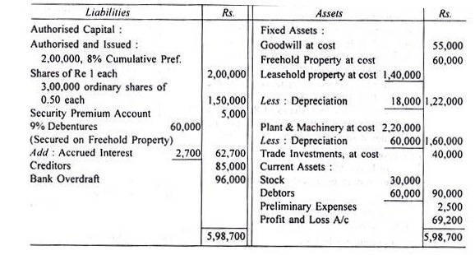
Note:
Preference dividends are in arrears for four years.
Subsequent to approval by court of a scheme for the reduction of capital, the following steps were taken:
(i) The preference shares were reduced to Rs 0.75 per share, and the ordinary shares to Re. 0.10 per share. After reduction the shares were consolidated into Re. 1 shares. The authorised capital was restored to 2, 00,000, 8% Cumulative Pref. Shares and 1, 50,000 ordinary shares, both of Re. 1 each.
(ii) One new ordinary share of Re. 1 was issued for every Rs. 4 of gross preferred dividend in arrears.
(iii) The balance on Security Premium Account was utilised.
(iv) The debenture holders took over the freehold property at an agreed figure of Rs 75,000 and paid the balance to the company after deducting the amount due to them,
(v) Plant and Machinery was written down to Rs. 1, 40,000.
(vi) Trade Investments were sold for Rs. 32,000.
(vii) Goodwill, Preliminary Expenses, Debts of Rs. 8,600 and obsolete stock of Rs. 10,000 were written off.
(viii) A contingent liability of which no provision had been made was settled at Rs. 7,000 and of the amount Rs. 6,300 was recovered from the insurance.
You are required (a) to show the Journal Entries, necessary to record the above transactions in the company’s books and (b) to prepare the Balance Sheet, after completion of the scheme.
Ques3. Computation of Purchase Consideration
The following is the Balance Sheet of Swarna Ltd. as on 31st March: (8Marks)
Liabilities | Amount | Assets | Amount
14,000 Equity Shares of Rs. 100  each fully paid | 14,00,000 | Sundry Assets | 18,00,000
General Reserve | 10,000 | Discount on issue of Debentures | 10,000
10% Debentures | 2,00,000 | Preliminary Expenses | 30,000
Sundry Creditors | 2,00,000 | Profit & Loss A/c | 60,000
Bank Overdraft | 50,000
Bills Payable | 40,000
Total | 19,00,000 | Total | 19,00,000

Rajata Ltd. agreed to take over the business of Swarna Ltd. Calculate Purchase Consideration under
Net Assets Method. The Market Value of 75% of the Sundry Assets is estimated to be 12% more than the
Book Value and that of the remaining 25% at 8% less than the Book Value. The Liabilities are taken over at Book Values. There is an unrecorded liability of Rs. 25,000.

Ques 4 (6Marks)
- Define Goodwill. State the circumstances under which the need for valuation of goodwill arises in case of a joint stock company.
- Enumerate the distinguishing features of ‘Pooling of interest method’ and ‘purchase method’ of accounting for amalgamation.
- Differentiate between: External Reconstruction and Internal Reconstruction.

