Understanding how the brain works is key to understanding how we make decisions in life. This has fundamental implications for businesses, customers, and investors. The field of neuroscience is helping us to improve this understanding.

"The total number of different possible moves in a single game of chess is more than the number of seconds that have elapsed since the big bang created the universe."
– Garry Kasparov, chess grandmaster
For Kasparov, who claims to be able to think up to 15 moves in advance, “intuition is the defining quality of a great chess player.”
Hunches and emotions are far more influential than what we have ever previously thought. They help fast-track decision making and are very often already made up by the time we verbalise our decision. Professor of Marketing at Harvard, Gerald Zaltman, suggests that “contrary to the classical economic theory which states that people make rational decisions, present studies show that 95% of our decisions are taken at the subconscious level”. This has a profound impact on our decision making. Given the subconscious nature of influence, it is important that consumers and clients are aware of the various principles pertaining to neuroscience practice.
The rate of change in business models, fragmentation of media channels, the pervasiveness of consumers, the availability of information to consumers when making a purchase decision means that influencing customer choice has become harder than ever. There are however two prominent ways in which business can influence decision making. The first is to increase motivation via emotional persuasion and the second is to make it easier to purchase the product or service. To fully appreciate the influence that these two aspects have on decision-making behaviour, one needs to understand how the brain comprehends information.

Understanding the brain
The easiest way to understand how the brain works is to think of it as a pathway in which external stimuli are processed. In his book “Thinking Fast and Slow”, Daniel Kahneman differentiates between two independent modes of brain activity: “system 1 thinking”, which he considers as fast and parallel, automatic, preconscious and driven by emotions and associations; and “system 2 thinking”, which is slow and sequential, deliberate, often rule-based and uses conscious calculation to arrive at decisions.
Hunches and emotions are far more influential than what we have ever previously thought.
System 1 is called the limbic system (comprising of the amygdala and the hippocampus). System 2 is the neocortex, which acts slowly and is associated with logic and rational thought. While both of these systems influence decision-making, the limbic system is far more influential than the neocortex in prioritizing information. Diagram 1 (below) illustrates how information is processed; it is first absorbed in the thalamus, and this functions as the first control centre. These signals are then sent further to the limbic system.
The amygdala (the name stems from the Greek word for almond) is the chief decision-making prioritise. It determines whether something is important or not based on whether the stimuli evoke an emotional response or not. Recognising emotion is the primary function of the
amygdala.
You cannot make decisions without emotions.
The hippocampus then informs the amygdala about past experiences that help contextualise and give meaning to the current stimuli. The strength and quality of our associated memories inform the degree of attention and emotional response we give something. If there is no emotion, the information presented is ignored, as per diagram 1. If emotion is presented, the information is deemed important (diagram 2).
To illustrate this, think of a distinct childhood experience. For myself, this would be running through a sprinkler at home in the garden on a hot summer’s day with family. This memory would be stored in the hippocampus and be associated with family and fun. If this scenario were presented to you in a movie, picture or live scenario, your brain would deem this imagery important as it evokes memories of your past and you will likely spend time looking at it. You will be familiar with what images, sounds, etc trigger positive (or negative) emotions based on your personal experiences.
Nobel Prize winner Antonio Damasio, who wrote for the book, “Descartes’ Error”, questioned the long-held view that humans are entirely rational. He experimented with people who had suffered neurological damage to specific sites of their limbic system, finding that this resulted in a loss of certain emotions, and with it, the ability to make decisions.
His conclusion stated that you cannot make decisions without emotions.

Diagram 1

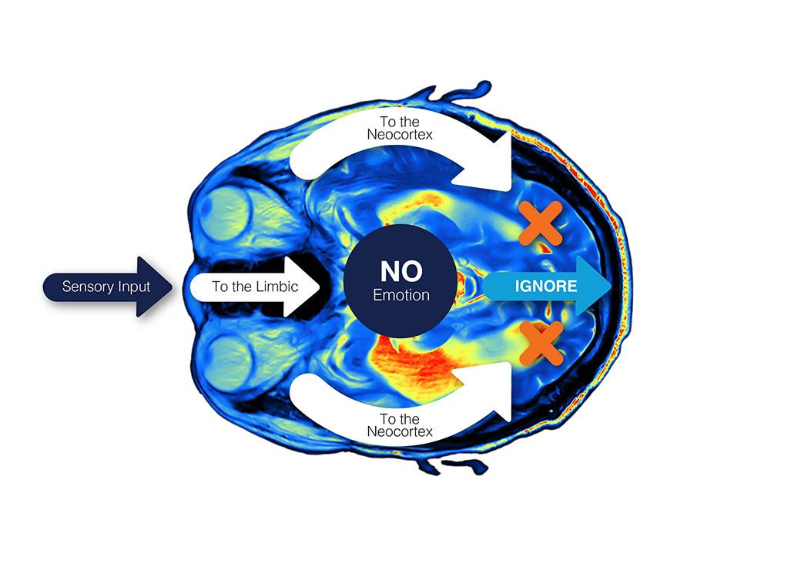

Diagram 2

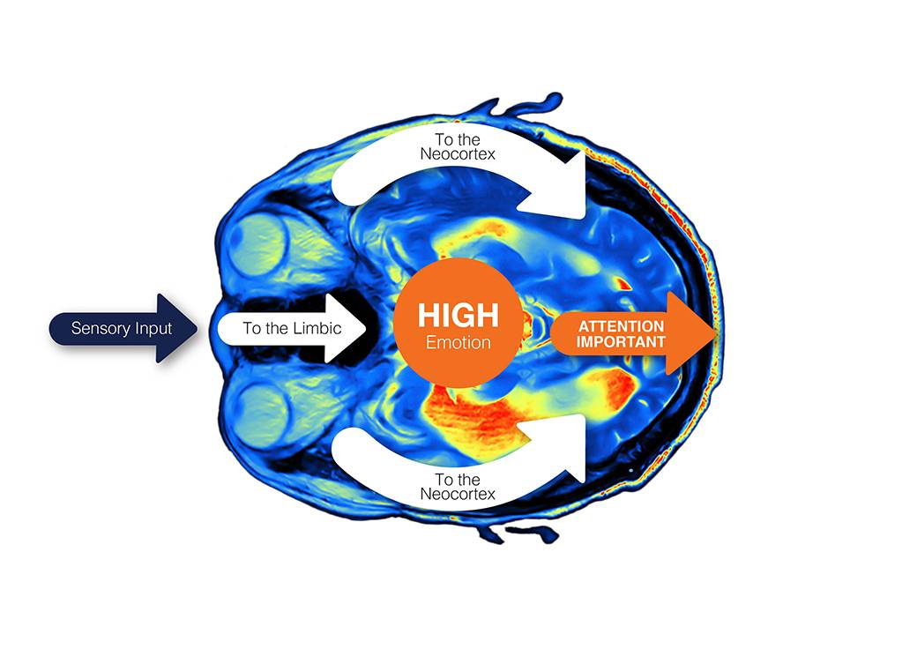

So what for Business?
While there are many implications for business, two of the most significant aspects that leverage to influence decision making, are the use of emotion and making it as easy as possible to buy your product or service.

Leveraging emotion:
Emotion can be invoked in many ways, for example in brand communication, how products are physically wrapped or by focusing on common interests with potential clients. An example of leveraging emotion to position a product or service is the way in which some financial institutions link their financial products to an emotional need. So, for a financial institution offering a high-end tertiary investment product, it would make far better sense to market an ‘Offshore University Education Investment’ than say, a ‘Prime +4% S&P 500 Saver’.

Why emotions matter:
- Emotions Matter
Everyone has them; without emotions, we cannot make decisions.
- Emotions speed up decision-making
Without getting an emotional response how would we know what our needs are?
- Emotions create action
Emotions help us change behaviour (e.g. fear, anxiety) because our emotions tell us what’s important or not.
- Emotions enhance recall
If an event is linked to an emotional experience or event, we tend to be able to recall it more easily than if it has no emotional consequences for us.

Making it easier to buy
In addition to using emotionally appropriate communication, the removal of friction points in the customer decision-making process is highly influential. The more friction there is, the less time the brain will allocate to thinking positively about the purchase. Things like physical or mental effort and time should be minimised. People tend to go for things that are easier to do. It is in our nature.
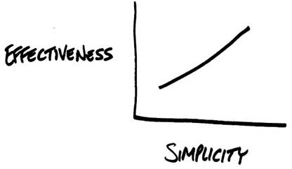
Think about a recent campaign by a well-known bank: “Switch banks in under 10 minutes.” Simplicity wins in a complex, time-pressured world. People respond to the ability and opportunity to make quick, hassle-free decisions. Simplicity has become a scarce, highly-valued resource. It has also created opportunities for disruptiveness. Think for example of Uber or Airbnb. Simplicity is the attractor. Can you think of ways to leverage simplicity in your business role?
Simplicity wins in a complex, time-pressured world.
An understanding of some of the above neuroscience insights could be important also for clients in order to improve their decision making.

